SIMATS ENGINEERING

ASSESSMENT TOOL 1: Constraint-Based Problem Solving

COURSE NAME: Cloud Computing and Big Data Analytics
COURSE CODE: CSA15

COURSE OUTCOME COVERED
CO5: Design big data processing systems using the Hadoop ecosystem including HDFS, MapReduce, and YARN. (BL5)

Assessment Tool Weightage: 40%
Dave's Taxonomy: Articulation (Level 4)
Question Count: 5
Total Marks: 50

Code of Conduct

I Kanishk C (Reg. No: 192511278) certify that this submission is my original work and that I have adhered to the guidelines specified for this assessment.
I understand that any violation of academic integrity rules will result in disciplinary action.

Signature of the student: ____________________

Assessment Tasks
Constraint-Based Problem Solving

Question 1. Design an HDFS-based storage solution for a media platform under the constraints that data availability must remain above 99.9%, replication factor cannot exceed 3, and storage growth must stay cost efficient. Justify your design.
Understanding the constraints
There are really three things pulling in different directions here. Availability above 99.9% means the design has to survive both DataNode failures and rack-level failures without the platform going down. A replication factor cap of 3 means the durability of the data cannot come from simply adding more and more full copies. Cost efficiency means storage growth (which for a media platform, full of large video and image files, is going to be constant and heavy) cannot be handled just by buying more expensive high-replication storage forever.
System design
For actively viewed, recently uploaded media, use the standard replication factor of 3, which is the maximum allowed, combined with HDFS's default rack-aware placement policy: one replica on the local node/rack where the write happens, and the other two replicas spread onto a different rack. This way, losing a single node never causes data loss, and even losing an entire rack still leaves at least one good replica available elsewhere. On top of that, deploy NameNode High Availability with an Active NameNode and a Standby NameNode kept in sync through a Quorum Journal Manager, with ZooKeeper handling automatic failover. This matters because 99.9% availability is a promise about the whole service, not just the data blocks, and a single NameNode would be a hidden weak point even with perfect replication underneath it. For older media that is rarely accessed any more (which in a media platform is usually the bulk of total storage), move it into a cold storage tier that uses HDFS Erasure Coding instead of full 3x replication. Erasure Coding reconstructs data from parity fragments instead of keeping three whole copies, giving comparable durability at roughly half the storage overhead of full replication, which directly helps with the cost constraint without needing to increase the replication factor at all.
Application of Hadoop concepts
This design uses HDFS's replica placement policy and rack awareness, NameNode High Availability with Quorum Journal Manager and ZooKeeper-based failover, and Erasure Coding as a storage-efficient alternative to replication for cold data, along with basic hot/cold data tiering based on access frequency.
Justification
Splitting the platform into a hot tier (replication factor 3, rack-aware, fast access) and a cold tier (Erasure Coding, cheaper, still durable) satisfies the replication cap because RF3 is never exceeded on the hot tier, and Erasure Coding on the cold tier is not 'replication' in the same sense yet still protects against node/rack loss, so storage growth on the (much larger) cold tier does not multiply cost the way full replication would. NameNode HA removes the metadata service as a single point of failure, and rack-aware placement means neither a single node failure nor a single rack failure can take the platform below the 99.9% target.
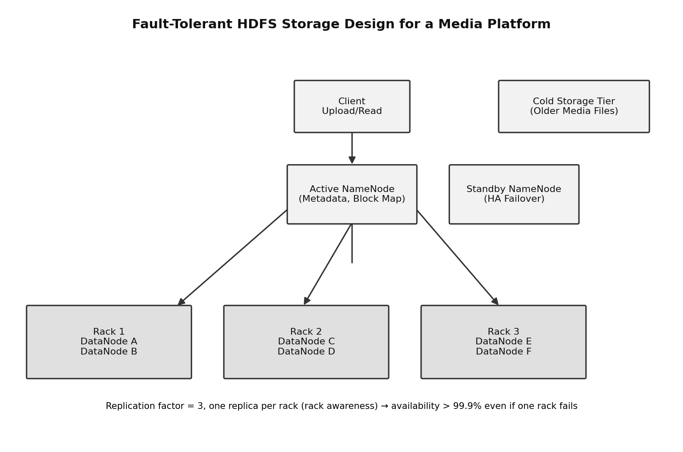
Figure 1: Rack-aware HDFS layout with an Active/Standby NameNode pair and a cheaper cold-storage tier for older media files.

Question 2. A MapReduce workflow must process log data within a 20-minute batch window using limited cluster nodes. Propose a job design under these constraints and explain task distribution.
Understanding the constraints
The hard limit is time (20 minutes), and the resource available to work with is limited (only a fixed, presumably modest, number of cluster nodes). That combination means the job design has to squeeze the most useful work out of every available slot rather than assuming it can just throw more machines at the problem.
System design
Start with the input splits: size them to line up with the HDFS block size so each mapper reads data that is already local to it, avoiding unnecessary network transfer before the mapper even starts. Use CombineFileInputFormat if the logs arrive as many small files, so mappers are not wasted on tiny splits. Add a combiner so each mapper aggregates its own output locally before shuffle, which cuts down the amount of data that has to move across the limited number of nodes during the shuffle phase; this matters a lot when the cluster is small, because shuffle traffic competes for the same limited network and disk resources that the mappers and reducers are also using. Compress the intermediate map output (for example with Snappy, which is fast rather than maximally compact) so shuffle takes less time at the cost of only a small amount of CPU. Set the number of reducers to match the cluster's actual reduce-slot capacity rather than leaving it at a default, so reducers do not queue up waiting for a slot to free; too many reducers on a small cluster just means more waiting, and too few under-uses the nodes that are free. Turn on speculative execution, so if one mapper or reducer is unusually slow (a straggler) on one of the limited nodes, a duplicate copy of that task is started elsewhere and whichever finishes first is used, protecting the 20-minute window from being wrecked by a single slow task.
Task distribution
Mapper tasks are distributed based on data locality: the ResourceManager tries to schedule each map task on (or close to) the node that already holds that block, so with a small number of nodes this locality-aware placement is what keeps network transfer to a minimum. Reducer tasks are distributed across whatever capacity remains once mapping is well underway, and because the reducer count has been deliberately matched to available slots, reducers should start pulling shuffled data and producing output without long queuing delays. If the cluster supports it, reserving the batch job its own YARN queue with a guaranteed capacity for the duration of the run helps make sure the time-critical job is not competing with unrelated work for the same limited nodes.
Application of Hadoop concepts
This uses input split sizing and data locality, combiners, intermediate compression, tuned reducer counts against real slot capacity, and speculative execution, all standard MapReduce techniques for getting a job to finish reliably inside a tight time budget on a small cluster.
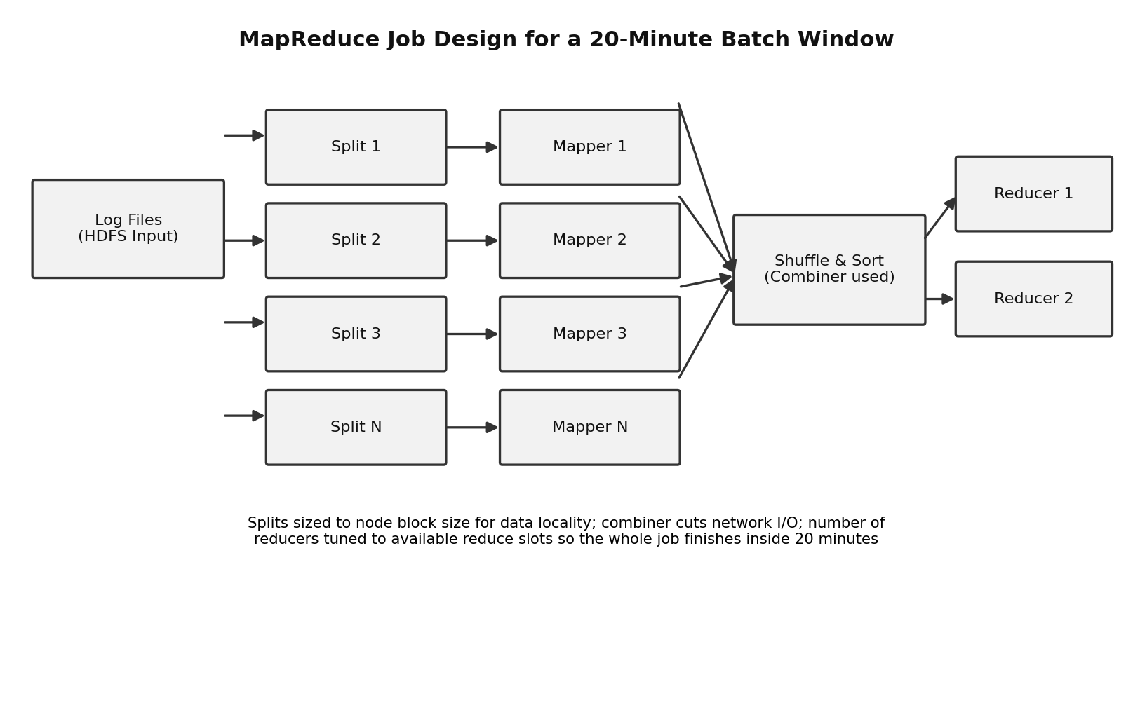
Figure 2: Splits sized for data locality, feeding mappers with a combiner, then shuffle/sort into a small, correctly-sized set of reducers.

Question 3. A YARN-managed cluster supports ETL, reporting, and machine learning jobs. Design a scheduler policy under the constraints of fairness, priority for ETL, and recovery from node failure.
Understanding the constraints
Three requirements have to hold at once: different users/workloads need to be treated fairly rather than one starving another, ETL jobs specifically need to be prioritized above the others, and the whole thing needs to keep running smoothly even if a node crashes mid-job.
System design
Configure YARN's Capacity Scheduler with three queues, one each for ETL, Reporting, and Machine Learning. Give ETL the largest guaranteed capacity share, say 50%, since it needs priority, with Reporting at around 30% and ML at 20%; all three queues are set up as elastic, meaning any queue can temporarily use idle capacity from the others when they are not busy, so cluster resources are not left sitting unused just to protect a queue's guarantee. To make ETL's priority concrete rather than just a bigger number, use YARN's queue priority setting so ETL's queue is marked as higher priority, and turn on preemption, so that if ETL genuinely needs resources that are currently being used by Reporting or ML beyond their own guaranteed share, YARN can reclaim those containers back for ETL instead of making it wait. Within the Reporting and ML queues, where multiple users or multiple concurrent jobs are more likely, apply a fair ordering policy inside the queue so that users sharing that queue get roughly equal turns rather than a first-submitted job hogging the whole queue.
Recovery from node failure
For resilience against a node going down mid-job, enable NodeManager recovery (yarn.nodemanager.recovery.enabled) so that if a NodeManager process itself restarts, it can reattach to containers that were already running instead of killing them outright. If the physical node genuinely fails, the ApplicationMaster for the affected job detects the lost containers through missed heartbeats and requests replacement containers from the ResourceManager on healthy nodes, so the job continues rather than restarting from scratch; setting yarn.resourcemanager.am.max-attempts high enough also means the ApplicationMaster itself can be restarted if needed without the whole job failing outright. For extra protection against the ResourceManager itself being the weak link, ResourceManager HA (Active/Standby, coordinated by ZooKeeper) means even an RM failure does not bring the scheduler down.
Application of Hadoop concepts
This uses the YARN Capacity Scheduler's queue hierarchy and elastic capacity, queue priority with preemption, fair ordering policy within a queue, NodeManager recovery, ApplicationMaster retry behaviour, and ResourceManager High Availability, which together cover fairness, prioritization, and fault recovery as separate but complementary scheduler features.
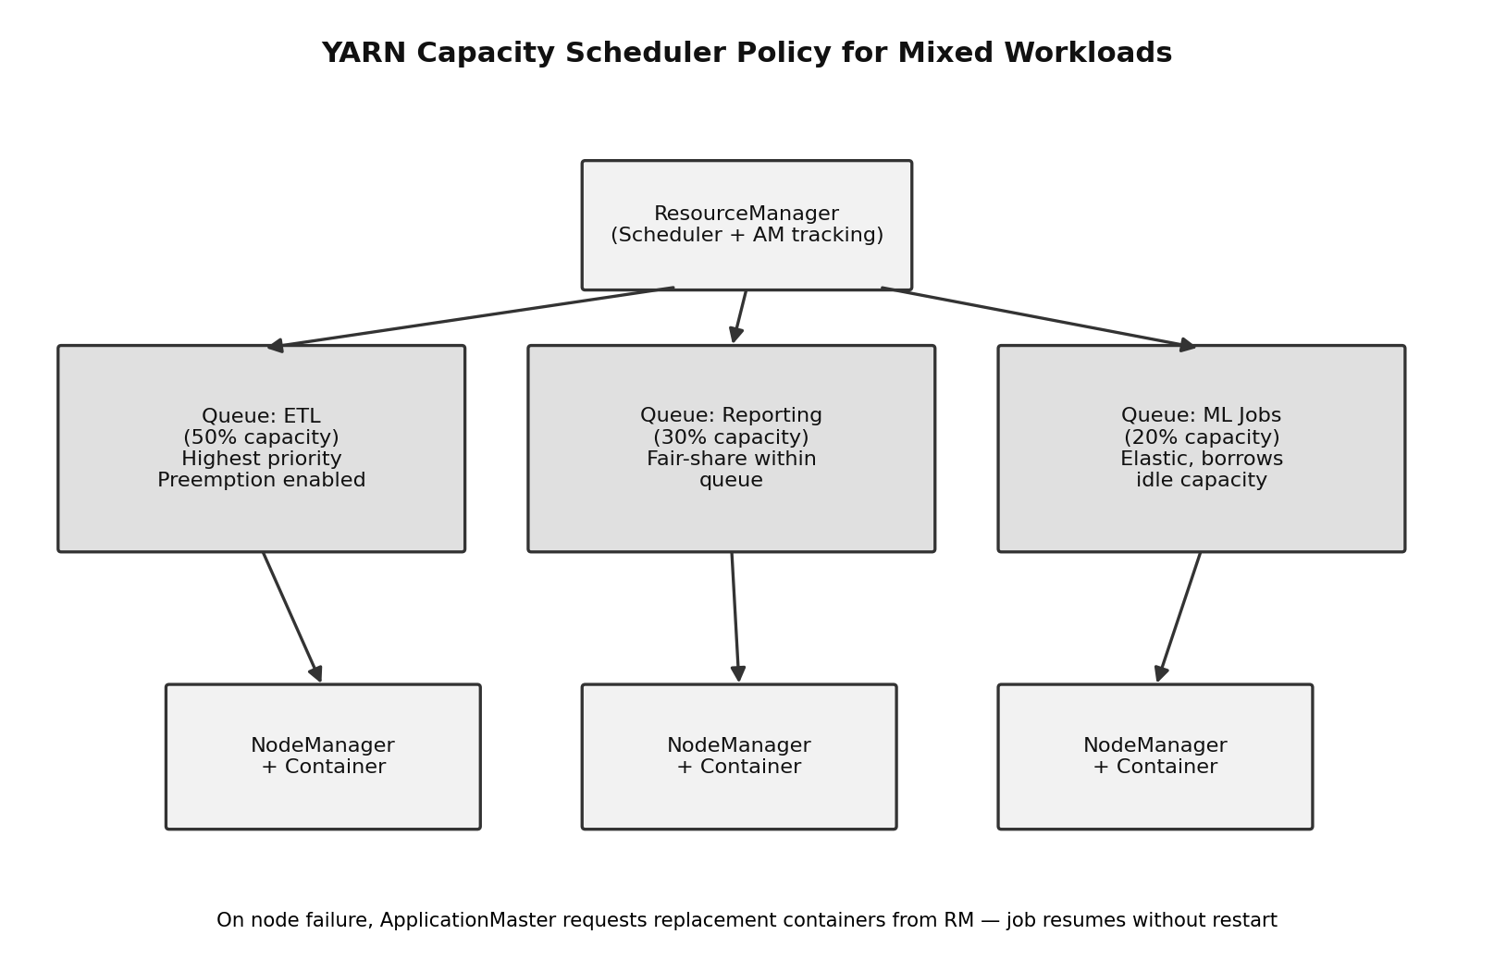
Figure 3: Capacity Scheduler queues giving ETL a guaranteed, prioritized share, Reporting and ML their own fair shares, with NodeManagers running the actual containers.

Question 4. An enterprise needs to ingest data from SAN, NAS, and operational databases into a big data platform while maintaining backup reliability and minimal duplication. Propose a constrained architecture and justify each component.
Understanding the constraints
Three different types of sources have to be handled together (block storage, file storage, and relational databases), which each behave differently to read from, and on top of that, whatever is built needs to be reliably backed up and must avoid creating duplicate records, which is a common problem when multiple sources or retries are involved.
Proposed architecture
Apache NiFi sits at the front as the ingestion layer because it can speak to all three source types through different processors within one consistent pipeline. For SAN and NAS, which expose data as files, NiFi processors like GetSFTP, FetchFile, or ListFile pull files in as they appear. For the operational databases, instead of repeatedly pulling entire tables (which is slow and a major source of duplicate re-ingestion), use Change Data Capture (CDC), for example NiFi's QueryDatabaseTable or a CDC-specific processor, so only new or changed rows are picked up each time. As data enters the pipeline from any of the three sources, it is tagged with a content hash or a natural unique key, and a de-duplication step (a DetectDuplicate-style processor) checks this against recently seen records before letting anything through, catching duplicates whether they come from a retry or from overlapping data across sources. Data then lands in an HDFS landing zone for staging, goes through a validation/cleaning step, and is finally loaded into the warehouse (Hive, for example) using UPSERT/MERGE semantics keyed on the same unique identifier, so that even if a duplicate somehow gets through the earlier check, the load step still cannot create a duplicate row.
Backup reliability
Separately from the main ingestion flow, the HDFS landing zone and the warehouse are both replicated to a backup cluster, either through scheduled incremental distcp jobs or NiFi's own site-to-site replication capability, so a copy exists off the primary cluster. Regular HDFS snapshots are taken on the landing zone so a consistent point-in-time copy is always available to restore from, and backup jobs are monitored so a failed backup run gets noticed and re-run rather than being discovered only during an actual incident.
Justification of each component
NiFi is justified because it gives one place to manage very different source types and provides built-in provenance for auditing exactly what has been ingested. CDC on the databases is justified because it directly reduces duplication at the source rather than trying to clean it up afterwards, and it is also far cheaper than repeatedly pulling full tables. The hash-based de-duplication step is justified as a safety net that works regardless of which source produced the duplicate. UPSERT-based loading is justified as a final guarantee that duplication cannot happen even if every earlier check somehow fails. The separate backup cluster and scheduled, monitored snapshots are justified because they directly satisfy the backup-reliability requirement without depending on the same infrastructure that is also handling live ingestion.
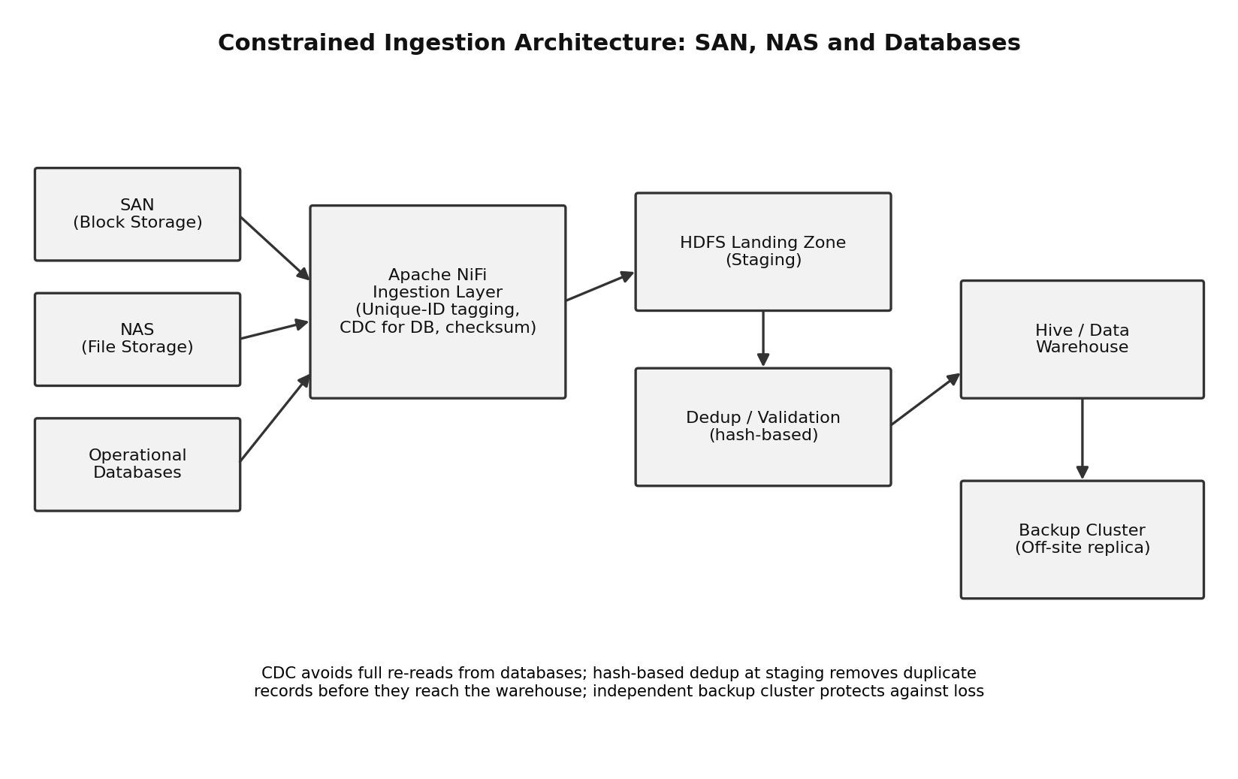
Figure 4: NiFi ingesting from SAN, NAS, and databases, followed by hash-based de-duplication before the data warehouse, with a separate backup cluster for reliability.

Question 5. Design an end-to-end Hadoop ecosystem solution under the constraints of secure data movement, high availability, and integration with Apache NiFi or ETL pipelines. Explain how your design satisfies all constraints.
Understanding the constraints
Three constraints need to be satisfied together across the whole ecosystem, not just in one component: data has to move securely from source to storage, the platform overall has to stay highly available, and NiFi or an equivalent ETL pipeline needs to be properly integrated as the way data actually enters and moves through the system.
System design
Data originates at various source systems and is picked up by Apache NiFi, which handles the ingestion and any light transformation needed before the data lands in HDFS. NiFi hands heavier ETL and aggregation work off to Hive or Spark jobs running under YARN, and the results are made available through a serving layer such as Hive tables for reporting or HBase for fast lookups. Underneath all of this, HDFS uses replication factor 3 with rack-aware placement so the data itself survives node and rack failures, and the NameNode runs in an Active/Standby High Availability pair, kept synchronized through a Quorum Journal Manager, with ZooKeeper handling automatic failover if the Active NameNode goes down. YARN's ResourceManager is similarly deployed in an Active/Standby HA configuration, so job scheduling itself does not depend on a single machine either. If the environment needs NiFi itself to be highly available, NiFi is run as a NiFi cluster (multiple nodes coordinated through ZooKeeper) rather than a single instance, so ingestion does not stop if one NiFi node fails.
Secure data movement
For security, NiFi flows between nodes and to/from external sources use TLS encryption, including NiFi's Site-to-Site protocol in secure mode. Kerberos is enabled across the Hadoop services (HDFS, YARN, Hive) so every service and every user is properly authenticated rather than trusted by default, and NiFi itself authenticates to these services using its own Kerberos principal/keytab. On top of authentication, a tool like Apache Ranger is used to control fine-grained authorization (who can read or write which datasets), and HDFS Transparent Data Encryption zones are used so sensitive data is encrypted at rest as well as in transit.
How the design satisfies all constraints
Secure data movement is satisfied through the combination of TLS in transit, Kerberos authentication end to end, Ranger-based authorization, and HDFS encryption zones at rest, covering the data's entire journey. High availability is satisfied because every layer that could otherwise be a single point of failure, NameNode, ResourceManager, and optionally NiFi itself, is deployed as an Active/Standby or clustered setup with automatic failover through ZooKeeper, and the data layer itself is protected through RF3 replication. Integration with NiFi/ETL is satisfied because NiFi is the single, consistent entry point for all ingestion, handing off cleanly to Hive/Spark under YARN for heavier processing, which keeps the pipeline auditable (through NiFi provenance) and avoids ad-hoc, untracked ways of getting data into the platform.
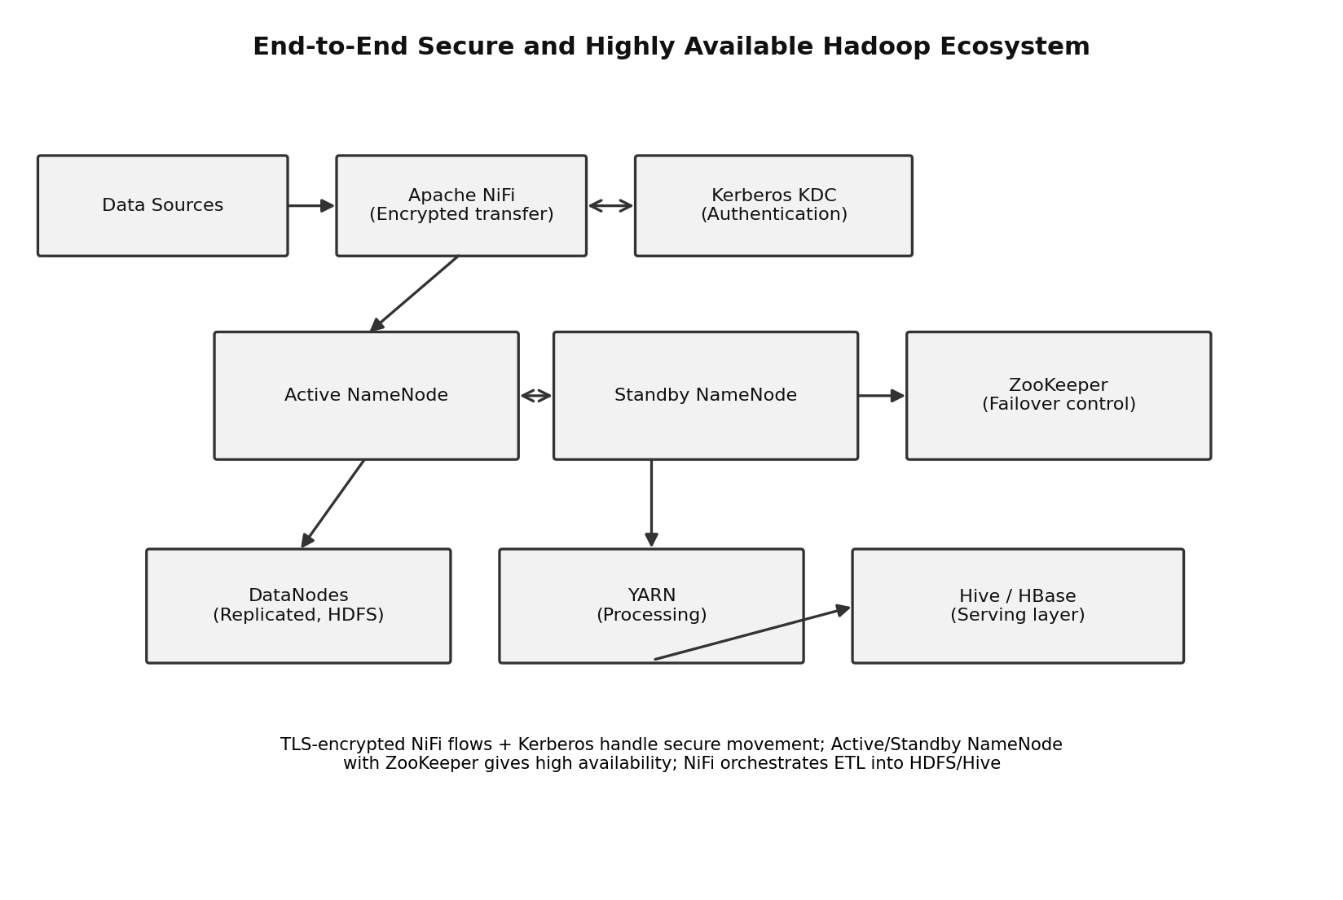
Figure 5: Secure, Kerberos-authenticated NiFi ingestion into an HA HDFS/YARN cluster, feeding a Hive/HBase serving layer.

Constraint-Based Problem Solving Rubric

Criteria | Weightage | Level 4 - Exemplary | Level 3 - Proficient | Level 2 - Developing | Level 1 - Beginning
Understanding of Constraints | 25% | All technical constraints are identified and prioritized accurately | Most constraints identified | Some constraints identified | Constraints poorly understood
System Design Quality | 25% | Design is robust, feasible, and aligned to constraints | Reasonable design | Basic design with gaps | Weak design
Application of Hadoop Concepts | 20% | Uses HDFS, MapReduce, YARN, and integration concepts effectively | Mostly effective use | Partial use of concepts | Weak concept application
Justification | 15% | Strong technical reasoning for all choices | Good justification | Basic justification | Little justification
Clarity | 15% | Clear, well-structured, and professional answer | Mostly clear | Somewhat unclear | Poorly structured

