SIMATS ENGINEERING
ASSESSMENT TOOL 3: MCQ Test
COURSE NAME: Cloud Computing and Big Data Analytics
COURSE CODE: CSA15
COURSE OUTCOME COVERED
CO3: Implement cloud-based solutions using cloud storage, web APIs, and platform services for real-world applications. (BL3)
Assessment Tool Weightage: 10%
Dave's Taxonomy: Precision (Level 3)
Question Count: 50
Total Marks: 100
Code of Conduct
I Kanishk C, Reg. No. 192511278 (Name / Reg No) certify that this submission is my original work and that I have adhered to the guidelines specified for this assessment.
I understand that any violation of academic integrity rules will result in disciplinary action.
Signature of the student: Kanishk C

Assessment Tasks
MCQ Test – Answers with Justification
Name: Kanishk C Registration Number: 192511278
1. A company wants to run several virtual machines on a single physical server to reduce hardware costs. Which technology should it use?
Answer: B) Virtualization
Reason: Virtualization allows one physical machine to run multiple isolated virtual machines, so the company gets more use out of the same hardware instead of buying a separate server for every workload.
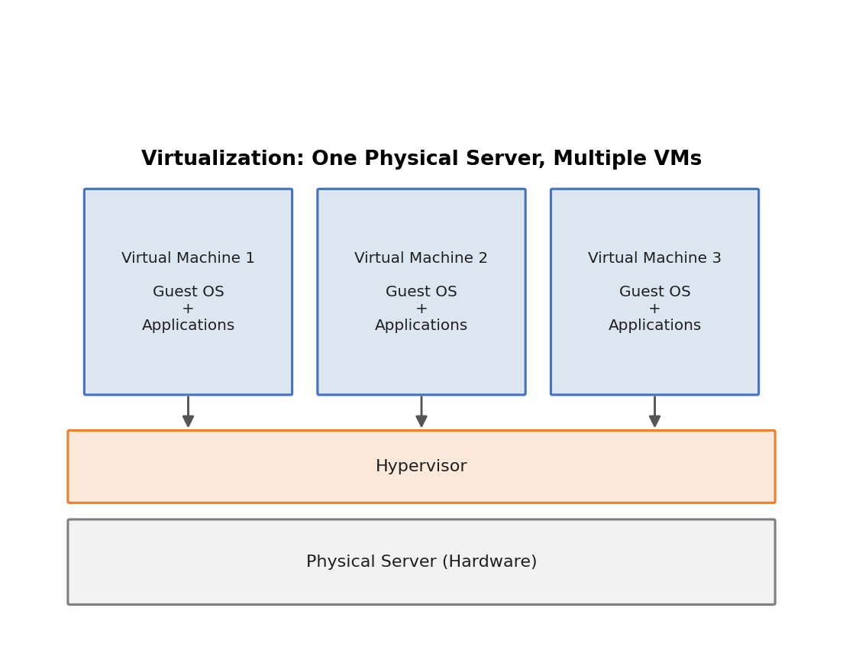
Fig. 1 – Virtualization: multiple virtual machines running on a single physical server
2. A student wants to access a cloud-based document application from a laptop without installing the application. Which component is most suitable?
Answer: A) Web browser
Reason: Cloud applications are accessed through a web browser, which connects to the remote server, so nothing needs to be installed on the laptop.
3. A hospital stores patient records in the cloud and wants to prevent unauthorized users from reading the data. Which technique should be used?
Answer: A) Encryption
Reason: Encryption converts readable data into a coded form, so even if the storage is accessed by an unauthorized person, the patient records cannot be read without the decryption key.
4. An organization experiences heavy traffic on its cloud application and wants to distribute requests across several servers. Which technology should it implement?
Answer: B) Load balancer
Reason: A load balancer spreads incoming requests evenly across multiple servers, preventing any single server from being overloaded during heavy traffic.
5. A startup wants to rent virtual machines, storage, and networking resources instead of purchasing physical infrastructure. Which cloud service model is appropriate?
Answer: C) IaaS
Reason: IaaS provides raw computing resources such as virtual machines, storage, and networking on a rental basis, which is exactly what the startup needs instead of buying physical hardware.
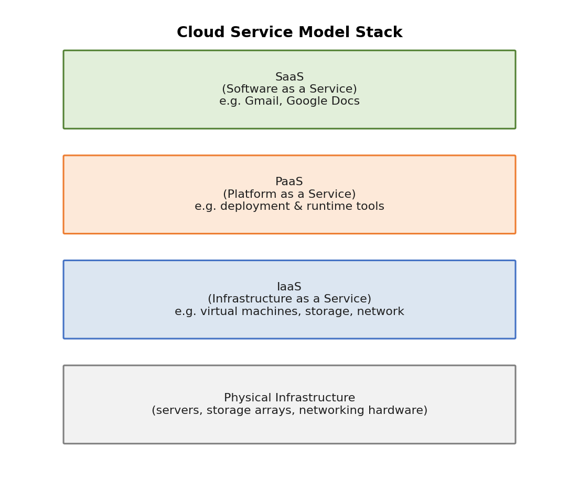
Fig. 2 – Cloud service model stack (IaaS, PaaS, SaaS) over physical infrastructure
6. A user wants to access an online cloud storage service from a desktop computer. What does the user primarily require?
Answer: A) Web browser and Internet connection
Reason: To reach any cloud service, the user needs an internet connection to communicate with the remote servers and a browser to interact with the service.
7. A software company wants an environment containing development tools and runtime services to build and deploy applications. Which model should it select?
Answer: B) PaaS
Reason: PaaS gives developers a ready-made platform with development tools, libraries and runtime environments, so they can focus on building and deploying applications without managing servers.
8. A teacher uses an online application to create, edit, and share documents with students without installing desktop software. What type of application is being used?
Answer: A) Web application
Reason: A web application runs inside a browser and does not require any local installation, which matches the scenario described.
9. An e-commerce application needs to obtain payment information from an external payment service. Which technology can facilitate this communication?
Answer: A) Web API
Reason: A web API defines a standard way for two different applications to exchange data over the internet, which is how the e-commerce app can talk to the payment gateway.
10. A user enters a cloud application's web address into Chrome and accesses the application. What role does Chrome perform?
Answer: B) Cloud client
Reason: Chrome acts as the client that sends requests to the cloud server and displays the response, while the actual application logic runs on the server side.
11. A company wants employees to access files from different offices without maintaining local storage servers at every office. Which solution is most appropriate?
Answer: A) Cloud storage
Reason: Cloud storage centralizes files on remote servers that can be accessed from any office over the internet, removing the need for local storage servers everywhere.
12. A bank requires high-speed block-level storage that can be shared by multiple servers. Which technology should it use?
Answer: A) SAN
Reason: A Storage Area Network (SAN) provides fast, block-level storage that multiple servers can access simultaneously, which suits the bank's high-speed shared storage requirement.
13. A data center is designing a SAN and needs a centralized device that provides storage capacity to connected servers. Which component is required?
Answer: A) Storage array
Reason: A storage array is the centralized hardware unit that pools disks together and presents storage capacity to servers connected over the SAN.
14. Five students located in different cities need to work simultaneously on the same project document. Which cloud feature would help them most?
Answer: A) Cloud collaboration
Reason: Cloud collaboration tools let multiple users edit the same document at the same time from different locations, which is exactly what the students need.
15. An organization wants applications from different cloud providers to communicate effectively. What should it emphasize?
Answer: A) Cloud standards
Reason: Following common cloud standards and protocols ensures that services built on different provider platforms can interoperate with one another.
16. A business experiences unpredictable demand during festival seasons. It wants resources to increase during peak periods and decrease afterward. Which cloud characteristic is most useful?
Answer: A) Elasticity
Reason: Elasticity is the ability of the cloud to automatically scale resources up during high demand and scale them back down afterward, matching the business's seasonal traffic pattern.
17. A company subscribes to an online email application and does not manage the underlying servers or operating system. Which model is being used?
Answer: C) SaaS
Reason: In SaaS, the provider manages the servers, operating system, and application, while the company simply uses the software as a subscribed service, as with a hosted email application.
18. A developer wants to deploy an application without managing physical servers or operating systems. Which cloud model is most suitable?
Answer: A) PaaS
Reason: PaaS hides the underlying servers and operating system from the developer, who only has to focus on writing and deploying application code.
19. A company wants only authorized employees to access its cloud application. Which security mechanism should be implemented?
Answer: A) Authentication
Reason: Authentication verifies the identity of a user (for example with a username and password), ensuring that only recognized employees can log in.
20. After logging into a cloud system, an employee should only be allowed to access financial reports. Which security process determines what the employee can access?
Answer: A) Authorization
Reason: Once a user's identity is confirmed, authorization decides which specific resources or actions that user is permitted to use, such as restricting access to only financial reports.
21. A company wants to block unauthorized network traffic entering its cloud infrastructure. Which security component should it deploy?
Answer: A) Firewall
Reason: A firewall filters incoming and outgoing network traffic based on defined security rules, blocking traffic that is not authorized to enter the infrastructure.
22. A bank's customers access their accounts through a website. The bank wants communication between customers and the server to be encrypted. Which protocol should be used?
Answer: B) HTTPS
Reason: HTTPS is HTTP combined with SSL/TLS encryption, so all data exchanged between the customer's browser and the bank's server is encrypted in transit.
23. A mobile application retrieves weather information from an external cloud service. Which technology is most likely used?
Answer: A) Web API
Reason: External services like weather data providers expose their information through a web API, which the mobile app calls to retrieve the data.
24. An organization develops a mobile application that communicates with a cloud server using HTTP requests. What is being used?
Answer: A) Web API
Reason: Sending and receiving structured data over HTTP between the mobile app and the server is the defining behaviour of a web API.
25. A company wants employees to access business files from their office, home, and mobile devices. Which solution is most appropriate?
Answer: A) Cloud storage
Reason: Cloud storage can be reached from any device with internet access, letting employees get their files whether they are at the office, at home, or on mobile.
26. An online business expects its data volume to grow rapidly. Which cloud storage advantage would be most useful?
Answer: A) Scalability
Reason: Scalability allows storage capacity to expand smoothly as data volume grows, without the business needing to plan and purchase new hardware manually.
27. A video processing company needs very fast access to large amounts of data from multiple servers. Which solution is suitable?
Answer: A) SAN
Reason: A SAN offers high-speed, block-level access to shared storage from multiple servers, which meets the demanding performance needs of video processing.
28. A project team wants members to edit a shared presentation and see updates immediately. Which capability should they use?
Answer: A) Real-time cloud collaboration
Reason: Real-time collaboration synchronizes edits instantly across all users viewing the same document, so changes appear immediately for everyone.
29. A company wants to migrate its application between different cloud providers without major compatibility problems. What is important?
Answer: A) Interoperability standards
Reason: Interoperability standards ensure that data formats and interfaces are compatible across providers, which reduces friction when migrating an application between clouds.
30. A small company cannot afford to purchase expensive servers but needs computing resources for its new application. What is a major advantage of cloud computing for this company?
Answer: A) Pay-as-you-use resource availability
Reason: The pay-as-you-use model lets the company access computing resources on demand and pay only for what it consumes, avoiding large upfront hardware costs.
31. A developer creates an application that automatically increases the number of instances when user traffic becomes high. Which cloud concept is being applied?
Answer: A) Auto-scaling
Reason: Auto-scaling automatically adds or removes application instances based on real-time traffic, keeping performance steady without manual intervention.
32. A development team wants its application to be scalable, resilient, and optimized for cloud infrastructure. Which approach should it follow?
Answer: A) Cloud-native development
Reason: Cloud-native development builds applications specifically to take advantage of cloud features such as scalability, resilience, and distributed infrastructure.
33. A large application is difficult to maintain because all functionality is contained in one large program. The development team wants to divide it into smaller independently deployable components. Which architecture should it choose?
Answer: A) Microservices
Reason: Microservices architecture breaks a large application into small, independently deployable services, making the system easier to maintain and update.
34. A government organization wants its cloud infrastructure to be used exclusively by its departments. Which deployment model is appropriate?
Answer: A) Private cloud
Reason: A private cloud is dedicated to a single organization, giving the government body exclusive control and use of the infrastructure.
35. A company stores sensitive financial information in its private cloud but uses a public cloud for its website during high-traffic periods. Which model is being used?
Answer: C) Hybrid cloud
Reason: A hybrid cloud combines private and public cloud resources, which matches the company keeping sensitive data private while using the public cloud for extra capacity.
36. A company uses services from two different cloud providers for computing and backup. What type of cloud strategy is this?
Answer: B) Multi-cloud
Reason: Using two or more separate cloud providers for different purposes is described as a multi-cloud strategy.
37. A user enters a URL into a browser, and the browser sends a request to a cloud server. What is the browser acting as?
Answer: A) Client
Reason: In the client-server model, the browser is the client that initiates requests, while the cloud server processes them and returns a response.
38. An online shopping application must remain available even when one server fails. What approach should the company use?
Answer: A) Multiple servers with redundancy
Reason: Redundant servers ensure that if one server fails, another can take over the load, keeping the application available to customers.
39. A researcher stores confidential research data in cloud storage and wants to protect it even if unauthorized people obtain the storage files. What should be implemented?
Answer: A) Encryption
Reason: Encrypting the data means that even if the actual storage files are obtained by someone unauthorized, the content remains unreadable without the decryption key.
40. A company wants to detect whether cloud-stored files have been modified without authorization. Which mechanism is useful?
Answer: A) Hashing
Reason: Hashing generates a unique fixed-length value for a file; if the file changes even slightly, the hash value changes too, making unauthorized modification detectable.
41. A university wants students to use an online learning management application without installing or maintaining the software. Which service model is most appropriate?
Answer: A) SaaS
Reason: SaaS delivers ready-to-use software over the internet, so students can use the learning management system directly through a browser without installing anything.
42. A developer has completed a cloud application and wants to identify errors before releasing it to users. What should be performed?
Answer: A) Application testing
Reason: Application testing is carried out to find and fix bugs or errors before the software is released for general use.
43. A company wants to recover important files after accidental deletion or system failure. Which service should it implement?
Answer: A) Cloud backup
Reason: Cloud backup keeps copies of important files in the cloud, allowing them to be restored after accidental deletion or a system failure.
44. A cloud administrator wants to identify which virtual machines are consuming excessive CPU resources. Which activity is required?
Answer: A) Resource monitoring
Reason: Resource monitoring tracks metrics such as CPU, memory, and storage usage across virtual machines, helping the administrator spot which ones are consuming excessive resources.
45. A company wants cloud resources to be automatically created whenever application demand increases. Which approach is most suitable?
Answer: A) Cloud automation
Reason: Cloud automation uses predefined rules and scripts to provision new resources automatically as soon as demand increases, without manual setup.
46. A company wants to use an online CRM system without purchasing servers or installing the application on employee computers. Which service is suitable?
Answer: A) SaaS
Reason: An online CRM accessed purely through a browser, with the provider handling servers and installation, is a classic SaaS offering.
47. A cloud application becomes slow because too many users are accessing a single server. Which solution would improve traffic distribution?
Answer: A) Load balancing
Reason: Load balancing distributes incoming user requests across several servers instead of overloading a single one, improving response times.
48. A financial application uses an API to exchange sensitive customer information. Which practice is most important?
Answer: A) Use secure HTTPS communication and authentication
Reason: For sensitive financial data, the API must use HTTPS to encrypt data in transit and authentication to confirm that only authorized systems can exchange the information.
49. A development team wants to deploy an application quickly without manually configuring every server. Which cloud capability would help?
Answer: A) Automated deployment
Reason: Automated deployment tools handle server configuration and application rollout automatically, allowing the team to deploy quickly and consistently.
50. A company wants to develop a web application, store its data in the cloud, provide access through browsers, communicate with external services using APIs, and automatically scale during high demand. Which approach best satisfies these requirements?
Answer: A) Cloud-based application architecture
Reason: A cloud-based application architecture brings together cloud storage, browser-based access, API integration, and auto-scaling in one coherent design, matching all the stated requirements.

