SIMATS ENGINEERING

ASSESSMENT TOOL 2: Error Analysis Task

COURSE NAME: Cloud Computing and Big Data Analytics
COURSE CODE: CSA15

COURSE OUTCOME COVERED
CO5: Design big data processing systems using the Hadoop ecosystem including HDFS, MapReduce, and YARN. (BL5)

Assessment Tool Weightage: 20%
Dave's Taxonomy: Articulation (Level 4)
Question Count: 5
Total Marks: 25

Code of Conduct

I Kanishk C (Reg. No: 192511278) certify that this submission is my original work and that I have adhered to the guidelines specified for this assessment.
I understand that any violation of academic integrity rules will result in disciplinary action.

Signature of the student: ____________________

Assessment Tasks
Error Analysis Task

Question 1. A Hadoop job repeatedly fails because input splits are uneven and reducers remain idle. Identify the likely design error and propose corrective actions.
Identifying the error
The real problem here is not a hardware fault, it is a poor split design. When Hadoop breaks the input data into splits, each split is supposed to be handled by one mapper, and ideally all splits should be close to the same size so that all mappers finish around the same time. In this job, some splits are clearly much bigger than others. This happens very often when the input folder has a mix of very large files and many small files, because the default FileInputFormat usually creates one split per file (or per block boundary within a large file), so a huge file becomes one massive split that only one mapper has to chew through, while a bunch of tiny files each become their own tiny split. The mapper that gets the huge split takes a long time to finish, and because a reducer cannot start reducing until it has received all the map output meant for it, the reducers assigned to already-finished mappers just sit there waiting. That is why the job looks like it is 'stuck' with idle reducers even though most of the cluster is done working.
Cause analysis
Digging a bit deeper, there are usually two or three things stacking up to cause this. First, the input files are not uniform in size, so the default input format ends up creating unbalanced splits instead of splits that are all close to the HDFS block size. Second, if there is any data skew in the keys being processed (for example one key appears in the data far more often than others), then even if the splits were even, the partitioner may still send a disproportionate amount of intermediate data to one or two reducers, making them the stragglers instead. Third, if no combiner is used, the mapper with the largest split also produces the largest amount of intermediate output, which then takes longer to shuffle and sort across the network, adding even more delay before the reducers can begin.
Corrective actions
The fix has a few parts. Instead of relying on the default input format, use CombineFileInputFormat so that many small files get bundled together into one split of a sensible target size, while very large files get broken into multiple splits, roughly matching the HDFS block size. This alone usually solves most of the imbalance. Next, add a combiner function so that each mapper reduces its own intermediate output locally before it is sent over the network, which shrinks the shuffle time for the heavier mappers. If key-level skew is suspected, apply a technique like salting (adding a random suffix to a hot key and later merging the results) or choose a custom partitioner that spreads a skewed key's records across more than one reducer. Finally, it helps to actually look at the job history UI after a run and check the size of each split and the time taken by each mapper, then adjust mapreduce.input.fileinputformat.split.maxsize and split.minsize so future runs stay balanced.
Use of Hadoop concepts
This answer relies on core Hadoop ideas: how input splits map to mappers, how the shuffle-and-sort phase depends on every mapper finishing, the role of combiners in cutting down network transfer, and how partitioners decide which reducer gets which key. Getting these right is really the difference between a job that runs evenly and one that limps along because of a few slow tasks.
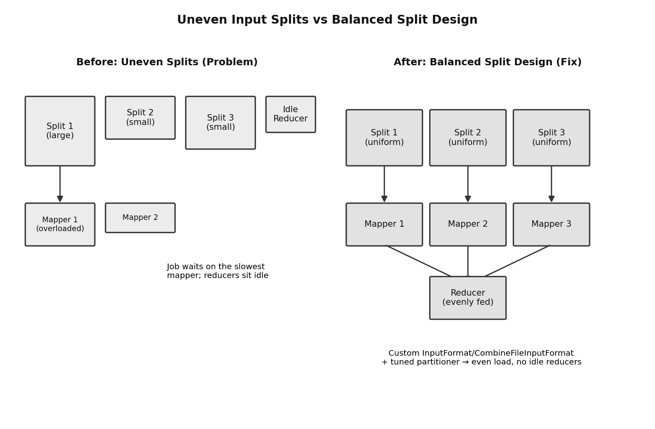
Figure 1: Uneven input splits causing an overloaded mapper and an idle reducer (left) versus a balanced split design where every mapper gets roughly the same amount of work (right).

Question 2. An HDFS deployment shows frequent data unavailability after a single node failure. Analyze the probable replication or NameNode design error.
Identifying the error
If losing just one node in the cluster is enough to make data unavailable, then something in the fault-tolerance design of the deployment is not set up the way HDFS is meant to be used. There are two likely culprits, and in practice it is often a mix of both. The first is that the replication factor has been left too low, sometimes even at 1, which means a block genuinely exists on only one DataNode. If that specific node goes down, the block is gone until the node comes back, because there was never a backup copy anywhere else. The second, and often the bigger issue, is that the NameNode itself has not been configured for High Availability. HDFS uses the NameNode to hold all of the metadata (which blocks belong to which file, and which DataNodes hold each block). If that single NameNode process or its host machine fails, the entire filesystem becomes unreachable even though the actual data blocks on the DataNodes are still sitting there completely fine.
Cause analysis
Looking at why this typically happens: teams sometimes leave the replication factor at a low value during testing and forget to raise it before going into production, or they place all replicas of a block within the same rack (or even the same physical machine group) because rack awareness was never configured, which means a single rack-level failure can take out every copy of a block at once. On the NameNode side, running only one NameNode with no standby, no ZooKeeper coordination and no Quorum Journal Manager means there is nothing to automatically take over metadata service if that one process crashes. It is also common to see the heartbeat and block-report intervals left at very relaxed default values, so even blocks that do become under-replicated after a node failure are not detected and re-replicated quickly, extending the window of unavailability.
Corrective actions
The recommended fix is to bring the deployment in line with how HDFS is designed to be resilient. Set dfs.replication to at least 3, which is the normal production value, and make sure rack awareness is configured so HDFS's default block placement policy spreads the three replicas across at least two different racks rather than piling them onto the same one. For the NameNode itself, set up NameNode High Availability with an Active NameNode and a Standby NameNode, using a Quorum Journal Manager to keep their edit logs in sync and ZooKeeper with the ZKFailoverController to detect a failure and automatically promote the Standby to Active within seconds. It is also worth tightening the heartbeat interval and running periodic hdfs fsck checks so under-replicated blocks are found and re-replicated quickly rather than sitting in a vulnerable state.
Use of Hadoop concepts
This draws on the HDFS replication model, rack-awareness in block placement, and the NameNode High Availability architecture built around the Quorum Journal Manager and ZooKeeper. Together these are exactly the mechanisms HDFS provides so that no single machine failure should ever take the whole filesystem down.
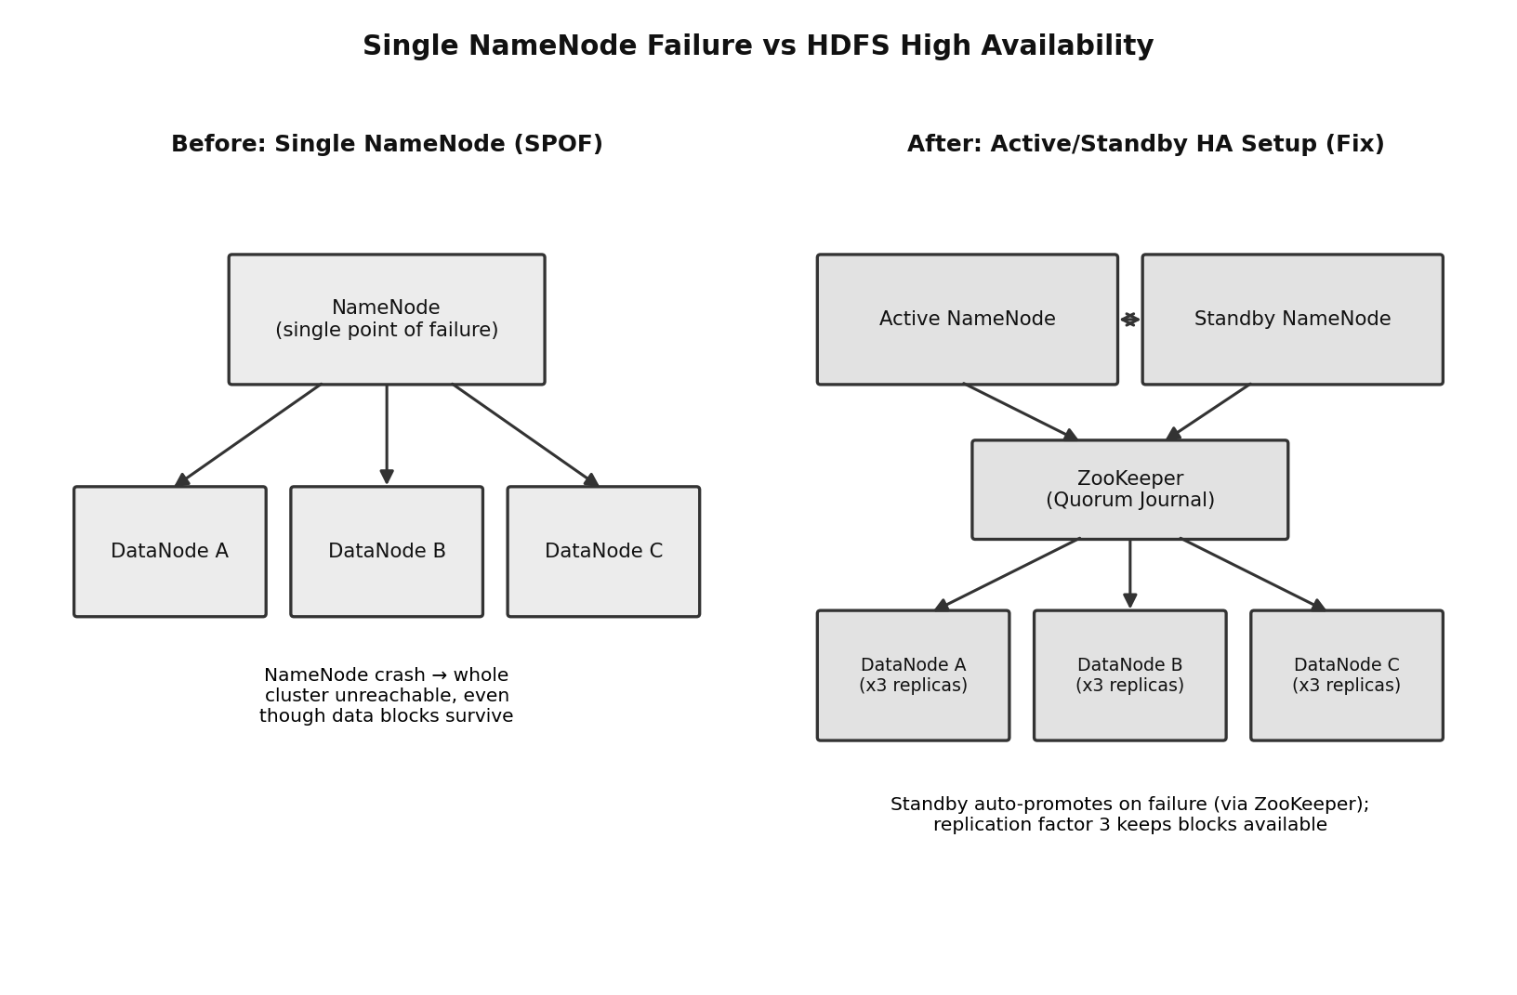
Figure 2: A single NameNode acting as a single point of failure (left) versus an Active/Standby NameNode pair coordinated through ZooKeeper, with data replicated across nodes (right).

Question 3. A data ingestion workflow using ETL and Apache NiFi creates duplicate records in the analytics store. Identify the likely causes and recommend fixes.
Identifying the error
Duplicate rows showing up in the analytics store almost always point to the ingestion pipeline delivering the same piece of data more than once, rather than the analytics store itself doing anything wrong. NiFi, like most streaming/ingestion tools, generally guarantees 'at-least-once' delivery, which means that if something goes wrong partway through processing a batch, NiFi's normal behaviour is to retry that batch rather than silently drop it. That is good for not losing data, but if the pipeline has no way of recognising that a record has already been written once, a retry after a timeout or a brief network hiccup ends up writing the exact same record a second time.
Cause analysis
The most common root cause is that records flowing through NiFi do not carry any kind of unique identifier or content hash that the downstream system can use to tell 'this is the same record I saw before' apart from 'this is new data'. Without that, every retry looks like brand-new data to the analytics store. A second contributing cause is that the ETL job that loads data into the analytics store does not use idempotent writes, for example it always runs an INSERT instead of an UPSERT/MERGE, so replaying the same batch adds a fresh row rather than overwriting the existing one. A third possibility, especially with multiple source systems feeding the same store, is that two upstream systems occasionally send overlapping data for the same event, and there is no merge or de-duplication step to catch that before load.
Corrective actions
The cleanest fix is to make the whole pipeline idempotent, so that no matter how many times a piece of data is processed, the end result in the analytics store is the same. Practically, this starts inside NiFi: use processors such as UpdateAttribute together with a hashing function (or an UniqueID/ generated content hash) to tag every FlowFile with a fingerprint based on its content or a natural key, and add a DetectDuplicate (or similar de-duplication) processor early in the flow so a record that has already passed through recently is dropped rather than forwarded again. On the load side, make sure the ETL step performs an UPSERT (an INSERT that updates on conflict) or a MERGE statement keyed on that unique identifier, instead of a plain INSERT, so that even if a duplicate does slip through, it simply overwrites the same row instead of creating a new one. It is also good practice to add monitoring on record counts and to review NiFi provenance data periodically, since provenance can directly show when a FlowFile was reprocessed.
Use of Hadoop/Integration concepts
This answer uses NiFi's flow-based processing model, FlowFile provenance, at-least-once delivery semantics, and the general ETL/idempotency principle of upsert-based loading, all of which are central to building a reliable ingestion pipeline on top of a Hadoop-based analytics platform.
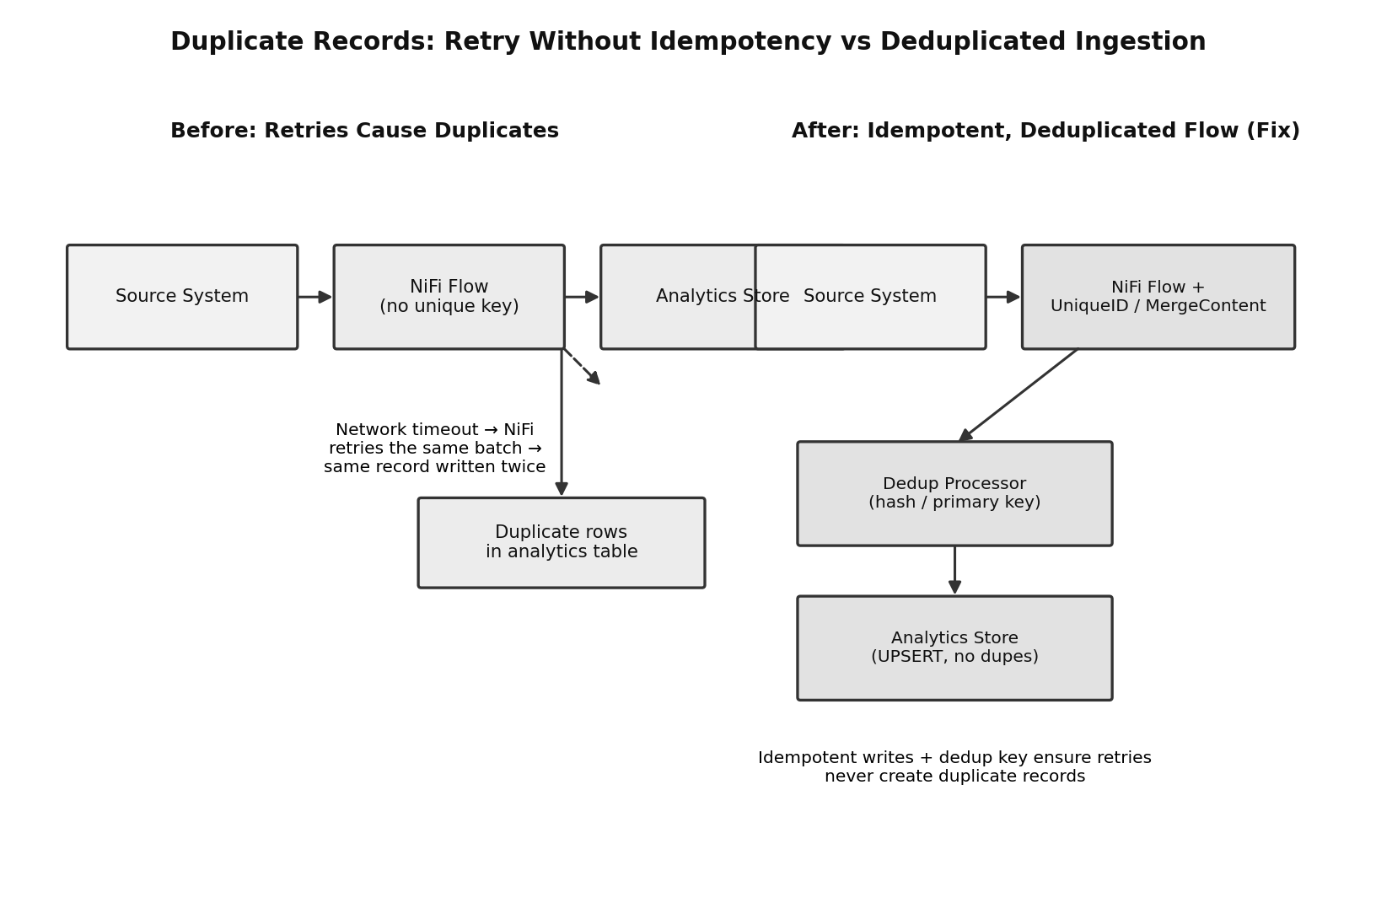
Figure 3: A NiFi flow without a unique key that writes the same record twice after a retry (left) versus a flow that tags each record and de-duplicates before an idempotent write (right).

Question 4. A YARN cluster suffers from resource starvation when multiple users submit jobs together. Analyze the scheduling error and suggest a better resource management approach.
Identifying the error
Resource starvation when several users submit jobs at the same time is a classic symptom of the cluster running with a scheduling policy that does not divide resources fairly, usually because it is effectively still behaving like a single FIFO (first-in-first-out) queue, or a Capacity Scheduler that has not actually been split into separate queues with real limits. In a FIFO-style setup, whichever job gets submitted first (or happens to be the largest) is free to grab every available container, and any job submitted after it simply has to wait in line until the first one finishes, no matter how small or urgent the later job is.
Cause analysis
The underlying cause is almost always a missing or badly configured queue structure. If there is only one queue for the whole cluster, YARN has no concept of 'this much belongs to team A' versus 'this much belongs to team B', so it happily lets one job's ApplicationMaster keep requesting and holding containers as long as resources are free, even if that starves everyone else. Even when a Capacity Scheduler is technically in use, if the queues have not been given a proper capacity split, if there is no user-limit-factor set to cap how much of a queue a single user can consume, and if preemption is switched off, then one heavy user or one runaway job can still end up monopolising almost the entire cluster while other users' jobs sit pending.
Corrective actions
The better approach is to properly configure the Capacity Scheduler (or, depending on the environment, the Fair Scheduler) with dedicated queues per team or workload type, each given a guaranteed minimum percentage of cluster capacity, with the ability to borrow idle capacity from other queues when those queues are not fully using their share (this is often called elastic queue capacity). Setting yarn.scheduler.capacity.<queue>.user-limit-factor stops a single user inside a queue from taking over the whole queue. Turning on preemption means that if one queue is over its guaranteed share and another queue genuinely needs its capacity back, YARN can politely reclaim some containers instead of letting the second queue wait indefinitely. It also helps to cap yarn.scheduler.capacity.maximum-am-resource-percent, so ApplicationMasters themselves cannot eat up so many resources that no room is left to actually run tasks.
Use of Hadoop concepts
This relies on the YARN ResourceManager's scheduling layer, specifically the Capacity Scheduler's queue hierarchy, elastic capacity, user limits, and preemption, which together are exactly the tools YARN provides so multiple users can safely share one cluster without one job starving the rest.
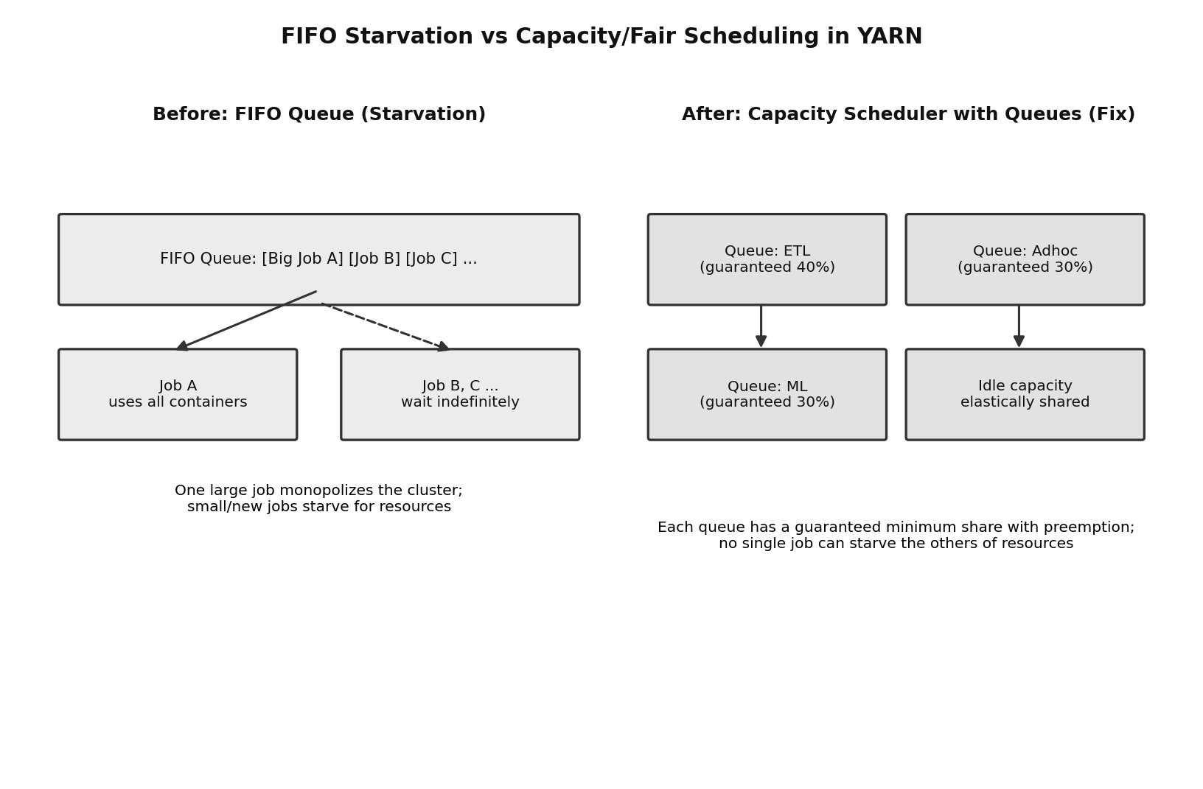
Figure 4: A single FIFO queue letting one large job hold every container while other jobs wait indefinitely (left) versus Capacity Scheduler queues with guaranteed shares (right).

Question 5. A backup strategy for distributed storage restores outdated data after recovery. Identify the probable design flaw in the replication or backup approach.
Identifying the error
When a restore brings back data that is noticeably older than what was actually in the system just before the failure, the flaw is in how often and how consistently backups are being taken, not in the replication that HDFS does automatically for fault tolerance. Regular HDFS replication (multiple copies of each block on different DataNodes) protects against losing data because of a single node dying, but it does not protect against mistakes, accidental deletions, or a need to go back to an earlier point in time, because all replicas normally mirror the current state of the data. A separate, deliberate backup or snapshot strategy is needed for that, and it sounds like the one in place is not being run often enough or consistently enough.
Cause analysis
The most likely cause is that snapshots or backup jobs are being taken on an irregular, ad-hoc schedule rather than a fixed, automated one, so a lot of real business time can pass between the last backup and the moment of failure. It is also common for backup jobs (for example, distcp copies to a secondary cluster) to be run as one-off full copies rather than incremental jobs, which makes them expensive to run often, so teams end up running them less frequently than they should, purely to save time and resources. Another possibility is that backup jobs are failing silently sometimes (network issue, cluster busy, etc.) and there is no monitoring or alerting to catch that, so the 'latest' backup people think they have is actually much older than expected. Finally, if backups are not versioned, restoring simply gives back whatever the single stored copy happens to be, with no way to pick a more recent, still-valid checkpoint if the very latest one turns out to be corrupted.
Corrective actions
The fix is to move to a proper, scheduled backup approach built around HDFS Snapshots and incremental replication. HDFS Snapshots can be taken on a fixed schedule (for example every few hours) at very low cost because they are copy-on-write, so this alone can shrink the gap between 'last known good copy' and 'time of failure' dramatically. For protection against a full cluster loss, use incremental distcp (or a similar tool) to a secondary cluster or a DR site, only shipping the data that changed since the last run, which makes it realistic to run backups more frequently. Keep multiple versioned snapshots rather than overwriting a single backup copy, so if the most recent one is somehow bad, an earlier valid one is still available. Just as important, set up monitoring and alerts on the backup jobs themselves, so a failed backup run is noticed and fixed immediately rather than being discovered only during an actual recovery, and periodically test a real restore to confirm the backup approach genuinely meets the business's Recovery Point Objective (RPO).
Use of Hadoop concepts
This uses HDFS Snapshots, incremental distcp-based replication to a secondary cluster, and the general backup concepts of RPO and versioning, layered on top of (but separate from) HDFS's normal block replication, which is the correct way to think about backup design in a Hadoop environment.
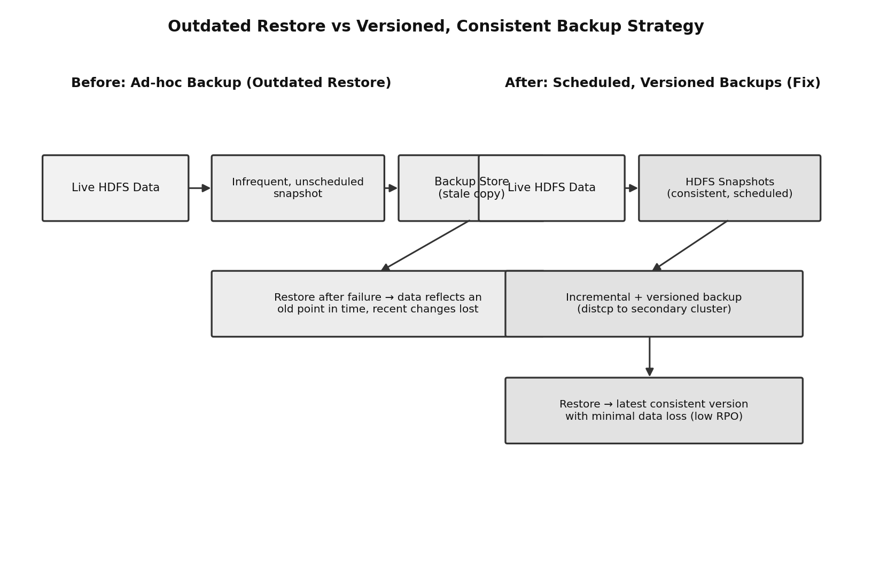
Figure 5: An infrequent, unscheduled backup restoring stale data after a failure (left) versus a scheduled, versioned, incremental backup that restores the latest consistent copy (right).

Error Analysis Task Rubric

Criteria | Weightage | Level 4 - Exemplary | Level 3 - Proficient | Level 2 - Developing | Level 1 - Beginning
Identification of Error | 30% | Accurately identifies the root technical issue | Identifies most of the issue | Partially identifies issue | Fails to identify issue
Cause Analysis | 20% | Explains root cause with strong technical reasoning | Reasonable cause analysis | Basic cause analysis | Weak analysis
Corrective Action | 25% | Proposes effective and feasible corrections | Reasonable corrections | Basic corrections | Ineffective corrections
Use of Hadoop / Integration Concepts | 15% | Applies relevant concepts appropriately | Mostly appropriate application | Partial application | Incorrect application
Clarity | 10% | Clear and direct explanation | Generally clear | Somewhat unclear | Poorly presented

