SIMATS ENGINEERING
ASSESSMENT TOOL 1 : Concept Mapping

COURSE NAME: | Cloud Computing and Big Data Analytics | COURSE CODE: | CSA15

COURSE OUTCOME COVERED
CO1: Apply cloud computing technologies including hardware-software evolution, virtualization, web services, and service models to develop cloud-based solutions. (BL2)
Assessment Tool Weightage: 20%

Dave's Taxonomy: Imitation (Level 1)  Question Count: 4 | Total Marks: 50

Code of Conduct
I __KANISHK C (192511278)__(Name / Reg No) certify that this submission is my original work and that I have adhered to the guidelines specified for this assessment.
I understand that any violation of academic integrity rules will result in disciplinary action.
Signature of the student: ______KANISHK.C______________

Assessment Tasks
Concept Mapping Tasks
Create concept maps for the following tasks. Each map must show key nodes, link labels, and a logical hierarchy.
- Concept Map 1: Cloud Computing Fundamentals. Include definition, characteristics, benefits, and limitations.
- Concept Map 2: Evolution of Cloud Computing. Connect hardware evolution, internet software evolution, distributed systems, and service delivery.
- Concept Map 3: Service Models. Map IaaS, PaaS, SaaS, and XaaS with provider responsibilities and user responsibilities.
- Concept Map 4: Virtualization and Web Services as Enablers of Cloud. Show how these two concepts support cloud deployment and scalability.
Expected concept nodes:
- Elasticity, scalability, resource pooling, on-demand access, measured service
- Virtual machine, hypervisor, abstraction, API, SOAP, REST, provider, consumer
- Infrastructure layer, platform layer, application layer, shared responsibility

Concept Mapping Rubric
Criteria | Weightage | Level 4 – Exemplary | Level 3 – Proficient | Level 2 – Developing | Level 1 – Beginning
Concept Identification | 25% | All major concepts are accurately identified | Most concepts are identified correctly | Limited concepts are identified | Essential concepts are missing
Relationship Mapping | 25% | Links between concepts are accurate and meaningful | Most links are correct | Some links are weak or unclear | Relationships are mostly incorrect
Hierarchy and Organization | 20% | Excellent structure with clear hierarchy | Mostly organized with minor issues | Basic structure with weak hierarchy | No logical organization
Technical Relevance | 20% | Map strongly reflects cloud course content | Mostly aligned to topic | Partially aligned to topic | Weak alignment to topic
Visual Clarity | 10% | Neat, readable, and easy to interpret | Generally readable | Somewhat cluttered | Poorly presented

Concept Map 1: Cloud Computing Fundamentals
This first map explains what cloud computing actually is, and it does that by branching the central idea into four smaller groups: the definition, the characteristics, the benefits, and the limitations. Keeping these four groups separate, instead of mixing everything into one long list, is what gives the map its hierarchy.
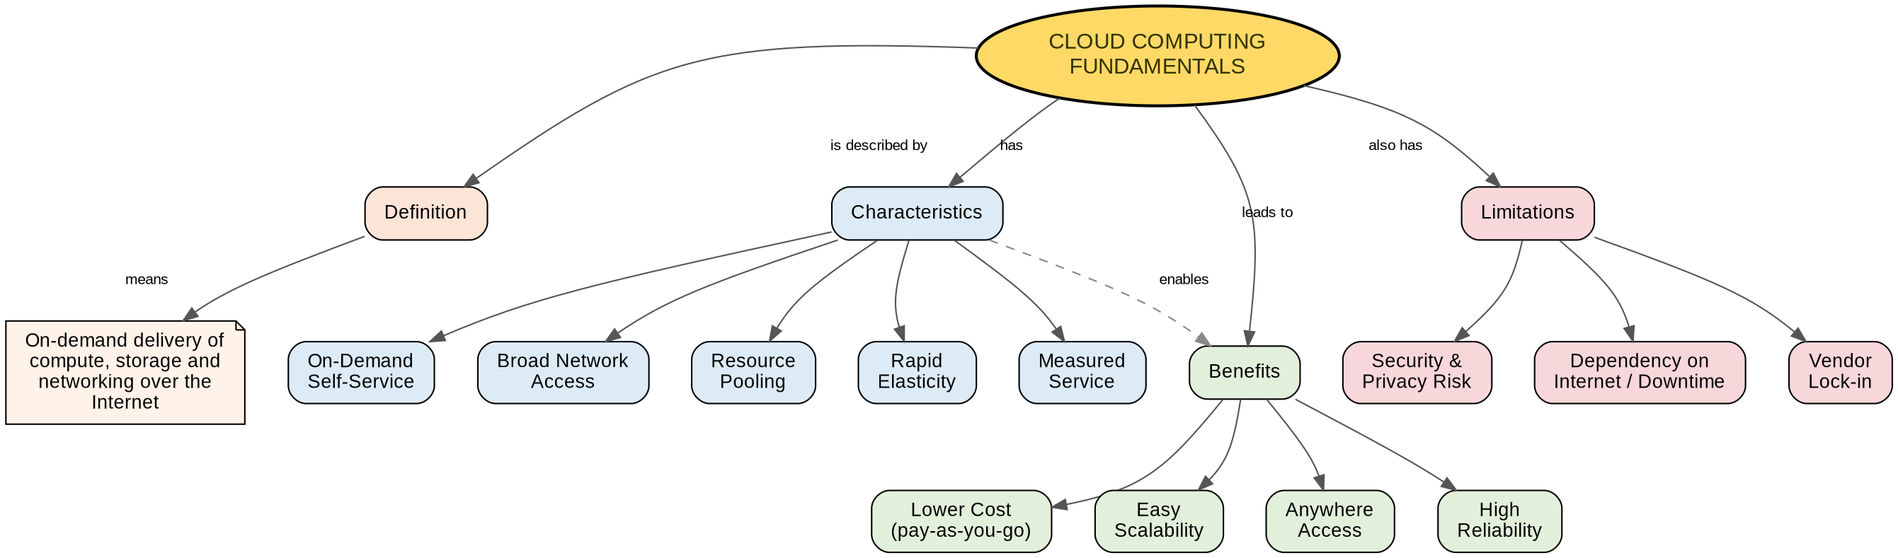
Figure 1: Concept map showing the fundamentals of cloud computing

How the map is organised
At the very top sits the anchor node, "Cloud Computing Fundamentals", shown in gold so it stands out from everything else. From there, the definition branch (in orange) explains cloud computing in one line — the on-demand delivery of computing resources such as servers, storage and networking over the internet, usually on a pay-as-you-go basis.
The characteristics branch (in blue) lists the five properties that most textbooks use to describe cloud computing: on-demand self-service, broad network access, resource pooling, rapid elasticity, and measured service. These five ideas are the technical backbone of the whole topic, so they are grouped together under one parent node rather than scattered around the map.
The benefits branch (in green) shows what an organisation gains once these characteristics are in place — lower cost because you only pay for what you use, easy scalability when demand grows, access to services from anywhere with an internet connection, and better reliability because providers run multiple data centres. A dashed arrow links Characteristics to Benefits because the benefits do not exist on their own; they come directly from the characteristics above them.
The limitations branch (in red) balances the picture by pointing out the trade-offs: security and privacy risk when data leaves an organisation's own servers, dependency on a stable internet connection, and vendor lock-in, where switching cloud providers later becomes difficult and costly.

Node and relationship summary
Concept Node | Relationship (Link Label) | Connected Concept
Cloud Computing Fundamentals | is described by | Definition
Cloud Computing Fundamentals | has | Characteristics
Cloud Computing Fundamentals | leads to | Benefits
Cloud Computing Fundamentals | also has | Limitations
Characteristics | includes | On-Demand Self-Service, Broad Network Access, Resource Pooling, Rapid Elasticity, Measured Service
Benefits | includes | Lower Cost, Easy Scalability, Anywhere Access, High Reliability
Limitations | includes | Security & Privacy Risk, Downtime Dependency, Vendor Lock-in
Characteristics | enables (dashed link) | Benefits

Concept Map 2: Evolution of Cloud Computing
The second map tells the story of how cloud computing came to exist. Instead of a single timeline, it is split into four parallel tracks that all feed into the same result — modern cloud service delivery. This layout was chosen because cloud computing is not the result of one invention; it is the combined outcome of progress in hardware, software, and distributed systems.
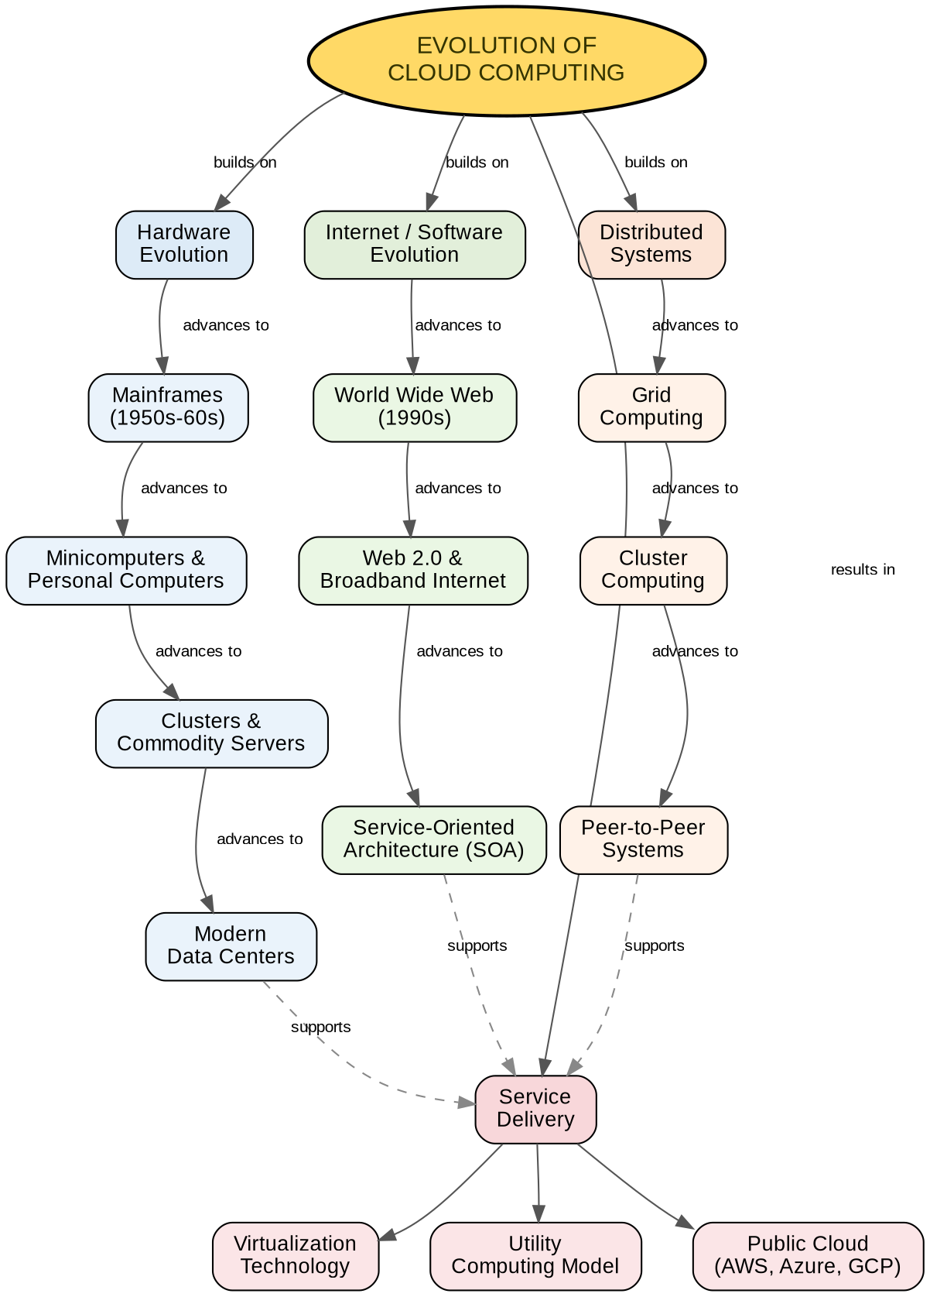
Figure 2: Concept map showing the evolution of cloud computing

How the map is organised
The hardware evolution track (blue) moves from large mainframe computers in the 1950s and 60s, to minicomputers and personal computers, then to clusters of commodity servers, and finally to the large modern data centres that host cloud platforms today. Each stage is connected with an "advances to" arrow so the reader can see the progression rather than a random list.
The internet and software evolution track (green) begins with the World Wide Web in the 1990s, moves through Web 2.0 and the growth of broadband internet, and reaches service-oriented architecture (SOA), where software started to be built as independent, reusable services rather than single large programs.
The distributed systems track (orange) shows grid computing, cluster computing, and peer-to-peer systems — three earlier approaches to sharing computing work across many machines. These ideas taught the industry how to coordinate resources across a network, which is exactly what cloud platforms do today.
The service delivery track (red) is where the other three tracks meet. Virtualization technology, the utility computing model, and today's public cloud platforms (AWS, Azure, GCP) all depend on advances made in hardware, internet software, and distributed systems, which is why dashed arrows connect the last node of each earlier track into this final branch.

Node and relationship summary
Concept Node | Relationship (Link Label) | Connected Concept
Evolution of Cloud Computing | builds on | Hardware Evolution
Hardware Evolution | advances to | Mainframes → Minicomputers/PCs → Clusters → Modern Data Centres
Evolution of Cloud Computing | builds on | Internet / Software Evolution
Internet / Software Evolution | advances to | World Wide Web → Web 2.0 → Service-Oriented Architecture
Evolution of Cloud Computing | builds on | Distributed Systems
Distributed Systems | advances to | Grid Computing → Cluster Computing → Peer-to-Peer Systems
Evolution of Cloud Computing | results in | Service Delivery
Modern Data Centres / SOA / Peer-to-Peer | supports (dashed link) | Service Delivery (Virtualization, Utility Computing, Public Cloud)

Concept Map 3: Service Models
The third map compares the four main cloud service models — IaaS, PaaS, SaaS, and XaaS. Rather than describing each model in isolated text, the map shows, side by side, what the provider is responsible for and what the user is responsible for in every model. This directly answers the assignment's requirement to map provider and user responsibilities.
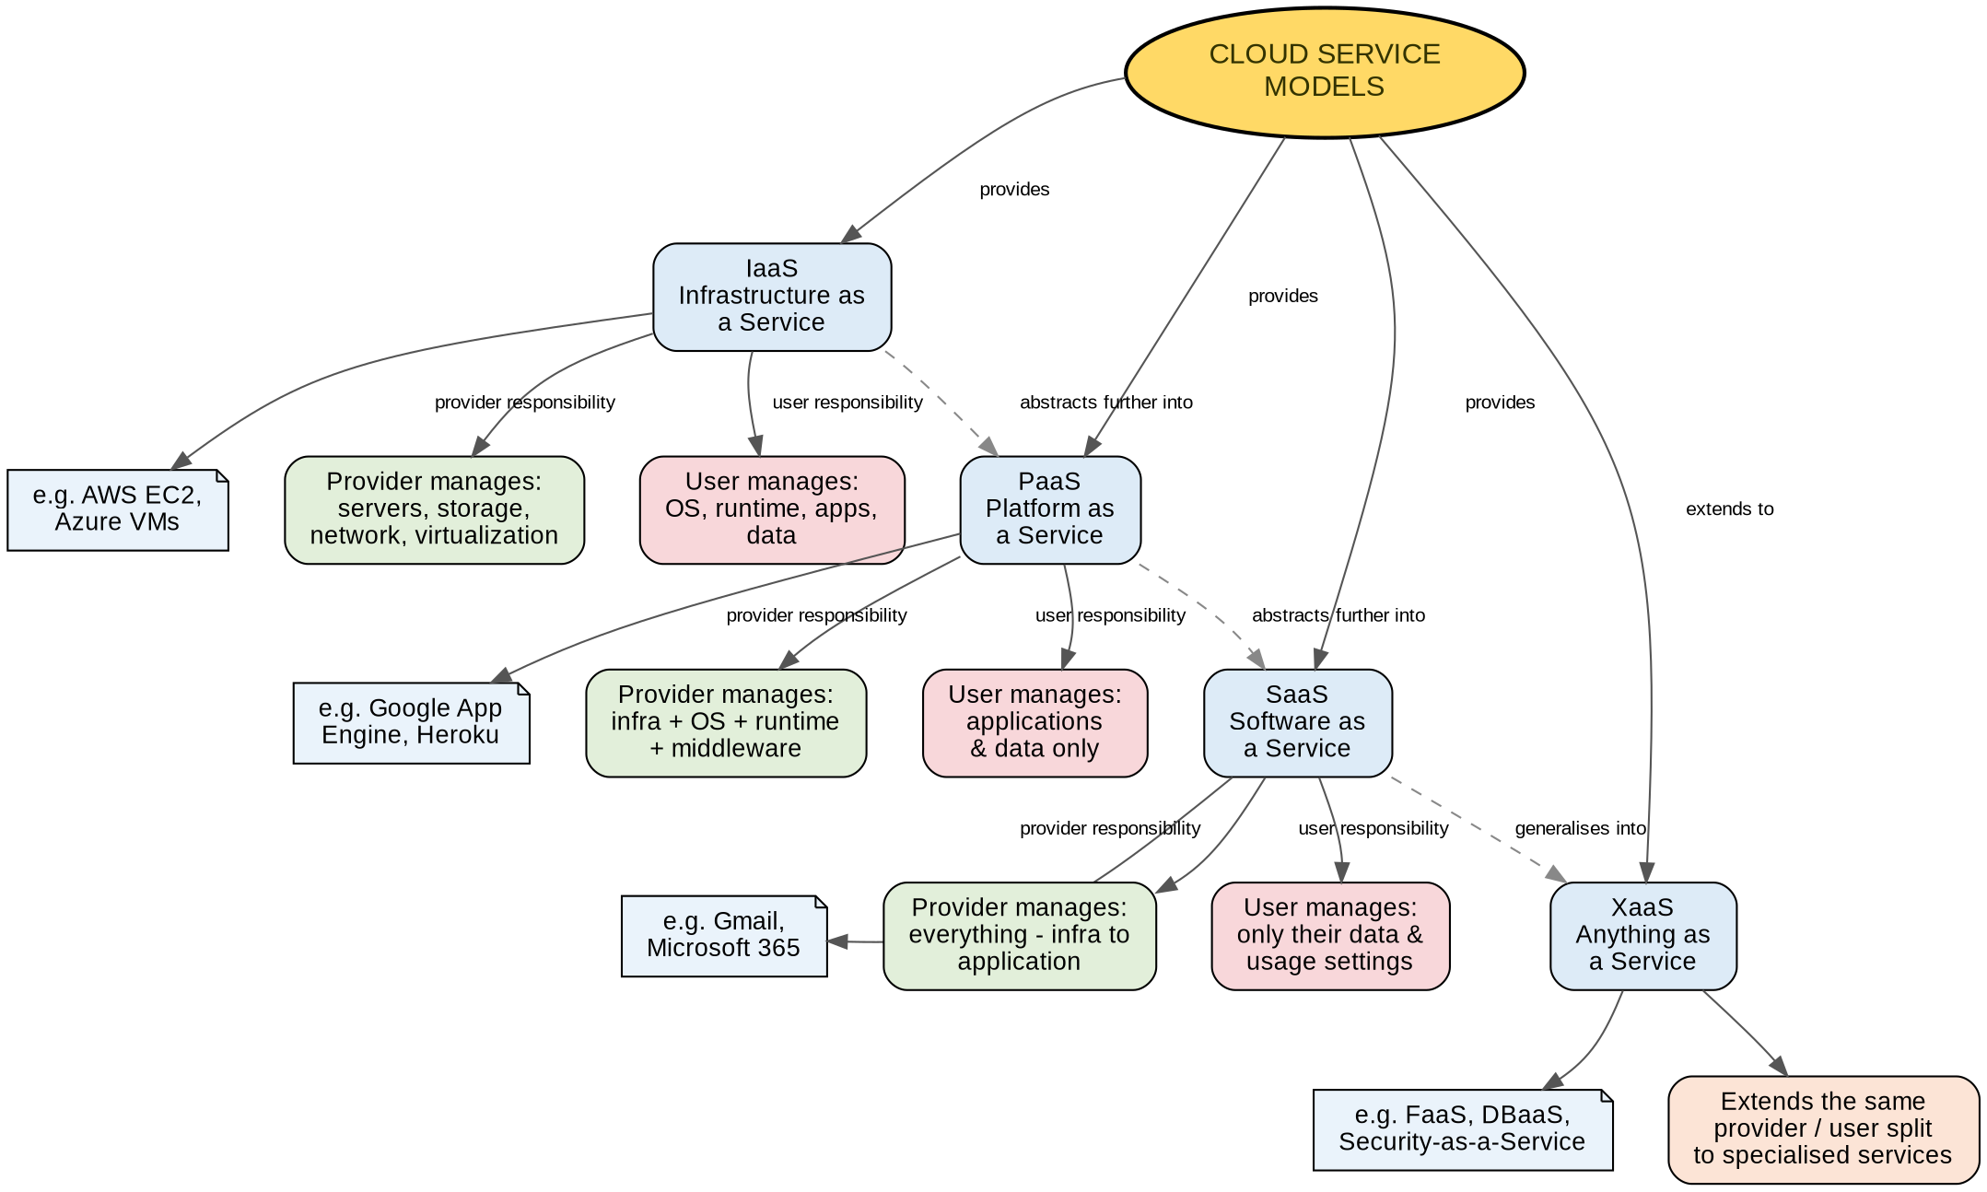
Figure 3: Concept map showing cloud service models and shared responsibility

How the map is organised
Each service model node branches into three children: an example (shown as a small note, such as AWS EC2 for IaaS or Gmail for SaaS), a green node listing what the cloud provider manages, and a red node listing what the user or application team manages. Colour is used purposefully here — green always means "provider responsibility" and red always means "user responsibility", no matter which service model it appears under, so the pattern is easy to follow across the whole map.
In Infrastructure as a Service (IaaS), the provider only manages the physical servers, storage, networking, and the virtualization layer; the user still has to manage the operating system, runtime, applications and data. In Platform as a Service (PaaS), the provider takes on more — infrastructure, operating system and middleware — leaving the user responsible only for the application and its data. In Software as a Service (SaaS), the provider manages everything from the infrastructure up to the finished application, and the user is only responsible for their own data and account settings.
Anything as a Service (XaaS) is placed at the end of the map with a dashed "generalises into" arrow from SaaS, because it extends the same idea to more specific offerings such as Function as a Service, Database as a Service, or Security as a Service. The dashed arrows connecting IaaS → PaaS → SaaS → XaaS also show a second relationship: each model is a further layer of abstraction built on top of the one before it.

Node and relationship summary
Concept Node | Relationship (Link Label) | Connected Concept
Cloud Service Models | provides | IaaS, PaaS, SaaS
Cloud Service Models | extends to | XaaS
IaaS | provider responsibility | Servers, storage, network, virtualization
IaaS | user responsibility | OS, runtime, applications, data
PaaS | provider responsibility | Infrastructure + OS + middleware
PaaS | user responsibility | Applications and data only
SaaS | provider responsibility | Entire stack, infrastructure to application
SaaS | user responsibility | Data and usage settings only
IaaS → PaaS → SaaS → XaaS | abstracts further into / generalises into (dashed) | next service model

Concept Map 4: Virtualization and Web Services as Enablers of Cloud
The last map explains the two technologies that make cloud computing practically possible: virtualization and web services. Both branches eventually connect into a shared "Cloud Deployment" node, and from there into scalability and elasticity, which shows how these two enabling technologies combine to produce the outcomes cloud computing is known for.
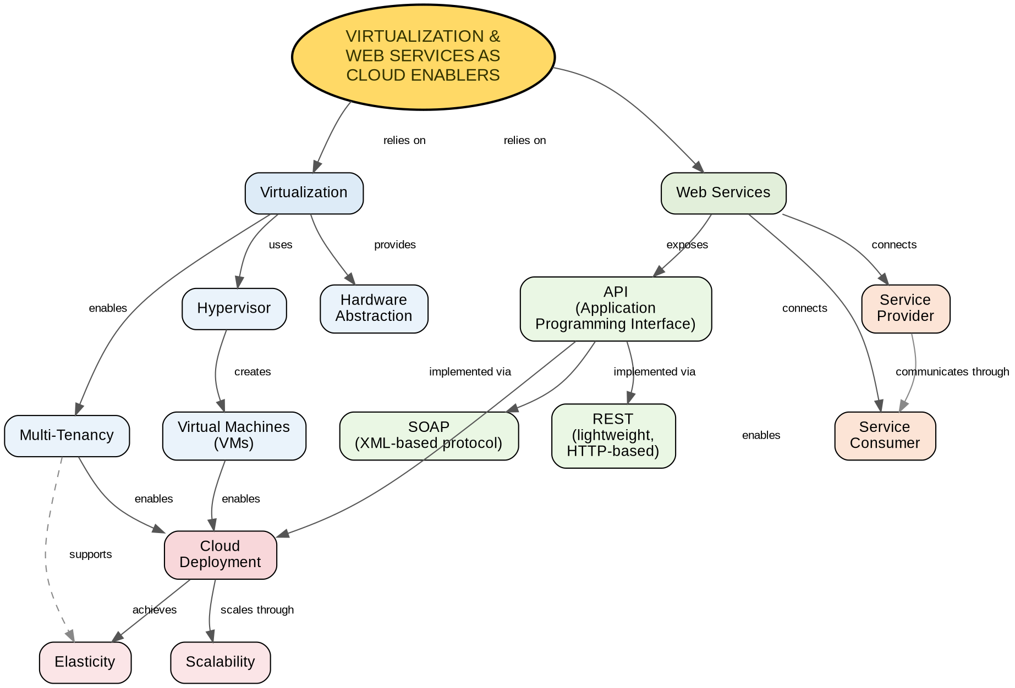
Figure 4: Concept map showing how virtualization and web services enable the cloud

How the map is organised
On the virtualization side (blue), a hypervisor is the piece of software that creates and manages virtual machines (VMs) on top of physical hardware. This gives hardware abstraction, meaning the user does not need to worry about the physical machine underneath, and it allows multi-tenancy, where many customers can safely share the same physical server.
On the web services side (green), an API (Application Programming Interface) is what allows different software systems to talk to each other over a network. Two common ways of building APIs are shown: SOAP, an older XML-based protocol, and REST, a lighter and more widely used approach based on standard HTTP methods. Web services also connect a service provider to a service consumer, and the arrow between them is labelled "communicates through" to show that this communication happens through the API layer, not directly.
Both branches feed into Cloud Deployment: virtual machines and multi-tenancy make it possible to deploy workloads flexibly, and APIs make it possible for cloud services to be requested, configured and connected automatically. From deployment, the map ends with the two outcomes the whole assignment keeps coming back to — scalability, the ability to handle more load by adding resources, and elasticity, the ability to automatically shrink or grow resources to match real-time demand. A dashed link also shows that multi-tenancy directly supports elasticity, since sharing hardware efficiently is what allows resources to be reassigned quickly.

Node and relationship summary
Concept Node | Relationship (Link Label) | Connected Concept
Virtualization & Web Services | relies on | Virtualization
Virtualization | uses | Hypervisor
Hypervisor | creates | Virtual Machines
Virtualization | provides / enables | Hardware Abstraction, Multi-Tenancy
Virtualization & Web Services | relies on | Web Services
Web Services | exposes | API
API | implemented via | SOAP, REST
Web Services | connects | Service Provider ↔ Service Consumer (communicates through)
VMs / Multi-Tenancy / API | enables | Cloud Deployment
Cloud Deployment | scales through / achieves | Scalability, Elasticity

Critical Reflection Questions

1. Evaluate the effectiveness of your concept map in representing cloud computing principles. Which design decisions most strongly support your solution, and why?
I think the four maps do a fair job of covering cloud computing without turning into a single overcrowded diagram. The decision that helped most was splitting the topic into four separate maps instead of forcing everything onto one page. Fundamentals, evolution, service models, and the virtualization/web-services layer are genuinely different kinds of information — one is conceptual, one is historical, one is comparative, and one is technical — so keeping them apart made each map easier to read and easier to grade against the rubric criteria one at a time.
The second decision that paid off was using colour consistently across all four maps rather than picking colours randomly per diagram. Gold always marks the central anchor idea, blue always marks a general or structural concept, green always marks a benefit or a provider-side responsibility, and red always marks a limitation or a user-side responsibility. Once that pattern is set in Map 1, it carries into Map 3's provider/user split and Map 4's outcomes without me having to explain the colours again.
Labelling every arrow was also important. A line with no label only tells you two ideas are related, not how. Labels like "enables", "advances to", or "provider responsibility" turn the map into something that can almost be read as a sentence, which is really the whole point of a concept map — it should show relationships, not just group boxes together.

2. Analyze how scalability, elasticity, and resource management influence the architecture shown in your concept map. What challenges could arise if these capabilities were absent?
In Map 1, rapid elasticity and resource pooling are listed as core characteristics, and in Map 4 they reappear as the end goal of the whole architecture — multi-tenancy and virtual machines feed into cloud deployment, which then scales through Scalability and achieves Elasticity. That placement is not an accident. Scalability and elasticity are the reason the earlier layers (hypervisors, VMs, APIs) exist at all; the technology stack is built specifically so that resources can grow or shrink automatically depending on demand, and so that many customers can share the same physical hardware safely through resource pooling.
If scalability were missing, an application would be stuck with whatever capacity it was originally given. A sudden spike in traffic, say during an exam registration window or a sale, would slow the system down or crash it completely, because there would be no mechanism to add more servers on demand. Without elasticity, a company would either have to over-provision hardware permanently, which wastes money during quiet periods, or under-provision and risk poor performance during busy periods — there is no middle ground without automatic scaling.
Poor resource management creates a different kind of problem: contention. If the hypervisor and multi-tenancy layer in Map 4 did not manage resources properly, one customer's workload could slow down or interfere with another customer's workload on the same physical server. This is exactly why resource pooling and measured service are treated as fundamental characteristics in Map 1 rather than optional extras — without them, the cloud model would basically collapse back into old-style dedicated hosting, which defeats the purpose of moving to the cloud in the first place.

3. Justify the selection of the APIs, web services, or cloud services included in your concept map. How do they contribute to the overall functionality and efficiency of the system?
For Map 3, I picked real, well-known examples for each service model — AWS EC2 for IaaS, Google App Engine and Heroku for PaaS, Gmail and Microsoft 365 for SaaS — instead of made-up placeholder names. The reason is simple: these are services most people have actually used or at least heard of, so they make an abstract category like "Platform as a Service" concrete. Efficiency-wise, each example also matches its category correctly in terms of what layer of the stack the provider is responsible for, which keeps the provider/user responsibility split in the map technically accurate rather than just illustrative.
For Map 4, I included both SOAP and REST under the API node rather than only REST, even though REST is far more common today. SOAP is still worth showing because it represents the older, stricter, XML-based way of building web services, and comparing it with REST helps explain why REST became the popular choice — it is lighter, works directly over HTTP, and is easier for modern applications to use. Including both protocols, instead of just the trendier one, gives a more complete and more technically honest picture of how cloud services actually communicate with each other.
Overall, these choices contribute to the system shown in the maps by connecting every abstract concept to something concrete. A reader who does not fully understand "Platform as a Service" as a phrase can still recognise Heroku or Google App Engine, and that recognition is what makes the map function as a teaching tool rather than just a diagram of labels.

4. Critically examine the relationships between the components in your concept map. How do these interactions improve reliability, performance, or user experience?
The relationship I find most important is the chain in Map 4: Hypervisor creates Virtual Machines, Virtual Machines enable Cloud Deployment, and Cloud Deployment scales through Scalability and achieves Elasticity. This is a direct, working example of how one technical decision at the bottom of the stack (running a hypervisor) eventually produces a business-level benefit at the top (a system that scales automatically). Reliability improves here because if one virtual machine fails, the hypervisor can start another one without affecting the physical hardware or other tenants.
The Service Provider to Service Consumer link in Map 4, labelled "communicates through" the API layer, is also worth examining critically. It would have been easy to draw a direct line between provider and consumer, but that would hide an important detail — in real cloud systems, providers and consumers almost never talk to each other directly; everything passes through a defined API contract. Showing the API in between improves performance and reliability in real systems because it lets the provider change internal implementation details without breaking the consumer's application, as long as the API contract stays the same.
In Map 3, the dashed relationships connecting IaaS to PaaS to SaaS to XaaS represent increasing abstraction rather than a strict step-by-step order. This matters for user experience because it shows that a business does not have to start at IaaS and manually build up to SaaS — they can choose the abstraction level that matches their technical skill and their need for control. A small business with no dedicated IT team benefits from starting closer to SaaS, while a company that needs full control over its infrastructure benefits from staying at the IaaS level.

5. Reflect on the process of developing your concept map. How has creating and analyzing the map changed your understanding of cloud computing architecture, and what improvements would you make if you were redesigning it?
Before building these maps, I understood cloud computing mostly as a list of separate facts — IaaS, PaaS, SaaS, virtualization, APIs — without a strong sense of how they connect. Drawing the maps forced me to decide, for every single concept, exactly what it depends on and exactly what depends on it. That process made it obvious that cloud computing is not really a list of separate technologies at all; it is a layered system where each layer exists specifically to make the layer above it possible. Virtualization exists to make multi-tenancy possible, multi-tenancy exists to make elastic scaling possible, and elastic scaling is what finally delivers the pay-as-you-go benefit that most people think of first when they hear "cloud computing".
If I were redesigning these maps, I would add a fifth map focused specifically on security and compliance, since right now security only appears as a single limitation node in Map 1 and does not get the deeper treatment that scalability or service models get. I would also add rough numbers or examples of failure scenarios next to a few key nodes — for instance, showing what response time looks like with and without elasticity — because concrete numbers would make the "why this matters" argument stronger than descriptive labels alone. Finally, I would consider adding one small linking map at the end that shows how all four existing maps connect to each other, since right now that connection is explained in the written reflection but is not shown visually.

Overall Reflection
Together, these four concept maps move from basic definitions to real technical mechanisms. The first map defines what cloud computing is; the second shows where it came from; the third breaks down how cloud services are packaged and shared between provider and user; and the fourth explains the two core technologies, virtualization and web services, that actually make all of this work in practice. Using a consistent colour scheme and labelled arrows across all four maps also makes it easier to see how ideas from one map connect to ideas in another — for example, the "resource pooling" characteristic in Map 1 is the same idea as "multi-tenancy" in Map 4, and the "service models" mentioned briefly in Map 2 are expanded in full detail in Map 3.

