SIMATS ENGINEERING
ASSESSMENT TOOL 3: Mock Interview
COURSE NAME: Cloud Computing and Big Data Analytics
COURSE CODE: CSA15
COURSE OUTCOME COVERED
CO5: Design big data processing systems using the Hadoop ecosystem including HDFS, MapReduce, and YARN. (BL5)
Assessment Tool Weightage: 10%
Dave's Taxonomy: Articulation (Level 4)
Question Count: 10
Total Marks: 25
Code of Conduct
I Kanishk C (Name / Reg No: 192511278) certify that this submission is my original work and that I have adhered to the guidelines specified for this assessment.
I understand that any violation of academic integrity rules will result in disciplinary action.
Signature of the student: ____________________
Assessment Tasks
Mock Interview
Answer the following interview-oriented questions clearly and concisely. Support your responses with architecture-level reasoning wherever appropriate.
Mock Interview Rubric
Criteria | Weightage | Level 4 - Exemplary | Level 3 - Proficient | Level 2 - Developing | Level 1 - Beginning
Technical Knowledge | 25% | Shows deep and accurate technical understanding | Good technical understanding | Basic understanding | Weak understanding
Problem Solving | 20% | Responds with strong architecture-level reasoning | Reasonable reasoning | Basic reasoning | Weak reasoning
Communication | 20% | Answers are confident, precise, and professional | Mostly clear communication | Moderate clarity | Weak communication
Practical Awareness | 20% | Connects concepts to real-world implementation well | Some practical relevance | Limited practical relevance | No practical linkage
Confidence and Professionalism | 15% | Highly confident and professional | Generally professional | Moderately professional | Low confidence and professionalism

Question 1: Explain the difference between HDFS and traditional file systems.
A traditional file system, like the one running on our laptop or a single server, stores data on one machine and depends on the storage capacity and reliability of that single disk. If that disk fails, the data is simply lost unless a separate backup exists. It also does not scale well because you are limited by the size of the disk attached to that one machine.
HDFS, or Hadoop Distributed File System, is built differently. It is designed to store very large files across many machines in a cluster instead of one. When a file is stored, HDFS breaks it into large blocks, usually 128 MB by default, and spreads these blocks across multiple DataNodes. A separate NameNode keeps track of where every block is located, almost like an index. Because the same block is copied onto more than one DataNode, the system can survive individual machine failures without losing data.
In short, a traditional file system is built for a single machine and does not handle huge volumes of data well, while HDFS is built from the ground up for distributed storage, fault tolerance, and horizontal scaling across commodity hardware.
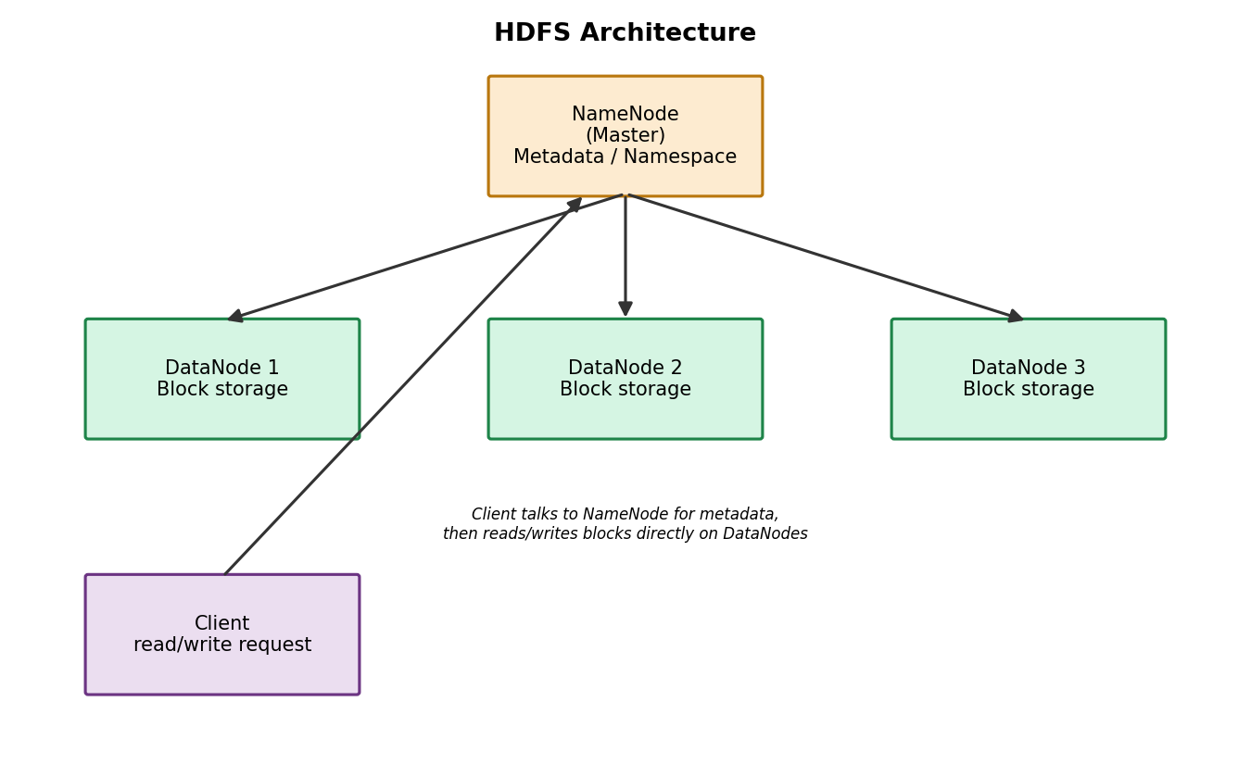
Figure 1: HDFS Architecture with NameNode and DataNodes
Question 2: Why is replication important in distributed storage systems?
In any large cluster, hardware failure is not a rare event, it is expected. With hundreds or thousands of machines running continuously, disks fail, network links go down, and nodes crash. If data were stored only once, a single failure would mean permanent data loss.
Replication solves this problem by keeping multiple copies of the same block of data on different nodes, and often on different racks. HDFS uses a default replication factor of three, meaning every block is stored on three separate DataNodes. If one node goes down, the NameNode simply directs read requests to another node that still holds a copy, and it also arranges for a new replica to be created elsewhere to restore the replication factor.
Beyond fault tolerance, replication also improves performance because multiple clients can read different copies of the same data in parallel, which reduces bottlenecks and improves overall throughput of the cluster.
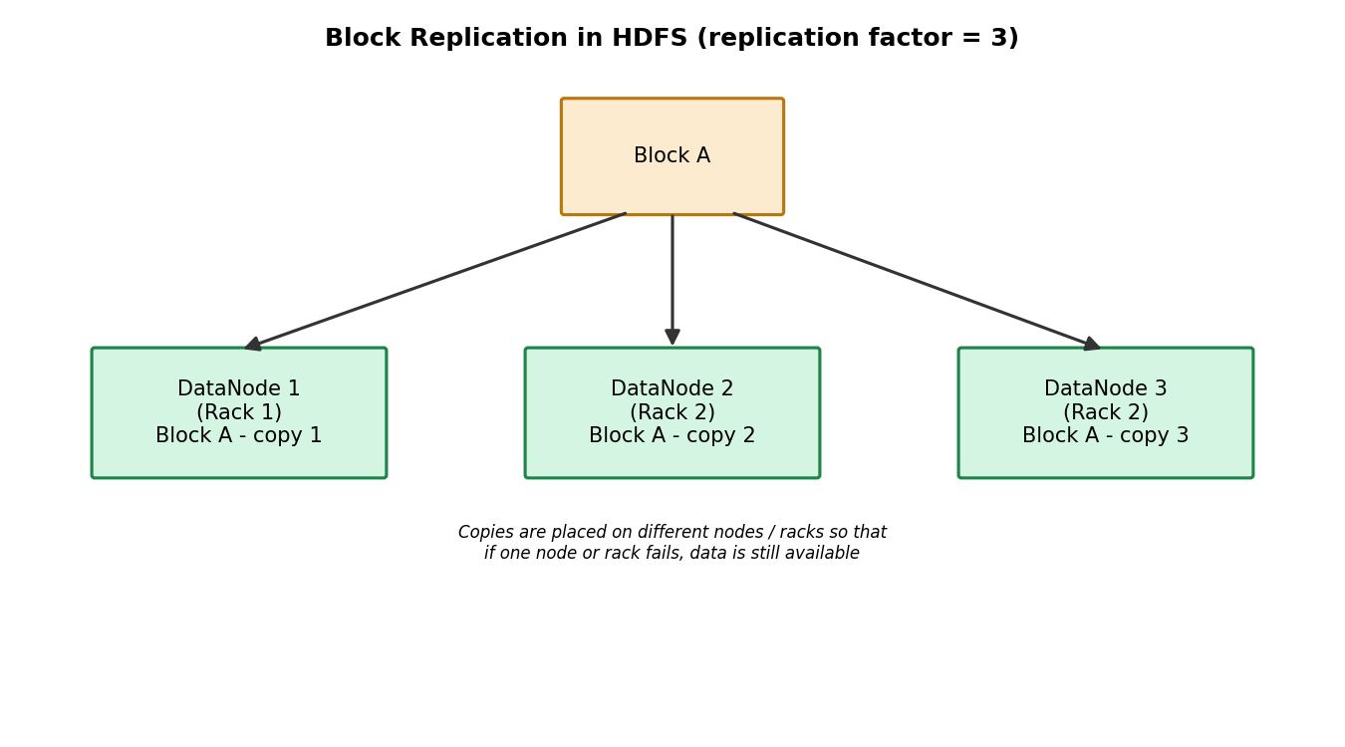
Figure 2: Block replication placed across different DataNodes and racks
Question 3: How does MapReduce divide work between map and reduce phases?
MapReduce is a programming model that breaks a large computation into two main stages: the Map phase and the Reduce phase, with a Shuffle and Sort step in between.
In the Map phase, the input data, which is already split into blocks by HDFS, is processed in parallel by many map tasks. Each map task reads its own portion of data and produces a set of intermediate key-value pairs. For example, in a word count program, each mapper would read a chunk of text and output a pair like (word, 1) for every word it encounters.
After mapping, the framework performs a shuffle and sort step, where all the values associated with the same key from every mapper are grouped together and sent to the appropriate reducer. This is handled automatically by the framework, so the programmer does not need to manage the data movement.
Finally, in the Reduce phase, each reducer receives one key and the full list of values for that key, and combines them into a final result, such as adding up all the counts for a particular word. Because the map tasks run in parallel across many nodes, MapReduce can process very large datasets much faster than a single machine ever could.
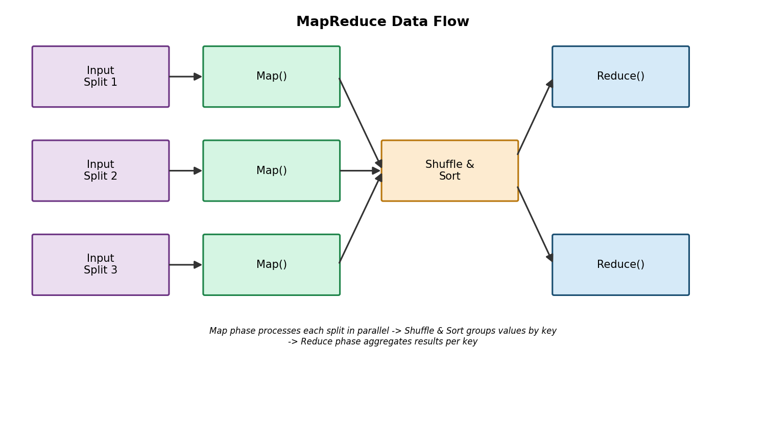
Figure 3: MapReduce data flow from input splits to final output
Question 4: What role does YARN play in large-scale Hadoop processing?
YARN stands for Yet Another Resource Negotiator, and it acts as the resource management and job scheduling layer of Hadoop. Before YARN, MapReduce itself was responsible for both processing data and managing cluster resources, which limited Hadoop to running only MapReduce jobs. YARN separated these two responsibilities, which allows the same cluster to run many different types of processing engines, not just MapReduce, but also Spark, Tez, and others.
YARN has a few key components. The ResourceManager is the master process that keeps track of all the resources, CPU and memory, available across the cluster and decides how to allocate them. On every worker node, a NodeManager monitors resource usage and manages containers on that specific machine. When a new job is submitted, YARN launches an ApplicationMaster for that job, which negotiates with the ResourceManager for the containers it needs and coordinates the actual execution of tasks inside those containers.
In short, YARN allows Hadoop clusters to be used more efficiently and flexibly, sharing the same hardware among multiple applications and workloads at the same time.
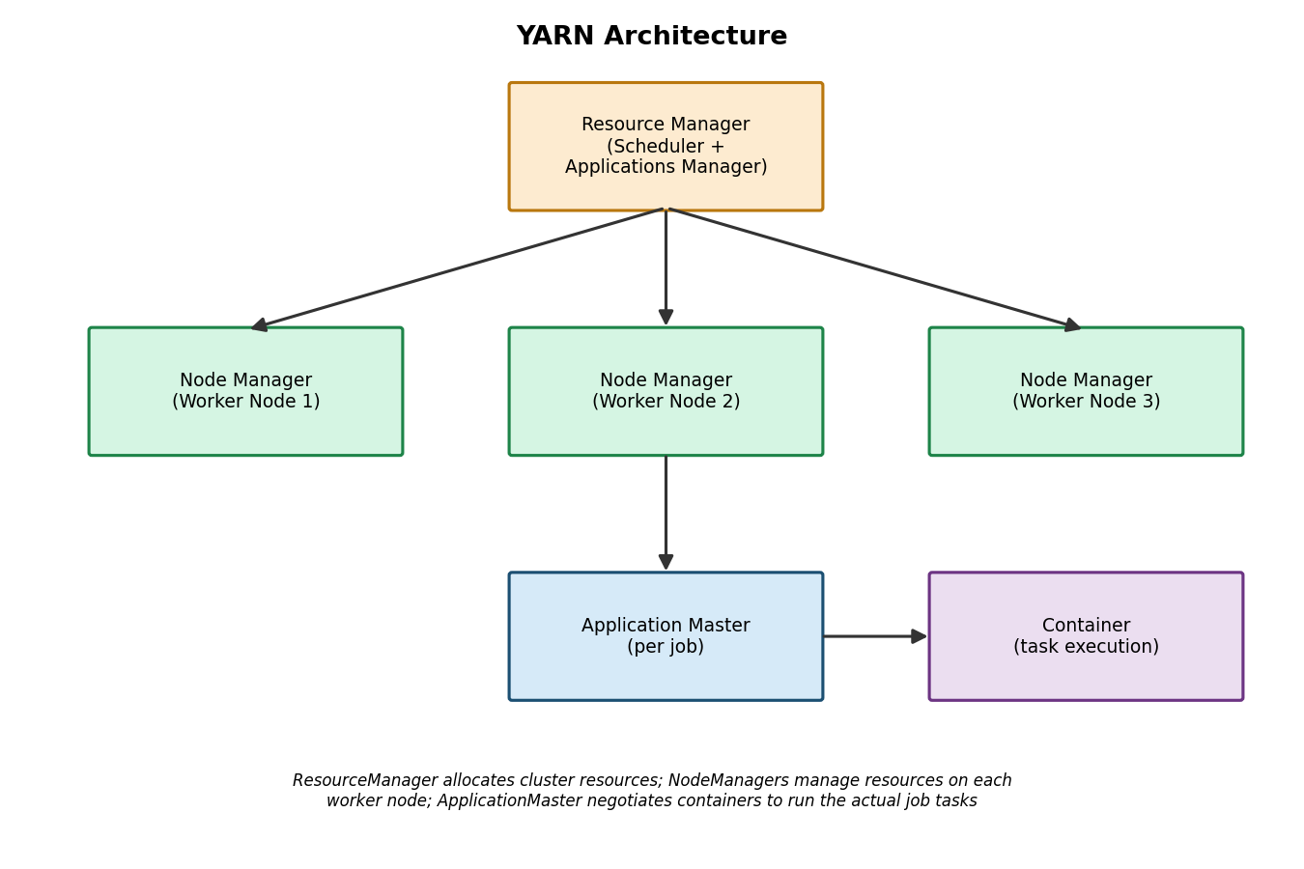
Figure 4: YARN architecture showing ResourceManager, NodeManagers, and ApplicationMaster
Question 5: Differentiate NAS and SAN in an enterprise data environment.
NAS, or Network Attached Storage, is a storage device connected to a network that provides file-level access to data. It typically uses standard network protocols such as NFS or SMB, and from the client's point of view, it behaves like a shared folder that many users and applications can access at the same time over a normal Ethernet network. NAS is relatively simple to set up and cost effective, which makes it popular for file sharing and general-purpose storage.
SAN, or Storage Area Network, works differently. It provides block-level access to storage, meaning the server sees the SAN storage almost as if it were a locally attached disk, not a shared folder. SANs usually run over a dedicated high-speed network, such as Fibre Channel or iSCSI, and are designed for performance-critical and mission-critical applications like large databases, where low latency and high throughput really matter.
In an enterprise environment, organisations often use both together, NAS for general file storage and collaboration, and SAN for high-performance workloads like transactional databases or virtual machine storage.
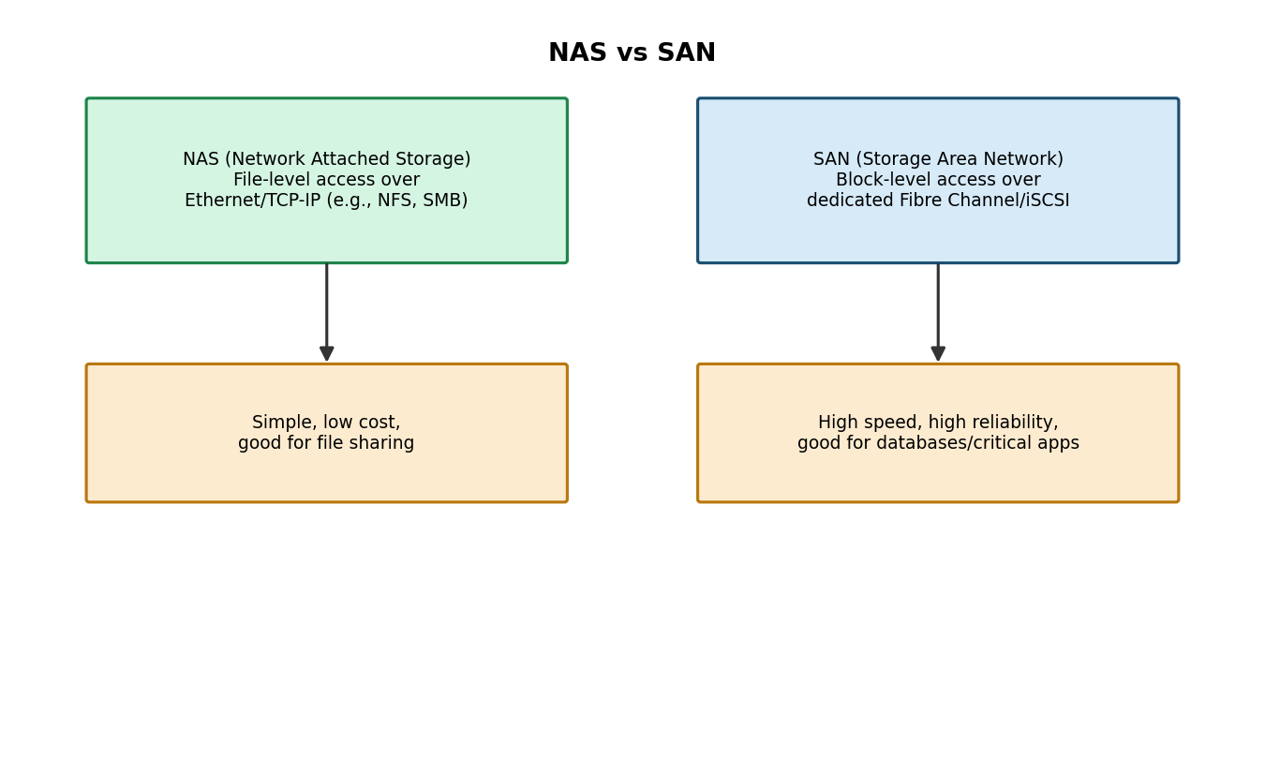
Figure 5: NAS versus SAN comparison
Question 6: What is the purpose of ETL in a big data pipeline?
ETL stands for Extract, Transform, Load, and it describes the process of moving data from various source systems into a central place, usually a data warehouse or a big data platform like Hadoop, so that it can be analysed consistently.
In the Extract step, data is pulled from different source systems such as databases, log files, APIs, or third-party services. This raw data is often inconsistent in format because it comes from many different places. In the Transform step, this raw data is cleaned, validated, converted into a common format, and sometimes aggregated or enriched, for example converting dates into a single format, removing duplicate records, or joining data from multiple sources. In the Load step, the cleaned and transformed data is written into the target system, such as HDFS, a data warehouse, or a database, where it becomes available for reporting and analytics.
The main purpose of ETL is to make sure that the data used for analysis is accurate, consistent, and in a usable format, rather than analysts having to deal with messy raw data every single time.
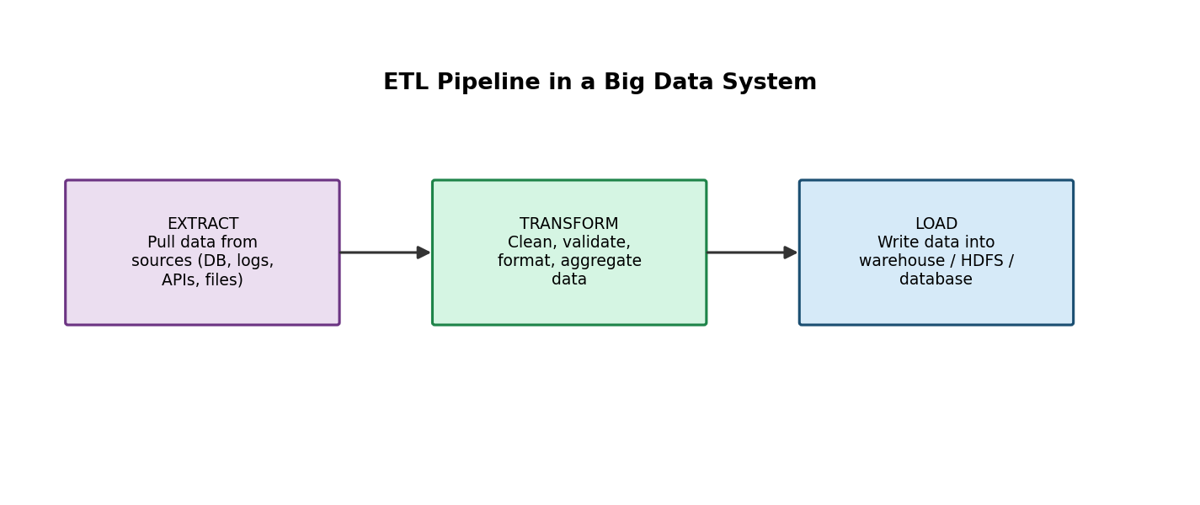
Figure 6: ETL pipeline stages
Question 7: How does Apache NiFi help in data integration workflows?
Apache NiFi is a data flow tool that helps automate the movement of data between different systems in a reliable and easy to manage way. Instead of writing custom scripts for every data movement task, NiFi provides a visual, drag-and-drop interface where you build a flow using small building blocks called processors, each of which does a specific job, such as fetching data from a source, filtering it, converting its format, or routing it to a destination.
One of the biggest advantages of NiFi is data provenance, which means it keeps track of exactly what happened to each piece of data as it moved through the flow, which is very useful for debugging and for meeting compliance requirements. NiFi also handles back-pressure automatically, so if a downstream system slows down, NiFi will not overwhelm it, and it guarantees delivery of data even if part of the flow temporarily fails.
Because of these features, NiFi is commonly used to connect IoT devices, application logs, and databases to big data platforms like Hadoop or streaming systems like Kafka, making it a very practical tool for real-world data integration.
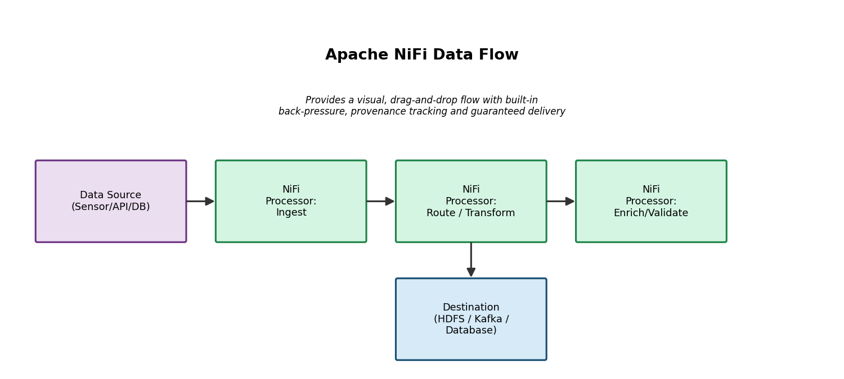
Figure 7: Apache NiFi data flow with chained processors
Question 8: What are the key failure points in a Hadoop cluster and how would you handle them?
A Hadoop cluster has several components, and each one can potentially fail in its own way.
Key failure points:
- NameNode failure: Since the NameNode holds the metadata for the entire file system, its failure can bring down access to the whole cluster. This is handled by configuring NameNode High Availability, where a Standby NameNode can take over automatically if the Active NameNode fails.
- DataNode or disk failure: Individual DataNodes or their disks can fail. Because HDFS replicates data across multiple nodes, this is handled automatically by redirecting reads to a healthy replica and re-replicating the lost blocks elsewhere.
- Network partition or switch failure: If part of the cluster becomes unreachable, jobs running on those nodes may fail. Redundant network paths and proper rack awareness settings help reduce the impact.
- ResourceManager failure: Since it schedules all jobs, its failure stops new job submissions. YARN also supports ResourceManager High Availability with an active-standby pair.
- Task or NodeManager failure: Individual tasks can fail due to bugs, memory issues, or node problems. YARN automatically retries failed tasks on other healthy nodes, up to a configured number of attempts.
Overall, the general approach to handling these failure points is a combination of redundancy through replication, automatic failover for master components, continuous monitoring, and configuring the cluster to retry failed work automatically rather than requiring manual intervention every time something goes wrong.
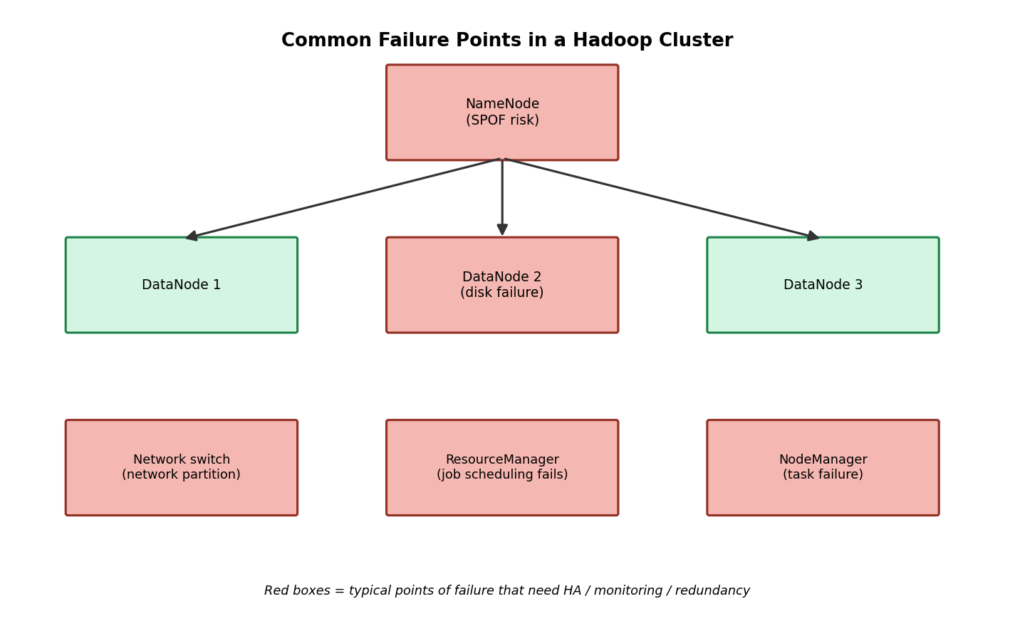
Figure 8: Common failure points across a Hadoop cluster
Question 9: How would you design a secure data ingestion pipeline for a large organization?
For a large organisation, security has to be built into every stage of the pipeline, not added as an afterthought. I would design the pipeline in layers.
Design approach:
- Secure connection at the source: All data coming from applications, databases, or IoT devices should be sent over encrypted channels using TLS, and every source should be authenticated before it is allowed to send data.
- Gateway with authentication and authorization: A gateway layer checks that only approved systems and users can push data into the pipeline, using mechanisms like API keys, OAuth tokens, or certificates.
- Ingestion layer: Tools like Apache NiFi or Kafka receive the data, and this layer can apply rate limiting so no single source can overwhelm the system.
- Validation and masking: Before storing the data, it should be validated for correctness, and sensitive fields such as personal information should be masked or encrypted so that raw sensitive data is not exposed unnecessarily.
- Encrypted storage: Data at rest should be stored in an encrypted form in HDFS or the chosen storage system.
- Access control and auditing: Tools like Kerberos for authentication and Apache Ranger for fine-grained authorization ensure that only the right people and services can access specific datasets, and every access is logged for audit purposes.
This layered approach makes sure that data is protected in transit, during processing, and at rest, while also keeping a clear record of who accessed what, which is essential for compliance in a large organisation.
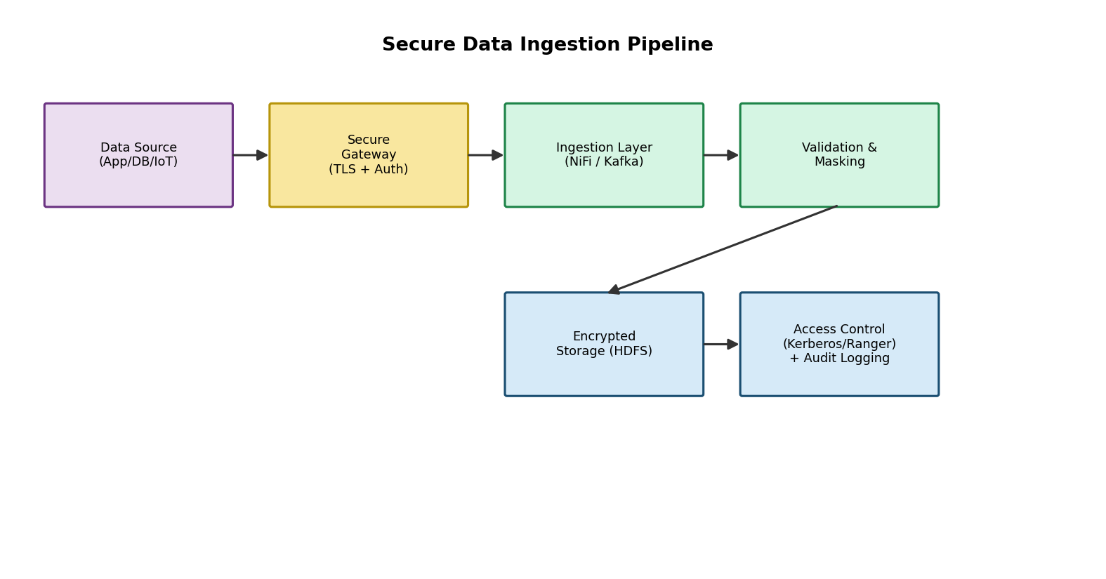
Figure 9: A secure data ingestion pipeline with layered protection
Question 10: How would you explain a scalable Hadoop-based processing system to a non-technical manager?
When explaining this to someone without a technical background, I would avoid jargon and use a simple analogy, such as comparing Hadoop to a very large library.
Imagine a library so big that no single room could hold all the books, so the books are spread across many different shelves in different sections. There is a librarian who keeps track of exactly which shelf holds which book, so whenever someone needs a book, the librarian can point them to the right place immediately, without searching the whole library. This librarian represents the NameNode, and the shelves represent the DataNodes that actually store the data.
To make sure no book is ever lost, the library keeps a few extra copies of every book, stored on different shelves, so if one shelf is damaged, the book is still available elsewhere. This is similar to replication in HDFS.
Now, instead of one person trying to read through thousands of books to find information, imagine a large team of helpers, where each helper reads a small portion of the books at the same time and reports back a summary. Their results are then combined into one final answer. This is exactly what MapReduce does, and YARN is like the manager who decides how many helpers are available and assigns them to different tasks so that the work gets done efficiently without anyone being overloaded.
I would explain that this design is what allows the system to handle huge amounts of company data reliably and quickly, and that it can keep growing simply by adding more shelves, that is, more machines, whenever the organisation's data grows.
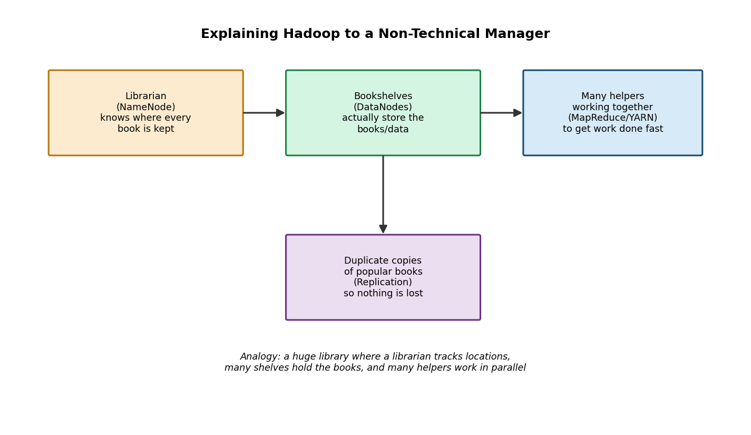
Figure 10: Explaining Hadoop using a library analogy

