SIMATS ENGINEERING
ASSESSMENT TOOL 1: Short Answer Test
COURSE NAME: Cloud Computing and Big Data Analytics
COURSE CODE: CSA15
COURSE OUTCOME COVERED
CO1: Apply cloud computing technologies including hardware-software evolution, virtualization, web services, and service models to develop cloud-based solutions. (BL2)
Assessment Tool Weightage: 40%
Bloom's Taxonomy Level: Imitation (Level 1)
Question Count: 5
Total Marks: 25
Code of Conduct
I Kanishk C (Name / Reg No: 192511278) certify that this submission is my original work and that I have adhered to the guidelines specified for this assessment.
I understand that any violation of academic integrity rules will result in disciplinary action.
Signature of the student: Kanishk C

Question 1: Define cloud computing and explain any four characteristics that make it different from traditional on-premise computing.

Definition of Cloud Computing
Cloud computing is a way of using computing resources such as servers, storage, databases, networking, and software over the internet instead of owning and maintaining physical hardware at our own site. Instead of buying and running our own machines, we simply rent computing power from a cloud provider, use only what we need, and pay for it based on our usage. The resources are hosted in large data centers managed by companies like Amazon, Google, or Microsoft, and users can access them through the internet from anywhere, at any time.
In traditional on-premise computing, an organisation has to buy its own servers, set up its own data centre, hire people to maintain the hardware, and plan capacity years in advance. This is expensive and slow to change. Cloud computing removes most of this burden because the provider takes care of the hardware, and the user just focuses on using the service.

Four Key Characteristics That Make Cloud Computing Different
- 1. On-Demand Self-Service: A user can provision computing resources such as server time, storage, or applications automatically, without needing to talk to a human representative of the service provider. For example, a student can log into AWS and launch a virtual server within minutes, something that would take days or weeks in a traditional setup where hardware has to be physically purchased and configured.
- 2. Broad Network Access: Cloud services are available over the network and can be accessed through standard mechanisms such as a web browser or mobile app, from laptops, desktops, tablets, and smartphones. This means an employee can access company applications from home, from office, or while travelling, which is not always easy in a purely on-premise system tied to a local network.
- 3. Resource Pooling: The cloud provider's computing resources are pooled together to serve multiple customers using a multi-tenant model, where physical and virtual resources are dynamically assigned and reassigned according to demand. The customer generally has no control over the exact physical location of the resources, but this pooling allows the provider to use hardware far more efficiently than a single organisation running its own dedicated servers.
- 4. Rapid Elasticity: Resources can be scaled up or scaled down quickly, sometimes automatically, to match the actual workload. If an e-commerce website suddenly gets heavy traffic during a sale, cloud resources can expand instantly and shrink back once traffic drops. In traditional on-premise computing, scaling means purchasing new hardware, which takes time and cannot be reversed easily once bought.
- 5. Measured Service: Cloud systems automatically monitor and control resource usage, and the customer is billed only for what is actually used, similar to how we pay an electricity bill. This pay-as-you-go model is very different from on-premise computing, where an organisation must invest a large amount of money upfront regardless of how much the hardware is actually used.
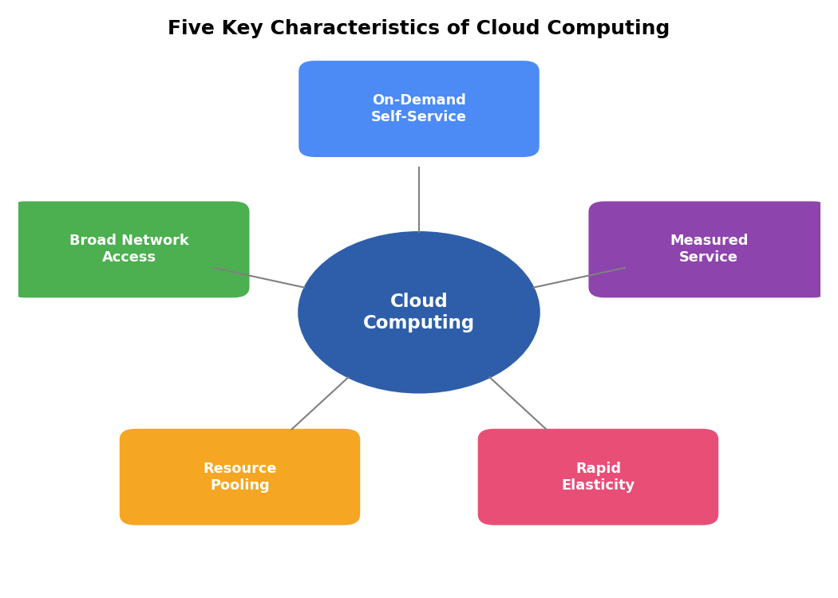
Figure 1: Five key characteristics of cloud computing
Overall, the main difference between cloud computing and traditional on-premise computing is that cloud computing shifts the responsibility of buying, maintaining, and scaling hardware away from the user and onto the cloud provider, while giving the user flexible, on-demand, pay-per-use access to computing power over the internet.

Question 2: Trace the evolution of cloud computing from hardware evolution to internet software evolution, and show how these changes enabled modern cloud platforms.

Hardware Evolution
The story of cloud computing begins with mainframe computers in the 1950s and 1960s. These were huge, expensive machines owned only by large organisations and universities. Since mainframes were costly, a technique called time-sharing was introduced, which allowed multiple users to share the same physical mainframe by taking turns using its processing power. This idea of many users sharing one large computer is actually the earliest ancestor of the cloud concept, where resources are shared among many users.
In the 1980s, the industry moved to client-server computing. Personal computers (clients) became affordable, and they connected to more powerful servers that stored data and handled heavy processing. This decentralised computing to some extent, but organisations still had to own and manage their own servers, which meant high maintenance costs and limited scalability.

Internet and Software Evolution
During the 1990s, the growth of the internet completely changed how computers could communicate. Websites and web browsers made it possible to access information and applications remotely, without needing the software installed on a local machine. This period also saw the early idea of Application Service Providers (ASPs), companies that hosted software applications and let customers use them over the internet for a fee, which is very close to today's Software as a Service model.
In the 2000s, the concept of grid computing and utility computing became popular. Grid computing connected many computers together to work as one large system for solving big computational problems, while utility computing introduced the idea of treating computing power like a utility such as electricity or water, where a customer pays only for what they use. Virtualization technology also matured during this time, allowing one physical server to be divided into multiple virtual machines, which made resource sharing far more efficient and secure than the older time-sharing method.

Emergence of Modern Cloud Platforms
All of these developments came together around 2006, when Amazon launched Amazon Web Services (AWS), offering Infrastructure as a Service to the public for the first time on a large commercial scale. This was quickly followed by Google App Engine, Microsoft Azure, and many other providers. Modern cloud platforms became possible because of three things working together: powerful and affordable hardware, mature virtualization technology that could safely share hardware among many customers, and a reliable, high-speed internet that could deliver these services anywhere in the world.
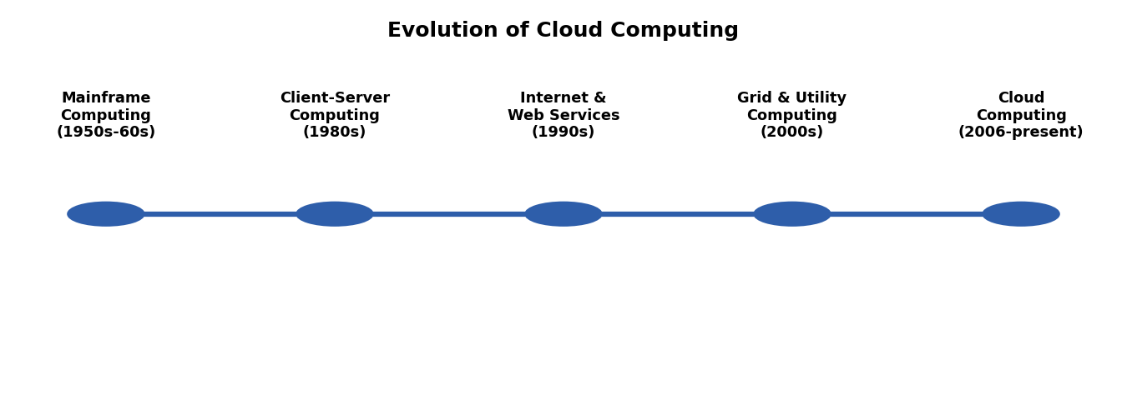
Figure 2: Evolution of cloud computing from mainframes to modern cloud platforms
In short, hardware evolution gave us powerful and shareable machines, and internet and software evolution gave us the connectivity and delivery models needed to turn that shared hardware into a service that anyone could access remotely. Together, these two paths of evolution enabled the modern cloud platforms we use today.

Question 3: Explain the role of server virtualization in cloud computing. Differentiate between virtualization as an enabling technology and cloud computing as a service model.

Role of Server Virtualization in Cloud Computing
Server virtualization is the process of dividing a single physical server into multiple isolated virtual machines (VMs), each of which behaves like an independent computer with its own operating system, applications, and resources. This is made possible by a software layer called a hypervisor, which sits between the physical hardware and the virtual machines and manages how the underlying CPU, memory, storage, and network resources are shared among them.
In cloud computing, server virtualization plays a foundational role because it allows a cloud provider to run many customers' workloads on the same physical hardware safely and efficiently, without one customer's virtual machine being able to see or affect another customer's data. This is what makes resource pooling and multi-tenancy possible. Virtualization also allows virtual machines to be created, resized, moved, or deleted within minutes, which is exactly what gives cloud computing its rapid elasticity and on-demand self-service characteristics. Without virtualization, a cloud provider would have to dedicate an entire physical machine to each customer, which would be extremely expensive and would remove most of the flexibility that makes cloud computing attractive.
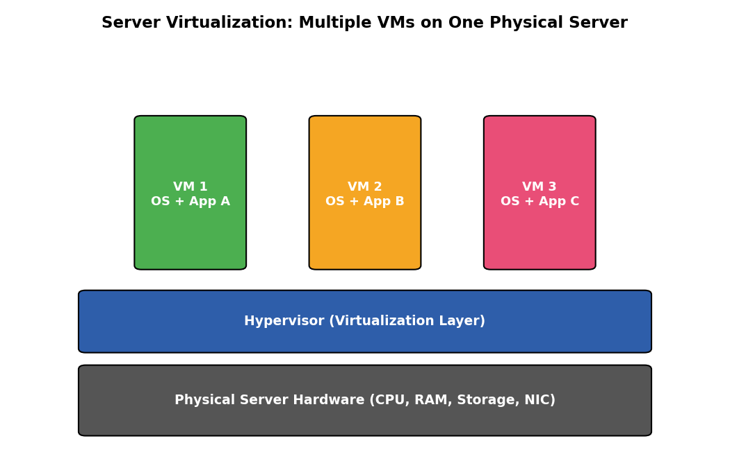
Figure 3: Multiple virtual machines running on one physical server through a hypervisor

Virtualization vs. Cloud Computing: The Key Difference
It is important to understand that virtualization and cloud computing are not the same thing, even though cloud computing depends heavily on virtualization.
- Virtualization is a technology. It is a technical method of creating multiple virtual versions of a physical resource, such as a server, storage device, or network, so that hardware can be used more efficiently. Virtualization can exist entirely inside a single organisation's own data centre, with no cloud involved at all.
- Cloud computing is a service delivery model. It refers to how computing resources are packaged, offered, and consumed as an on-demand, self-service, pay-per-use service over the internet, following characteristics such as broad network access and measured service.
In simple words, virtualization is one of the important building blocks (an enabling technology) that makes cloud computing possible and efficient, while cloud computing is the overall business and service model built on top of virtualization, along with other technologies like automation, self-service portals, and internet-based delivery. A company can use virtualization purely for its own internal data centre without offering any cloud services, but true cloud computing almost always relies on virtualization behind the scenes.

Question 4: Discuss the role of data centers in delivering cloud services.
A data center is a physical facility that houses the servers, storage systems, and networking equipment that cloud providers use to run and deliver their services. It is essentially the backbone of cloud computing, because every virtual machine, database, or application that a cloud user accesses is, in reality, running on hardware located inside one of these data centers.

Key Roles Played by Data Centers
- Hosting Computing Resources: Data centers physically house the thousands of servers and storage devices that provide the raw processing power and storage capacity offered as cloud services.
- Ensuring High Availability: Cloud providers usually operate multiple data centers spread across different geographic regions. If one data center faces an issue, workloads can be shifted to another, ensuring that cloud services remain available to users almost all the time.
- Providing Scalability: Because data centers contain very large pools of hardware, they can support rapid elasticity, allowing a cloud provider to instantly allocate more virtual machines or storage to a customer whenever demand increases.
- Maintaining Security and Reliability: Data centers use physical security measures such as restricted access, surveillance, and fire protection, along with technical measures like firewalls and redundant power supplies (backup generators and uninterruptible power supplies) to keep customer data safe and services running without interruption.
- Supporting Networking and Connectivity: Data centers are connected to high-speed internet backbones so that customers anywhere in the world can access cloud services with low delay, fulfilling the 'broad network access' characteristic of cloud computing.
- Cooling and Power Management: Since thousands of servers generate a large amount of heat, data centers invest heavily in cooling systems and efficient power management to keep hardware running reliably and to reduce operating costs.
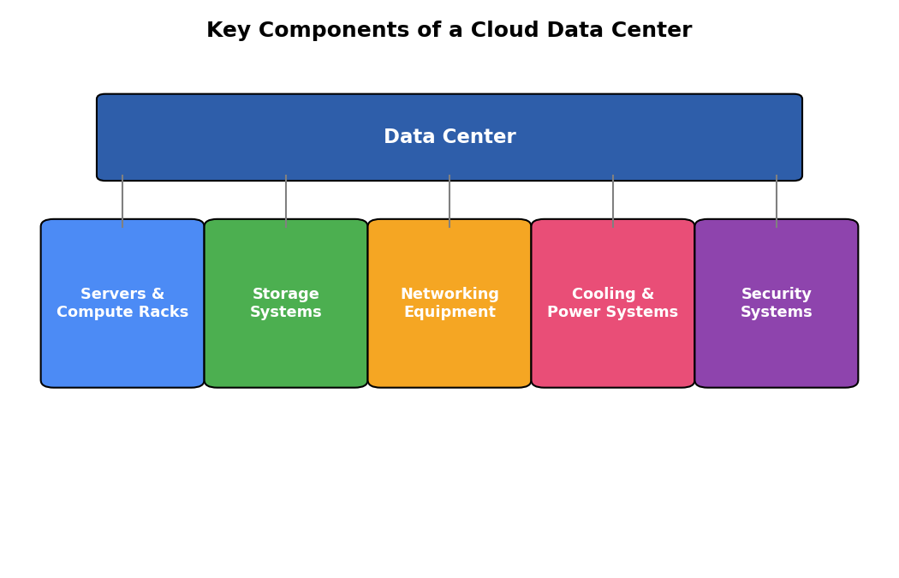
Figure 4: Key components housed within a cloud data center
In summary, data centers are the physical foundation on which cloud computing is built. Without well-designed, secure, and reliable data centers, cloud providers would not be able to offer the on-demand, always-available, and scalable services that define modern cloud computing.

Question 5: Differentiate IaaS, PaaS, SaaS, and XaaS with one suitable real-world example for each model.
Cloud computing offers several service models depending on how much control the user needs and how much the provider manages. The four common models are IaaS, PaaS, SaaS, and the broader category, XaaS.
Service Model | What It Provides | User Controls | Real-World Example
IaaS  (Infrastructure as a Service) | Virtualized computing resources — servers, storage, and networking — over the internet | Operating system, storage, deployed applications, and some networking components | Amazon EC2, Microsoft Azure Virtual Machines
PaaS  (Platform as a Service) | A ready-made platform (runtime, libraries, development tools) to build and deploy applications | The applications the user develops and their configuration settings | Google App Engine, Microsoft Azure App Service
SaaS  (Software as a Service) | Complete, ready-to-use software applications delivered over the internet | Only limited application-level settings such as user preferences | Gmail, Google Docs, Microsoft Office 365
XaaS  (Anything as a Service) | A broad, umbrella term covering any IT capability delivered as a service (e.g., Storage as a Service, Database as a Service, Security as a Service) | Depends entirely on the specific service being consumed | Dropbox (Storage as a Service), Amazon RDS (Database as a Service)

Explanation of Each Model
- Infrastructure as a Service (IaaS) gives users the basic building blocks of computing, such as virtual servers, storage, and networking, while the user is still responsible for installing and managing the operating system and applications on top. It offers the most control but also the most responsibility. Example: Amazon EC2, where a user rents virtual machines and configures them as needed.
- Platform as a Service (PaaS) goes one step further by also providing the operating system, runtime environment, and development tools, so developers can focus purely on writing and deploying their application code without worrying about the underlying servers. Example: Google App Engine, where a developer simply uploads code and the platform handles scaling and infrastructure automatically.
- Software as a Service (SaaS) provides a complete, ready-to-use application over the internet, and the user does not need to manage anything related to infrastructure, platform, or even installation. Example: Gmail, where a user simply logs in through a browser and uses the email service directly.
- Anything as a Service (XaaS) is a broader umbrella term that covers any IT capability delivered as a service over the internet, beyond just infrastructure, platform, and software. It includes services such as Storage as a Service, Database as a Service, and Security as a Service. Example: Dropbox, which delivers cloud storage as a service to end users.
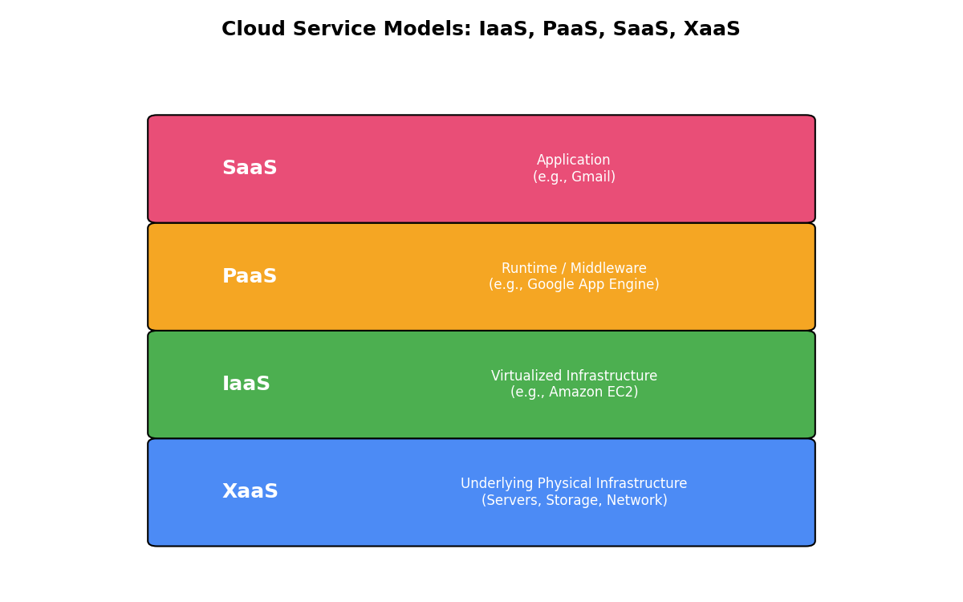
Figure 5: Layered view of IaaS, PaaS, SaaS, and XaaS service models
The key difference among these four models lies in the level of control the user has versus the level of management the provider takes on. IaaS gives maximum control to the user, SaaS gives maximum convenience with minimum control, PaaS sits in between by managing infrastructure but leaving application development to the user, and XaaS extends this same as-a-service idea to virtually any IT capability an organisation might need.

