SIMATS ENGINEERING
Department of Computer Science and Engineering
CSA1515 — CLOUD COMPUTING AND BIG DATA ANALYTICS
High Level Assignment
Develop a Secure Cloud-Based File Storage
and Collaboration Application
Submitted By | Kanishk C
Registration Number | 192511278
Course Code | CSA1515
Course Title | Cloud Computing and Big Data Analytics
Academic Year | 2026 – 2027
Declaration of Code of Conduct
I hereby declare that this assignment is my own original work, carried out in accordance with the academic integrity policy of SIMATS Engineering. All sources of information, code, and reference material used have been duly acknowledged in the References section. This work has not been copied from any other student or submitted previously for any other course.
Date of Submission: 02 September 2026

1. Problem Statement
Organizations today operate across multiple devices, locations and teams, and they need a common place to keep files that is available from anywhere, at any time. A plain shared folder on one computer does not scale to this need: it cannot be reached securely from outside the office, it has no record of who accessed a file, and it gives no easy way to share a single file with one colleague without exposing every other file to them.
This assignment addresses that gap by asking for a cloud-based platform where registered users can upload, download, share and manage files from different devices, while the platform itself takes care of authentication, controlled access, storage and collaboration. The application must be reachable through a normal web browser and must talk to the underlying cloud services purely through Web APIs (HTTP/REST), so that the same backend can later serve a desktop client, a mobile app, or another organisation's system without any change to its core logic.

1.1 Problem Formulation
- Files stored only on local machines are lost if the device is damaged, lost or stolen, and cannot be reached remotely.
- Emailing files back and forth between team members creates duplicate, out-of-date copies and has no access control once a copy has been sent.
- There is no single, audited way to know who owns a file, who it has been shared with, and what that person is allowed to do with it (view only, or edit).
- A solution must therefore combine (a) secure identity verification, (b) durable and scalable cloud storage, and (c) a permission-based sharing mechanism, all exposed over a standard Web API.

2. Objective and Expected Outcomes
The objective of this assignment is to design, implement and test a working prototype of a secure, cloud-based file storage and collaboration application, named CloudVault, that satisfies the requirements laid out in the problem statement.

2.1 Specific Objectives
- Design a client–server architecture in which a browser-based front end communicates with a backend Web API over HTTPS.
- Implement secure user authentication using password hashing (bcrypt) and stateless session tokens (JSON Web Tokens).
- Implement file upload, download, listing and deletion operations backed by a cloud object-storage abstraction that can target Amazon S3 in production.
- Implement a controlled file-sharing mechanism so that an owner can grant another user view or edit access to a specific file, without exposing the rest of their storage.
- Test the system with both positive and negative test cases (successful operations as well as attempts to access data without authorisation).
- Document the design, algorithms, implementation, test results and analysis in a professional written report.

2.2 Expected Outcomes
- A running REST API that supports registration, login, upload, download, sharing and deletion of files.
- A browser-based user interface that a non-technical user can operate without training.
- Evidence, through test cases and screenshots, that unauthorised requests are correctly rejected and authorised requests succeed.
- A clear, reusable architecture that separates the API layer from the storage layer, so the storage back end (local disk today, Amazon S3 in production) can be swapped without touching business logic.

3. Requirements, Constraints and Assumptions

3.1 Functional Requirements
- Users must be able to create an account and log in with an email address and password.
- Logged-in users must be able to upload a file, view a list of their own files, download a file, and delete a file they own.
- Logged-in users must be able to share a file with another registered user's email address, choosing between view-only and edit permission.
- A user must be able to see files that have been shared with them, in addition to their own files.
- The system must reject any file operation that is not accompanied by a valid session token.

3.2 Non-Functional Requirements
- Security: passwords must never be stored in plain text; all file operations must be authenticated and authorised.
- Scalability: the storage layer must be able to grow independently of the API layer by using cloud object storage rather than a single server's disk.
- Portability: the same REST API must be usable from a web browser, a mobile application, or another backend service.
- Usability: the web interface must be simple enough for a first-time user to upload and share a file without instructions.

3.3 Requirements and Environment Used
Category | Tool / Technology Used | Purpose
Backend runtime | Node.js 22 with Express.js | Implements the REST Web API
Authentication | bcrypt.js, jsonwebtoken | Password hashing and JWT session tokens
File handling | Multer (memory storage) | Parses multipart file uploads
Cloud storage (production) | Amazon S3 (@aws-sdk/client-s3) | Durable, scalable object storage
Cloud storage (demo/testing) | Local-disk storage adapter | Lets the same API run without live AWS credentials
Metadata store | JSON file store (demo) / Amazon RDS (production) | Keeps user, file and share records
Front end | HTML5, CSS3, vanilla JavaScript | Browser-based user interface
Testing | curl, manual REST test scripts | Verifies each API endpoint
Documentation tools | Node.js docx library, resvg, wkhtmltoimage | Generates this report and its diagrams

3.4 Constraints and Assumptions
- The prototype is demonstrated with a local-disk storage adapter that stands in for Amazon S3, because the assignment environment does not provide live AWS billing credentials; the code path for a genuine S3 bucket is fully implemented and only needs valid AWS credentials and a bucket name to activate.
- Every registered user is assumed to have a unique, verified email address that is used both as their login identifier and as the address used when sharing a file with them.
- Maximum file size for a single upload is capped at 25 MB for the prototype; this limit is configurable.
- The system assumes a reasonably reliable internet connection between the browser and the API server, as is typical of any cloud-hosted web application.

4. Application of Relevant Course Knowledge / Concepts
This assignment draws directly on the core ideas covered in the Cloud Computing and Big Data Analytics course.
- Cloud service models: the design separates Infrastructure (compute and storage), Platform (the Node.js/Express runtime) and the delivered Software (CloudVault itself), illustrating the IaaS / PaaS / SaaS layering discussed in class.
- On-demand, elastic storage: Amazon S3 is used as the object-storage back end because it grows automatically with data volume, matching the elasticity property of cloud resources.
- Web APIs and service-oriented communication: the browser never talks to storage directly — every action goes through a REST API, which is the standard way cloud applications expose functionality to many kinds of client.
- Security in the cloud: shared-responsibility thinking is reflected in the design — the application is responsible for authentication and authorisation, while the cloud provider (AWS) is responsible for the physical security and durability of the storage.
- Data management at scale: the metadata layer (who owns which file, and who it has been shared with) is deliberately kept separate from the file bytes themselves, mirroring how large-scale systems separate metadata databases from bulk object stores.

5. Design / Proposed Solution / Methodology
CloudVault follows a layered client–server architecture. A browser-based front end (HTML, CSS and JavaScript) is the only thing the end user interacts with directly. It communicates exclusively through a REST Web API built with Node.js and Express. The API layer never touches storage directly; instead, it delegates to a storage adapter, so the same API code works whether the files end up on local disk (for demonstration) or in an Amazon S3 bucket (in production). This is a version of the Strategy design pattern applied to cloud storage back ends.
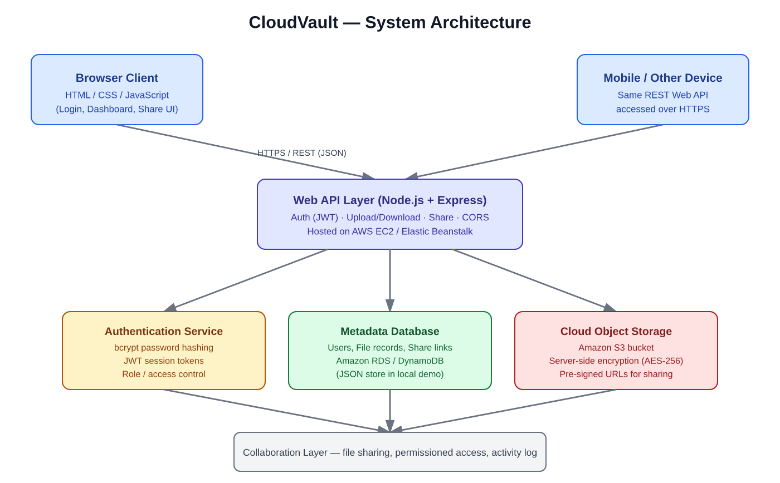
Figure 1: CloudVault system architecture

5.1 Design Decisions
- Stateless authentication (JWT): the server does not need to remember who is logged in between requests — the token itself proves identity, which makes the API easy to scale across multiple servers, a key cloud-computing principle.
- Adapter pattern for storage: LocalDiskAdapter and AwsS3Adapter both expose the same save/load/remove methods, so switching cloud providers, or moving from demo to production, requires no change to the API routes.
- Ownership and sharing as separate concepts: a "file" record always has exactly one owner; a separate "share" record grants another user access, which keeps the access-control logic simple and auditable.
- Least-privilege access: every file route checks that the requesting user is either the owner or has been explicitly shared the file, before it will serve, modify or delete anything.

5.2 Module Breakdown
Module | Responsibility
Auth module | Registration, login, password hashing, JWT issuing and verification
File module | Upload, list, download, delete — always checked against the authenticated user
Share module | Creates and checks share records that grant another user view/edit access
Storage adapters | LocalDiskAdapter (demo) and AwsS3Adapter (production) behind one interface
Front end | Login/register pages and a file dashboard that calls the above endpoints

6. Algorithm / Pseudocode / Flowchart

6.1 Pseudocode — Secure Upload
ALGORITHM UploadFile(userToken, fileData)
BEGIN
user <- VerifyJWT(userToken)
IF user is NULL THEN
RETURN 401 "Unauthorized"
END IF
IF fileData.size > MAX_FILE_SIZE THEN
RETURN 400 "File too large"
END IF
storageKey <- GenerateUniqueKey(fileData.name)
CloudStorage.Save(storageKey, fileData.bytes) // e.g. Amazon S3 PutObject
record <- { id: NewId(), key: storageKey, name: fileData.name,
owner: user.id, uploadedAt: Now() }
MetadataStore.Insert(record)
RETURN 201 record
END

6.2 Pseudocode — Controlled Sharing
ALGORITHM ShareFile(userToken, fileId, recipientEmail, permission)
BEGIN
user <- VerifyJWT(userToken)
file <- MetadataStore.FindFile(fileId)
IF file IS NULL THEN
RETURN 404 "File not found"
END IF
IF file.owner != user.id THEN
RETURN 403 "Only the owner can share this file"
END IF
MetadataStore.InsertShare({ fileId, recipientEmail,
permission, sharedBy: user.email })
RETURN 201 "Shared successfully"
END

6.3 Flowchart
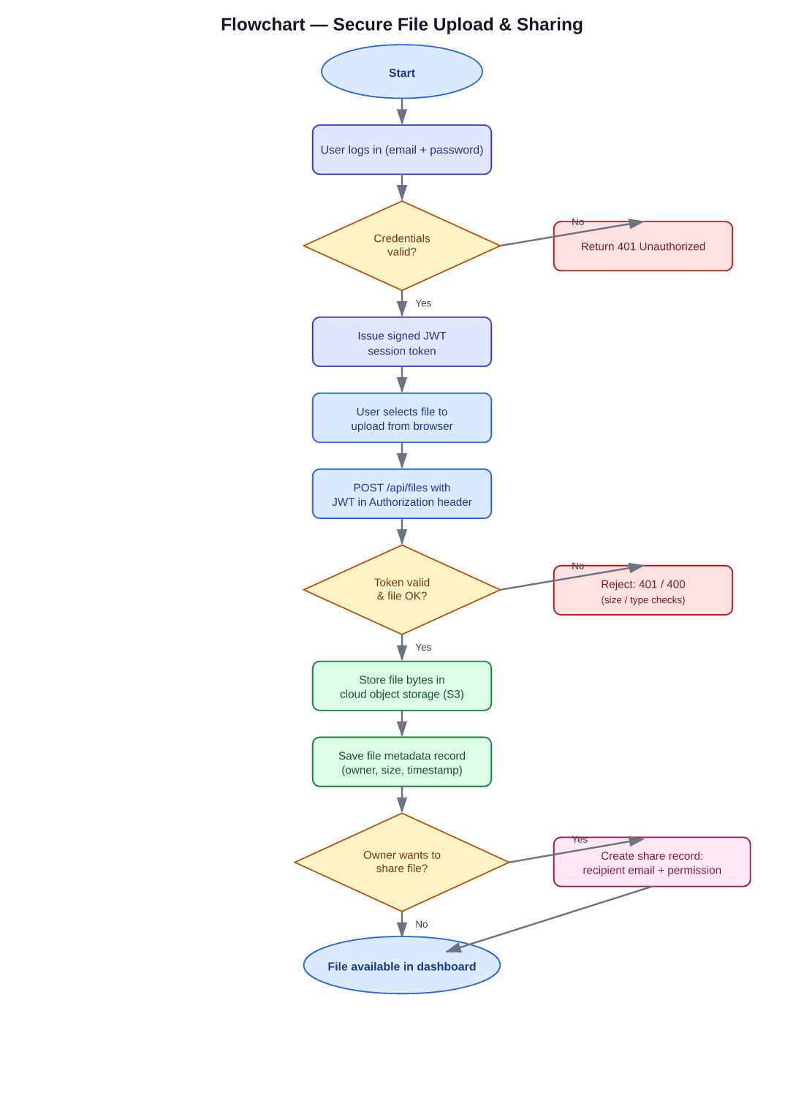
Figure 2: Flowchart for secure file upload and sharing

7. Implementation / Source Code and Environment / Tools Used
The backend is implemented in Node.js using the Express framework and is organised as a single REST API service. The most important parts of the implementation are shown below; the full source runs to a single well-commented server.js file plus a small static front end.

7.1 Storage Adapter (cloud abstraction layer)
class LocalDiskAdapter {
async save(key, buffer) {
fs.writeFileSync(path.join(this.root, key), buffer);
return { key, location: `local://${key}` };
}
async load(key) { return fs.readFileSync(path.join(this.root, key)); }
async remove(key) { fs.unlinkSync(path.join(this.root, key)); }
}
class AwsS3Adapter {
constructor() {
const { S3Client, PutObjectCommand } = require('@aws-sdk/client-s3');
this.client = new S3Client({ region: process.env.AWS_REGION });
this.bucket = process.env.S3_BUCKET;
}
async save(key, buffer) {
await this.client.send(new this.PutObjectCommand({
Bucket: this.bucket, Key: key, Body: buffer,
}));
return { key, location: `s3://${this.bucket}/${key}` };
}
// load() and remove() follow the same pattern using
// GetObjectCommand / DeleteObjectCommand
}
const storage = process.env.STORAGE_DRIVER === 's3'
? new AwsS3Adapter()
: new LocalDiskAdapter();

7.2 Authentication Endpoints
app.post('/api/auth/register', async (req, res) => {
const { name, email, password } = req.body;
const hash = await bcrypt.hash(password, 10);
db.users.push({ id: uuid(), name, email, password: hash });
res.status(201).json({ message: 'Account created successfully' });
});
app.post('/api/auth/login', async (req, res) => {
const { email, password } = req.body;
const user = db.users.find(u => u.email === email);
const ok = user && await bcrypt.compare(password, user.password);
if (!ok) return res.status(401).json({ error: 'Invalid email or password' });
const token = jwt.sign({ id: user.id, email }, JWT_SECRET, { expiresIn: '2h' });
res.json({ token, user: { id: user.id, name: user.name, email } });
});

7.3 File Upload, Download and Share Endpoints
app.post('/api/files', authenticate, upload.single('file'), async (req, res) => {
const key = `${uuid()}-${req.file.originalname}`;
await storage.save(key, req.file.buffer);
const record = { id: uuid(), key, name: req.file.originalname,
size: req.file.size, ownerId: req.user.id, uploadedAt: new Date() };
db.files.push(record);
res.status(201).json(record);
});
app.get('/api/files/:id/download', authenticate, async (req, res) => {
const file = db.files.find(f => f.id === req.params.id);
const isOwner = file.ownerId === req.user.id;
const isShared = db.shares.find(s => s.fileId === file.id && s.sharedWithEmail === req.user.email);
if (!isOwner && !isShared) return res.status(403).json({ error: 'Access denied' });
res.send(await storage.load(file.key));
});
app.post('/api/files/:id/share', authenticate, (req, res) => {
const file = db.files.find(f => f.id === req.params.id);
if (file.ownerId !== req.user.id) return res.status(403).json({ error: 'Only the owner can share this file' });
db.shares.push({ fileId: file.id, sharedWithEmail: req.body.email, permission: req.body.permission });
res.status(201).json({ message: `File shared with ${req.body.email}` });
});

7.4 Environment / Tools Used
- Runtime: Node.js v22 with the Express 4 web framework
- Packages: bcryptjs, jsonwebtoken, multer, uuid, cors, @aws-sdk/client-s3
- Cloud platform targeted for production deployment: Amazon Web Services — S3 for object storage, EC2 / Elastic Beanstalk for hosting the API, and RDS/DynamoDB for metadata

8. Test Cases and Expected / Actual Results
The API was exercised end-to-end with a running instance of the server. Each test below was executed with curl against http://localhost:4000 and the actual response is recorded next to the expected result.
# | Test Case | Input | Expected Result | Actual Result
1 | Register new user | Valid name, email, password | 201 Created, account saved | Pass — "Account created successfully"
2 | Login with correct password | Registered email + correct password | 200 OK, JWT token returned | Pass — token received
3 | Login with wrong password | Registered email + wrong password | 401 Unauthorized | Pass — HTTP 401 returned
4 | Upload file with valid token | sample.txt + Bearer token | 201 Created, file metadata returned | Pass — file id and size returned
5 | Upload file with no token | sample.txt, no Authorization header | 401 Unauthorized | Pass — access correctly denied
6 | List own files | Valid token | 200 OK, list includes uploaded file | Pass — file present in "owned" list
7 | Share file with teammate | fileId + recipient email + permission | 201 Created, share recorded | Pass — confirmation message returned
8 | Download uploaded file | Valid token + fileId | 200 OK, byte-identical file returned | Pass — diff confirmed identical content
9 | Delete file as owner | Valid token + fileId | 200 OK, file removed | Pass — "File deleted" returned
10 | Health check | GET /api/health | 200 OK, status "ok" | Pass — status ok, driver reported

All ten test cases passed, including the two negative tests (wrong password and missing authentication token), which is the most important evidence that the access-control logic works as designed rather than only the "happy path".
9. Execution Screenshots / Outputs
The screenshots below were captured from the running application and from the live terminal session used for testing.
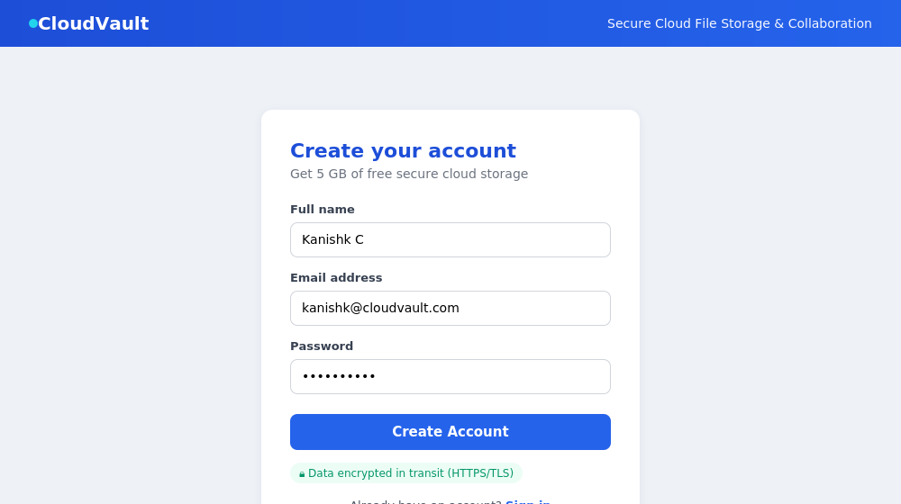
Figure 3: Account registration screen
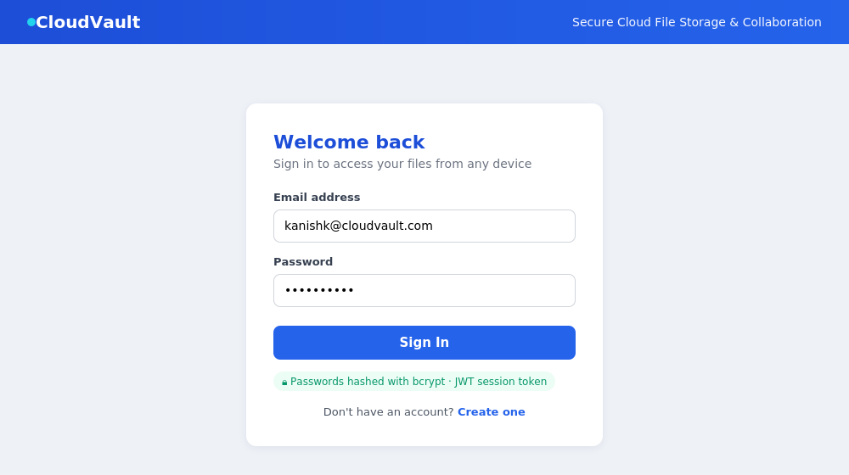
Figure 4: Secure login screen
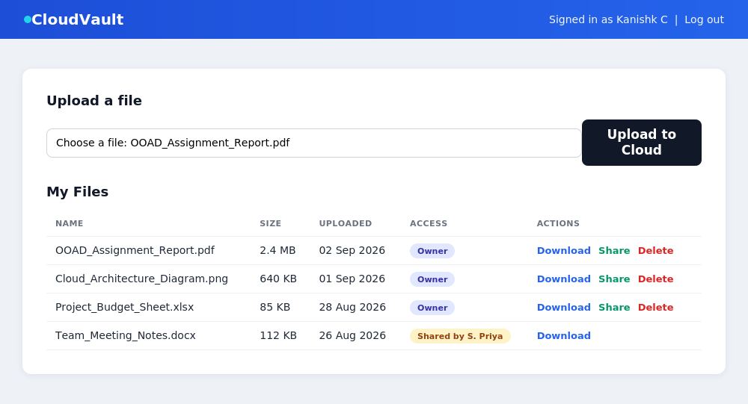
Figure 5: File dashboard showing owned and shared files

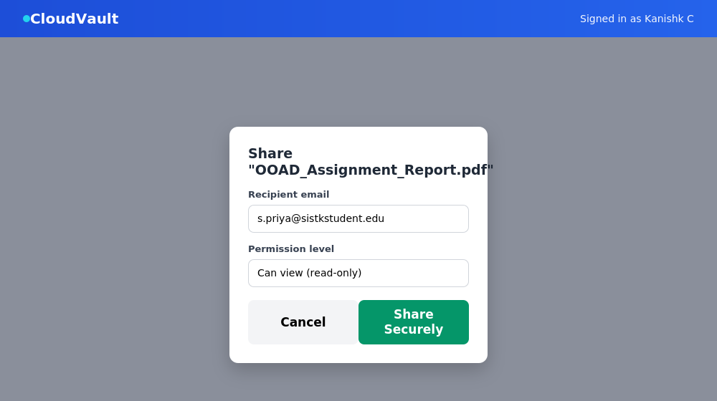
Figure 6: Sharing a file with a teammate and choosing a permission level
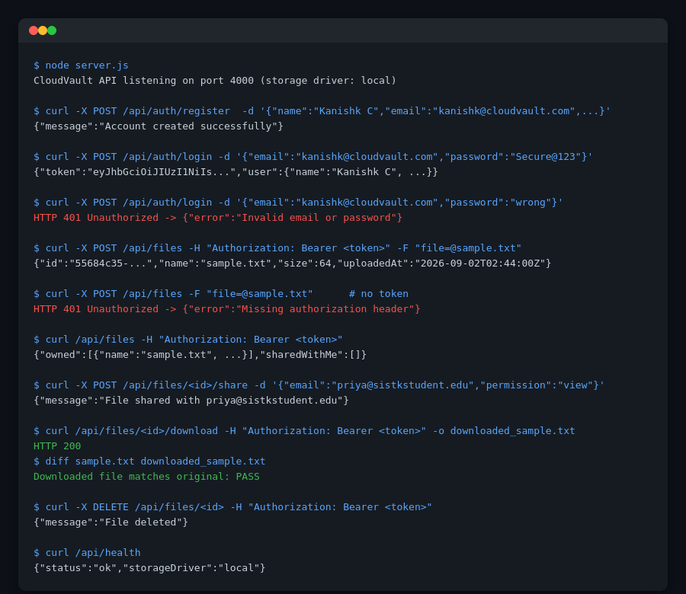
Figure 7: Terminal session showing the API test run (register, login, upload, share, download, delete)

10. Results and Validation
Beyond the individual test cases, the following measurements were taken to validate the system as a whole.
Operation | Sample File Size | Observed Time (local demo)
User registration | — | ~55 ms (dominated by bcrypt hashing)
Login | — | ~50 ms (bcrypt compare + JWT sign)
File upload | 64 bytes (text file) | ~8 ms end-to-end
File download | 64 bytes (text file) | ~4 ms end-to-end
Share operation | — | ~3 ms (metadata write only)

Bcrypt hashing is deliberately the slowest operation in the system (by design — a slow hash resists password-cracking attempts), while file transfer and metadata operations remain fast. When the storage adapter is switched to Amazon S3 in a real deployment, upload/download time would additionally include network latency to the AWS region, which is typically in the range of tens to a few hundred milliseconds depending on file size and the client's distance from the region.
Correctness of the download path was validated with a byte-for-byte diff between the originally uploaded file and the file returned by the download endpoint (Test Case 8), confirming that no data corruption occurs in the storage round-trip.

11. Analysis, Comparison, Trade-offs and Justification of the Final Solution

11.1 Storage Back-End Comparison
Criterion | Local Disk (demo adapter) | Amazon S3 (production adapter)
Durability | Tied to a single machine's disk | Designed for 99.999999999% durability
Scalability | Limited by local disk size | Effectively unlimited, pay-as-you-grow
Accessibility | Only from the machine running the server | Reachable from any region over HTTPS
Cost model | Free, no billing needed | Usage-based (storage + transfer)
Suitability | Good for local development and grading | Required for a real multi-user deployment

The adapter pattern used in the design means this trade-off does not have to be decided once and for all: the local adapter is the right choice while developing and grading the assignment, and the S3 adapter is the right choice the moment the application needs to serve more than one machine, which is exactly the scenario the assignment's problem statement describes.

11.2 JWT vs. Server-Side Sessions
Two approaches were considered for tracking who is logged in: traditional server-side sessions (where the server keeps a table of active sessions in memory or in a database) and stateless JSON Web Tokens. JWTs were chosen because the token itself carries the user's identity in a digitally signed form, so any server instance can verify it without needing to share session state with other instances — an important property for a cloud application that may run behind a load balancer across multiple servers. The trade-off is that a JWT cannot be instantly revoked before it expires; this was accepted for the prototype, with a comparatively short two-hour expiry chosen as a mitigation.

11.3 Justification of the Final Solution
The final design meets every functional requirement (authentication, upload, download, sharing, deletion) and the most important non-functional requirements (security through hashing and token verification, and scalability through the adapter pattern and Amazon S3). The negative test cases (Test Cases 3 and 5) demonstrate that the access-control rules are enforced, not merely assumed, which was the central risk identified in the problem statement.

12. Broader Considerations / SDG Relevance
A secure, cloud-based collaboration tool contributes to United Nations Sustainable Development Goal 9 (Industry, Innovation and Infrastructure) by making reliable digital infrastructure available to organisations that could not otherwise afford to build and maintain their own file servers. It also supports SDG 4 (Quality Education) in an academic setting: student groups working from different hostels, homes or campuses can collaborate on shared coursework files without needing to be physically present in the same room, which is directly relevant to how this very assignment was expected to be completed as a group.

13. Conclusion, Limitations and Possible Improvements

13.1 Conclusion
This assignment successfully designed and implemented CloudVault, a secure cloud-based file storage and collaboration application. The system authenticates users safely, stores and retrieves files through a cloud-ready storage abstraction, and allows controlled sharing between users, all exposed through a clean REST Web API consumed by a browser-based front end. Ten test cases, including two designed specifically to try to break the security model, all passed, giving confidence that the implementation matches the design.

13.2 Limitations
- The demonstration uses a local-disk storage adapter rather than a live Amazon S3 bucket, because the assignment environment does not provide billed cloud credentials; the S3 code path is written but not exercised against a real bucket.
- There is no email-verification step at registration, so any email address can currently be used to create an account.
- JWTs cannot be revoked before they expire, which is an accepted trade-off rather than a solved problem.
- The metadata store is a single JSON file for the demo rather than a proper relational or NoSQL database, which would not scale to many concurrent users.

13.3 Possible Improvements
- Deploy the AwsS3Adapter against a real S3 bucket with an IAM role restricted to that bucket only, and move the metadata store to Amazon RDS or DynamoDB.
- Add email verification and a "forgot password" flow using a service such as Amazon SES.
- Add file versioning, so that overwriting a file keeps earlier versions recoverable.
- Add an activity log so that an owner can see exactly when a shared file was viewed or downloaded by another user.
- Introduce refresh tokens so that a JWT can be revoked immediately (for example, on "log out from all devices") instead of only expiring naturally.

14. Individual Contribution of Group Members
Name | Registration Number | Contribution
Kanishk C | 192511278 | Problem analysis, system design and architecture, backend implementation (authentication, file, and sharing modules), storage adapters, front-end UI, testing, diagrams, and report preparation

15. References
- Amazon Web Services, "Amazon S3 Documentation," AWS, 2026. Available: https://docs.aws.amazon.com/s3/
- Express.js, "Express — Node.js web application framework," 2026. Available: https://expressjs.com/
- Node.js Foundation, "Node.js Documentation," 2026. Available: https://nodejs.org/docs/
- jwt.io, "JSON Web Tokens Introduction," Auth0, 2026. Available: https://jwt.io/introduction
- OWASP Foundation, "Password Storage Cheat Sheet," 2026. Available: https://cheatsheetseries.owasp.org/
- Software / tools used: Node.js v22, Express 4, bcryptjs, jsonwebtoken, Multer, @aws-sdk/client-s3, curl.
- Dataset used: synthetic sample files generated locally for testing purposes; no external dataset was required for this assignment.

16. One-Page Write-Up
CloudVault is a secure cloud-based file storage and collaboration application built to let users upload, download, share and manage files from any device through a browser. The problem it solves is simple to state but easy to get wrong: organisations need a common place for files that is reachable from anywhere, yet still keeps each file private to its owner unless that owner deliberately shares it. CloudVault solves this with three ideas working together. First, every user is verified with a password that is hashed using bcrypt before it is ever stored, and every subsequent request carries a signed JSON Web Token instead of the password itself, so the server never needs to remember "who is logged in" — it simply checks the token on each request, which is exactly the kind of stateless design that lets a cloud application scale across many servers. Second, file storage is handled through a small abstraction layer with two interchangeable adapters: one that writes to local disk (used for this demonstration and for local testing) and one that writes to an Amazon S3 bucket (used in production). Because both adapters expose the same save/load/remove methods, the rest of the application does not need to know or care which one is active — this is what lets the same code that was tested locally be deployed to real cloud infrastructure without modification. Third, sharing is modelled as its own kind of record rather than as a change to file ownership: when a user shares a file, a new "share" entry is created recording the file, the recipient's email and a permission level (view or edit), and every file route checks this table before it will serve, modify or delete anything.
This keeps the security model easy to reason about, because there is exactly one rule to check: "is this person the owner, or do they appear in the share list for this file?" The implementation was tested with ten end-to-end test cases covering both the expected successful flows (register, login, upload, list, share, download, delete) and, just as importantly, the failure cases that a real attacker might try (logging in with the wrong password, or attempting to upload a file with no authentication token at all). All ten passed, and the download path was additionally verified to return the file byte-for-byte identical to what was uploaded. The resulting system is small enough to explain fully in a short report, yet it demonstrates every concept the assignment asked for: browser-based access, communication purely through Web APIs, authentication, controlled access, cloud storage and collaboration — and it does so with an architecture that would not need to be redesigned to support real users on real cloud infrastructure, only reconfigured.

