SIMATS ENGINEERING
ASSESSMENT TOOL 1: Analytical Problem Solving
COURSE NAME: Cloud Computing and Big Data Analytics
COURSE CODE: CSA15
COURSE OUTCOME COVERED
CO2: Analyze virtualization architectures to identify performance and security issues in cloud computing environments. (BL3)
Assessment Tool Weightage: 40%
Dave's Taxonomy: Manipulation (Level 2)
Question Count: 5
Total Marks: 50
Code of Conduct
I Kanishk C (Reg. No: 192511278) certify that this submission is my original work and that I have adhered to the guidelines specified for this assessment.
I understand that any violation of academic integrity rules will result in disciplinary action.
Signature of the student: Kanishk C

Assessment Tasks
Analytical Problem Solving

Question 1
Compare Type-1 and Type-2 hypervisors for a cloud datacenter hosting mission-critical applications. Analyze performance, security, and manageability, then justify the better choice.

Understanding the two types of hypervisors
A hypervisor is the piece of software that lets several virtual machines share one physical server. Depending on where this software sits, hypervisors fall into two categories. A Type-1 hypervisor, also called a bare-metal hypervisor, installs directly on the physical hardware without needing a host operating system underneath it. Examples are VMware ESXi, Microsoft Hyper-V and Citrix XenServer. A Type-2 hypervisor, also called a hosted hypervisor, installs on top of an existing operating system, the way any normal application would. Examples are VMware Workstation, Oracle VirtualBox and Parallels Desktop. The diagram below shows how the two stacks are arranged.
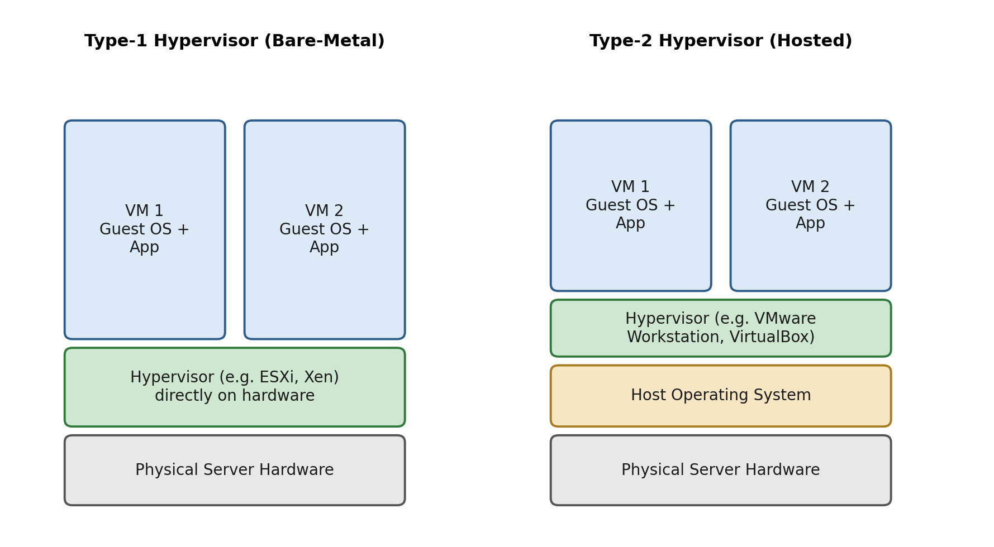
Figure 1: Architecture of Type-1 (bare-metal) versus Type-2 (hosted) hypervisor

Performance analysis
Because a Type-1 hypervisor talks to the hardware directly, it does not have to pass instructions through a host operating system first. This cuts down the number of software layers a request has to travel through, so CPU scheduling, memory access and I/O operations all happen with less delay. This is why almost every commercial cloud datacenter (AWS, Azure, Google Cloud) runs on Type-1 hypervisors. A Type-2 hypervisor, on the other hand, has to share CPU time and memory with the underlying host OS and whatever other programs are running on it. Every VM operation is filtered through the host OS kernel first, which adds overhead and makes performance far less predictable. For a datacenter running thousands of workloads at once, this overhead adds up quickly and becomes unacceptable.

Security analysis
A Type-1 hypervisor has a much smaller attack surface because it does not depend on a general-purpose host operating system that could itself carry vulnerabilities, unpatched services or malware. It can enforce strict isolation between VMs at a very low level, close to the hardware, which makes it harder for an attacker who compromises one VM to break out and reach another. A Type-2 hypervisor inherits every weakness of its host OS. If the host OS is compromised, every VM running above it is at risk, because the hypervisor itself is just one more process the attacker could target once they control the OS. For mission-critical applications such as banking systems or patient health records, this extra layer of exposure is a serious concern.

Manageability analysis
Type-1 hypervisors are built for large scale operation. They come with centralized management consoles (such as VMware vCenter) that allow an administrator to manage hundreds of hosts, automate VM placement, apply patches without downtime, and set up live migration and high availability across a cluster. Type-2 hypervisors are designed more for individual desktops, developer testing, or small labs, and generally lack this level of centralized, datacenter-wide control. Managing many Type-2 installations across many host machines quickly becomes a manual and error-prone task.

Justification and conclusion
Taking performance, security and manageability together, a Type-1 hypervisor is clearly the better choice for a cloud datacenter that hosts mission-critical applications. It gives near-native performance because it talks to hardware directly, it keeps a smaller and more controllable attack surface because it does not depend on a host OS, and it offers enterprise-grade management tools that are necessary to run a large, always-on datacenter reliably. Type-2 hypervisors remain useful for development, testing or personal use, but they are not suitable where uptime, performance and security guarantees are critical.

Question 2
A cloud provider must isolate workloads belonging to finance, healthcare, and student portals on the same hardware. Analyze how virtualization architecture supports isolation and identify two major attack surfaces.

How virtualization supports isolation
When workloads that belong to different, unrelated organizations (finance, healthcare and a student portal) are placed on the same physical server, the cloud provider depends on virtualization to keep them separated as if they were on completely different machines. This isolation happens at several levels.
- Compute isolation: The hypervisor gives each virtual machine its own virtual CPU, virtual memory space and its own kernel. One VM cannot directly read or write another VM's memory, because the hypervisor mediates every access to the physical CPU and RAM.
- Storage isolation: Virtual disks are presented to each VM as if they were dedicated physical drives, even though they may sit on a shared storage array. Access control at the hypervisor and storage-virtualization layer stops one tenant's VM from browsing or mounting another tenant's virtual disk.
- Network isolation: Software Defined Networking (SDN) creates virtual switches, VLANs or overlay networks (such as VXLAN) so that finance traffic, healthcare traffic and student portal traffic travel on logically separate networks even though they use the same physical switches and cables.
- Resource isolation: Hypervisor-level controls (CPU shares, memory limits, I/O throttling) stop one tenant from starving another tenant of resources, which also protects against a workload monopolising shared hardware.
Together, these layers create what is called a 'multi-tenant' environment, where the finance, healthcare and student workloads believe they each have a dedicated machine, while in reality they are sharing the same physical server under the hypervisor's control.

Two major attack surfaces
Even with these isolation mechanisms, a shared-hardware setup introduces attack surfaces that would not exist if each tenant had a physically separate server. Two of the most significant ones are explained below.
1. VM escape (hypervisor-level attack surface): This is when an attacker who has compromised one VM (for example, the student portal VM, which may be the least protected) finds a flaw in the hypervisor and uses it to break out of that VM and gain access to the hypervisor itself, or to another VM such as the healthcare or finance workload. Because the hypervisor sits underneath every tenant, a successful escape can compromise the entire host, not just one tenant.
2. Side-channel and shared-resource attacks (hardware-level attack surface): Because tenants share the same physical CPU cache, memory bus and sometimes the same physical network interface, an attacker's VM can sometimes infer sensitive information from a neighbouring VM by observing patterns such as cache access timing (as in Spectre or Meltdown-style attacks) or unusual resource usage, without ever formally breaking the hypervisor's isolation rules. This is especially dangerous when the neighbouring VM belongs to a healthcare or finance tenant handling regulated, sensitive data.

Recommendation
To reduce these risks, the provider should keep the hypervisor patched at all times, use hardware-assisted virtualization features (such as Intel VT-x/EPT or AMD-V with SLAT) that strengthen isolation boundaries, apply strict micro-segmentation in the network layer, and consider placing highly regulated tenants (healthcare and finance) on dedicated hosts or reserved instances rather than fully shared multi-tenant hosts, especially where compliance rules such as HIPAA or PCI-DSS apply.

Question 3
Study the following VM host utilization snapshot and recommend corrective actions: CPU 92%, memory 88%, storage I/O latency 35 ms, average VM boot time 170 s. Explain the likely bottlenecks.

Reading the snapshot
Before recommending any fix, it helps to line up each metric against what a healthy host normally looks like. The table below summarizes this comparison.
Metric | Observed Value | Typical Healthy Range | Status
CPU utilization | 92% | Below ~ 75-80% | Critical
Memory utilization | 88% | Below ~ 80-85% | High
Storage I/O latency | 35 ms | Below ~ 10-20 ms | High
Average VM boot time | 170 s | Below ~ 60-90 s | Critical
Table 1: VM host utilization snapshot compared against healthy operating ranges

Likely bottlenecks
All four numbers point to a host that is overcommitted, not to a single isolated fault. They are also connected to each other, so it is useful to explain how one bottleneck feeds into the next.
CPU bottleneck: 92% sustained CPU usage means the hypervisor's scheduler is constantly deciding which VM's vCPUs get to run next, and some VMs are left waiting in a 'ready queue'. This waiting time, called CPU ready time, directly slows down every application running on the host, and it is very likely the biggest contributor to the long boot times, since boot involves a burst of CPU activity that now has to queue behind other VMs.
Memory bottleneck: 88% memory usage is close to the point where the hypervisor may start reclaiming memory from VMs using techniques such as ballooning or swapping to disk. Swapping is extremely slow compared to RAM, so once it starts, VM performance drops sharply, and this also explains part of the slow boot behaviour, because a booting VM needs a burst of memory that may not be immediately available.
Storage I/O bottleneck: A latency of 35 ms is high; a healthy virtualized datastore is usually expected to stay in the low tens of milliseconds or less. This suggests the shared storage backend (disks, storage network or storage controller) cannot keep up with the number of read/write requests coming from all the VMs at once, which is another major reason VM boot time has stretched out, since boot involves heavy disk activity.
VM boot time: The 170-second boot time is not an independent problem; it is the visible symptom of the CPU, memory and storage pressure described above all happening together. Boot is one of the most resource-hungry moments in a VM's life cycle, so it is the first place these bottlenecks become obvious to users.

Recommended corrective actions
- Right-size the host: check the current VM-to-host consolidation ratio and migrate some VMs to other hosts, or add more physical hosts to the cluster, to bring CPU usage down to a safer range.
- Enable and tune DRS (Distributed Resource Scheduler) or an equivalent load-balancing feature, so VMs are automatically redistributed across hosts in the cluster based on real-time load.
- Increase physical RAM on the host, or reduce over-allocated memory reservations on VMs that do not actually need them, to relieve memory pressure and avoid swapping.
- Upgrade or reconfigure the storage layer: move to faster storage media (SSD/NVMe), add more storage paths or bandwidth, or use storage tiering to separate high-priority VMs from lower-priority ones.
- Set CPU and memory reservations/limits appropriately for critical VMs, so that essential workloads are guaranteed resources even under contention.
- Monitor CPU ready time and storage queue depth directly (not just raw utilization), since these are more precise indicators of contention and can guide exactly where the bottleneck is forming.
Applying these actions together should bring CPU and memory usage back into a healthy range, reduce I/O latency, and in turn bring the average VM boot time back down closer to normal levels.

Question 4
Analyze how Software Defined Datacenter architecture improves agility compared with a traditional datacenter. Support your answer with compute, storage, and network virtualization considerations.

Traditional datacenter versus SDDC
A traditional datacenter is built around fixed, dedicated hardware. A particular application is tied to a particular physical server, a particular storage array and a particular network switch configuration. If the provider wants to add capacity, move a workload, or change a network policy, someone has to physically rack new equipment or manually reconfigure devices, which takes days or weeks. A Software Defined Datacenter (SDDC) takes the opposite approach: compute, storage and network resources are abstracted away from the physical hardware through virtualization, pooled together, and then delivered and controlled entirely through software and automation. The diagram below shows the layered structure of an SDDC.
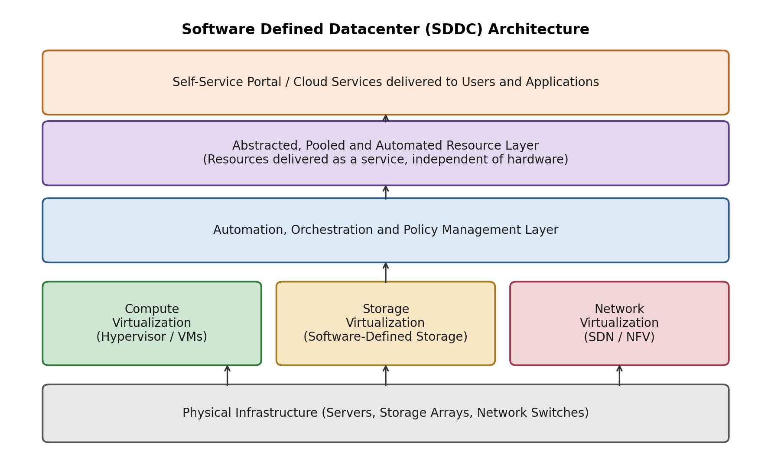
Figure 2: Layered architecture of a Software Defined Datacenter

Compute virtualization and agility
In an SDDC, physical servers are pooled and shared through hypervisors, so a virtual machine is no longer tied to one specific piece of hardware. New VMs can be provisioned in minutes from templates, and existing VMs can be live-migrated between hosts with no downtime, for example to balance load or free up a host for maintenance. In a traditional datacenter, provisioning a new application server could mean ordering hardware, waiting for delivery, racking it and manually installing an operating system, a process that takes far longer.

Storage virtualization and agility
Software Defined Storage pools capacity from many physical disks and storage arrays and presents it as flexible, policy-based virtual volumes. Storage can be resized, snapshotted, replicated or tiered (fast SSD for critical data, slower disk for archives) purely through software policy, without manual rewiring of storage hardware. In a traditional setup, resizing storage for an application often means manually provisioning LUNs on a specific array and physically connecting it, which is slow and error-prone.

Network virtualization and agility
Software Defined Networking (SDN) and Network Functions Virtualization (NFV) let administrators create, change or tear down entire virtual networks, firewalls, load balancers and routing policies through software, independent of the physical switches and cables underneath. A new application's network segment, security rules and load balancer can be spun up in minutes as code, instead of an engineer manually configuring physical switch ports and firewalls, which in a traditional datacenter could take days and is much harder to reverse safely.

Overall agility gained
Bringing compute, storage and network virtualization together under one automation and orchestration layer is what makes an SDDC agile: entire application environments, not just single servers, can be defined as code, deployed on demand, scaled elastically, and torn down safely once no longer needed. This is exactly what allows a cloud provider to offer self-service, pay-as-you-go infrastructure to customers, something a traditional, hardware-bound datacenter simply cannot do at the same speed or scale.

Question 5
A multi-cloud federation project fails due to identity mismatches between providers. Analyze the issue and propose a secure identity and privacy design using federation concepts.

Understanding the failure
Identity federation is meant to let a user log in once with their home organization's identity and then use that same identity to access resources across multiple, independently-run cloud providers, without creating and managing a separate account on every provider. The project described has failed because of 'identity mismatches', which typically happens for reasons such as these:
- Each cloud provider represents user identity differently (different attribute names, different formats for roles or group membership), so an identity that is valid and meaningful on Provider A is not understood correctly by Provider B.
- There is no single, trusted identity standard or protocol agreed upon between the providers (for example, one uses SAML while another expects OAuth2/OIDC in a different way), so tokens issued by one provider are not accepted, or are misinterpreted, by another.
- There is no common trust anchor: the providers do not have a shared way to verify that an identity token really was issued by a legitimate, trusted identity provider, so they either reject valid users or, worse, risk accepting forged tokens.
- Attribute and privacy policies differ: one provider may pass along more personal attributes than another provider is willing to accept or is legally allowed to store, which breaks the handshake or creates compliance risk.
The direct result is that users cannot move between providers, some sessions may authenticate with the wrong permissions, and there is a real risk of a mismatched identity being given more or less access than it should have, both of which are serious problems for a production cloud service.

Proposed secure identity and privacy design
A safer, standards-based federation design should be built around the following components.
1. A common identity standard: Adopt a single, well-supported federation protocol across all providers, such as SAML 2.0 or OpenID Connect (OIDC) built on OAuth 2.0. Using one agreed standard removes the translation problem between mismatched formats.
2. A central or trusted Identity Provider (IdP): Set up one authoritative Identity Provider (or a small, clearly trusted circle of IdPs) that issues signed identity tokens. Each cloud provider becomes a 'Service Provider' that trusts tokens signed by this IdP, instead of every provider maintaining its own separate user database.
3. A shared trust framework and metadata exchange: Providers exchange signed metadata (certificates, token endpoints, supported attributes) in advance, and agree on a common attribute schema, so every provider interprets a role such as 'finance-admin' or 'read-only-user' in exactly the same way.
4. Strong authentication and short-lived tokens: Require multi-factor authentication at the IdP, and issue short-lived, signed tokens (JWTs) rather than long-lived passwords being shared around, so a stolen token has a very limited window in which it can be misused.
5. Privacy-preserving attribute release: Apply the principle of least privilege to identity attributes, meaning the IdP releases only the specific attributes each provider actually needs (for example, just a role and a pseudonymous user ID) rather than full personal details, which keeps the design compliant with privacy regulations and reduces the impact of any single breach.
6. Continuous monitoring and revocation: Maintain centralized audit logging of federated logins across providers, and support fast token/session revocation at the IdP so that a compromised identity can be shut off everywhere at once, instead of provider by provider.

Conclusion
By standardizing on one federation protocol, anchoring trust in a single verified Identity Provider, agreeing on a shared attribute schema, and applying least-privilege, privacy-aware attribute release, the multi-cloud project can resolve the identity mismatches it faced while also making the overall system more secure and easier to audit than the original, uncoordinated setup.

