SIMATS ENGINEERING
ASSESSMENT TOOL 3: Reverse Engineering Task
COURSE NAME: Cloud Computing and Big Data Analytics
COURSE CODE: CSA15
COURSE OUTCOME COVERED
CO4: Analyze big data characteristics and challenges across domains including security and application aspects. (BL4)
Assessment Tool Weightage: 10%
Dave's Taxonomy: Articulation (Level 4)
Question Count: 5
Total Marks: 30
Code of Conduct
I Kanishk C (Name / Reg No: 192511278) certify that this submission is my original work and that I have adhered to the guidelines specified for this assessment.
I understand that any violation of academic integrity rules will result in disciplinary action.
Signature of the student: Kanishk C

Question 1
A recommendation engine processes user clicks, search queries, and purchases from multiple devices. Reverse engineer the probable data types, ingestion flow, and analytics stages.
Answer
Looking at a recommendation engine that uses clicks, search queries and purchases from multiple devices, it is possible to work backwards and guess how it was probably built.
Data types: this system is almost certainly handling a mix of formats. Clicks and search queries are semi-structured event data, usually JSON logs containing a user ID, timestamp, item ID and action type. Purchases are structured data, such as order ID, amount, product and date, that likely sit in a transactional database. Because the same user is tracked across multiple devices like a phone, laptop and tablet, there is also probably a user-identity mapping layer that stitches together sessions from different devices into one single user profile.
Ingestion flow: each click, search or purchase event is generated on the user's device or app and sent to the backend almost instantly. Given the volume of events a large platform would generate, it is likely they use a message queue or streaming system such as Kafka to collect all these events without dropping any, even during traffic spikes like a sale event. From there, events probably branch into two directions, one going to a fast, real-time processing path, and one going into a data lake for long-term storage and batch analysis.
Analytics stages: on the real-time side, the system likely does lightweight processing to update "you might also like" suggestions almost instantly after a click. On the batch side, the full history of clicks, searches and purchases is probably used to train a proper machine learning recommendation model overnight, using techniques such as collaborative filtering, which recommends things similar users liked, or content-based filtering, which recommends items similar to what a user already viewed. The trained model is then deployed to a serving layer, so recommendations shown to a user come from a fast lookup instead of running the whole model live every single time.
The likely design choice here is a two-speed system, a real-time layer for instant reactions and a batch layer for deeper, more accurate learning, because relying on only one of the two would either be too slow to react, or too shallow to feel genuinely personalised.
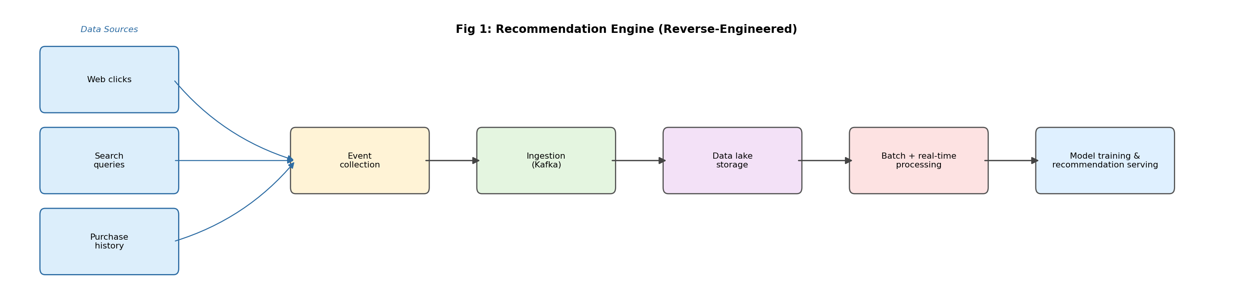
Fig 1: Recommendation engine, reverse engineered

Question 2
A ride-sharing company displays live traffic heatmaps and demand forecasts. Reverse engineer the likely distributed storage and processing backbone behind the system.
Answer
A ride-sharing app showing live traffic heatmaps and demand forecasts has to be built around location data that changes constantly, so the backbone is almost certainly designed for streaming, not batch processing.
Likely data flow: every driver's app is probably sending GPS location pings every few seconds, and every rider's app is sending ride requests. This means huge volumes of small, frequent updates are hitting the system continuously, especially in busy cities. To handle this, the system likely uses a streaming ingestion layer, something like Kafka, that can absorb this constant stream of tiny location updates without falling behind.
Processing backbone: once the location data is ingested, it probably passes through a stream processing engine such as Apache Spark Streaming or Apache Flink, since these tools are built to do calculations, like counting how many drivers are in an area or how demand is trending, on data that is still flowing in, rather than waiting for it to be fully collected first.
Storage: for something like a live heatmap, the system needs to read and update location data extremely fast, so a distributed NoSQL database such as Cassandra, which is built for fast writes and reads at scale, is a likely choice, rather than a traditional relational database, which would struggle under this kind of write volume. Older or historical trip data, used for demand forecasting models, is probably kept separately in a distributed file system like HDFS or a cloud data lake, since that data is queried less often but in much larger batches.
Forecasting: the demand forecast part likely runs as a separate batch or near-real-time job that looks at historical patterns, such as day of week, time, weather and local events, combined with current live data, and produces predictions that are refreshed every few minutes rather than recalculated non-stop.
So the probable design decision was to split the system into a fast, always-on streaming path for the live heatmap, and a slower, pattern-based path for demand forecasting, because trying to do deep forecasting on every single GPS ping would be far too slow and simply unnecessary.
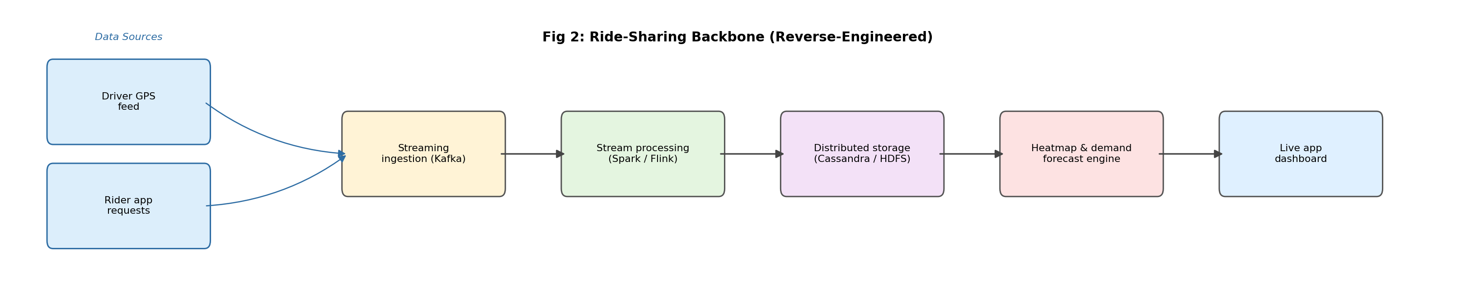
Fig 2: Ride-sharing backbone, reverse engineered

Question 3
A fraud detection dashboard flags suspicious card transactions in near real time. Reverse engineer the probable big data security, streaming, and alerting mechanisms used.
Answer
A fraud detection dashboard that flags suspicious card transactions in near real time is built around one main priority: speed, because a fraud check that takes minutes instead of seconds is basically useless.
Streaming mechanism: transactions almost certainly flow through a real-time ingestion and processing pipeline the moment a card is swiped or an online payment is made. This likely uses a message queue such as Kafka to pass transaction events instantly to a scoring engine, rather than storing them first and analysing later in a batch job.
Scoring and detection: the system probably combines two approaches together. First, a rule-based engine checks for obvious red flags, like a transaction happening in two different countries within minutes, or an unusually large amount compared to the customer's normal spending. Second, a machine learning model, trained on historical fraud and non-fraud transactions, scores each transaction with a fraud probability, picking up patterns that fixed rules might miss. Combining both is a common real-world choice, because rules catch known patterns instantly, while the ML model catches new or more subtle fraud patterns.
Alerting: when a transaction crosses a risk threshold, the system likely triggers an immediate alert. This could mean blocking the transaction automatically, or sending it to a human fraud analyst's queue for a quick review, depending on how confident the system is in its own score.
Security: given that this handles live card data, the pipeline almost certainly encrypts data both in transit and at rest, masks or tokenises the card number so raw numbers are rarely seen even internally, and keeps a detailed audit log of every flagged transaction and every action taken on it, both for compliance and for improving the model later.
The likely reasoning behind this design is that no single method, rules alone or machine learning alone, is good enough on its own. Rules are fast but rigid, and machine learning is adaptive but can be slower or need regular retraining, so combining them on top of a low-latency streaming pipeline gives the best balance of speed and accuracy.
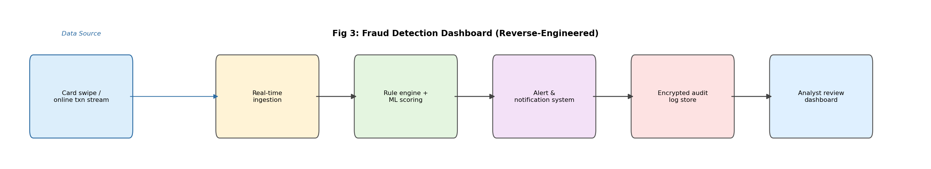
Fig 3: Fraud detection dashboard, reverse engineered

Question 4
A social media platform stores videos, text comments, hashtags, and user engagement metrics. Reverse engineer how structured and unstructured data are probably managed together.
Answer
A platform storing videos, text comments, hashtags and engagement metrics together has to deal with formats that are almost opposites of each other, huge binary video files versus small, frequent text and metric updates, so it likely does not store everything in one single place.
Likely storage split: videos are large, unstructured files, so they are almost certainly kept in object storage, similar to what a platform like YouTube or Instagram would use, which is built to store and stream huge files efficiently without needing to search inside them row by row. Text comments and hashtags, on the other hand, are smaller pieces of data that need to be searched and filtered constantly, such as searching a hashtag or showing comments under a post, so they are likely stored in a NoSQL database or a search-optimised index like Elasticsearch, which is built for fast text search and flexible fields. Engagement metrics, such as likes, shares and views, are numeric and update extremely frequently, so they are probably kept in a fast key-value or NoSQL store that can handle constant small updates, possibly kept separate from the comments database.
Bringing it together: even though these are stored in different systems, the app still needs to show a video with its comments, hashtags and like count all together on one screen. This means there is likely a unified analytics or serving layer that pulls from all these different stores and combines them into a single response, so the underlying split is completely invisible to the end user.
Design reasoning: the probable decision here was driven by differences in access patterns. Video needs bulk storage and streaming speed, comments need search and filtering, and metrics need extremely fast, frequent updates. Trying to force all three into one single type of database would likely make at least one of these three much slower than it needs to be, so splitting storage by data type is the more sensible engineering choice.
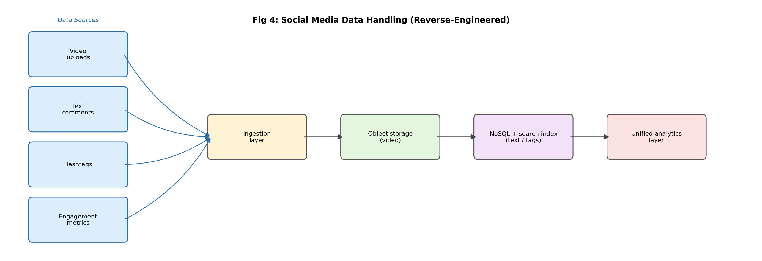
Fig 4: Social media data handling, reverse engineered

Question 5
A manufacturing IoT platform collects machine logs and maintenance events from many plants. Reverse engineer the likely integration tools, storage strategy, and analytics path.
Answer
A manufacturing IoT platform collecting machine logs and maintenance events from many plants is a case of data being generated at the edge, on the factory floor, but needing to be understood at a central level, across all plants together, so the design is likely built around that gap.
Integration tools: since each plant may have different machines, sensors and even different software systems, there is likely a data integration layer, using tools such as Apache NiFi or Kafka Connect, that standardises data coming from many different machine types into one common format before it goes anywhere else. Edge gateways at each plant probably do some basic filtering or batching first, since sending every single raw sensor reading over the network from every plant, all the time, would be wasteful and slow.
Storage strategy: given that this is machine log and sensor data, high in volume and not always neatly structured, a data lake approach, using something like HDFS or a cloud-based lake, is a likely choice, since it can store raw logs cheaply and does not force a rigid structure onto the data before it is even properly understood. Maintenance event records, which are more structured, containing a machine ID, issue type, date and technician, are probably kept in a more traditional structured store, or a well-defined section of the data lake, since these need to be queried more like normal database records.
Analytics path: with data centralised, the platform can run both batch analysis, such as a monthly report on which machines break down most often, and predictive analytics, using sensor patterns to predict a machine failure before it actually happens, often called predictive maintenance. This likely uses historical sensor readings paired with past maintenance events as training data for a model that flags at-risk machines early.
The probable reasoning behind this design is that manufacturing data is naturally distributed across many plants and many machines, but the real value comes from combining it centrally, spotting patterns across plants that a single plant's data alone could never reveal. This is likely why integration and centralised storage were prioritised over keeping each plant's data separate.
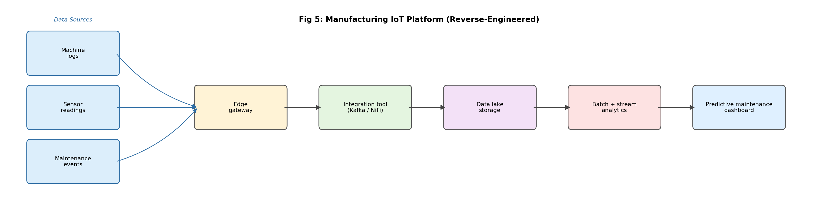
Fig 5: Manufacturing IoT platform, reverse engineered

