SIMATS ENGINEERING
ASSESSMENT TOOL 2: Industry Problem Solving Task
COURSE NAME: Cloud Computing and Big Data Analytics
COURSE CODE: CSA15
COURSE OUTCOME COVERED
CO4: Analyze big data characteristics and challenges across domains including security and application aspects. (BL4)
Assessment Tool Weightage: 20%
Dave's Taxonomy: Articulation (Level 4)
Question Count: 5
Total Marks: 40
Code of Conduct
I Kanishk C (Name / Reg No: 192511278) certify that this submission is my original work and that I have adhered to the guidelines specified for this assessment.
I understand that any violation of academic integrity rules will result in disciplinary action.
Signature of the student: Kanishk C

Question 1
An e-commerce company receives clickstream, transaction, and review data from millions of users daily. Propose a big data analytics pipeline and explain how the 5Vs influence architecture design.
Answer
An e-commerce company like this deals with three very different kinds of data every single day - clickstream data (what users click, search, and browse), transaction data (actual purchases and payments), and review data (text feedback, ratings, and comments). To handle all this at scale, the pipeline needs to be built in layers.
The first layer is ingestion. Since millions of users are generating events every second, a streaming tool like Apache Kafka works well here because it can absorb high-speed data without losing anything. Clickstream events come in continuously, while transaction and review data may arrive a little slower but still needs to be captured in near real time.
Once the data is ingested, it goes into a data lake, usually something like HDFS or a cloud storage system like Amazon S3. This is where raw data of all types is stored cheaply and can be processed later without forcing a fixed structure on it right away.
The processing layer is where tools like Apache Spark come in, since Spark can run both batch jobs (like nightly sales reports) and streaming jobs (like showing what is trending right now) on the same data lake. After processing, the cleaned data goes into analytics and machine learning models, which can do things like personalised recommendations, fraud checks, and customer segmentation. Finally, the output reaches dashboards for business teams and recommendation panels for customers.
Now, why do the 5Vs matter so much here?
- Volume: millions of users mean the storage and ingestion layers must scale across many machines, not run on a single server.
- Velocity: clickstream data especially demands real-time or near real-time processing, so a batch-only design would be too slow to be useful.
- Variety: clickstream is semi-structured JSON, transactions are structured rows and columns, and reviews are unstructured text, so the architecture has to support multiple storage formats, not just one relational database.
- Veracity: reviews and clickstream data can be noisy or even fake, such as bot clicks or spam reviews, so the pipeline needs cleaning and validation steps before the data reaches analytics.
- Value: not all data is equally useful, so the design should give more processing priority to high-value data, like purchase patterns, while still keeping the rest for later analysis.
In short, the 5Vs are not just theory here. They directly decide which tools get picked and how the pipeline is laid out, right from ingestion all the way to the final dashboard.
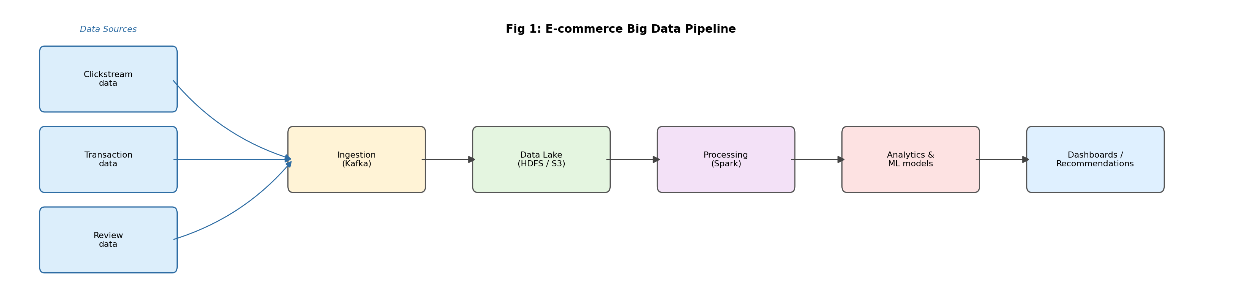
Fig 1: Proposed big data pipeline for the e-commerce platform

Question 2
A healthcare organization collects structured patient records, semi-structured insurance claims, and unstructured medical images. Design an approach to manage and secure this data ecosystem.
Answer
A hospital or healthcare organisation is a tricky case because it handles three very different data types at once - structured patient records such as name, age, diagnosis codes and lab values stored in tables, semi-structured insurance claims that come as XML or JSON documents with varying fields depending on the insurer, and unstructured medical images like X-rays, MRIs and CT scans, which are large binary files.
Because these are so different, one single database will not work for all three. A practical approach is to split the storage by type. Patient records go into a relational database, since they need strong consistency and easy querying. Insurance claims, which vary in structure, fit better in a NoSQL document store like MongoDB, which can handle flexible schemas. Medical images are best kept in object storage, similar to a PACS system or cloud object storage, because they are large files that do not need row-level querying, just fast and reliable retrieval.
All three systems then feed into a common data integration layer, so that a doctor or analyst can pull a combined view of a patient, records, claims and scans together, without needing to know where each piece physically lives.
Security is the part that really cannot be compromised in healthcare, since this kind of data falls under strict privacy regulations. The approach should include the following points.
- Encryption both at rest, so stored files are unreadable if stolen, and in transit, so data moving between systems is protected.
- Role-based access control, so a billing clerk cannot see medical images and a radiologist cannot see full billing details. Access is limited to exactly what each role needs.
- Audit logging, so every access to a patient record is tracked, which matters both for security and for legal compliance.
- De-identification or masking of data when it is used for research or analytics, so patient identity stays protected even during internal analysis.
- Regular backups and a disaster recovery plan, since healthcare data loss can directly affect patient safety, not just business continuity.
Overall, the ecosystem needs a mix of the right storage type for each data format, plus a security layer that treats every access point, whether it is a database, an API or a file share, as something that needs to be locked down and logged.
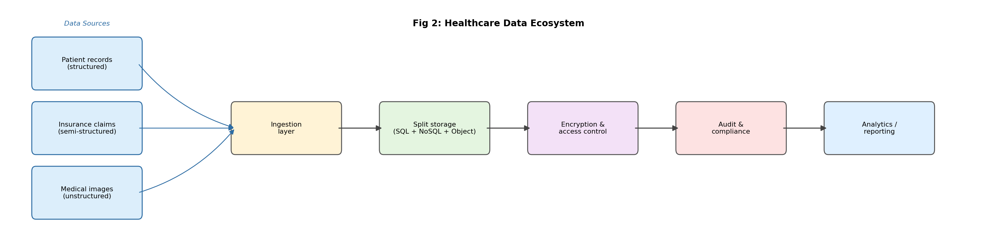
Fig 2: Data management and security design for the healthcare ecosystem

Question 3
A telecom company wants to detect churn patterns using high-volume customer interaction data. Identify the big data challenges and recommend suitable analytics and integration strategies.
Answer
Telecom companies sit on a huge amount of customer interaction data, including call logs, data usage, app usage, customer support tickets, billing history and even network quality data. The goal here is to spot patterns that show a customer is likely to leave, generally called churn, before they actually do.
The big data challenges in this case are as follows.
- Volume and velocity: millions of customers generate call detail records and usage logs every minute, so the system has to process high-speed streaming data, not just batch reports run once a day.
- Data variety: usage logs, support tickets, billing records and app behaviour data all look completely different, so combining them into one usable dataset takes real integration work.
- Data quality: dropped calls, incomplete logs or duplicate records caused by network issues can throw off predictions if the data is not cleaned properly first.
- Real-time decision making: by the time a monthly batch report shows a customer is at risk, that customer may have already switched to another provider, so the system needs to flag risk early enough for the company to act.
For the analytics and integration strategy, a good approach would be the following.
- Use a streaming ingestion tool such as Kafka to bring in call records and app usage in near real time.
- Build a feature engineering step that turns raw logs into meaningful signals, like a drop in usage minutes, a rise in complaint tickets, or a change in payment behaviour.
- Train a machine learning churn prediction model, such as a gradient boosting or random forest model, on these features, since churn prediction is basically a classification problem.
- Feed the output into a retention system, so that when a customer is flagged as high risk, the customer service or marketing team can automatically trigger an offer or a support call.
- Integrate all data sources through one central data pipeline, so the model always sees the full picture instead of only one type of data, for example only billing but not support tickets.
The key point is that churn detection is not just a modelling problem. It is equally an integration and speed problem, since old, disconnected or slow data will always lead to late, and mostly useless, predictions.
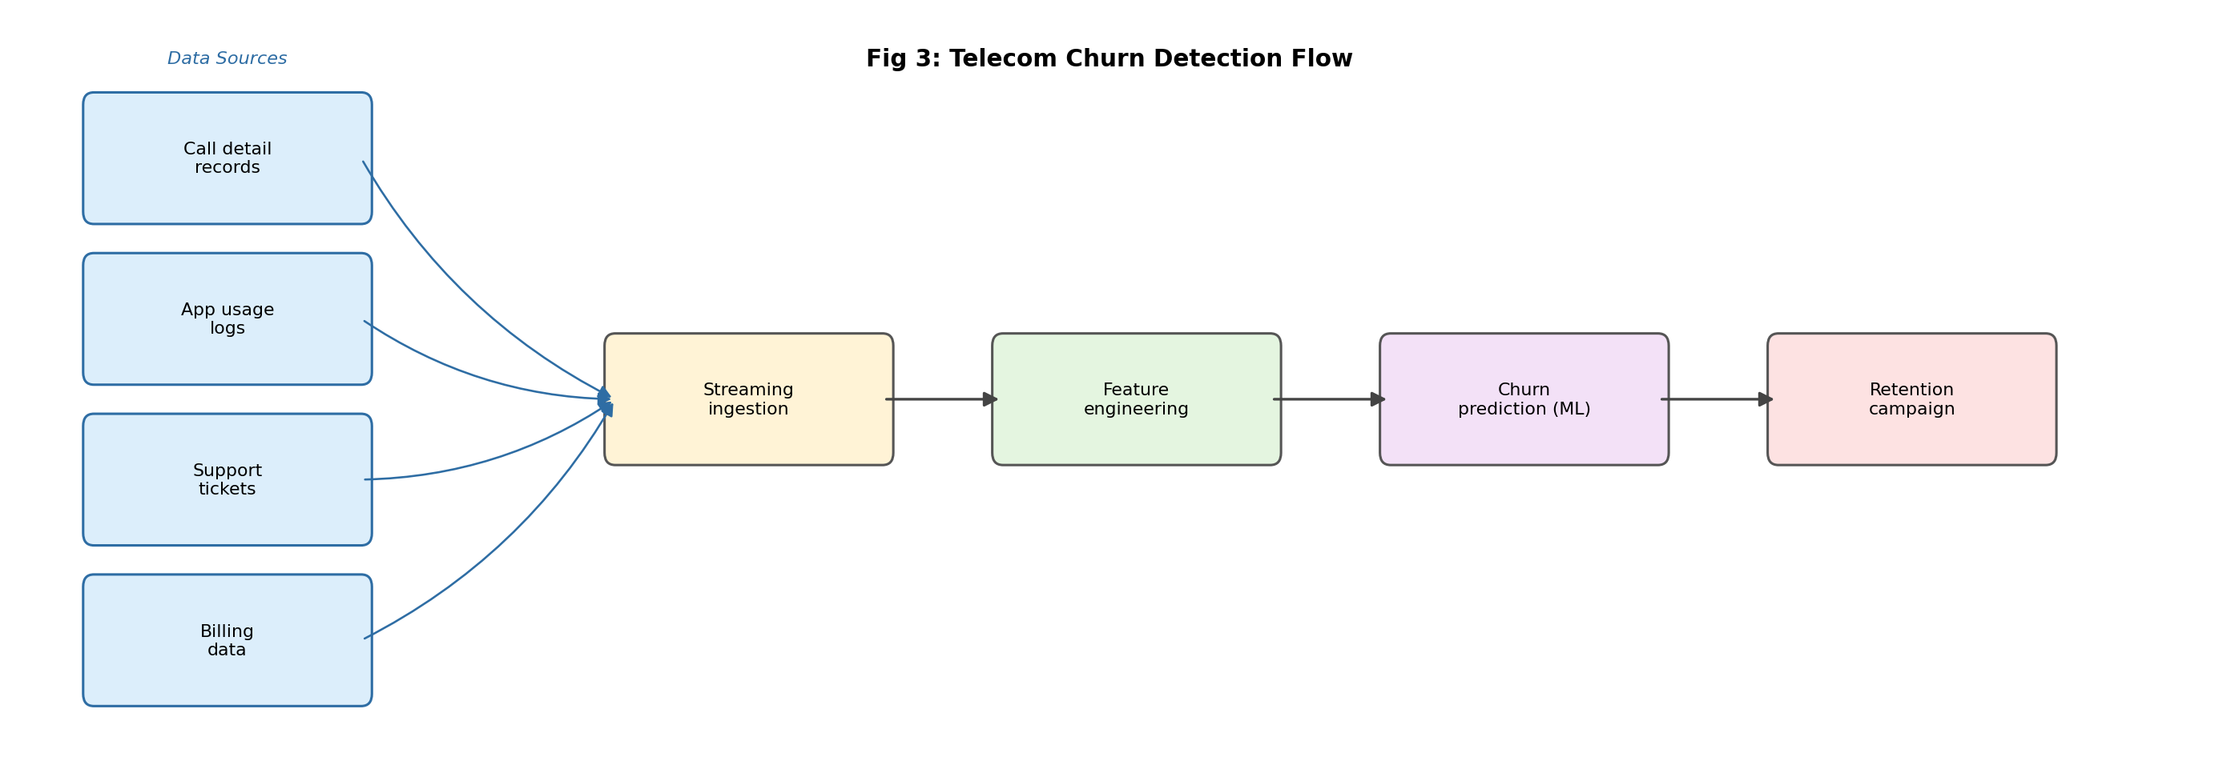
Fig 3: Telecom churn detection flow

Question 4
A smart city project generates sensor streams from traffic, air quality, and surveillance systems. Explain how distributed file systems and data integration tools can support large-scale analysis.
Answer
A smart city project generating traffic, air quality and surveillance sensor data is a classic example of high-volume, high-velocity streaming data coming from thousands of physical devices spread across a wide area, rather than from one central source.
The first thing to understand is that this kind of data cannot be sent directly to one central server for processing, because the sheer number of sensors and the constant stream would overwhelm any single machine. This is where a distributed file system, like the Hadoop Distributed File System, becomes important. HDFS breaks large data files into blocks and spreads them across many machines in a cluster, so no single machine becomes a bottleneck, and if one machine fails, the data is still safe because it is replicated on others.
Before the data even reaches long-term storage, it needs to pass through data integration tools that combine and route it properly.
- Apache Kafka can act as the messaging backbone, collecting live sensor streams such as traffic counts, air quality readings and camera feeds, and passing them to different consumers.
- Apache NiFi or a similar ETL tool can handle the transformation step, cleaning up sensor noise, converting units, and tagging each reading with location and time before it is stored.
- Edge gateways placed near the sensors themselves can do some basic filtering, like ignoring obviously faulty readings, before sending data over the network, which reduces load on the central system.
Once the data lands in HDFS or a similar distributed store, large-scale analysis becomes possible using tools like Spark, which can run across the whole cluster instead of just one server. This means the city can, for example, analyse a full day of traffic data across every junction at once, or correlate air quality dips with traffic congestion, something that would be far too slow on a single machine.
So the overall design principle is simple: spread the storage across many machines using a distributed file system, and use integration tools to properly clean, route and combine the different sensor streams before they reach that storage. This combination is what actually makes city-wide, large-scale analysis possible.
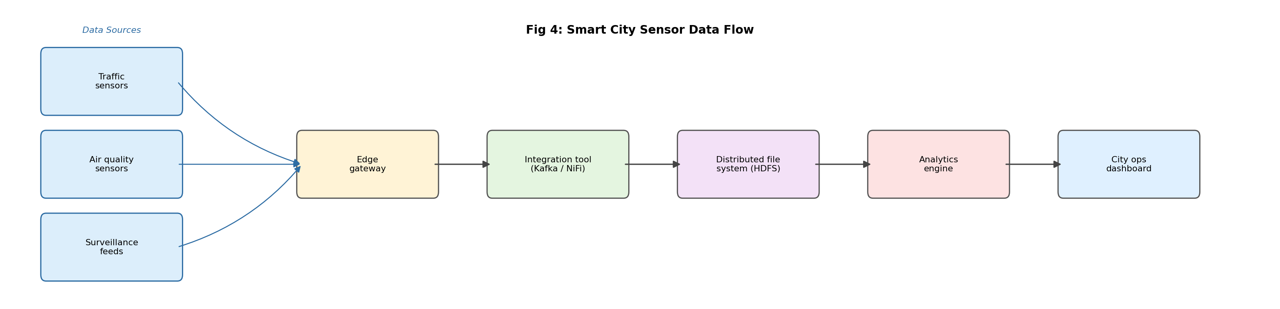
Fig 4: Smart city sensor data flow

Question 5
A financial analytics firm must comply with strict privacy requirements while processing high-velocity transaction data. Design a secure big data solution and justify the controls chosen.
Answer
A financial analytics firm processing high-velocity transaction data has two goals that can sometimes pull in different directions: process data fast enough to catch fraud or generate insights in real time, and also follow strict privacy rules at every single step.
A secure design for this would look like the following.
- Encrypted ingestion: all transaction data should be sent over encrypted channels the moment it leaves the source, such as an ATM, a POS terminal or a banking app, so nobody can intercept raw data on the way in.
- Tokenisation and masking: sensitive fields like card numbers or account numbers should be replaced with tokens right at ingestion, so people working on later stages of the pipeline never see the real numbers unless they have special clearance.
- Encrypted storage: once data reaches the data lake or warehouse, it should be encrypted at rest and separated into zones, such as a raw zone, a cleaned zone and an analytics zone, so access can be controlled zone by zone.
- Strict access control: role-based access control means an analyst building a spending-pattern dashboard only sees masked data, while only a small, audited team can ever access raw identifiable data, and only when there is a genuine business reason.
- Audit logging: every single access, query or export of the data should be logged, so if something goes wrong there is a full trail of who touched what and when.
- Real-time processing with privacy built in: a stream processor such as Spark Streaming or Flink can apply masking rules as data flows through, so speed is not sacrificed for privacy, and the two happen together rather than one after the other.
The reasoning behind these controls is straightforward. Tokenisation and masking protect customer identity even if a breach happens somewhere downstream. Encryption protects data both while it is moving and while it is stored, covering both attack scenarios. Access control and audit logs satisfy compliance requirements and also make it possible to detect insider misuse. Zone separation means a compromise in one area, such as a public-facing dashboard, does not automatically expose raw sensitive data.
This kind of layered design lets the firm keep processing transactions at high speed while still meeting the privacy obligations that financial data will always carry.
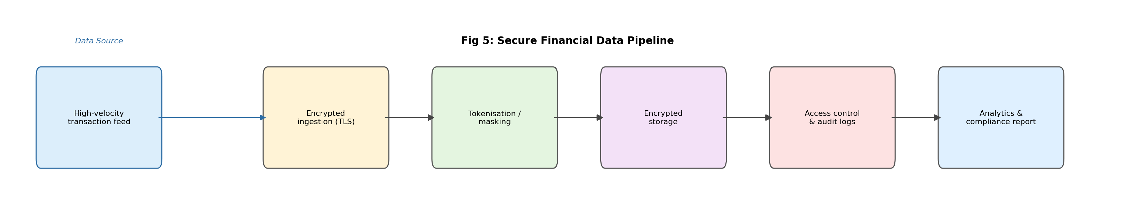
Fig 5: Secure big data pipeline for the financial analytics firm

