Matériels à acheter : 7 ESP32, module Sim, carte Sim, actionneurs relais, capteurs lumière, présence, température, fumée

Propositions de 3 fournisseurs :

**ESP32, fournisseur 1 :** [DuoMi Store](https://www.aliexpress.com/store/5361253)

**(Se vend par pièce)**

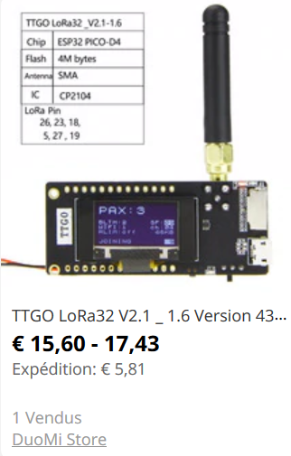

<https://fr.aliexpress.com/item/4000295854397.html?spm=a2g0o.productlist.0.0.18f2406e7r8TGM&algo_pvid=d9bb1d4e-d52a-4e30-a3b5-daab9c081da4&algo_expid=d9bb1d4e-d52a-4e30-a3b5-daab9c081da4-25&btsid=1f0a36c9-7848-4fdf-9d3a-7f62d625a70f&ws_ab_test=searchweb0_0,searchweb201602_9,searchweb201603_52>

**ESP32, fournisseur 2 :** Lilygo Store

**(Se vend par pièce)**

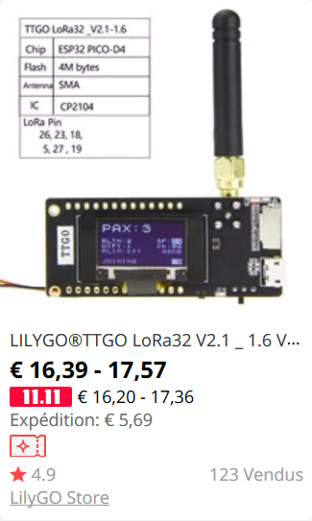

<https://fr.aliexpress.com/item/32872078587.html?spm=a2g0o.productlist.0.0.18f2406eMbgVRE&algo_pvid=6c6ea2e8-1967-4864-b982-1caadb639762&algo_expid=6c6ea2e8-1967-4864-b982-1caadb639762-8&btsid=e4484194-088a-4885-97d8-de8068a81958&ws_ab_test=searchweb0_0,searchweb201602_9,searchweb201603_52>

**ESP32, fournisseur 3 :** [Development board factory Store](https://www.aliexpress.com/store/5244071)

**(Se vend par pièce)**

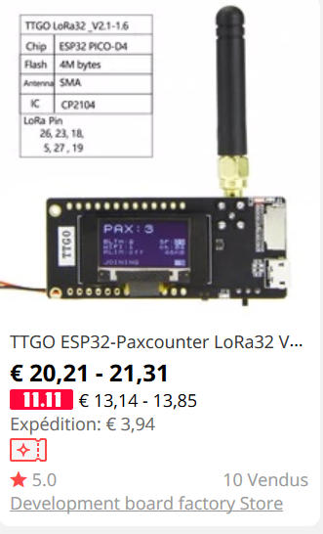

<https://fr.aliexpress.com/item/4000119208093.html?spm=a2g0o.productlist.0.0.18f2406eMbgVRE&algo_pvid=6c6ea2e8-1967-4864-b982-1caadb639762&algo_expid=6c6ea2e8-1967-4864-b982-1caadb639762-13&btsid=e4484194-088a-4885-97d8-de8068a81958&ws_ab_test=searchweb0_0,searchweb201602_9,searchweb201603_52>

Module Sim pour ESP32, 3 founisseurs :

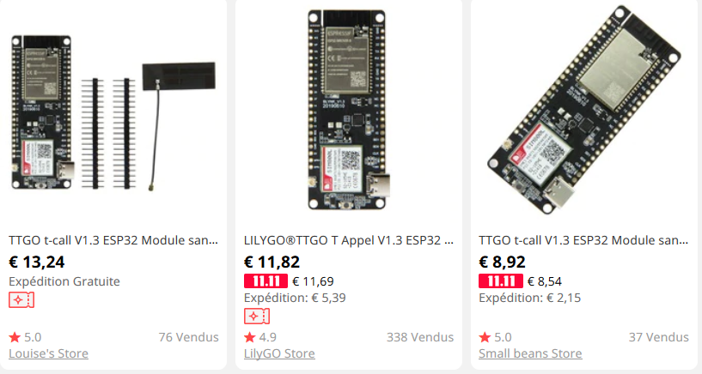

1. <https://fr.aliexpress.com/item/4000073689363.html?spm=a2g0o.productlist.0.0.44e55728WnzIsc&algo_pvid=bfdab69b-476a-421f-8d6a-645dd23837a2&algo_expid=bfdab69b-476a-421f-8d6a-645dd23837a2-0&btsid=5b23ef86-0e9f-4996-9910-d0b852dbfcea&ws_ab_test=searchweb0_0,searchweb201602_9,searchweb201603_52>
2. <https://fr.aliexpress.com/item/33045221960.html?spm=a2g0o.productlist.0.0.44e55728WnzIsc&algo_pvid=bfdab69b-476a-421f-8d6a-645dd23837a2&algo_expid=bfdab69b-476a-421f-8d6a-645dd23837a2-1&btsid=5b23ef86-0e9f-4996-9910-d0b852dbfcea&ws_ab_test=searchweb0_0,searchweb201602_9,searchweb201603_52>
3. <https://fr.aliexpress.com/item/4000049948202.html?spm=a2g0o.productlist.0.0.44e55728WnzIsc&algo_pvid=bfdab69b-476a-421f-8d6a-645dd23837a2&algo_expid=bfdab69b-476a-421f-8d6a-645dd23837a2-2&btsid=5b23ef86-0e9f-4996-9910-d0b852dbfcea&ws_ab_test=searchweb0_0,searchweb201602_9,searchweb201603_52>

Matériels à acheter : 7 ESP32, module Sim, carte Sim, actionneurs relais, capteurs lumière, présence, température, fumée.

**Capteurs : (3 x de chaque capteur)**

|  |  |
| --- | --- |
| Capteur de température | https://www.planete-domotique.com/capteur-de-temperature-ds18b20.html?adwords=1#page=1 |
| https://euro-makers.com/fr/capteurs-detecteurs-arduino/1909-capteur-de-temperature-et-humidite-arduino-raspberry-dht11-integre-3701172908527.html?utm_campaign=google-merchant&utm_source=google-merchant-module&utm_medium=&gclid=CjwKCAiAh5_uBRA5EiwASW3IaqMVqPj0HNHDNhsZ6KGvEJF65G4TmIs8LUYAiFxouuTEQQoxVfQqYBoC4uUQAvD_BwE |
| https://fr.farnell.com/texas-instruments/lm35dz-nopb/temp-sensor-0-4-c/dp/3124182?MER=sy-me-pd-mi-alte |
| Capteur de fumée | https://www.cdiscount.com/bricolage/securite-domotique/capteur-de-gaz-fumee-iduino-me079-1-pc-s/f-166200501-auc4053199514526.html?idOffre=352344607&ef_id=CjwKCAiAh5_uBRA5EiwASW3IamgGEJ5CLfd2OBsI7x5vWuowiEaykUPCkAcDRdY_IgwVmIQ8VXw77hoC5QQQAvD_BwE:G:s&cid=search_pla&cm_mmc=PLA!COR!BRI!MP!2047684499!m109540188_pAUC4053199514526-352344607_&gclid=CjwKCAiAh5_uBRA5EiwASW3IamgGEJ5CLfd2OBsI7x5vWuowiEaykUPCkAcDRdY_IgwVmIQ8VXw77hoC5QQQAvD_BwE |
| https://fr.shopping.rakuten.com/offer/buy/3582824750/capteur-de-gaz-fumee-iduino-me084-1-pc-s.html?bbaid=4359446983&t=180114&xtatc=PUB-%5Bggp%5D-%5Bbricolage%5D-%5Bdomotique%5D-%5B3582824750%5D-%5Bneuf%5D-%5BCONRAD_SAS%5D&ptnrid=pt%7C79136202443%7Cc%7C53512532603%7C3582824750&ptnrid=s4uv7vL66_dc|pcrid|53512532603|pkw||pmt||targetids|aud-473968998433:pla-79136202443|adgroupid|14478400523&gclid=CjwKCAiAh5_uBRA5EiwASW3IatJwgHtvtyLUak0umcJ-_0qokKfr9sEh2zDMCWATr7rDfhC5fh-kShoCJgAQAvD_BwE |
| https://euro-makers.com/fr/capteurs-detecteurs-arduino/2968-sen-mq2.html?utm_campaign=google-merchant&utm_source=google-merchant-module&utm_medium=&gclid=CjwKCAiAh5_uBRA5EiwASW3IarZcs2u_E3b5aQTU7hWVfxcU08OoziXc1AwaPUrPm0_OVLvOgytGNxoCZ_cQAvD_BwE |
| Capteur de présence | https://www.manomano.fr/detecteur-de-mouvement-1373?g=1&referer_id=687129&gclid=CjwKCAiAh5_uBRA5EiwASW3IapeVyuczy6wZ6TEf51spJqcDXwCqBTqyIpsgyU2xFfElJxdzVbFxchoCQ6wQAvD_BwE&model_id=4346029 |
| https://www.manomano.fr/detecteur-de-mouvement-1373?g=1&referer_id=687129&gclid=CjwKCAiAh5_uBRA5EiwASW3IapeVyuczy6wZ6TEf51spJqcDXwCqBTqyIpsgyU2xFfElJxdzVbFxchoCQ6wQAvD_BwE&model_id=4346029 |
| https://www.manomano.fr/detecteur-de-mouvement-1373?g=1&referer_id=687129&gclid=CjwKCAiAh5_uBRA5EiwASW3IaiAN9I7iPfYU3pgIk_44YD2aGcmPpXlRfGy91JtIoqVpKl9H9WlkBRoCDGcQAvD_BwE&model_id=4682227 |
| Capteur de lumière | https://www.cdiscount.com/bricolage/electricite/module-de-capteur-de-lumiere-capteur-d-intensite-l/f-1661416-tem6472063250557.html?idOffre=323470664&ef_id=CjwKCAiAh5_uBRA5EiwASW3Ialk049Fp1e6sk-uAUxFZJvFeg1y9Y3eotIar9GpVdgQd-BfFgYEDchoCV6sQAvD_BwE:G:s&cid=search_pla&cm_mmc=PLA!COR!AUT!MP!6471461997!m113087406_pTEM6472063250557-323470664_&gclid=CjwKCAiAh5_uBRA5EiwASW3Ialk049Fp1e6sk-uAUxFZJvFeg1y9Y3eotIar9GpVdgQd-BfFgYEDchoCV6sQAvD_BwE |
| https://www.reichelt.com/fr/fr/arduino-capteur-de-lumi-re-pour-rainure-gl5528-grv-light-sens-p191152.html?PROVID=2788&gclid=CjwKCAiAh5_uBRA5EiwASW3IahcKoHXVMtgrtXsgOClKXyc14E7xaaruiXlGZIOUTLv0J2atig0JbxoCntEQAvD_BwE&&r=1 |
| https://www.robotshop.com/eu/fr/capteur-lumiere-v12-grove.html |

**Actionneurs : (3 x de chaque actionneur)**

|  |  |
| --- | --- |
| Module SIM Arduino | <https://www.amazon.fr/lzndeal-SIM800L-Panneau-Quad-Band-Arduino/dp/B073TF2QKL/ref=pd_sbs_107_5/257-7939076-8316548?_encoding=UTF8&pd_rd_i=B073TF2QKL&pd_rd_r=62aa800f-c340-4711-bb32-5e3ad3e0aa9b&pd_rd_w=W6v90&pd_rd_wg=l87DE&pf_rd_p=26d54ac2-ee81-4c62-8302-1e18ced12245&pf_rd_r=NPMDA7W2X37D84NVQCCZ&psc=1&refRID=NPMDA7W2X37D84NVQCCZ#customerReviews> |
| <https://www.amazon.fr/SIM800L-Wireless-Quad-Band-Antenna-Quadband/dp/B07LH3PLB2/ref=sr_1_3?keywords=Sim900&qid=1573663950&sr=8-3> |
| Relais | https://www.amazon.fr/Elegoo-Optocoupleur-%EF%BC%94-Channel-Arduino-Raspberry/dp/B06XKST8XC/ref=asc_df_B06XKST8XC/?tag=googshopfr-21&linkCode=df0&hvadid=186819215161&hvpos=1o1&hvnetw=g&hvrand=11068009241101681829&hvpone=&hvptwo=&hvqmt=&hvdev=c&hvdvcmdl=&hvlocint=&hvlocphy=1006094&hvtargid=pla-349480060511&psc=1 |
|  |
|  |

<https://www.banggood.com/fr/SIM900-Quad-band-GSM-GPRS-Shield-Development-Board-For-Arduino-p-964229.html?gmcCountry=FR&currency=EUR&createTmp=1&utm_source=googleshopping&utm_medium=cpc_bgs&utm_content=frank&utm_campaign=ssc-fr-all-0716&ad_id=367115636049&gclid=CjwKCAiA8K7uBRBBEiwACOm4dxBYttCH0xNafK1ip46UErsY1g4JMoPl3E52ypcvLKEUYVSDEMJkNhoCelwQAvD_BwE&cur_warehouse=CN>

**Pompe à eau 5V : (3 x)**

|  |  |
| --- | --- |
| Pompe à eau | <https://fr.banggood.com/Machifit-JT80SL-DC-3-6V-Water-Pump-120LH-Ultra-quiet-Micro-Horizontal-Submersible-Mini-Water-Pump-p-1348608.html?gmcCountry=FR&currency=EUR&createTmp=1&utm_source=googleshopping&utm_medium=cpc_bgcs&utm_content=frank&utm_campaign=pla-frg-brand-top-pc&gclid=CjwKCAiA8K7uBRBBEiwACOm4d3mBFSJgyGQPFVdKzBcyR0qW2u9eiCpKiuo1Sr69-D_BKfDheO763xoCA8MQAvD_BwE&cur_warehouse=CN> |
| <https://www.amazon.fr/pompe-submersible-faible-bruit-moteur/dp/B07CTKTS7C/ref=alp_dpwidget_a_w_?th=1&psc=1&smid=A1R7OR2ZYBFKVO> |
| <https://www.cdiscount.com/auto/camping-car-caravaning/dc4v-6v-150l-h-mini-pompe-a-eau-micro-pompe-de/f-13330-auc0739665393157.html?idOffre=427629782&ef_id=CjwKCAiA8K7uBRBBEiwACOm4d857Zzmd8MP0irf2HOG9MdGC5fmAag0CLjkAA7fiEhm2CaShRKFUFhoCfc4QAvD_BwE:G:s&cid=search_pla&cm_mmc=PLA!COR!AUT!MP!6471660695!m142764153_pAUC0739665393157-427629782_&gclid=CjwKCAiA8K7uBRBBEiwACOm4d857Zzmd8MP0irf2HOG9MdGC5fmAag0CLjkAA7fiEhm2CaShRKFUFhoCfc4QAvD_BwE> |