- Consider a system for administering the lending of books at a university library. a person must be a member of the university’s community and must be in good standing – that is, not have any outstanding fines or overdue books – to borrow books. a book may be borrowed for up to two weeks at a time. a book loan may be renewed if the book is returned before the loan’s due date and if no other library member has expressed an interest in borrowing the book. if a book is returned after the loan’s due date, the borrower will be a charged a fine of $1 for each late day. fines are paid to the library staff at the circulation desk, where books are returned. heavily-used books may be put on reserve, meaning that members can read them only in the library and cannot borrow them.

Provide a use-case diagram that depicts only those use cases that are initiated by library members.

- Alice in the human resources department at the Cho Manufacturing plant is constantly being asked by employees how much is taken out of their paychecks for insurance, taxes, medical, mandatory retirement, and voluntary retirement. “It takes up to a few hours every day,” says Alice. She would like a Web system that would allow employees to use a secure logon to view the information. Alice wants the system to interface with health and dental insurance companies to obtain the amount remaining in the employee’s account for the year. She would also like to obtain retirement amounts saved along with investment results. Alice has a high regard for privacy and wants the system to have employees register and give permission to obtain financial amounts from the dental insurance and retirement companies.
Create a context-level data flow diagram for the Employee Benefit. Make any assumptions about the data to and from the central process.

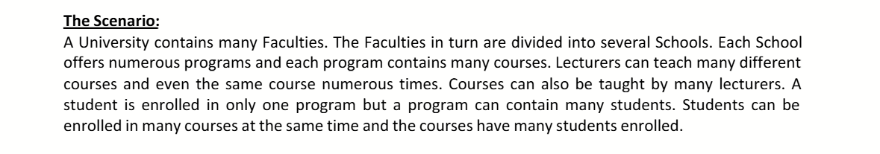
- Draw ER-Diagram from the scenario

- Draw a context-level data flow diagram of your school’s or university’s registration system. Label each entity and process. Discuss why there appear to be different ways to draw the diagram. Reach consensus as a group about the best way to draw the diagram and defend your choice in a paragraph. Now, working with your group’s members, follow the appropriate steps for developing an E-R diagram and create one for your school or university registration system. Make sure your group indicates whether the relationship you depict is one-to-one, one-to-many, many-to one, or many-to-many.

