- “Auto Cars” is a taxi service in Sri Lanka which has been in operation for several decades, serving the customers in city and urban areas. As a result of the increased use of information technology such as mobile phones and the internet, “Auto Cars” decided to launch a web-based system that enables customers to reserve vehicles conveniently. This also helps the company to gain a competitive advantage.
The main system features of the web-based system required for “Auto Cars” to reserve taxis for customers are:
a. Customers and drivers can use the online system to register. They will receive an email with their username and password once they have registered.
b. Customers can book taxis via the website. When they reserve a vehicle, they will receive an SMS on their phone with the driver's contact information and vehicle details.
c. Customers can rate drivers based on their experiences with them on trips.
d. In addition, the company employs a phone operator who manually reserves drivers from the system. This is the same as a customer reserving a driver, except there is no logged in customer in the application.
e. When the operator makes a taxi reservation, she enters the customer's phone number into the system, and the customer receives an SMS.
f. The driver closest to the customer must be assigned by the application. When a customer or the operator reserves a vehicle, the system should display a list of available drivers. From this list, the customer can then select the best driver.
g. The driver’s location is manually (by the driver) entered into the web-based system or via the telephone operator. Similarly, when reserving a taxi, the customer's location is specified (by the customer or through the operator).
Assume that you are the newly appointed system analyst for “Auto Cars” and assigned to work on this project. Produce a professional report including the answers to the following:

Activity 1
Conduct the feasibility study for the web-based system for “Auto Cars” and produce a feasibility report. Further, evaluate the importance of the feasibility criteria used to investigate the feasibility of the proposed system.
- Angus McIndoe wants to modernize his popular restaurant by adapting it more closely to the preferences of his repeat customers. He is interested in maintaining information such as customers’ preferred seating areas, favorite food items, and usual arrival times in order to improve customer satisfaction and increase business performance. Angus believes that keeping track of additional customer preferences may further enhance the quality of service.
Assume that you are appointed as a systems analyst for this project.
Develop a clear problem definition for Angus McIndoe’s proposed customer preference management system, identifying the core problem, key stakeholders, and the objectives the system should achieve.
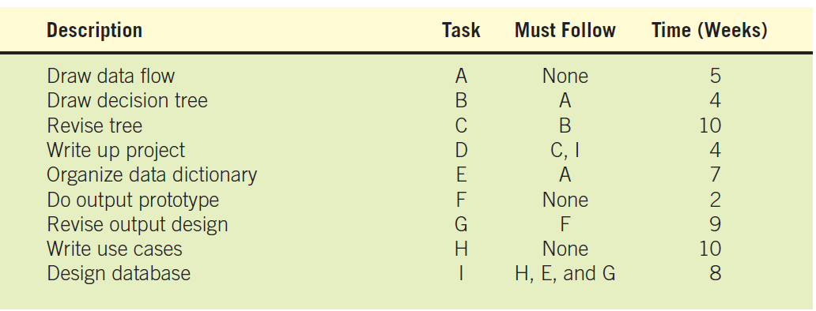

Brian F. O’Byrne (“F,” he says, stands for “frozen.”) owns a frozen food company and wants to develop an information system for tracking shipments to warehouses.
a. Using the data from the table in Figure 3.EX1, draw a Gantt chart to help Brian organize his design project.

Project Activities – 8 Tasks (Descriptive)
- Task 1: Project Planning & Initiation – Define project objectives, scope, and resources. Duration: 1 week. Predecessor: None.
- Task 2: Requirements Analysis – Gather and document the system requirements from stakeholders. Duration: 2 weeks. Predecessor: Task 1.
- Task 3: System & Database Design – Design the system architecture, modules, and database structure. Duration: 2 weeks. Predecessor: Task 2.
- Task 4: User Interface Design – Create the layout and navigation for the web-based system. Duration: 1 week. Predecessor: Task 3.
- Task 5: System Development / Coding – Develop and code the system modules. Duration: 4 weeks. Predecessor: Task 3 & Task 4.
- Task 6: Integration & System Testing – Integrate all modules and perform system testing for errors and performance. Duration: 2 weeks. Predecessor: Task 5.
- Task 7: User Training – Train users to operate the new system effectively. Duration: 1 week. Predecessor: Task 6.
- Task 8: System Deployment & Review – Deploy the system, make it operational, and review its performance. Duration: 1 week. Predecessor: Task 7.
Using the information above, draw a PERT chart showing all project activities, their durations, and dependencies. Identify the critical path and explain why it is important for project management.

