LAB 1

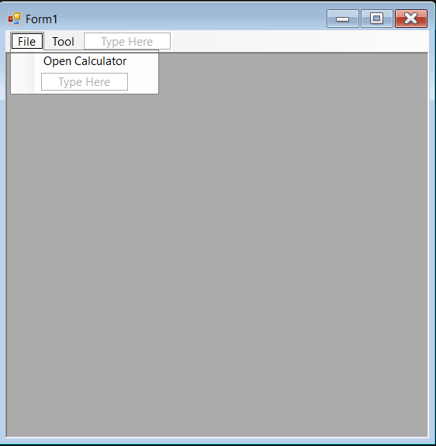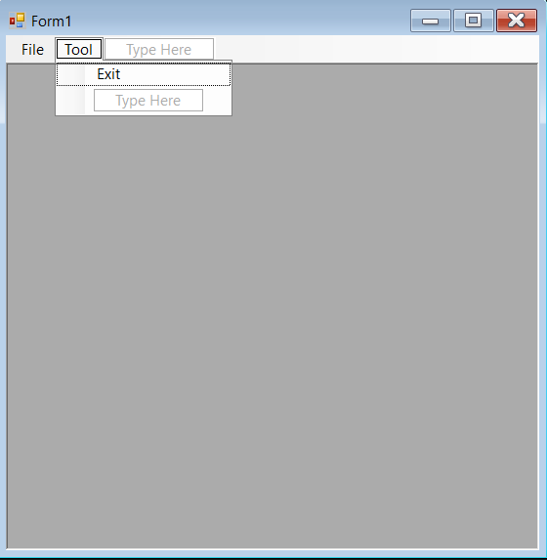

Public Class Form1

Private Sub OpenCalculatorToolStripMenuItem_Click(sender As Object, e As EventArgs) Handles OpenCalculatorToolStripMenuItem.Click

Calculator.MdiParent = Me

Calculator.Show()

End Sub

Private Sub ExitToolStripMenuItem_Click(sender As Object, e As EventArgs) Handles ExitToolStripMenuItem.Click

Me.Close()

End Sub

End Class

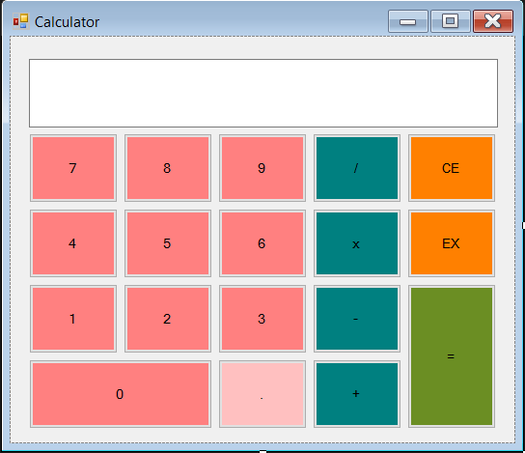

Public Class Calculator

Dim strOpertors As String = ""

Dim intFirstNumber As Double

Dim intLastNumber As Double

Private Sub Btn_num0_Click(sender As Object, e As EventArgs) Handles Btn_num0.Click

screen.Text += "0"

End Sub

Private Sub Btn_num1_Click(sender As Object, e As EventArgs) Handles Btn_num1.Click

screen.Text += "1"

End Sub

Private Sub Btn_num2_Click(sender As Object, e As EventArgs) Handles Btn_num2.Click

screen.Text += "2"

End Sub

Private Sub Btn_num3_Click(sender As Object, e As EventArgs) Handles Btn_num3.Click

screen.Text += "3"

End Sub

Private Sub Btn_num4_Click(sender As Object, e As EventArgs) Handles Btn_num4.Click

screen.Text += "4"

End Sub

Private Sub Btn_num5_Click(sender As Object, e As EventArgs) Handles Btn_num5.Click

screen.Text += "5"

End Sub

Private Sub Btn_num6_Click(sender As Object, e As EventArgs) Handles Btn_num6.Click

screen.Text += "6"

End Sub

Private Sub Btn_num7_Click(sender As Object, e As EventArgs) Handles Btn_num7.Click

screen.Text += "7"

End Sub

Private Sub Btn_num8_Click(sender As Object, e As EventArgs) Handles Btn_num8.Click

screen.Text += "8"

End Sub

Private Sub Btn_num9_Click(sender As Object, e As EventArgs) Handles Btn_num9.Click

screen.Text += "9"

End Sub

Private Sub Btn_adds_Click(sender As Object, e As EventArgs) Handles Btn_adds.Click

intFirstNumber = CDbl(screen.Text)

strOpertors = "+"

screen.Text = ""

End Sub

Private Sub Btn_subtracts_Click(sender As Object, e As EventArgs) Handles Btn_subtracts.Click

intFirstNumber = CDbl(screen.Text)

strOpertors = "-"

screen.Text = ""

End Sub

Private Sub Btn_multiplys_Click(sender As Object, e As EventArgs) Handles Btn_multiplys.Click

intFirstNumber = CDbl(screen.Text)

strOpertors = "x"

screen.Text = ""

End Sub

Private Sub Btn_divides_Click(sender As Object, e As EventArgs) Handles Btn_divides.Click

intFirstNumber = CDbl(screen.Text)

strOpertors = "/"

screen.Text = ""

End Sub

Private Sub Btn_sumall_Click(sender As Object, e As EventArgs) Handles Btn_sumall.Click

intLastNumber = screen.Text

If strOpertors = "+" Then

screen.Text = intFirstNumber + intLastNumber

ElseIf strOpertors = "-" Then

screen.Text = intFirstNumber - intLastNumber

ElseIf strOpertors = "x" Then

screen.Text = intFirstNumber * intLastNumber

Else : strOpertors = "/"

screen.Text = intFirstNumber / intLastNumber

End If

End Sub

Private Sub Btn_clearall_Click(sender As Object, e As EventArgs) Handles Btn_clearall.Click

screen.Text = ""

End Sub

Private Sub Btn_addpoint_Click(sender As Object, e As EventArgs) Handles Btn_addpoint.Click

If screen.Text Like "*.*" Then

screen.Text += ""

Else : screen.Text += "."

End If

End Sub

Private Sub Btn_exits_Click(sender As Object, e As EventArgs) Handles Btn_exits.Click

Me.Close()

End Sub

End Class

LAB 2

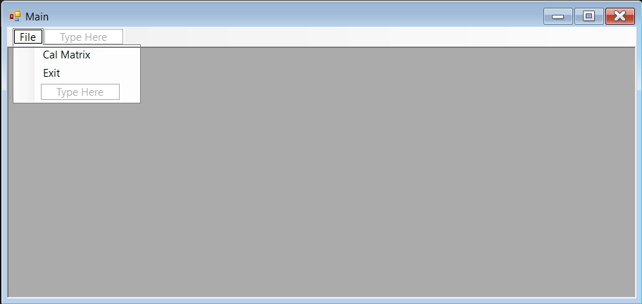

Public Class Main

Private Sub CalMatrixToolStripMenuItem_Click(sender As Object, e As EventArgs) Handles CalMatrixToolStripMenuItem.Click

MatrixForm.MdiParent = Me

MatrixForm.Show()

End Sub

Private Sub ExitToolStripMenuItem_Click(sender As Object, e As EventArgs) Handles ExitToolStripMenuItem.Click

Me.Close()

End Sub

End Class

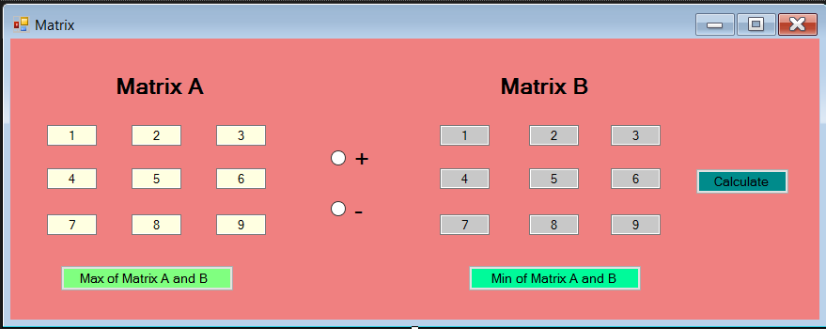

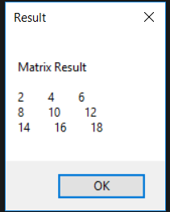 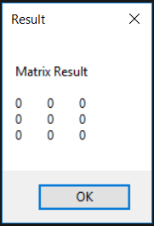

Public Class MatrixForm

Dim Array_A(2, 2), Array_B(2, 2) As Integer

Sub inputArrayA()

Array_A = {{TxtB_A1.Text, TxtB_A2.Text, TxtB_A3.Text},

{TxtB_A4.Text, TxtB_A5.Text, TxtB_A6.Text},

{TxtB_A7.Text, TxtB_A8.Text, TxtB_A9.Text}}

End Sub

Sub inputArrayB()

Array_B = {{TxtB_B1.Text, TxtB_B2.Text, TxtB_B3.Text},

{TxtB_B4.Text, TxtB_B5.Text, TxtB_B6.Text},

{TxtB_B7.Text, TxtB_B8.Text, TxtB_B9.Text}}

End Sub

Function AddMatrix(ByVal A(,) As Integer, ByVal B(,) As Integer)

Dim sumAB(2, 2) As Integer

For i = 0 To A.GetLength(1) - 1

For j = 0 To B.GetLength(1) - 1

sumAB(i, j) = A(i, j) + B(i, j)

Next

Next

Return sumAB

End Function

Function SubtractMatrix(ByVal A(,) As Integer, ByVal B(,) As Integer)

Dim sumAB(2, 2) As Integer

For i = 0 To A.GetLength(1) - 1

For j = 0 To B.GetLength(1) - 1

sumAB(i, j) = A(i, j) - B(i, j)

Next

Next

Return sumAB

End Function

Sub Show_matrix(ByVal result(,) As Integer)

Dim resultMatrix As String = ""

resultMatrix &= "Matrix Result" & vbCrLf & vbCrLf

For i = 0 To result.GetLength(1) - 1

For j = 0 To result.GetLength(1) - 1

resultMatrix &= result(i, j) & " "

Next

resultMatrix &= vbCrLf

Next

MessageBox.Show(resultMatrix, "Result", MessageBoxButtons.OK)

End Sub

Private Sub btn_calculate_Click(sender As Object, e As EventArgs) Handles btn_calculate.Click

inputArrayA()

inputArrayB()

If RadioBtn_add.Checked Then

Show_matrix(AddMatrix(Array_A, Array_B))

ElseIf RadioBtn_sub.Checked Then

Show_matrix(SubtractMatrix(Array_A, Array_B))

Else : MessageBox.Show("Please select : + RadioButton OR - RadioButton", "Error", MessageBoxButtons.OK, MessageBoxIcon.Warning)

End If

End Sub

Function MatrixMin(ByVal A(,) As Integer, ByVal B(,) As Integer) As String

Dim minA = A(0, 0)

Dim minB = B(0, 0)

Dim ia = 0

Dim ja = 0

Dim ib = 0

Dim jb = 0

For i = 0 To A.GetLength(0) - 1

For j = 0 To A.GetLength(0) - 1

If A(i, j) < minA Then

minA = A(i, j)

ia = i + 1

ja = j + 1

End If

If B(i, j) < minB Then

minB = B(i, j)

ib = i + 1

jb = j + 1

End If

Next

Next

Dim str = "Min value of Matrix A: A[" & ia & "," & ja & "] = " & minA

str += vbCrLf & "Min value of Matrix B: B[" & ib & "," & jb & "] = " & minB

Return str

End Function

Function MatrixMax(ByVal A(,) As Integer, ByVal B(,) As Integer) As String

Dim maxA = A(0, 0)

Dim maxB = B(0, 0)

Dim ia = 0

Dim ja = 0

Dim ib = 0

Dim jb = 0

For i = 0 To A.GetLength(0) - 1

For j = 0 To A.GetLength(0) - 1

If A(i, j) > maxA Then

maxA = A(i, j)

ia = i + 1

ja = j + 1

End If

If B(i, j) > maxB Then

maxB = B(i, j)

ib = i + 1

jb = j + 1

End If

Next

Next

Dim str = "Max value of Matrix A: A[" & ia & "," & ja & "] = " & maxA

str += vbCrLf & "Max value of Matrix B: B[" & ib & "," & jb & "] = " & maxB

Return str

End Function

Private Sub btn_min_Click(sender As Object, e As EventArgs) Handles btn_min.Click

inputArrayA()

inputArrayB()

MessageBox.Show(MatrixMin(Array_A, Array_B), "Result", MessageBoxButtons.OK)

End Sub

Private Sub MatrixForm_Load(sender As Object, e As EventArgs) Handles MyBase.Load

End Sub

Private Sub btn_max_Click(sender As Object, e As EventArgs) Handles btn_max.Click

inputArrayA()

inputArrayB()

MessageBox.Show(MatrixMax(Array_A, Array_B), "Result", MessageBoxButtons.OK)

End Sub

End Class

LAB 3

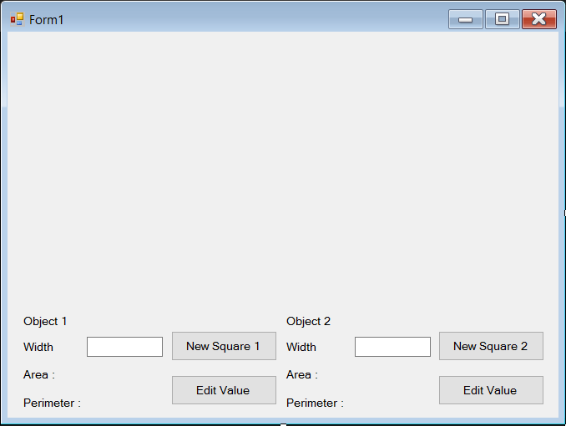 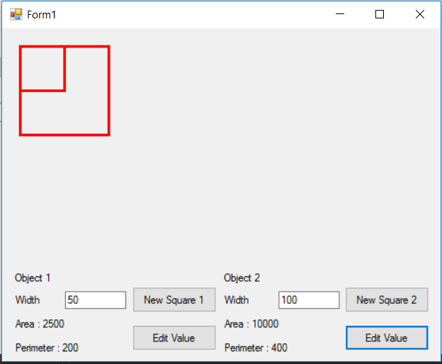

Public Class Form1

Dim MySquare1 As Square_class

Dim MySquare2 As Square_class

Private Sub btn_square1_Click(sender As Object, e As EventArgs) Handles btn_square1.Click

MySquare1 = New Square_class()

MySquare1.mywidth() = TxtB_width1.Text

Lb_square_area1.Text = "Area : " + CStr(MySquare1.Area(MySquare1.mywidth))

Lb_square_perimeter1.Text = "Perimeter : " + CStr(MySquare1.Perimeter())

MySquare1.Draw_square()

End Sub

Private Sub btn_edit1_Click(sender As Object, e As EventArgs) Handles btn_edit1.Click

MySquare1.Clear_square()

MySquare1.mywidth = TxtB_width1.Text

Lb_square_area1.Text = "Area : " + CStr(MySquare1.Area(MySquare1.mywidth))

Lb_square_perimeter1.Text = "Perimeter : " + CStr(MySquare1.Perimeter())

MySquare1.Draw_square()

End Sub

Private Sub btn_square2_Click(sender As Object, e As EventArgs) Handles btn_square2.Click

MySquare2 = New Square_class()

MySquare2.mywidth() = TxtB_width2.Text

Lb_square_area2.Text = "Area : " + CStr(MySquare2.Area(MySquare2.mywidth))

Lb_square_perimeter2.Text = "Perimeter : " + CStr(MySquare2.Perimeter())

MySquare2.Draw_square()

End Sub

Private Sub btn_edit2_Click(sender As Object, e As EventArgs) Handles btn_edit2.Click

MySquare2.Clear_square()

MySquare2.mywidth = TxtB_width2.Text

Lb_square_area2.Text = "Area : " + CStr(MySquare2.Area(MySquare2.mywidth))

Lb_square_perimeter2.Text = "Perimeter : " + CStr(MySquare2.Perimeter())

MySquare2.Draw_square()

End Sub

End Class

Public Class Square_class

Private width As Double

Public Property mywidth() As String

Get

Return width

End Get

Set(ByVal value As String)

value = value.Trim()

If value <> String.Empty And IsNumeric(value) Then

width = value

Else

MessageBox.Show("Width Value is 0", "Error !!!", MessageBoxButtons.OK, MessageBoxIcon.Error)

width = 0

End If

End Set

End Property

Public Function Area(ByVal w As Double) As Double

Dim area_Square As Double

area_Square = w * w

Return area_Square

End Function

Public Function Perimeter() As Double

Dim perimeter_Square As Double

perimeter_Square = (width * 4)

Return perimeter_Square

End Function

Public Sub Draw_square()

Dim g_Draw As Graphics = Form1.CreateGraphics

Dim Pen As Pen = New Pen(Color.Red, 3)

g_Draw.DrawRectangle(Pen, 20, 20, Convert.ToInt32(mywidth), Convert.ToInt32(mywidth))

End Sub

Public Sub Clear_square()

Dim g_Clear As Graphics = Form1.CreateGraphics

Dim Pen2 As Pen = New Pen(Color.FromArgb(Form1.BackColor.ToArgb), 3)

g_Clear.DrawRectangle(Pen2, 20, 20, Convert.ToInt32(mywidth), Convert.ToInt32(mywidth))

End Sub

End Class

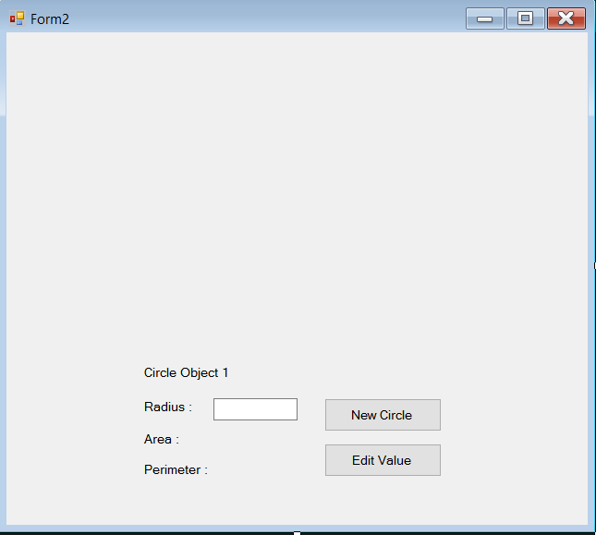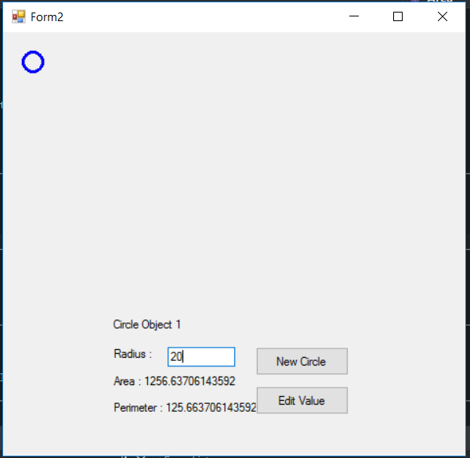

Public Class Form2

Dim MyCircle As Circle_class

Private Sub btn_circle_Click(sender As Object, e As EventArgs) Handles btn_circle.Click

MyCircle = New Circle_class()

MyCircle.myradius() = TxtB_radius.Text

Lb_circle_area.Text = "Area : " + CStr(MyCircle.Area(MyCircle.myradius))

Lb_circle_perimeter.Text = "Perimeter : " + CStr(MyCircle.Perimeter())

MyCircle.Draw_circle()

End Sub

Private Sub btn_edit_Click(sender As Object, e As EventArgs) Handles btn_edit.Click

MyCircle.Clear_circle()

MyCircle.myradius = TxtB_radius.Text

Lb_circle_area.Text = "Area : " + CStr(MyCircle.Area(MyCircle.myradius))

Lb_circle_perimeter.Text = "Perimeter : " + CStr(MyCircle.Perimeter())

MyCircle.Draw_circle()

End Sub

End Class

Public Class Circle_class

Private radius As Double

Public Property myradius() As String

Get

Return radius

End Get

Set(ByVal value As String)

value = value.Trim()

If value <> String.Empty And IsNumeric(value) Then

radius = value

Else

MessageBox.Show("Width Value is 0", "Error !!!", MessageBoxButtons.OK, MessageBoxIcon.Error)

radius = 0

End If

End Set

End Property

Public Function Area(ByVal radius As Double) As Double

Dim area_Ciecle As Double

area_Ciecle = Math.PI * Math.Pow(radius, 2)

Return area_Ciecle

End Function

Public Function Perimeter() As Double

Dim perimeter_Circle As Double

perimeter_Circle = 2 * Math.PI * radius

Return perimeter_Circle

End Function

Public Sub Draw_circle()

Dim g_Draw As Graphics = Form2.CreateGraphics

Dim Pen As Pen = New Pen(Color.Blue, 3)

g_Draw.DrawEllipse(Pen, 20, 20, Convert.ToInt32(myradius), Convert.ToInt32(myradius))

End Sub

Public Sub Clear_circle()

Dim g_Clear As Graphics = Form2.CreateGraphics

Dim Pen2 As Pen = New Pen(Color.FromArgb(Form2.BackColor.ToArgb), 3)

g_Clear.DrawRectangle(Pen2, 20, 20, Convert.ToInt32(myradius), Convert.ToInt32(myradius))

End Sub

End Class

LAB 4

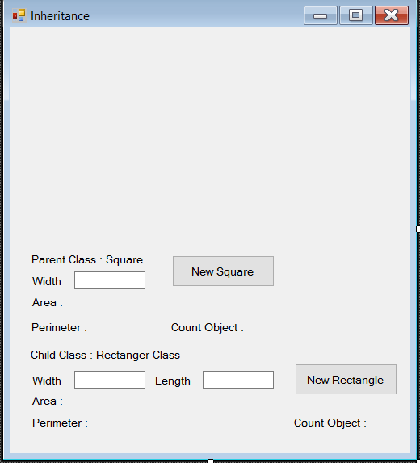 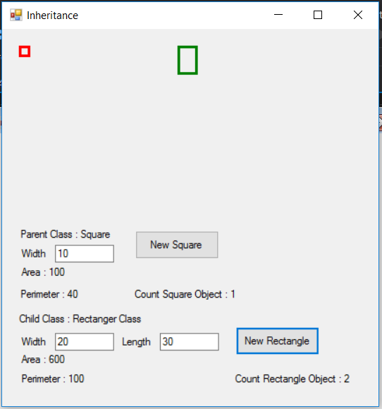

Public Class Form1

Private Sub Btn_square_Click(sender As Object, e As EventArgs) Handles Btn_square.Click

Dim MySquare As Square_class

MySquare = New Square_class()

MySquare.width_p = TxtB_square_width.Text

Lb_square_area.Text = "Area : " + CStr(MySquare.Area(MySquare.width_p))

Lb_square_perimeter.Text = "Perimeter : " + CStr(MySquare.Perimeter())

MySquare.Draw_square()

Lb_count_square.Text = "Count Square Object : " + CStr(MySquare.squareCount_p)

End Sub

Private Sub Btn_rectangle_Click(sender As Object, e As EventArgs) Handles Btn_rectangle.Click

Dim MyRectangle As Rectangle_class

MyRectangle = New Rectangle_class()

MyRectangle.width_p = TxtB_rectangle_width.Text

MyRectangle.length_p = TxtB_rectangle_length.Text

Lb_rectangle_area.Text = "Area : " + CStr(MyRectangle.Area(MyRectangle.width_p, MyRectangle.length_p))

Lb_rectangle_perimeter.Text = "Perimeter : " + CStr(MyRectangle.Perimeter())

MyRectangle.Draw_Rectangle()

Lb_count_rectangle.Text = "Count Rectangle Object : " + CStr(MyRectangle.squareCount_p)

End Sub

End Class

Public Class Square_class

Private width As Double

Private Shared squareCount As Integer

Public Property width_p() As String

Get

Return width

End Get

Set(value As String)

value = value.Trim

If value <> String.Empty And IsNumeric(value) Then

width = value

Else

MessageBox.Show("Width Value is 0", "Error!!!", MessageBoxButtons.OK, MessageBoxIcon.Error)

width = 0

End If

End Set

End Property

Public Property squareCount_p() As Integer

Get

Return squareCount

End Get

Set(value As Integer)

squareCount = value

End Set

End Property

Public Overridable Function Area(ByVal w As Double) As Double

Dim area_square = w * w

Return area_square

End Function

Public Overridable Function Perimeter() As Double

Dim perimeter_square As Double

perimeter_square = (4 * width)

Return perimeter_square

End Function

Public Sub Draw_square()

Dim g_Draw As Graphics = Form1.CreateGraphics

Dim Pen As Pen = New Pen(Color.Red, 3)

g_Draw.DrawRectangle(Pen, 20, 20, Convert.ToInt32(width_p), Convert.ToInt32(width_p))

End Sub

Public Sub New()

squareCount_p += 1

End Sub

End Class

Public Class Rectangle_class

Inherits Square_class

Private length As Double

Private Shared rectangleCount As Integer

Public Property length_p() As String

Get

Return length

End Get

Set(value As String)

value = value.Trim

If value <> String.Empty And IsNumeric(value) Then

length = value

Else

MessageBox.Show("Length Value is 0", "Error!!!", MessageBoxButtons.OK, MessageBoxIcon.Error)

length = 0

End If

End Set

End Property

Public Property rectangleCount_p() As Integer

Get

Return rectangleCount

End Get

Set(value As Integer)

rectangleCount = value

End Set

End Property

Public Overloads Function Area(w As Double, ByVal l As Double) As Double

Dim area_rectangle As Double

area_rectangle = w * l

Return area_rectangle

End Function

Public Overrides Function Perimeter() As Double

Dim perimeter_rectangle As Double

perimeter_rectangle = (2 * width_p) + (2 * length)

Return perimeter_rectangle

End Function

Public Sub Draw_Rectangle()

Dim g_DrawR As Graphics = Form1.CreateGraphics

Dim Pen_green = New Pen(Color.Green, 3)

g_DrawR.DrawRectangle(Pen_green, 200, 20, Convert.ToInt32(width_p), Convert.ToInt32(length_p))

End Sub

Public Sub New()

rectangleCount += 1

End Sub

End Class

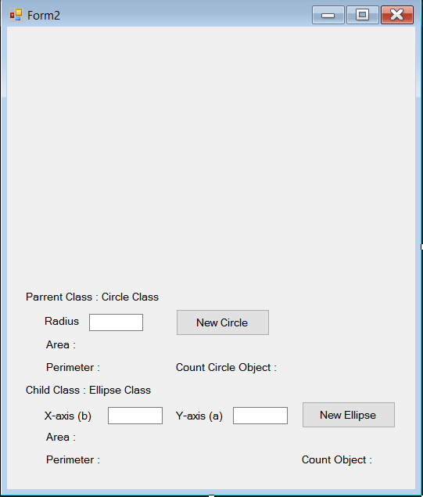 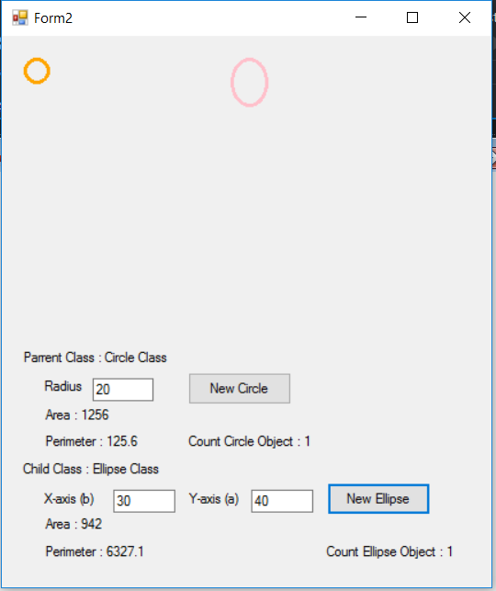

Public Class Form2

Private Sub Btn_circle_Click(sender As Object, e As EventArgs) Handles Btn_circle.Click

Dim MyCircle As New Circle()

MyCircle.radius_p = TxtB_circle_width.Text

Lb_circle_area.Text = "Area : " + CStr(MyCircle.Area(MyCircle.radius_p))

Lb_circle_perimeter.Text = "Perimeter : " + CStr(MyCircle.Perimeter())

MyCircle.Draw_Circle()

Lb_count_circle.Text = "Count Circle Object : " + CStr(MyCircle.circleCount_p)

End Sub

Private Sub Btn_ellipse_Click(sender As Object, e As EventArgs) Handles Btn_ellipse.Click

Dim MyEllipse As New Ellipse()

MyEllipse.xB_p = TxtB_x.Text

MyEllipse.yA_p = TxtB_y.Text

Lb_ellipse_area.Text = "Area : " + CStr(MyEllipse.Area(MyEllipse.xB_p, MyEllipse.yA_p))

Lb_ellipse_perimeter.Text = "Perimeter : " + CStr(MyEllipse.Perimeter())

MyEllipse.Draw_Circle()

Lb_count_ellipse.Text = "Count Ellipse Object : " + CStr(MyEllipse.EllipseCount_p)

End Sub

End Class

Public Class Circle

Private radius As Double

Private PI As Double = 3.14

Private Shared circleCount As Integer

Public Property radius_p() As String

Get

Return radius

End Get

Set(value As String)

value = value.Trim

If value <> String.Empty And IsNumeric(value) Then

radius = value

Else

MessageBox.Show("Radius Value is 0", "Error!!", MessageBoxButtons.OK, MessageBoxIcon.Error)

radius = 0

End If

End Set

End Property

Public Property circleCount_p() As Integer

Get

Return circleCount

End Get

Set(value As Integer)

circleCount = value

End Set

End Property

Public Overridable Function Area(ByVal rad As Double) As Double

Dim area_circle As Double

area_circle = PI * rad ^ 2

Return area_circle

End Function

Public Overridable Function Perimeter() As Double

Dim perimeter_circle As Double

perimeter_circle = 2 * PI * radius

Return perimeter_circle

End Function

Public Sub Draw_Circle()

Dim c_Draw As Graphics = Form2.CreateGraphics

Dim pen As Pen = New Pen(Color.Orange, 3)

c_Draw.DrawEllipse(pen, 20, 20, Convert.ToInt32(radius_p), Convert.ToInt32(radius_p))

End Sub

Public Sub New()

circleCount_p += 1

End Sub

End Class

Public Class Ellipse

Inherits Circle

Private xB As Double

Private yA As Double

Private PI As Double = 3.14

Private Shared EllipseCount As Integer

Public Property xB_p() As String

Get

Return xB

End Get

Set(value As String)

value = value.Trim

If value <> String.Empty And IsNumeric(value) Then

xB = value

Else

MessageBox.Show("x (b) Value is 0", "Error!!", MessageBoxButtons.OK, MessageBoxIcon.Error)

xB = 0

End If

End Set

End Property

Public Property yA_p() As String

Get

Return yA

End Get

Set(value As String)

value = value.Trim

If value <> String.Empty And IsNumeric(value) Then

yA = value

Else

MessageBox.Show("y (a) Value is 0", "Error!!", MessageBoxButtons.OK, MessageBoxIcon.Error)

yA = 0

End If

End Set

End Property

Public Property EllipseCount_p() As Integer

Get

Return EllipseCount

End Get

Set(value As Integer)

EllipseCount = value

End Set

End Property

Public Overloads Function Area(ByVal a As Double, ByVal b As Double) As Double

Dim area_Ellipse As Double

area_Ellipse = (PI / 4) * a * b

Return area_Ellipse

End Function

Public Overrides Function Perimeter() As Double

Dim perimeter_Ellipse As Double

perimeter_Ellipse = (PI * (yA_p + xB_p)) / 2

Return perimeter_Ellipse

End Function

Public Overloads Sub Draw_Circle()

Dim c_DrawR As Graphics = Form2.CreateGraphics

Dim Pen_green As Pen = New Pen(Color.Pink, 3)

c_DrawR.DrawEllipse(Pen_green, 200, 20, Convert.ToInt32(xB_p), Convert.ToInt32(yA_p))

End Sub

Public Sub New()

EllipseCount += 1

End Sub

End Class

LAB 5

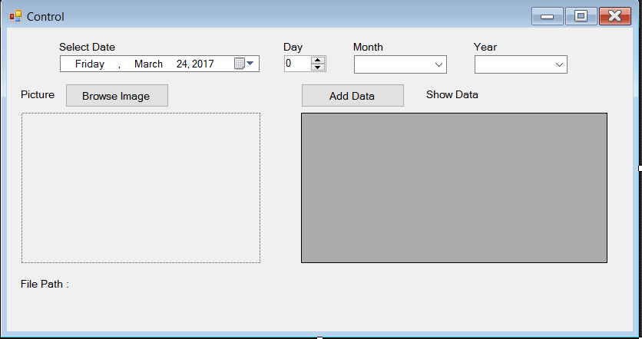

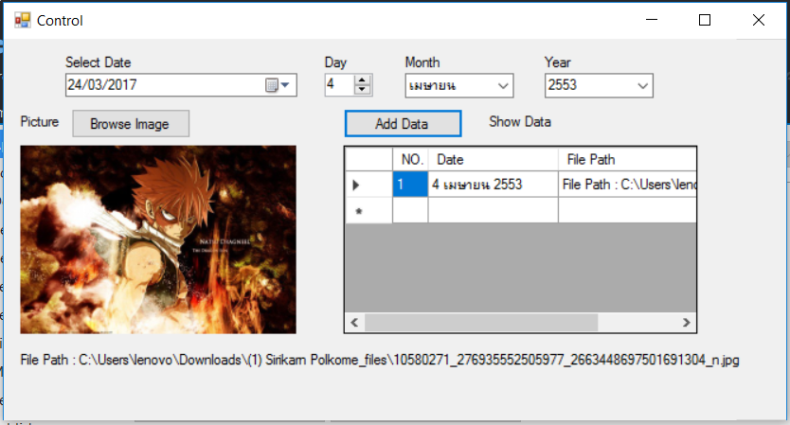

Public Class Form1

Private Sub Form1_Load(sender As Object, e As EventArgs) Handles MyBase.Load

MyDateTimePicker.Format = DateTimePickerFormat.Custom

MyDateTimePicker.CustomFormat = ("dd/MM/yyyy")

NumericUpDown_Day.Minimum = 1

NumericUpDown_Day.Maximum = 31

Dim localDate = DateTime.Now.Year

For i = -10 To 10

With ComboBox_year

.Items.Add(CStr(localDate + 543 + i))

End With

Next

With ComboBox_month

.Items.Insert(0, ("มกราคม"))

.Items.Insert(1, ("กุมภาพันธ์"))

.Items.Insert(2, ("มีนาคม"))

.Items.Insert(3, ("เมษายน"))

.Items.Insert(4, ("พฤษภาคม"))

.Items.Insert(5, ("มิถุนายน"))

.Items.Insert(6, ("กรกฎาคม"))

.Items.Insert(7, ("สิงหาคม"))

.Items.Insert(8, ("กันยายน"))

.Items.Insert(9, ("ตุลาคม"))

.Items.Insert(10, ("พฤศจิกายน"))

.Items.Insert(11, ("ธันวาคม"))

End With

DataGridView_data.ColumnCount = 3

DataGridView_data.Columns(0).Width = 30

DataGridView_data.Columns(1).Width = 110

DataGridView_data.Columns(2).Width = 200

DataGridView_data.Columns(0).Name = "NO."

DataGridView_data.Columns(1).Name = "Date"

DataGridView_data.Columns(2).Name = "File Path"

End Sub

Private Sub MyDateTimePicker_ValueChanged(sender As Object, e As EventArgs) Handles MyDateTimePicker.ValueChanged

NumericUpDown_Day.Value = MyDateTimePicker.Value.Day

ComboBox_month.SelectedIndex() = MyDateTimePicker.Value.Month - 1

ComboBox_year.Text = CStr(CDbl(MyDateTimePicker.Value.Year) + 543)

End Sub

Private Sub Btn_OpenFile_Click(sender As Object, e As EventArgs) Handles Btn_OpenFile.Click

Dim img As String = ""

OpenImageDialog.Filter = "Picture |*.bmp;*.jpg;*.gif| All Files|*.*"

OpenImageDialog.FileName = ""

If OpenImageDialog.ShowDialog(Me) = DialogResult.OK Then

img = OpenImageDialog.FileName

MyPictureBox.SizeMode = PictureBoxSizeMode.StretchImage

MyPictureBox.Image = System.Drawing.Bitmap.FromFile(img)

End If

Lb_filePath.Text = "File Path : " + img

End Sub

Private Sub Btn_AddData_Click(sender As Object, e As EventArgs) Handles Btn_AddData.Click

Dim num As Integer

Dim dateT As String

num = DataGridView_data.RowCount

dateT = NumericUpDown_Day.Value.ToString + " " + ComboBox_month.Text + " " + ComboBox_year.Text

Dim row As String() = New String() {num, dateT, Lb_filePath.Text}

DataGridView_data.Rows.Add(row)

End Sub

End Class

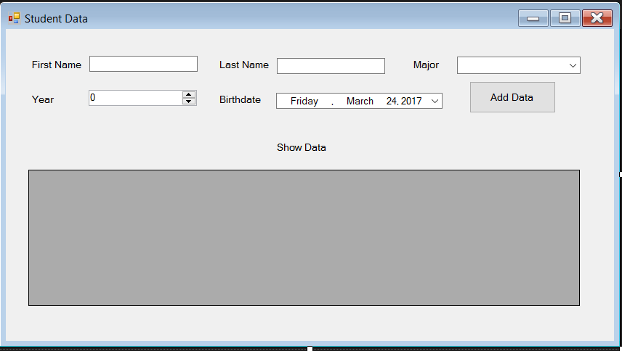

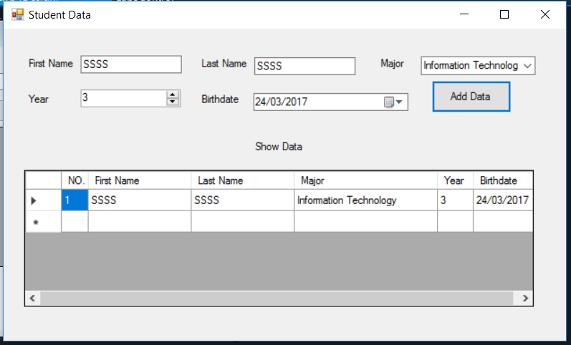

Public Class Form2

Private Sub Form2_Load(sender As Object, e As EventArgs) Handles MyBase.Load

MyDateTimePicker.Format = DateTimePickerFormat.Custom

MyDateTimePicker.CustomFormat = ("dd/MM/yyyy")

NumericUpDown_Year.Minimum = 1

NumericUpDown_Year.Maximum = 4

With ComboBox_Major

.Items.Add("Computer Science")

.Items.Add("Information Technology")

.Items.Add("Geographic Information System")

End With

DataGridView_data.ColumnCount = 6

DataGridView_data.Columns(0).Width = 30

DataGridView_data.Columns(1).Width = 115

DataGridView_data.Columns(2).Width = 115

DataGridView_data.Columns(3).Width = 160

DataGridView_data.Columns(4).Width = 40

DataGridView_data.Columns(5).Width = 70

DataGridView_data.Columns(0).Name = "NO."

DataGridView_data.Columns(1).Name = "First Name"

DataGridView_data.Columns(2).Name = "Last Name"

DataGridView_data.Columns(3).Name = "Major"

DataGridView_data.Columns(4).Name = "Year"

DataGridView_data.Columns(5).Name = "Birthdate"

End Sub

Private Sub Btn_AddData_Click(sender As Object, e As EventArgs) Handles Btn_AddData.Click

Dim num As Integer

num = DataGridView_data.RowCount

Dim row As String() = New String() {num, Tbx_Fname.Text, Tbx_Lname.Text, ComboBox_Major.Text,

NumericUpDown_Year.Value.ToString, MyDateTimePicker.Text}

DataGridView_data.Rows.Add(row)

End Sub

End Class