1. Write a simple "Hello World" program in two different programming languages of your choice. Compare the structure and syntax.
=> c language
#include<stdio.h>
main()
{
printf("hello word");
}
=> c++ language
#include<iostream>
using namespace std;
int main(){
cout<<"Hello World";
return 0;
}

2. Research and create a diagram of how data is transmitted from a client to a server over the internet.

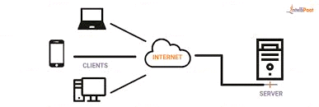
3. Simulate HTTP and FTP requests using command line tools.
- HTTP is primarily used for web communication, and tools
like curl and wget allow you to simulate requests to interact with web
servers.
- FTP is used for file transfers, and command line tools
like ftp and lftp enable you to connect to FTP servers to manage files.

4. Identify and explain three common application security
vulnerabilities. Suggest possible
1. SQL Injection
Explanation: Attackers insert malicious SQL code into input fields to access or manipulate the database.
Solution: Use prepared statements (parameterized queries), validate and sanitize all user inputs.
2. Cross-Site Scripting (XSS)
Explanation: Malicious scripts are injected into web pages, which execute in users' browsers and steal data or perform actions.
Solution: Encode output data, use Content Security Policy (CSP), and validate input to block scripts.
3. Cross-Site Request Forgery (CSRF)
Explanation: An attacker tricks a user into performing unintended actions on a trusted website where they're logged in.
Solution: Use anti-CSRF tokens, verify request origins, and implement user authentication checks.

5.
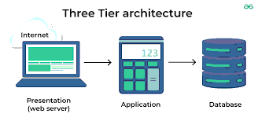
6. Write and upload your first source code file to GitHub.
- Create GitHub Account: Sign up at GitHub.
- Create Repository: Set up a new repository on GitHub.
- Install Git: Download and install Git on your machine.
- Set Up Git: Configure your username and email in Git.
- Create Local Repository: Initialize a new Git repository locally.
- Add Source Code File: Create and edit your source code file.
- Stage Changes: Use git add to stage your file.
- Commit Changes: Commit your changes with a message.
- Link to GitHub: Add the remote repository URL.
- Push Changes: Push your local commits to GitHub.
- Verify Upload: Check your GitHub repository for the file.
7. Create a GitHub repository and document how to commit and push code
changes.
- Creating a GitHub Repository
- 1. Log In: Access your GitHub account.
- 2. New Repository: Click the "+" icon and select "New repository."
- 3. Repository Details: Enter a name, description, and choose visibility.
- 4. Create Repository: Click "Create repository" to finalize.

- Committing and Pushing Code Changes
- 1. Clone Repository: Use git clone to copy the repository locally.
- 2. Make Changes: Edit or create files in your local repository.
- 3. Stage Changes: Use git add filename to stage files.
- 4. Commit Changes: Commit with git commit -m "Your message here".
- 5. Push Changes: Push to GitHub using git push origin main.
- 6 Verify Changes: Refresh your GitHub repository to see updates.

8. Create a student account on Github and collaborate on a small project
with a classmate.
- Verify your email and complete your GitHub profile setup.
- Apply for GitHub Student Pack at education.github.com.
- Create a new repository for your project from your GitHub
dashboard.
- Initialize the repository with a README file and choose
- visibility (public/private).
- Add your classmate as a collaborator under Settings >
Collaborators.
- Clone the repository to your local system using git clone
<repo_url>.
- Work on the project locally and commit changes using git add.,
git commit -m "", and git push.
- Your classmate can pull changes, add their contributions, and
push updates.
- Use GitHub issues or pull requests to manage tasks and
collaborate effectively.
9.
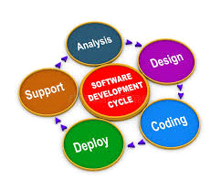
10.
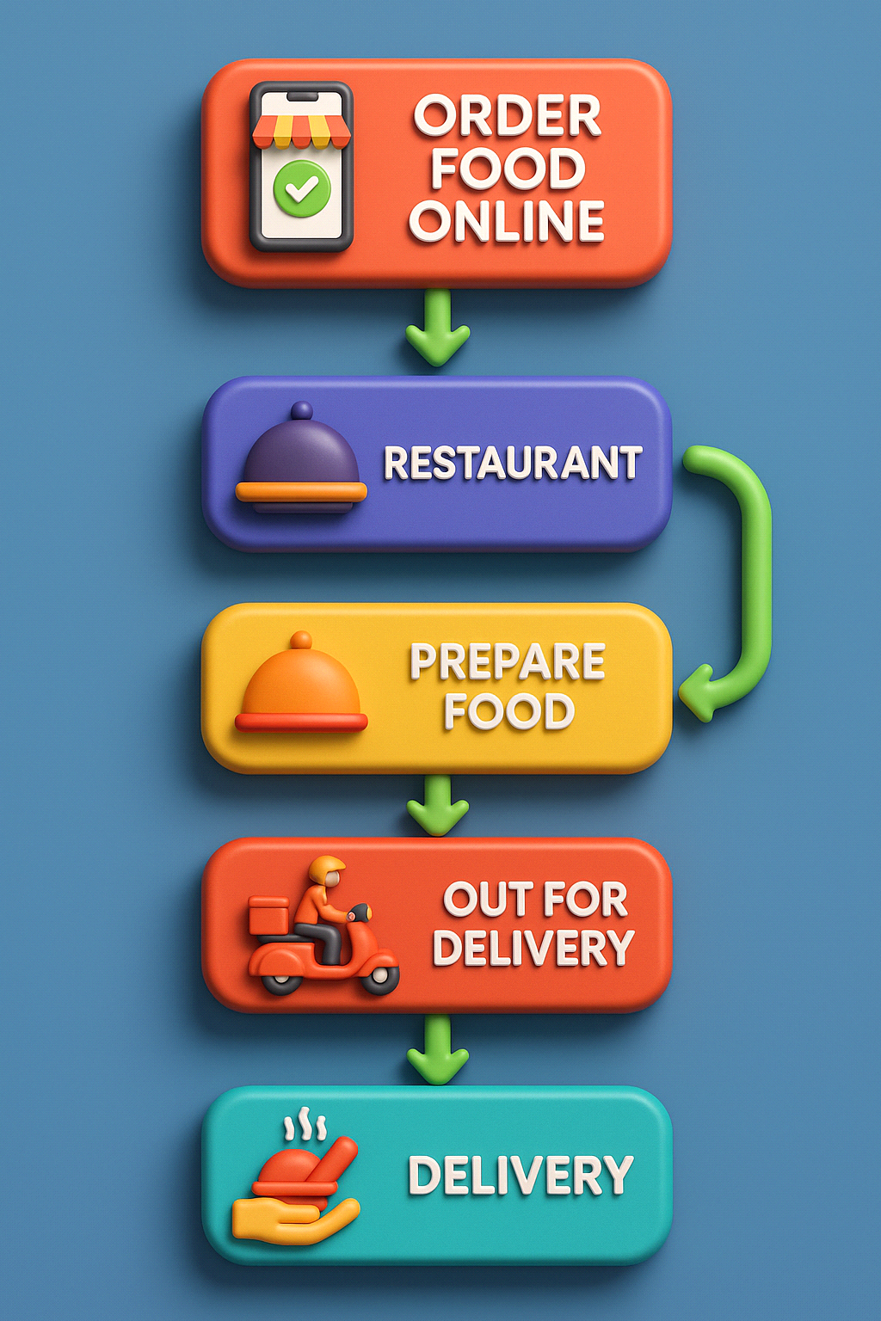

11.
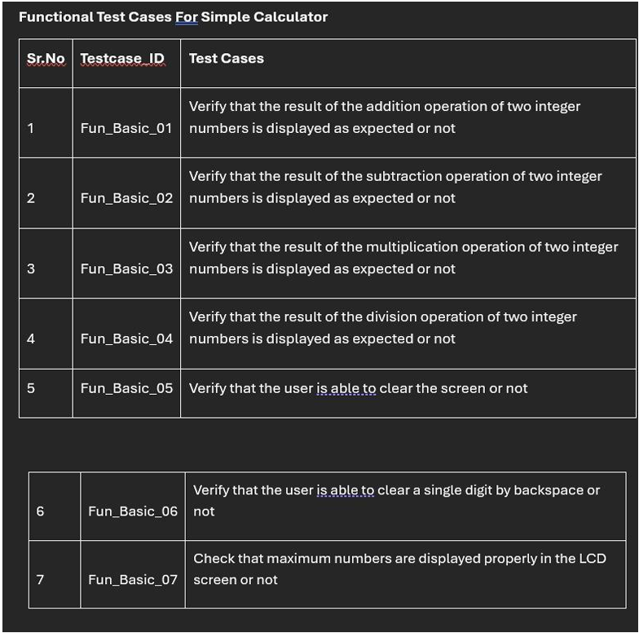
12.
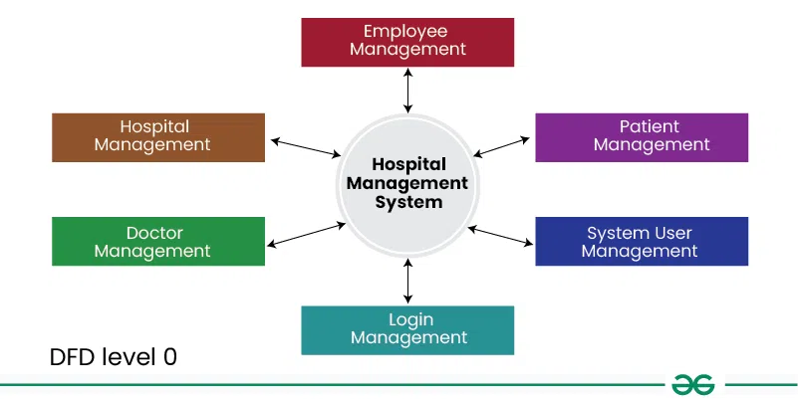

13.
