A Document For The Basic Information Of Calendar Cluster And It’s Operation

Cluster:
A related collection of attributes and commands, which together define a
communications interface between two devices. The devices implement server
and client sides of the interface respectively.
A container for one or more attributes and/or messages in a command structure.

Client:
A cluster interface which is listed in the output cluster list of the simple
descriptor on an endpoint. Typically this interface sends commands that
manipulate the attributes on the corresponding server cluster.

Server:
A cluster interface which is listed in the input cluster list of the simple
descriptor on an endpoint. Typically this interface supports all or most of the
attributes of the cluster.

Attribute:
A data entity which represents a physical quantity or state. This data is communicated to other devices using commands.

Cluster identifier:
A reference to the unique enumeration of clusters within a specific application profile.
The cluster identifier is a 16-bit number unique within the scope of the application profile
and identifies a specific cluster. Cluster identifiers are designated as inputs or outputs in
the simple descriptor for use in creating a binding table.

Why Calendar Cluster ?
- To maintain pricing for consumption in batter manner by using Date, Day, Week, Seasons and Special Days.

Calendar Cluster:
The Calendar cluster implements commands to transfer calendar information within the premises. The calendar information is distributed by an ESI.

Device which has calendar cluster server should have price cluster server and the device which has calendar cluster client should have price cluster client.

Calendar Cluster Server Commands,
Publish Calendar
Publish Day-Profile
Publish Week-Profile
Publish Seasons
Publish Special-Days

Calendar Cluster Client Commands,
Get Day-Profile
Get Week-Profile
Get Seasons
Get Special-Days

Below figure indicates which components calendar cluster have.

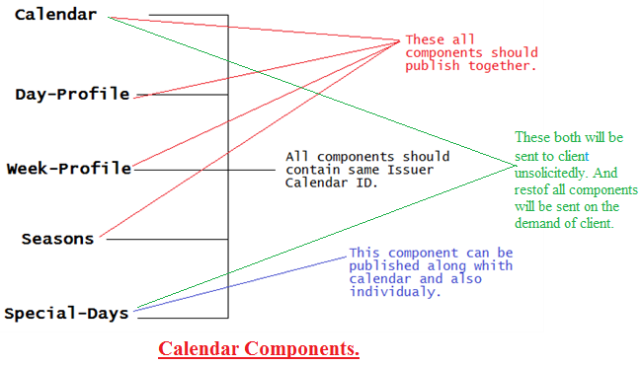

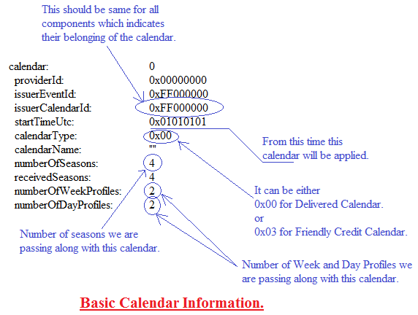

We are using Two type calendars :
- Delivered (Tariff switching Calendar)
- Friendly credit (Non-Disablement Calendar)

Friendly Credit Period:
A duration of time where delivery rules for supply interruption connected with the accounting functions of a meter are temporarily suspended. Also known as “Non-Disablement Period”.
NOTE1 - When a meter enters into a Friendly Credit Period with a useable positive credit balance, the consumer will be allowed to consume energy for the duration of the Friendly Credit Period, regardless of their credit status while in that period. If, however, the consumer had already run out of credit and supply was interrupted before entering into the Friendly Credit Period, they shall not be allowed to reconnect without first adding suitable additional credit.
NOTE2 - At the end of the Friendly Credit Period, the normal delivery rules connected with the accounting functions of the meter shall be resumed, and if the meter’s credit balance has dropped below the disablement threshold during the Friendly Credit Period, then the meter shall disconnect upon resuming normal delivery rules.

