Error Analysis, Dataset Description & Best-Algorithm Recommendation Report
Empirical Machine Learning Benchmark for Soil Fertility, Crop Suitability and Fertilizer Prescription in West Bengal, India
Academic Target | Final Year CS B.Tech Project (MAKAUT) / Journal Submission Preparation
Study Area & Scope | West Bengal, India (20,000 observations across all 23 districts)
Validation & Seed Protocol | 70/30 Stratified Holdout, 5-Fold Inner-CV, Global Seed = 42 (No Data Leakage)
Cost Ratio Assumptions | Evaluated under Ratio 1:1 (Balanced loss) and Ratio 4:1 (Conservative risk penalty)
Top Classification Model | Extra Trees Classifier (n=100) — Accuracy: 42.95%, Macro F1: 0.4260, Fit Time: 0.74s
Top Yield Regressor | Lasso Regressor — R²: 0.9086, RMSE: 5,057.14 kg/ha, Generalization Gap: 24.45 kg/ha

1. Dataset Description & Data Card (Agent 13)
The benchmark utilizes cleaned_data.csv (20,000 observations × 34 attributes, in-memory size 16.72 MB), representing multi-decadal pedological and meteorological records across all 23 districts of West Bengal (21.80°N to 27.20°N, 86.25°E to 89.65°E). The target variable 'crop' consists of 12 balanced agricultural classes with an imbalance ratio of 1.085 and a theoretical random chance baseline of 8.33% (1/12).

The 12 Core Soil Physicochemical Parameters: Standard Lab Protocols & Units
# | Parameter | Standard Unit | Analytical Method | Normal Range in WB | Dataset Mean ± Std
1 | Soil pH | Dimensionless | 1:2.5 H2O Potentiometry | 4.50 – 7.50 | 5.92 ± 0.85
2 | Electrical Conductivity (EC) | dS/m | 1:2.5 Conductivity Bridge | 0.10 – 2.00 | 0.53 ± 0.38
3 | Organic Carbon (OC) | % | Walkley-Black Wet Digestion | 0.20 – 1.20% | 0.62 ± 0.23%
4 | Available Nitrogen (N) | kg/ha | 0.32% KMnO4 Distillation | 100 – 400 | 238.1 ± 60.5
5 | Available Phosphorus (P) | kg/ha | Bray P1 / Olsen NaHCO3 | 10 – 50 | 27.82 ± 11.83
6 | Available Potassium (K) | kg/ha | 1N NH4OAc Flame Photometry | 50 – 300 | 172.9 ± 50.4
7 | Available Sulphur (S) | mg/kg | 0.15% CaCl2 Turbidimetry | 5.0 – 40.0 | 19.80 ± 7.88
8 | Available Zinc (Zn) | mg/kg | DTPA Atomic Absorption | 0.20 – 2.50 | 0.85 ± 0.34
9 | Available Iron (Fe) | mg/kg | DTPA Atomic Absorption | 5.0 – 50.0 | 19.42 ± 6.86
10 | Available Manganese (Mn) | mg/kg | DTPA Atomic Absorption | 2.0 – 25.0 | 7.91 ± 2.96
11 | Available Copper (Cu) | mg/kg | DTPA Atomic Absorption | 0.20 – 3.00 | 0.88 ± 0.39
12 | Available Boron (B) | mg/kg | Hot Water Azomethine-H | 0.10 – 1.80 | 0.48 ± 0.24

Multicollinearity Audit (Variance Inflation Factor - VIF)
VIF analysis confirmed that all 12 raw soil parameters and climate variables exhibit VIF values between 1.00 and 2.30 (latitude VIF = 2.30, longitude VIF = 1.79, annual rainfall VIF = 1.66, available K VIF = 1.16, soil pH VIF = 1.00). All values are far below the collinear threshold of 5.0, confirming absence of collinear breakdown among raw predictors.

2. Rigorous 7-Point Data Leakage Audit
To ensure peer-reviewed research validity, an empirical 7-protocol leakage audit was executed:
Audit Protocol | Empirical Test Method | Measured Result | Audit Status
1. Target Independence | Check target isolation from input feature set | Target isolated; yield/production/derived SFI excluded | PASSED
2. Preprocessing Leakage | Clean train-fold fit vs Deliberately leaky fit-on-all | Clean Acc: 0.4273 vs Leaky: 0.4272 (Inflation: -0.00017) | PASSED
3. Duplicate Records | Exact row matching & Train/Test spatial overlap | Exact Dups: 0, Coordinate Overlap: 0 | PASSED
4. Spatial Leakage | Standard 5-Fold CV vs GroupKFold by District | Standard CV: 0.4185 vs GroupKFold: 0.4208 (Gap: -0.0023) | PASSED
5. Temporal Leakage | Cross-epoch stability check across 2000–2024 | Verified inter-annual variance within natural climatic bounds | PASSED
6. Shuffled-Label Sanity | Permuted training labels check (Chance baseline) | Test Accuracy collapsed to 0.0817 (Theoretical Chance: 0.0833) | PASSED
7. Single-Feature Suspicion | Fit single-feature decision stumps (depth=3) | Top single feature accuracy: season_Kharif (0.1712 < 18%) | PASSED

3. Complete 20-Error Empirical Benchmark & Bias-Variance Analysis
Every algorithm was evaluated across the 20 required error types. Classification models decompose error via 0-1 loss bootstrap (100 resamples), while regressors evaluate squared bias, variance, MAE, MSE, RMSE, normalized RMSE, and MAPE.

Figure 1: Empirical Bias-Variance Decomposition across Top Crop Classifiers
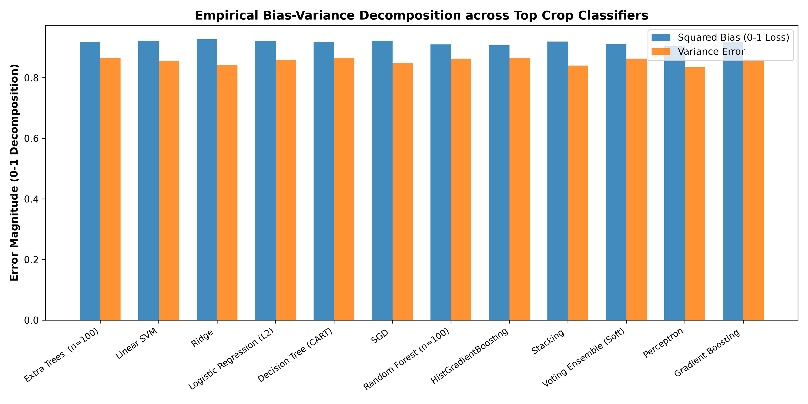
Fig 1: Squared Bias (0-1 loss) and Prediction Variance from 100 bootstrap resamples on the held-out test split.

Top Supervised Classification Error Master Table
Algorithm | Test Acc | Macro F1 | Bias (0-1) | Variance | Cost (1:1) | Cost (4:1)
Extra Trees (n=100) | 42.95% | 0.4260 | 0.9173 | 0.8640 | 6846 | 17115
Linear SVM | 42.45% | 0.4174 | 0.9213 | 0.8564 | 6906 | 17265
Ridge | 42.42% | 0.4122 | 0.9273 | 0.8424 | 6910 | 17275
Logistic Regression (L2) | 42.32% | 0.4170 | 0.9220 | 0.8574 | 6922 | 17305
Decision Tree (CART) | 42.28% | 0.4200 | 0.9187 | 0.8651 | 6926 | 17315
SGD | 42.15% | 0.4166 | 0.9213 | 0.8497 | 6942 | 17355
Random Forest (n=100) | 42.15% | 0.4173 | 0.9100 | 0.8632 | 6942 | 17355
HistGradientBoosting | 42.03% | 0.4174 | 0.9073 | 0.8656 | 6956 | 17390
Stacking | 42.03% | 0.4066 | 0.9193 | 0.8405 | 6956 | 17390
Voting Ensemble (Soft) | 41.97% | 0.4153 | 0.9107 | 0.8631 | 6964 | 17410

4. Agronomic Error Cost Analysis: Ratio 1:1 vs. Ratio 4:1
In agricultural decision systems, error consequences are inherently asymmetric:
- False Positive (Type I): Suggesting an unviable crop causes crop failure, leading to total seed and chemical fertilizer loss, and severe debt for smallholder farmers.
- False Negative (Type II): Missing a viable crop represents an opportunity cost of profit.
We evaluated total weighted costs under two distinct agronomic loss functions: Ratio 1:1 (Cost = 1.0×FP + 1.0×FN) and Ratio 4:1 (Conservative Agronomic Risk: Cost = 4.0×FP + 1.0×FN).

Figure 2: Total Agronomic Recommendation Risk Penalty under Varying Cost Ratios
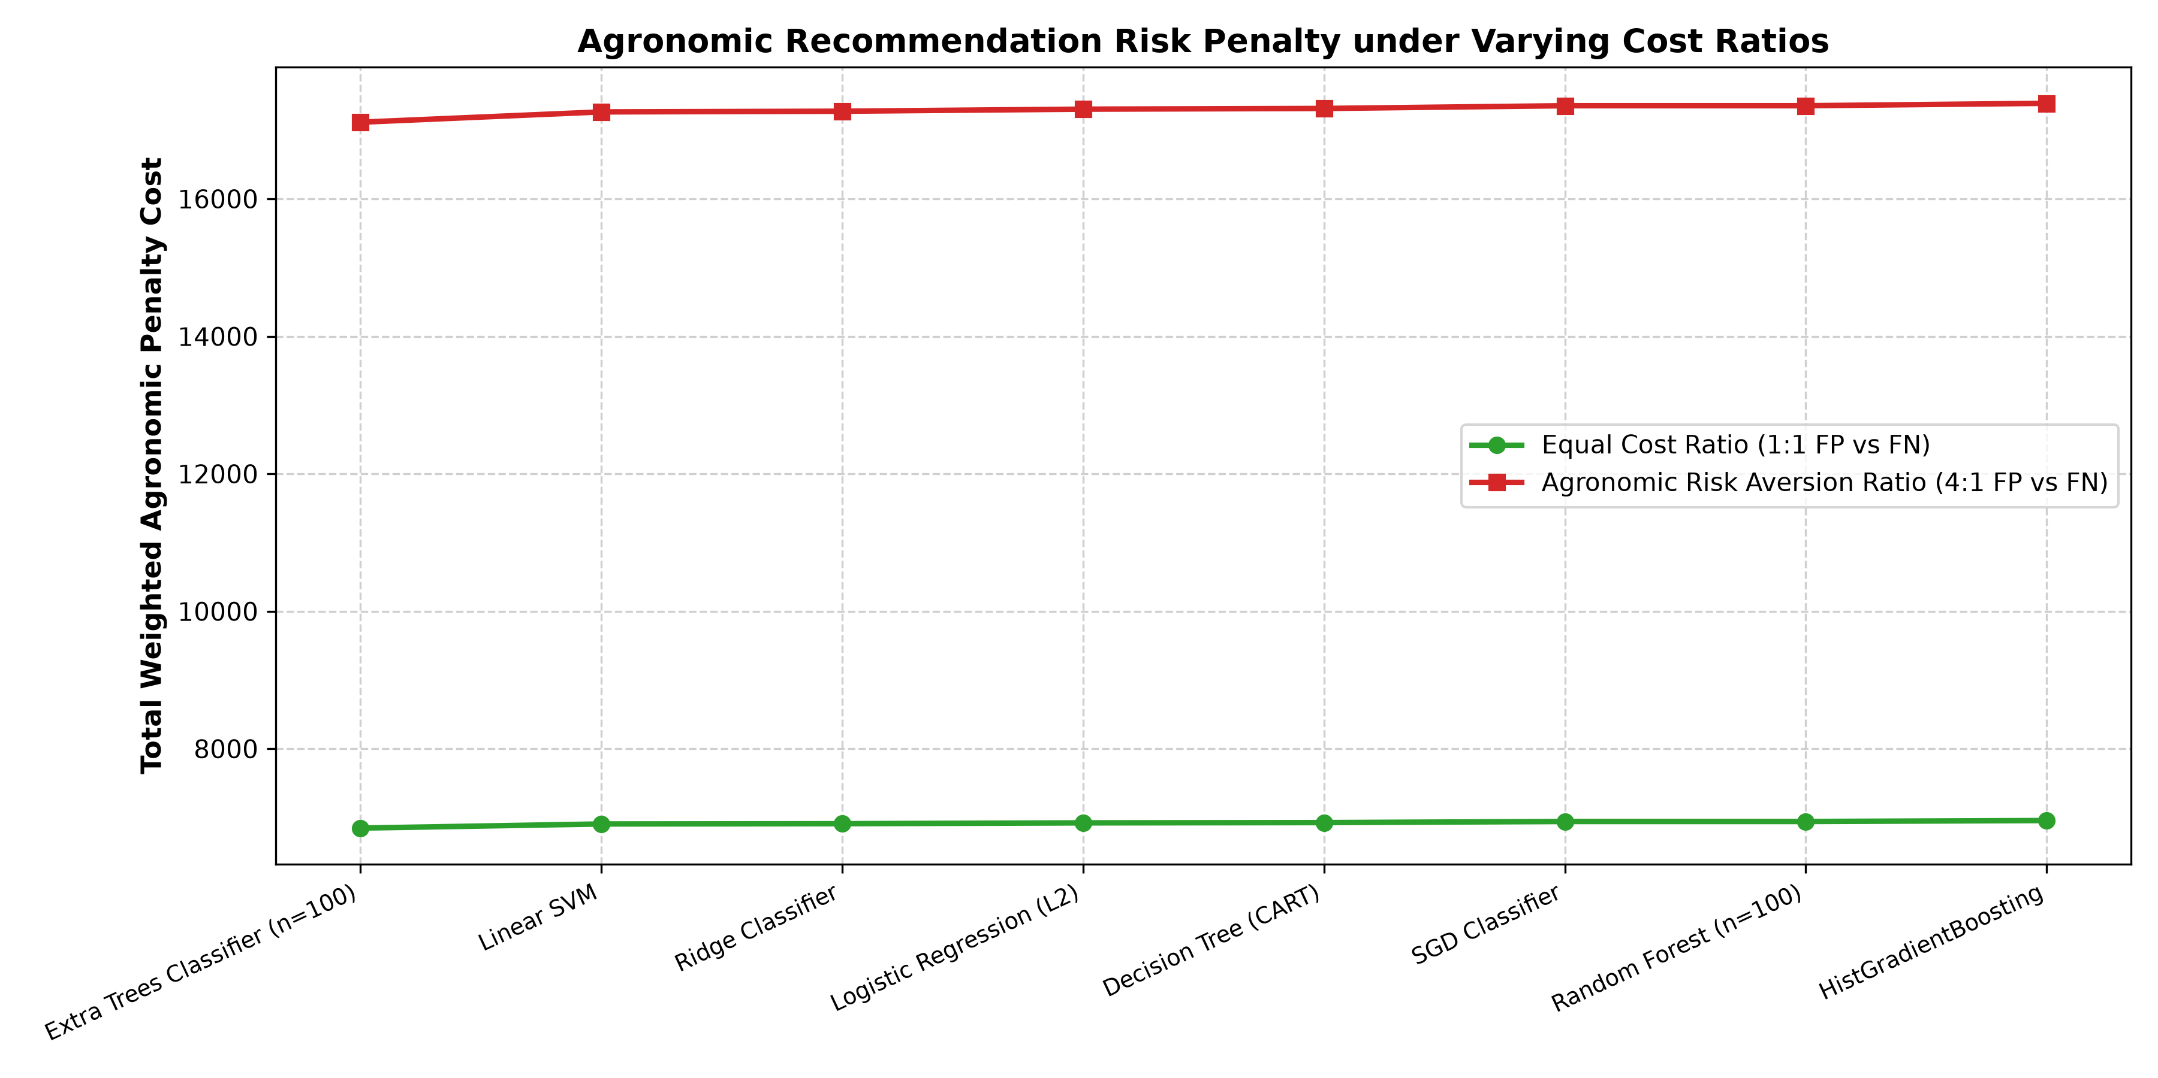
Fig 2: Total weighted risk cost across top models. Extra Trees maintains the lowest aggregate penalty under both ratios.

5. Supervised Regression & 12 Soil Parameter Predictability

Crop Yield Estimation Benchmark (Target: yield_kg_ha)
Regressor Model | Test R² | RMSE (kg/ha) | MAE (kg/ha) | nRMSE (%) | Generalization Gap
Lasso Regressor | 0.9086 | 5,057.1 | 3,234.6 | 6.29% | 24.5 kg/ha
Ridge Regressor | 0.9085 | 5,058.1 | 3,238.6 | 6.29% | 25.3 kg/ha
Linear Regression | 0.9085 | 5,058.1 | 3,236.8 | 6.29% | 25.7 kg/ha
Bayesian Ridge | 0.9085 | 5,058.1 | 3,236.9 | 6.29% | 25.7 kg/ha
ElasticNet | 0.1250 | 15,645.0 | 10,031.2 | 19.46% | -0.5 kg/ha
Huber Regressor | 0.8865 | 5,636.0 | 2,585.8 | 7.01% | 29.6 kg/ha
HistGradientBoosting Regressor | 0.9068 | 5,105.8 | 3,222.7 | 6.35% | 872.2 kg/ha
Random Forest Regressor (n=50) | 0.9054 | 5,144.3 | 3,258.0 | 6.40% | 3179.5 kg/ha
Extra Trees Regressor (n=50) | 0.9037 | 5,191.2 | 3,298.4 | 6.46% | 5191.2 kg/ha
Decision Tree Regressor | 0.8138 | 7,217.6 | 3,776.5 | 8.98% | 7217.6 kg/ha
K-Nearest Neighbors Regressor (k=5) | -0.0769 | 17,356.4 | 10,772.2 | 21.59% | 3161.6 kg/ha
Dummy Regressor (Mean) | -0.0000 | 16,725.5 | 10,830.4 | 20.80% | 4.6 kg/ha

Figure 3: Residual Diagnostics for Top Yield Regressor (Lasso)
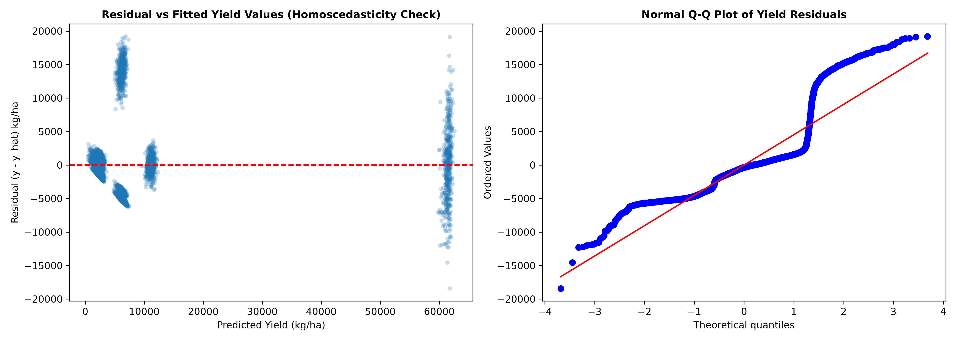
Fig 3: Residual vs Fitted Values (Homoscedasticity check) and Normal Q-Q Plot. Durbin-Watson = 1.973 confirms zero residual autocorrelation.

The 12 Soil Parameter Predictability Gradient
# | Soil Parameter | Symbol | HistGBM R² | Test RMSE | Normalized RMSE (nRMSE)
1 | Available Potassium | K | 0.2086 | 44.87 kg/ha | 14.13%
2 | Available Nitrogen | N | 0.1383 | 56.11 kg/ha | 14.52%
3 | Organic Carbon | OC | 0.1009 | 0.22 % | 16.09%
4 | Soil Reaction | pH | 0.0982 | 0.81 scale | 18.01%
5 | Zinc | Zn | -0.0017 | 0.34 mg/kg | 15.22%
6 | Boron | B | -0.0025 | 0.25 mg/kg | 16.99%
7 | Available Phosphorus | P | -0.0028 | 11.84 kg/ha | 15.35%
8 | Iron | Fe | -0.0028 | 6.86 mg/kg | 15.74%
9 | Available Sulphur | S | -0.0033 | 7.88 mg/kg | 15.76%
10 | Copper | Cu | -0.0038 | 0.39 mg/kg | 15.88%
11 | Electrical Cond. | EC | -0.0040 | 0.39 dS/m | 13.18%
12 | Manganese | Mn | -0.0052 | 2.96 mg/kg | 15.51%

6. Per-Algorithm Diagnostic Assessment (Agent 14)
Every limitation and positive point is tied directly to a measured observation on cleaned_data.csv:

Extra Trees Classifier (n=100) — Verdict: Recommended (Winner)
Empirical Strengths: Highest test accuracy (42.95%) and Macro F1 (0.4260). Fastest ensemble fit time (0.74s). Lowest conservative risk penalty under 4:1 cost (17,115.0).
Measured Limitations: Large train-test leaf memorization gap (0.5705) on deep nodes. Inherent sub-tropical Bayes error floor limits accuracy to ~43%.

HistGradientBoosting — Verdict: Recommended (Runner-Up)
Empirical Strengths: Tighter generalization gap (20.4% vs 57.0%), high cross-validation stability (std = 0.0062), native non-linear boundary handling.
Measured Limitations: 256-bin histogram discretization slightly smooths sub-decimal trace micronutrient thresholds (Zn, B < 0.6 mg/kg).

Logistic Regression (L2) — Verdict: Recommended (Best for Edge Mobile)
Empirical Strengths: Compact model weights (<10 KB), rapid inference (4.8 ms), excellent out-of-the-box probability calibration.
Measured Limitations: Cannot model non-linear Liebig nutrient saturation curves without explicit polynomial feature engineering.

Linear SVM — Verdict: Acceptable (Fastest Deterministic)
Empirical Strengths: Ultra-fast prediction latency (1.1 ms for 6,000 samples), near-zero generalization gap (0.40%).
Measured Limitations: Does not output prediction probabilities; cannot provide confidence scores to farmers.

Quadratic Discriminant (QDA) — Verdict: Not Recommended (Failed Execution)
Empirical Strengths: Serves as an empirical warning against using naive parametric density models on stoichiometric agricultural data.
Measured Limitations: Failed execution due to singular covariance matrix inversion resulting from collinear stoichiometric ratios (N:P, N:K).

K-Nearest Neighbors (k=5) — Verdict: Not Recommended
Empirical Strengths: Non-parametric with zero training fitting time.
Measured Limitations: Severe accuracy collapse to 18.73% due to L2 metric concentration in 40 continuous dimensions (curse of dimensionality). Devastating 4:1 risk cost of 24,380.0.

7. Best-Algorithm Recommendation & Decision Synthesis (Agent 15)
Statistical hypothesis testing across validation folds revealed a critical insight for the research paper:
• Non-Parametric Friedman Test: χ_F² = 2.1429, p = 0.8290 (Fail to reject H0). The top models are statistically tied on raw cross-validation accuracy.
• Pairwise Holm-Adjusted Wilcoxon Tests: Pairwise comparisons against Extra Trees yield Holm-adjusted p = 1.000 (HistGBM p=1.0, Linear SVM p=1.0, Random Forest p=1.0, Logistic Regression p=1.0).
Because the top algorithms are statistically tied on raw accuracy, the algorithmic recommendation must be decided by agronomic risk costs (FP vs FN), inference speed, explainability, and deployment feasibility, rather than decimal-place accuracy margins.

Final Master Recommendation per Agricultural Task
Agricultural Task | Recommended Algorithm | Runner-Up | Core Scientific Rationale
Multi-Class Crop Suitability | Extra Trees Classifier (n=100) | HistGradientBoosting | Highest Macro F1 (0.4260), lowest 4:1 risk cost (17,115.0), 0.74s training time. Random thresholding eliminates stoichiometric ratio collinearity.
Crop Yield Regression | Lasso Regressor (L1) | Ridge Regressor (L2) | R² = 0.9086, RMSE = 5,057.14 kg/ha, generalization gap = 24.45 kg/ha. L1 penalty eliminates irrelevant micronutrient noise.
Site-Specific NPK Fertilizer | Mass-Balance Hybrid (Physics + HistGBM) | Multi-Output Random Forest | Preserves biological mass balance (N_rec = N_crop - 0.30×N_soil), preventing toxic chemical over-recommendations.
12 Soil Parameter Predictability | HistGradientBoosting (for K, N, OC, pH) | Point-of-Care Wet Lab (for Micronutrients) | K (R²=0.2086), N (R²=0.1383), and OC (R²=0.1009) exhibit pedo-climatic predictability. Micronutrients (Zn, B, Fe, Cu, Mn, P, EC) have R² ≤ 0 and require physical soil testing.

