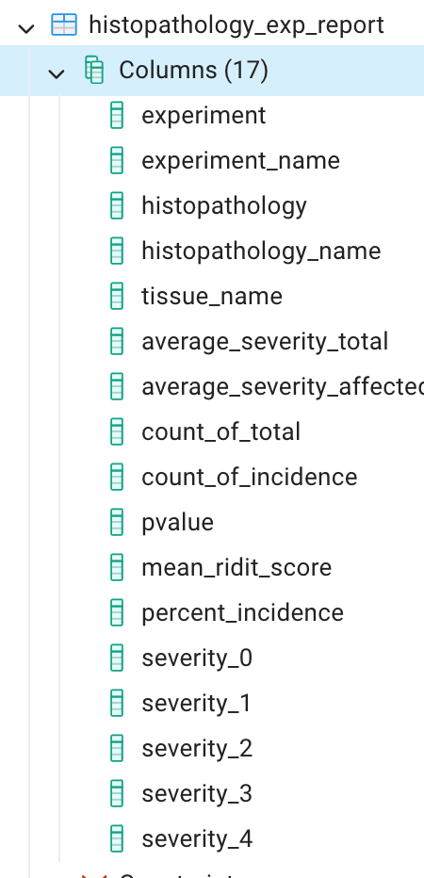

**Example 1:**

can you give the query for all script when gen name is 'interleukin 9 receptor' and tissue is 'HEART'

SELECT h.*

FROM "public".histopathology_exp_report h

JOIN "public".all_gene_fc g

ON h.experiment = g.experiment

WHERE g.gene_name = 'interleukin 9 receptor'

AND h.tissue_name = 'HEART';

there is no column "experiment" in the table "public".all_gene_fc g

SELECT h.*

FROM "public".histopathology_exp_report h

JOIN "public".all_gene_fc g ON h.histopathology = g.gene

WHERE g.gene_name = 'interleukin 9 receptor'

AND h.tissue_name = 'HEART';

**Example 2:**

Can you give me the experiment list of histopathology is 'HEPATOCYTE, MIDZONAL, NECROSIS, ONCOCYTIC' tissue is liver

SELECT DISTINCT experiment, experiment_name

FROM "public".histopathology_exp_report

WHERE histopathology_name = 'HEPATOCYTE, MIDZONAL, NECROSIS, ONCOCYTIC'

AND tissue_name = 'LIVER';

**Correct!**

**Example 3:**

Can you give me the experiment list of histopathology is 'HEPATOCYTE, MIDZONAL, NECROSIS, ONCOCYTIC' tissue is liver and gene 'ESTs (1372749_at)'

SELECT DISTINCT h.experiment, h.experiment_name

FROM "public".histopathology_exp_report h

JOIN "public".all_gene_fc g ON h.histopathology = g.gene

WHERE h.histopathology_name = 'HEPATOCYTE, MIDZONAL, NECROSIS, ONCOCYTIC'

AND h.tissue_name = 'LIVER'

AND g.gene_name = 'ESTs (1372749_at)';

Are you sure you want join those two table by h.histopathology = g.gene??

-- First, find experiments with the specified histopathology and tissue:

SELECT DISTINCT experiment, experiment_name

FROM "public".histopathology_exp_report

WHERE histopathology_name = 'HEPATOCYTE, MIDZONAL, NECROSIS, ONCOCYTIC'

AND tissue_name = 'LIVER';

-- Then, find experiments with the specified gene:

SELECT DISTINCT experiment, experiment_name

FROM "public".all_gene_fc

WHERE gene_name = 'ESTs (1372749_at)';

I found 'all_transcript_report' report has gene and gent_name also has tissue which is integer. Can you write query : Can you give me the experiment list of histopathology is 'HEPATOCYTE, MIDZONAL, NECROSIS, ONCOCYTIC' tissue is liver and gene 'ESTs (1372749_at)'?

SELECT DISTINCT h.experiment, h.experiment_name

FROM "public".histopathology_exp_report h

JOIN "public".all_transcript_report t ON h.experiment = t.experiment

WHERE h.histopathology_name = 'HEPATOCYTE, MIDZONAL, NECROSIS, ONCOCYTIC'

AND h.tissue_name = 'LIVER'

AND t.gene_name = 'ESTs (1372749_at)';

**Correct!**