🧩 Definition
The echo command in CMD allows us to display messages or save them into files.
Using this command, we can create secret message files, share them, and read them later without any special software.
It’s a simple way to store text securely using basic terminal commands.

🎯 Outcomes / Learning
By the end of this practical, we will be able to:
- Use echo command in CMD to create text files.
- Save secret messages into files through CMD.
- Open and read hidden messages directly from CMD.
- Understand basic command-line message handling.

🛠️ Required Tools
- Laptop/PC with Windows OS
- Command Prompt (CMD)
- Basic knowledge of file paths

⚙️ Working Steps
Step 1:
Open Command Prompt on your computer.
You can press Win + R, type cmd and press Enter.
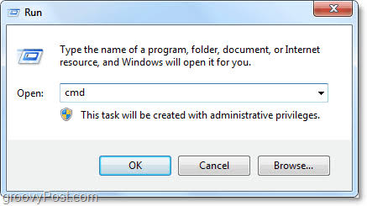

Step 2:
Navigate to the folder where you want to create the secret message fil
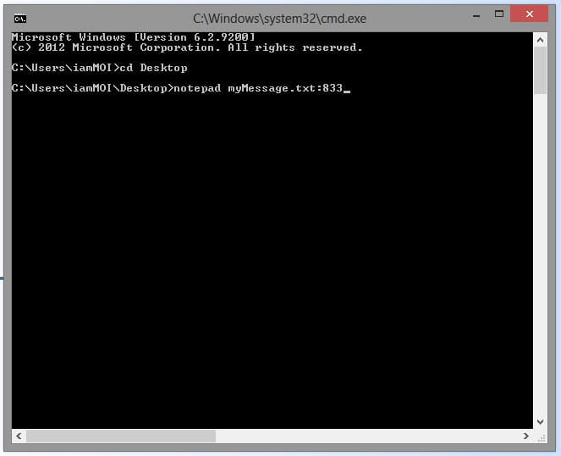

Step 3:
Type the following command to create a message file:
: ✅ This will create a file named message.txt containing the text: “This is my secret message”.


Step 4:
To check if the file is created, type:
You will see message.txt in the list.
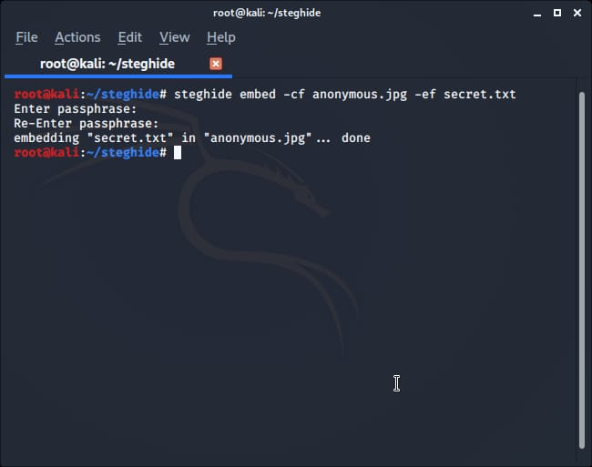

Step 5:
To read the hidden message, type:
✅ Your secret message will be displayed in the terminal.
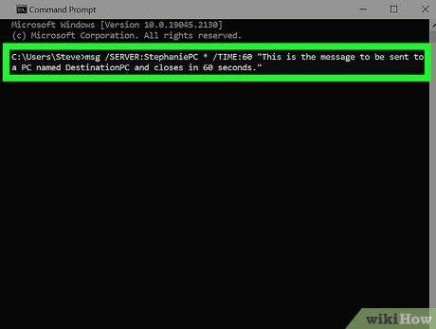

Step 6 (Optional):
You can send this message.txt file to anyone.
When they open CMD and use:
They will see the secret message you wrote.
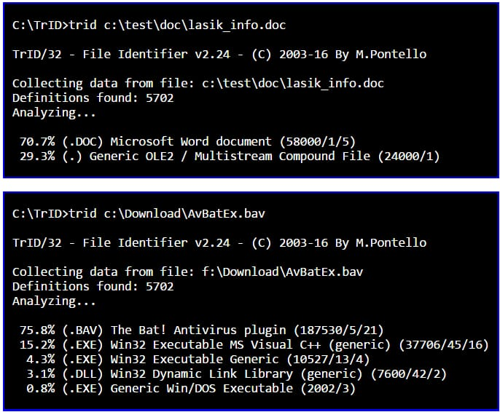

Step 7 (Conclusion):
We successfully created, saved, and read secret messages using the echo command in CMD.
No external software was required — only basic terminal commands.
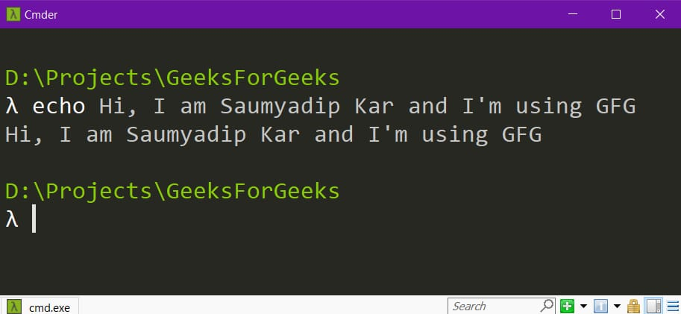

👨‍💻 Project Info
Created by: Himanshu Sahanii
Roll No: 1250264042
University: BBD University
Course: BCA Cybersecurity and Forensics

