**Pneumonia**

‘Pneumo’ comes from ancient greek work “pneuma”, means breathe. Pneumonia defined as infection of lung parenchyma. Parenchyma means functional part of an organ, supporting structure is known as stroma made of connected tissues.

Pneumonia can develop in person without pre disposing factors, however factors are present chances of pneumonia increases. Two factors that causes pneumonia are impaired defence and decreased host resistance. Pneumonia is one of the most significant causes for mortality of children under five. It kills more children under five than any other disease. It’s a very serious issue.

Pneumonia affects the lungs but it is a little more than only lung infection. In our right lung we have three lobes- upper, lower and middle, while in our left lung we have only two- upper and lower. When we breathe in air, the air travels along the smaller branches that branch off and at the end we see some tiny grape like air sacs, these sacs are called alveoli. Alveoli is the air sac where gas exchange happens and this is where oxygen ends up and carbon di oxide is given out. Underneath these alveoli lies blood vessels and lung tissues. Whenever an individual suffers from pneumonia, the infection is in alveoli. In a human body anytime when infection is caused an inflammation occurs. Thus when an infection occurs in alveolar tissue, the tissue inflames and leaks green fluid in air sac. In alveoli gas exchange takes place, the oxygen is carried by the blood to the body tissues. The oxygen from the air diffuses through the walls of alveoli and capillaries. In capillaries this block stops absorption and also blocks exhalation of carbon-di-oxide. If some person has pneumonia, we see air sacs are occupied by this infectious material.

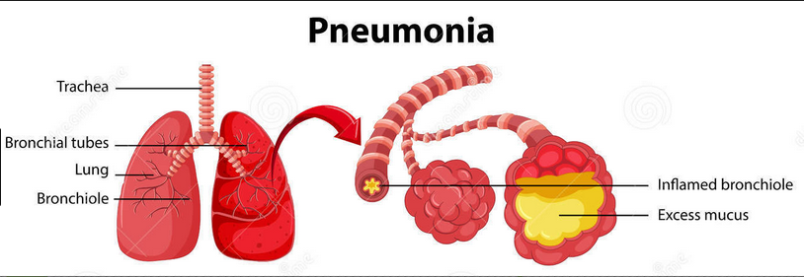

**Symptoms -**

As we see there is a block in gas exchange, it causes shortness of breath, known as dypsnea. We also see chest pain as the inflammation in alveolar tissue causes it. As it becomes important for the body to cough out this inflammated green liquid, which is being removed by coughing. We also see fever as one of the main symptoms as the body observes infection in lungs resulting in some attack and increasing body temperature as its defence mechanism. The most common symptoms of pneumonia can include dypsnea, chest pain, coughing and fever.  
Additional symptoms can vary according to the cause and severity of the infection, along with the health and general health of the individual. The symptoms are categorised into two groups by age and by cause. In age group lies children below 5 years. Children under 5 years of age have fast breathing issue. Also, the infants might vomit , they can lack energy or have high trouble drinking or eating.  
Additionally, the symptoms can also be divided into groups like symptoms by causes. Here, the organism that enters the body is a differentiator. For instance, viral pneumonia starts with symptoms which are similar to flu such as wheezing. Wheezing is basically breathing noisily and gasping for breath. While, bacterial pneumonia causes a fever as high as 105°F. It also causes profuse sweating, confusion and bluish lips.

**Different types of pneumonia based on underlying cause -**

The major types of pneumonia can be classified by the cause of the infection, where the infection was transmitted, and how the infection was acquired. For instance, when pneumonia is caused by germ like bacteria, viral or fungal. Now if the infection is caused by bacteria it is called bacterial pneumonia. The most common cause of bacterial pneumonia is Streptococcus pneumoniae. Chlamydophila pneumonia and Legionella pneumophila. If the organism is caused by some virus it is named as viral pneumonia. Often the cause of pneumonia is viral pneumonia especially in young children and elder people. It is not usually serious and the period for which it exists is shorter than bacterial pneumonia. Not always pneumonia is caused by viruses and bacteria, but by organisms like mycoplasma. Mycoplasma organisms are not viruses or bacteria but they qualities that are similar to bacterial and viral pneumonia. This is type is called mycoplasma pneumonia. Coccidioides fungi also causes pneumonia, fungi from soil or bird droppings have fungi which can cause pneumonia in people who inhale large amounts of the organisms. There is also aspiration pneumonia which is caused when person breathes food, liquid, or stomach contents into the lungs. It is not contagious.  
  
Pneumonia can also be classified as per the location as in where it was acquired. It is mainly of two types hospital-acquired pneumonia(HAP). This particular type of pneumonia is caused when patients is being treated in a hospital for other conditions. It is more serious as compared to other types as the bacteria which stays in hospital could become more resistant to antibiotics. For example, those attached to a respirator, or breathing machine. The second type would be community-acquired pneumonia(CAP), this denotes to pneumonia that is attained outside of a medical or institutional setting.

**Methods of Diagnosis or labs**Pneumonia can be diagnosed by physical examination or chest X-ray but depending on the severity of the symptoms and risk of complications, doctor may ask for one or more of the tests like blood test. This test can confirm an infection, but it may not be able to identify what’s causing it. It is done to find the virus or bacteria causing the infection. Sputum test, this test can provide a sample from your lungs that may identify the cause of the infection. Another test is [pulse oximetry](http://www.healthline.com/health/normal-blood-oxygen-level), an oxygen sensor placed on one of your fingers can indicate whether your lungs are moving enough oxygen through your bloodstream. Also, urine test, this test has capability to identify the bacteria *Streptococcus pneumoniae* and *Legionella pneumophila*. A CT scan is a test carried to get a clearer and more detailed picture of your lungs. As a CT scan shows tissues which a chest X-ray won’t show. A chest x-ray is also asked for to look inside patient’s chest as to visualise the fluid level found in alveoli. Another lab test carried is [Fluid sample](http://www.healthline.com/health/pleural-fluid-culture), if your doctor suspects there is [fluid in the pleural space](http://www.healthline.com/health/pleural-effusion) of your chest, they may take fluid using a needle placed between your ribs. This test can help identify the cause of your infection. Also, [bronchoscopy](http://www.healthline.com/health/bronchoscopy), this test looks into the airways in your lungs. It does this using a camera on the end of a flexible tube that’s gently guided down your throat and into your lungs. Your doctor may do this test if your initial symptoms are severe, or if you’re hospitalized and your body is not responding well to antibiotics.

**Methods of treatment**

Treatment will depend on the type of pneumonia you have, how severe it is, and your general health. The methods of treatment involve prescribed treatment, hospitalization and home treatment. Prescribed treatment the antibiotic, antiviral, and antifungal drugs are used to treat pneumonia, depending on the specific cause of the condition. Most cases of bacterial pneumonia can be treated at home with oral antibiotics, and most people respond to the antibiotics in [one to three days](https://www.nhlbi.nih.gov/health/health-topics/topics/pnu/treatment). Over-the-counter (OTC) medication to relieve your pain and fever, as needed. These may include aspirin, [ibuprofen](http://www.healthline.com/drugs/ibuprofen/oral-tablet) (Advil, Motrin), and [acetaminophen](http://www.healthline.com/drugs/acetaminophen/oral-tablet) (Tylenol). In Hospitalization the symptoms are very severe or you have other health problems, you may need to be hospitalized. At the hospital, doctors can keep track of your heart rate, temperature, and breathing. In hospital, [**intravenous antibiotics**](http://www.healthline.com/health/intravenous-medication-administration)are introduced into your vein. [**Respiratory therapy**](http://www.healthline.com/health/what-is-a-respiratory-therapist#overview1)uses a variety of techniques, including delivering specific medications directly into the lungs. The respiratory therapist may also teach you or help you to perform breathing exercises to maximize your oxygenation. While, [**oxygen therapy**](http://www.healthline.com/health/oxygen-therapy)helps maintain the oxygen level in your bloodstream. You may receive oxygen through a nasal tube or a face mask. If your case is risky, you may need a ventilator (a machine that supports breathing). In Home Treatment you can help your recovery and prevent a recurrence by taking your drugs as prescribed, getting a lot of rest, drinking plenty of fluids and not overdoing it by going back to school or work too soon.

**How to Prevent Pneumonia** People above age 65 should take vaccine to prevent pneumonia, patients with underlying disease heart or lung disease will require re-dosing. Also, re-dosing will be needed for patients already having any immune deficiency diseases. A single dose for other normal conditions are sufficient.

If pneumonia is not treated abscess (a cavity within the lungs) formation. This infection may also spread causing pleural cavity empyema. Pleural cavity empyema is a collection of pus in the cavity caused by microorganisms. The infection can spread via blood to other organs which is then spread to heart pericardium or kidney joint causing a lot of problem leading to arthritis or meningitis. It is important to treat pneumonia properly as it can go to complicated stages. Important vaccines include pnemococcal vaccine which would be the first line of defence against pneumonia. The two types of vaccines found in United States are Prevnar 13 and Pneumovax 23. In Preynar 13, this vaccine is effective against 13 types of pneumococcal bacteria. The [Centre for Disease Control and Prevention (CDC)](https://www.cdc.gov/vaccines/vpd/pneumo/public/index.html) recommends this vaccine for babies and children under the age of 2 and adults ages 65 years or older and people between ages 2 and 65 years with chronic conditions that increase their risk of pneumonia. While Pneumovax 23 vaccine is effective against 23 types of pneumococcal bacteria. The Centre for disease control (CDC) recommends it for adults ages 65 years or older and adults ages 19–64 years who smoke and people between ages 2 and 65 years with chronic conditions that increase their risk of pneumonia.

**Other prevention tips**

These include in addition to vaccination. There are other things you can to avoid pneumonia like if you smoke, try to [quit](http://www.healthline.com/health/quit-smoking) smoking as it makes you more vulnerable to respiratory infections, particularly pneumonia. Always wash your hands regularly with soap and water. Cover your coughs and sneezes by tissues, and dispose of used tissues promptly. Always maintain a healthy lifestyle to strengthen your immune system. Get enough [rest](http://www.healthline.com/health/sleep-disorders-prevention) when sick, eat a [healthy diet](http://www.healthline.com/health/balanced-diet), and get [regular exercise](http://www.healthline.com/health/fitness-exercise).

**Risk involved in pneumonia**Anyone can get pneumonia, but as per statistics definite people are at higher risk like infants from birth to age 2 years, and individuals ages 65 years or older, people who have had a [stroke](http://www.healthline.com/health/stroke-types), have problems swallowing, or are bedridden, people with weakened immune systems because of disease or use of medications such as steroids or certain cancer drugs. People who smoke, abuse certain types of illicit drugs, or drink excessive amounts of alcohol. People with definite chronic medical conditions such as [asthma](http://www.healthline.com/health/asthma), [cystic fibrosis](http://www.healthline.com/health/cystic-fibrosis), [diabetes](http://www.healthline.com/health/diabetes), or [heart failure](http://www.healthline.com/health/heart-failure)

**Statistics showing people morbidity rate based on age, economic status**Elderly People at Greater Risk  
Frailty  
Older people are simply more weak than younger individuals are. Frailty doesn’t boil down to a single disease or diagnosis, though. One study describes this condition as a data represent adults aged 65+ who report having ever had a pneumonia vaccine. Percentages are weighted to reflect population characteristics, please refer Figure2.

Seniors may have other ailments, such as diabetes, Parkinson's disease, Alzheimer’s disease and heart disease, which put them at a higher risk for developing pneumonia. Lung conditions like cystic fibrosis, asthma, COPD (chronic obstructive pulmonary disease) and bronchiectasis contribute significantly to this risk as well

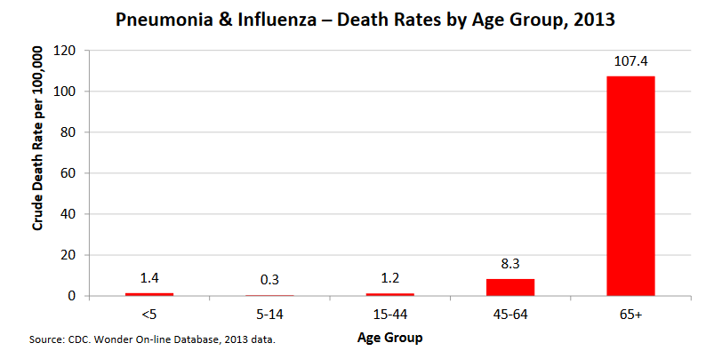  
Figure 2. Death rates by Age group

1. **Cost associated with treatment of Pneumonia**

Price of treated largely contrasts with the age, risk-status of pneumonia and whether have got inpatient or outpatient treatment. For a survey showed with patients having age more than 50 in year 2013. In this survey the inpatient treatment costed $11,148 although the outpatient Treatment costed $51,219. The total direct health care cost of pneumonia is expected to increase from $216.2 million in 2010 to $532.2 million in 2025. Incidence rates are forecast to rise nearly 20 per cent among those aged 75 and older over the forecast period

**Devices developed to treat pneumonia**

**Pneumonia Diagnostic Device**: Philips has launched a wearable diagnostic device to fight children’s pneumonia, as pneumonia is responsible for 15% deaths in children younger than 5 years, close to a million in 2015. This device estimates to end childhood deaths by 2025.   
It measures breath sounds of patients which are diagnosed to have pneumonia. This device could have a huge impact on healthcare in low resource countries.  
A common symptom of childhood pneumonia is fast breathing. Healthcare workers in low resource areas use acute respiratory infection timer and counting breaths to measure severity of pneumonia which is not reliable. They are also trained to differentiate between pneumonia and common cold by listening to breathing and coughing sounds. This device makes diagnosing pneumonia less subjective. Rather than listening for breaths, the CARM converts chest movements to breath counts using algorithms.

**Unyvero pneumonia application**

This is a time saving and safe solution application for comprehensive answers. Here, clinicians can make faster and more targeted treatment decisions for infections and a inflammations. Unyvero provides information on pathogens and resistances within only 4-5 hours thereby allowing timely adjustment of treatment. Thus leading to faster medical care for patient. It also allows “point of need” tests around the clock, seven days a week. Unyvero System can be placed in the intensive care unit at “point of need”, no need to transport samples long distance. It can also be used on patients on whom treatment has already started.

**Bone suppression tool**  
This tool helps find pneumonia in chest x-rays. Bone supressing image processing improves radiologists accuracy in identifying focal pneumonia. Bone suppression imaging software (SoftView version 2.2, Riverain Technologies) was applied to the resulting 56 chest x-rays and the results had better efficiency with the tool.

**Emerging technologies**

**SthethoCloud via Singularity Hub**

In this app, a health worker with minimal training grabs the patient phone and plugs the stethoscope attachment. It will ask how long the patient was sick, then prompts to check abnormal breathing with video clips to demonstrate how to breathe. As breathing rate in normal children is between 20 and 40 breaths per min. The worker records the breathing and uploads the sound file. The app algorithm counts the breath rate and returns a diagnosis with treatment instructions. The app will be attractive to various caregivers as it will give various advantages like convenience to do the test anywhere, avoiding exposure of pathogens.

**Mamaope medical smart jacket**

When we use a stethoscope it only checks the lungs, but pneumonia tends to be on side points of body not only in chest or back. Mamaope focuses more on distinguishing between malaria and pneumonia, as in many cases misdiagnosis is the factor of death.

**INSPIRE**  
A Spanish company, Libelium, developed an IoT device called INSPIRE to meet challenges faced like early detection of pneumonia. Even non skilled workers can easily analyse breathing in children using this device.

**Medgadget**

Medgadget tackles aspiration pneumonia and ventilator pneumonia. The system uses sensors that are located on smart sensor-based tubes that give real-time feedback and thus actions can be taken by alerting nurses or physician. It actually simplifies the chaos of the ICU, since it offers advanced results using the standard of care procedures that are currently used.Maedgadget's smART system, some procedures are done automatically and could not have been carried out otherwise due to real-time continuous monitoring

**ResApp Health**  
It is developing a smartphone application which uses machine learning algorithms to detect and measure the severity of respiratory conditions without any need of hardware. The app will have both adult and clinical studies with results showing accurate diagnoses.

**inScale APE CommCare**  
The app will ask many questions about the symptoms, also it uses a unique counter that helps check the respiratory rate of the child. If pneumonia is diagnosed, the app provides educational instructions. Recommendations are also provided for visits and referrals. Diagnosis and vaccination status is stored on the phone with aggregated weekly data for consultation. After submitting this data a feedback is also received. Periodic motivational messages increase the coordination. Also, here you get a monthly credit so that each patient can make a call thus improving performance.   
The app is focused with children, pregnant women and new-born’s thus improving the community standing. The issue faced by this app is that the target audience were unaccustomed to use smartphones and thus requires training for the application.

STAR Analytics Services  
Here, American and Australian scientist allows to cough into iPhone’s microphone to get an diagnosis, what the patient is suffering from flu or pneumonia or is healthy and has common cold. This coughing sound is compared with various respiratory disorders.

**On-going research work**

Researchers at Zurich are working on developing an app which measures breathing rate as observing breathing rate is an important indicator in diagnosing pneumonia. Here, instead of breath counter, we have to keep tapping the app when the chest rises and fall, we can also record rates for a particular date and then later compare it for other days. They are planning to include an instrument, pulse oximeter which measures oxygen saturation which is a goos indicator of severe pneumonia. It also includes a sensor attached to finger which uses infrared to measure levels of oxygen in the blood.

**Social Interactions**

Social websites like <https://www.patientslikeme.com> help patients live better and uncover ways to manage health. They also help researchers shorten the path to new treatments. This website helps patients track how they are doing over time, help the next person diagnosed learn.

Online Discussion Forums   
Websites like <http://lungfoundation.com.au/patient-support/> , information contained on this website educates the patients about lung diseases, it’s treatment and issues related with them. Also, events, webinars are conducted, patients share their stories via this portal.

Support Groups  
There are various support groups like https://support.dailystrength.org in which patients could post their daily issues and their fellow patients could share their experience or could advise appropriately. These support groups also contain daily strength tutorials which tell what do when crisis occur.

Safer alternative to lung ventilators  
Engineers at Draper Laboratory have thought of using chip technology to precisely mimic blood vessels in the lungs to treat patient of lung failure. It recreates important characteristics of structures in the lung. It is asafer alternative to respiratory or cardiac machines. It will not require patients to take a lot of blood thinners, it would be much safer.  
  
**Patent Papers**  
The Community-Acquired Pneumonia (CAP) is a disease frequently detected in hospitals demanding suitable treatment. This paper presents a mobile application system for diagnosis and management of community-acquired pneumonia so as to solve the CAP’s diagnosis process problem. According to these risks, it is decided that the patients requires hospitalization or not. IEEE published paper “A Mobile Application System For Diagnosis and Management of Community-Acquired Pneumonia” proposes a mobile application for diagnosis and management of CAP. This app for patients delivers rapid diagnosis and accurate identification of treatment. For clinicians, diagnosis mistakes can be avoided. The paper also implements an algorithm for treatment of pneumonia according to etiology. As per 20 variables related to patient characteristics every patient is assigned a score which is then categorized into 5 groups using risk stratification. From a medical perspective, handling high amount of variables needed for CAP’s diagnosis process is a problem due to the significant number of patients in nowadays hospitals and the difficulty of a physician to apply the knowledge in real-time for each patient what leads to delays and imprecisions in diagnosis. Thus, quick and precise diagnosis, besides medical penetration in hospital environment are important factors to deal with the CAP’s diagnosis process problem.

**Sentiment Analysis**

A sample of 150 reviews were collected from drugs.com and webmd.com for analysis, to see how are user’s reacting to the vaccine or medication used for pneumonia

|  |  |
| --- | --- |
| **Vaccine/Drug** | **Sentiment Score** |
| Azithromycin | -0.1119 |
| Levoflaxocin | -0.223 |
| Pneumovax | -1.997 |

Table1: Sentiment Analysis

First, Azithromycin was picked which showed the maximum sentiment score of -0.119 with least negative reviews. It had keywords like “better” in bold. Please refer Fig 1 and Fig 2. It is a recommended drug.

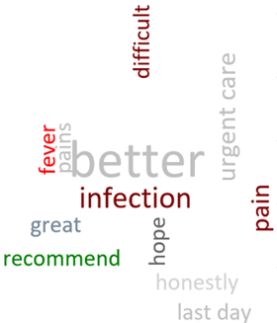

Fig 1: Azithromycin sentiment word cloud

We can see, from Fig 1 and Table1 that azithromycin had better reviews than Pneumovax and Levoflaxocin. Fig 1 has words like better highlighted which is a clear indication of it.

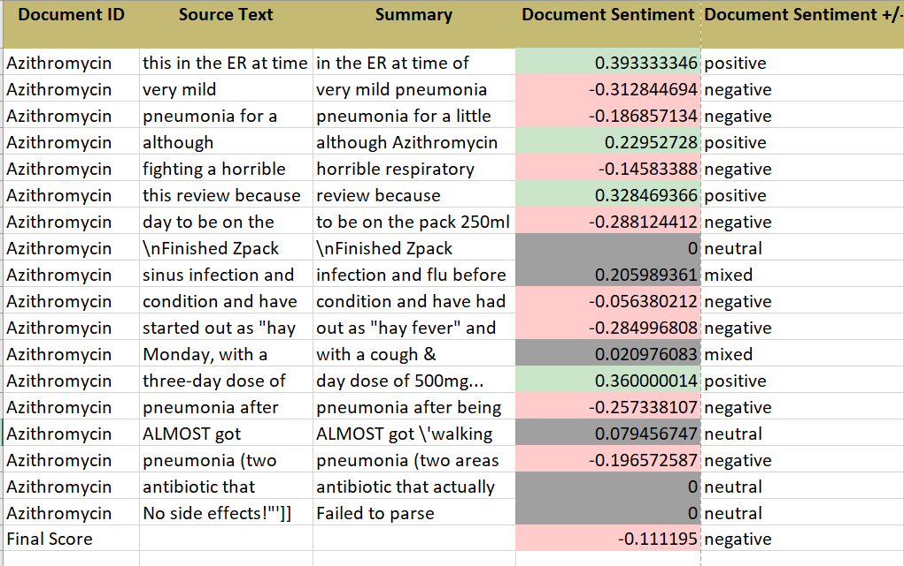

Fig 2: Sentiment Analysis for Azithromycin

.

Levoflaxocin

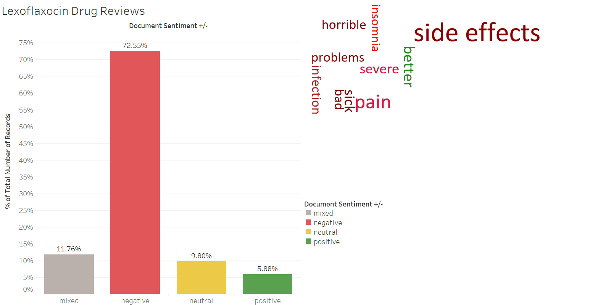

Fig 3: Levoflaxocin sentiment analysis

Here, in fig 3 the reviews were grouped into 4 catrgories mixed, negative, neutral and positive. A dashboard is presented to show that the negative reviews are approximately 72%. We can also infer from the word cloud that the drug has many negative reviews lik it is painful has side effects and causes infection.

Pneumovax

From table 1 and fig 4, we get that pneumovax has the least sentiment score. Lesser the score, more the negative reviews vaccine and drug has gained. For instance, pneumovax has various highlighted keywords like “side effects”, “overpriced”.

We can see from fig 4, that overpriced is highlighted to show that we will be using that particular feature later.

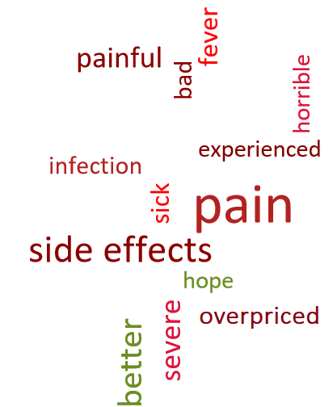

Fig 4: Pneumovax sentiment word cloud

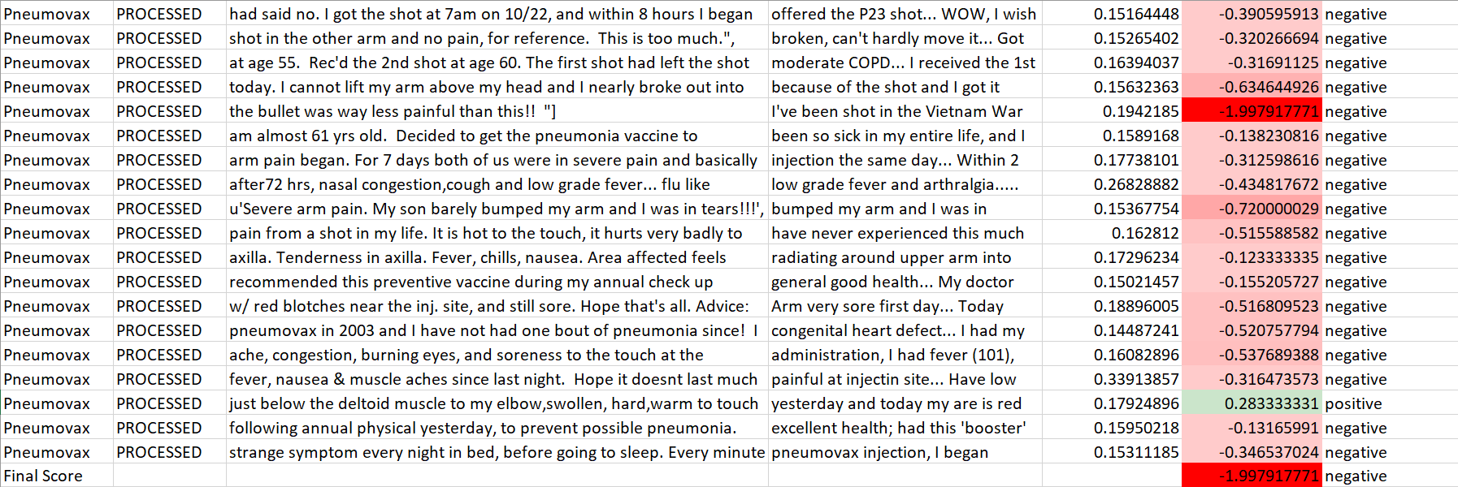

Fig 5: Sentiment score for pneumovax for every review which is then averaged

**Causes of death in pneumonia**

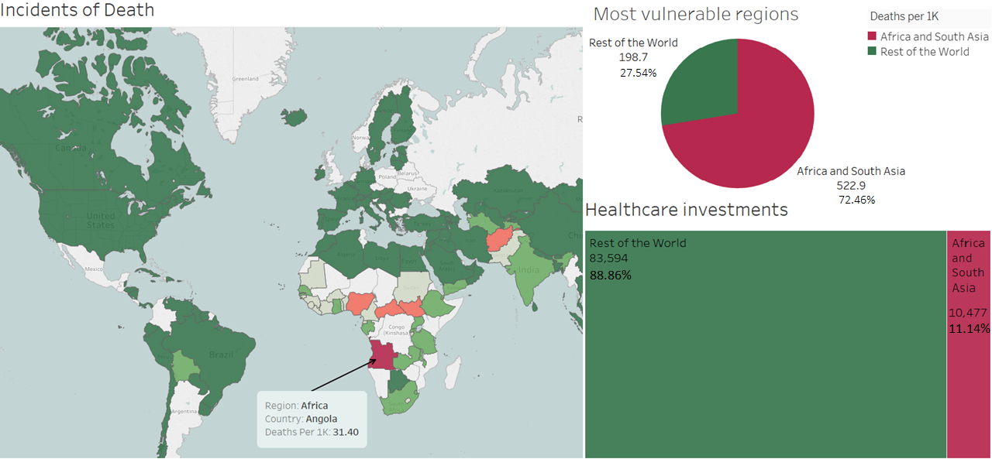

Fig 6: Mortality rates from pneumonia

From fig 6, we can see that infection disproportionately affects vulnerable people. We can see that the most vulnerable regions are Africa and South Asia who have the maximum incidents of death with Angola being the highest. Thus by looking at the world map we understand how prevalent this prevention of disease is.

Now let’s see what causes this disproportionality, what are the underlying factors behind the mortality due to pneumonia. A pie chart has been shown to show that the death incidents in MVR(must vulnerable region) is about 72%, while in heat map we understand how richer countries can afford better investments. About 12% healthcare investments are noticed in MVR. Thus, we can say that richer countries can afford expensive drugs, while poor countries.

Therefore, we can say that poverty lies at the heart of this issue. Effective social policies need to be implemented to have better healthcare investments in poor countries. Also other preventions such as having trained staff at local level will make a difference

There are various other factors that affect mortality from pneumonia such as child’s poor immunity. Child’s poor immunity through things like malnourishment causes pneumonia.

From fig 6 we saw lack of healthcare expenditure is also one of the reasons.   
Apart from that we also see that overpricing of drugs is also a cause from fig 4. Pricing strategies could be implemented to control the prices and make them available to the vulnerable regions.

Sanitation and hygiene is also observed to be one of the important issues to help children grow with cleaner local environments. In the following section we will see the effects of these causes on model.

**Building Model**

A predictive model using multiple linear regression model is built to be certain of the effect of these factors on mortality rate.

We have lack of expenditure, overpricing of drugs caught as features from our previous analysis.

A training dataset of 141 countries from Kaggle had been acquired to go ahead with the analysis. While cleaning the data we realised vaccine price had various missing values. From fig 7, we infer, about 57 records in grouping of vaccine prices were missing which is about 30% data was missing.

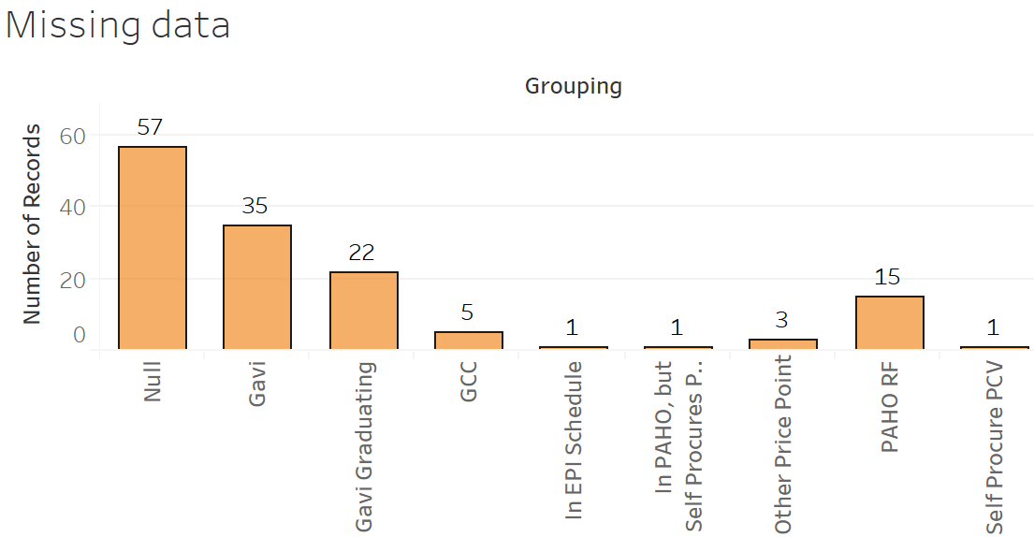

Fig 7: Missing records

To find those missing values, we saw fig 8 which showed that particular grouping like Gavi had similar prices. So the remaining missing values were filled using this method.

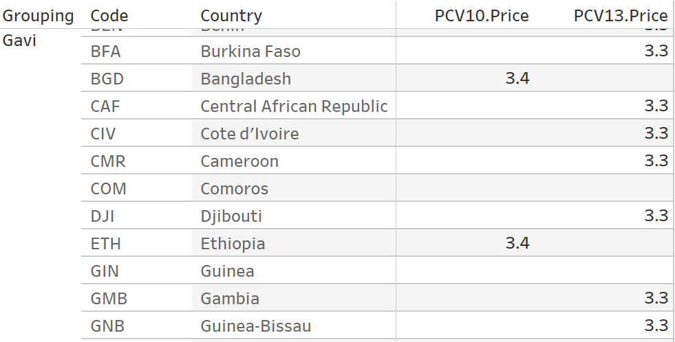

Fig 8: Price grouping for missing values

Then to proceed with building model, we first found the collinearity i.e. dependency of explanatory variables i.e. sanitation, PCV price (our vaccine) and government spending on response variable death rate. We see a moderately high collinearity between variables.

But still enough to proceed with the model, as the collinearity is still below 0.4. If collinearity ratio was higher, like we insert few more variables like children who are underweight or stunting found the rate increases. Thus, removing them from our analysis.

|  |  |
| --- | --- |
| **Response variable** | **Deaths per 1 k** |
| **Explanatory variables** |  |
| **Sanitation** | -0.399290 |
| **PCV 10 Price** | -0.32451 |
| **Govt usd 2000** | -0.365228 |

Fig 9: Collinearity between variables

We could also find other factors effect on response variable by removing multi collinearity.

Fig 10 contains regression statistics which shows significant p-value between variables.

|  |  |  |  |  |
| --- | --- | --- | --- | --- |
| **Variables** | **Coefficients** | **Standard Error** | **t Stat** | **P-value** |
| Intercept | 16.899 | 0.848 | 19.906 | 5.4532E-42 |
| **Sanitation.2013** | -0.157 | 0.01378 | -11.428 | 1.4034E-21 |
| **PCV10.Price** | 0.0127 | 0.01779 | 0.71915 | 0.0573290 |
| **Govt.usd.2000** | -0.000611 | 0.00062 | -0.9824 | 0.032763 |

Fig 10: Regression statistics

**Regression equation**

**Y= 16.899 +(-0.157)sanitation + (0.0127)PCV10 Price + (-0.00061) Govt usd**

**Y: predicted value(Mortality rate)**

Thus, from regression equation we conclude that decrease in sanitation or increase in vaccine price or decrease in government spending causes increase in mortality.

|  |  |
| --- | --- |
| **Coefficients** | ***Value*** |
| **Adjusted R Square** | 0.636 |
| **F value** | 81.44 |

Fig 11: Efficiency of model

We can see from Fig 11 the adjusted R square value is only 0.636, thus the efficiency of the model is pretty low 63.6 %. A better prediction model can be acquired by using advanced machine learning algorithms like SVM or KNN.

**Financial Analysis of vaccine Prernar 13(PCV-13) for pneumonia**

PCV-10 and PCV-13 are Pfizer’s product thus financial analysis on Pfizer. Pfizer is anticipated to come up with 7.1 billion U.S. dollars in vaccine revenues by 2022, mostly attributable to success with its pneumococcal vaccine, Prevnar 13. A vaccine usually contains associate degree agent that's made of a weakened style of a sickness germ, that's then accustomed stimulate the body's system to destroy and acknowledge the organism just in case of later exposures.

**Pfizer**Fig12 illustrates the highest 15 pharmaceutical product by sales worldwide in 2016. therein year, Pfizer's pharmaceutical product Prevnar 13 was graded tenth. Pfizer's 2012 vaccine revenue came in fourth with 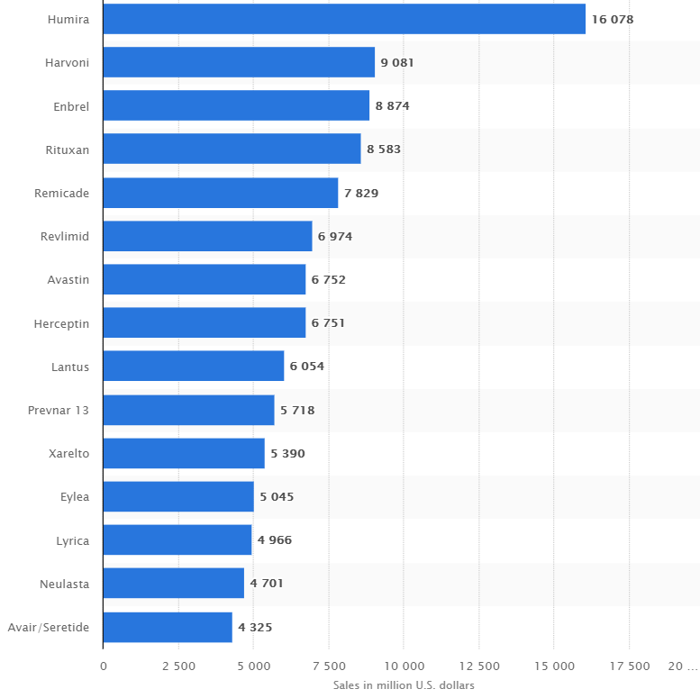$4.11 billion which has Prevnar 13 and its precursor Prevnar 10.

Fig. 12: PCV 13 vaccine is the 10th best selling product of Pfizer

**IT solution**

As we see some significant effect of sanitation effects on mortality, we go ahead to provide an IT solution to tackle sanitation issue in poor countries. Pay as you drink: eWATER’s initiative to extend the practicality of postpaid water sources. eWATER’s set up is to line up the “pay-for” facet as a mobile app, were credit is purchased at native stores, and used as phone credit works.

Since villagers are paying for it, while collecting water they take additional care not to spill any, thus fewer puddles within which mosquitos will breed.



Fig 12: Mock up screen for IT application

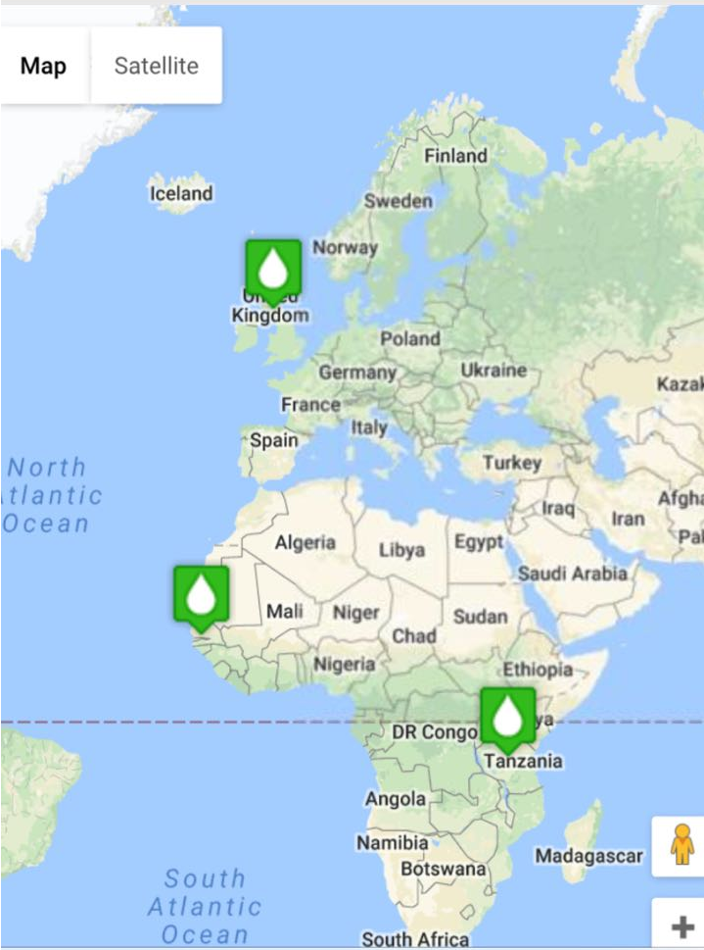

Fig 13: Mock up screen for IT application

Fig 12 and 13 have two mockup screens for eWater.

In fig 13. The location is specified basically water collecting centres

In essence, the entire report tells us the factors that predict deaths from pneumonia. Various parts are integrated to show the need to support poorer communities through health care attendants, building clean local environments.

References:

Orcutt, M. (2015, June 03). Artificial Lung Device Shows Promise in Treating Chronic Respiratory Conditions. Retrieved October 05, 2017, from <https://www.technologyreview.com/s/537911/new-device-could-be-a-safer-alternative-to-lung-ventilators>

Welfer, D., Silva, R. D., & Kazienko, J. (n.d.). A Mobile Application System For Diagnosis and Management of Community-Acquired Pneumonia. Retrieved October 04, 2017, from <http://ieeexplore.ieee.org/stamp/stamp.jsp?arnumber=7001865>

Hodsden, S. (n.d.). Philips Launches Wearable Diagnostic Device To Combat Children's Pneumonia. Retrieved October 04, 2017, from <https://www.meddeviceonline.com/doc/philips-launches-wearable-diagnostic-device-to-combat-children-s-pneumonia-0001>

FASTER DIAGNOSTICS HELPS SAVE LIVES. (n.d.). Retrieved October 04, 2017, from <http://www.unyvero.com/en/solution/applications-benefits/for-pneumonia.html>

App could help diagnose pneumonia. (2017, August 25). Retrieved October 04, 2017, from <https://www.greaterzuricharea.com/en/detail/app-could-help-diagnose-pneumonia-1>

App could help diagnose pneumonia. (2017, August 25). Retrieved October 04, 2017, from <https://www.greaterzuricharea.com/en/detail/app-could-help-diagnose-pneumonia-1>

E. (2017, July 31). ART MEDICAL's Technology to Prevent Pneumonia in ICU: Interview with CEO Liron Elia |. Retrieved October 05, 2017, from <https://www.medgadget.com/2017/07/art-medicals-technology-prevent-pneumonia-icu-interview-ceo-liron-elia.html>

A better way to provide drinking water in rural Africa. (2017, March 04). Retrieved December 17, 2017, from <https://www.economist.com/news/middle-east-and-africa/21717766-innovative-cure-broken-pumps-better-way-provide-drinking-water>