REST - Country Web Service:
- Created a Spring Boot project using Spring Initializr with the required Spring Web dependency and imported it into IntelliJ IDEA.
- Created the Country model class with code and name fields and configured the India country bean in country.xml.
- Configured the Spring Boot application to load the country.xml file.
- Created the CountryController and implemented the /country REST endpoint using @RequestMapping.
- Retrieved the India bean from the Spring application context in the getCountryIndia() method and returned it as the REST response.
- Ran the Spring Boot application on port 8083 and accessed the /country endpoint through the browser.
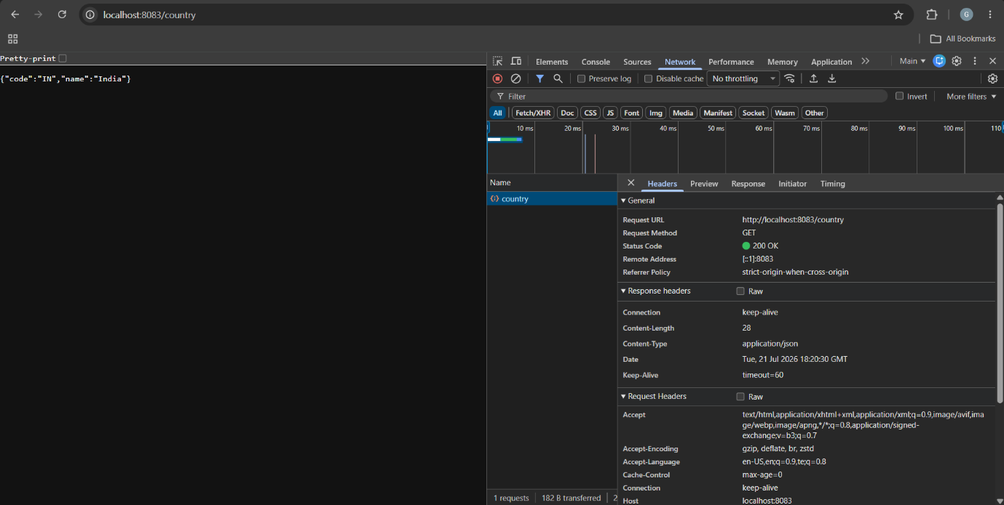
- Used the Network tab in Chrome Developer Tools to verify the GET request, HTTP status, headers, and JSON response containing India's country details.

