Hello World RESTful Web Service :
- Created a new Spring Boot project using Spring Initializr by selecting the required project details, adding the Spring Web MVC dependency, and downloading the generated project as a ZIP file.
- Extracted the downloaded ZIP file and imported the project into IntelliJ IDEA as a Maven project.
- Configured the application to run on port 8083 using the application.properties file.
- Created a controller package and added a HelloController.java class.
- Created a sayHello() method with @GetMapping("/hello") that returns the hard-coded text "Hello World!!".
- Started the Spring Boot application and tested the REST service using Google Chrome and Postman with the URL http://localhost:8083/hello.
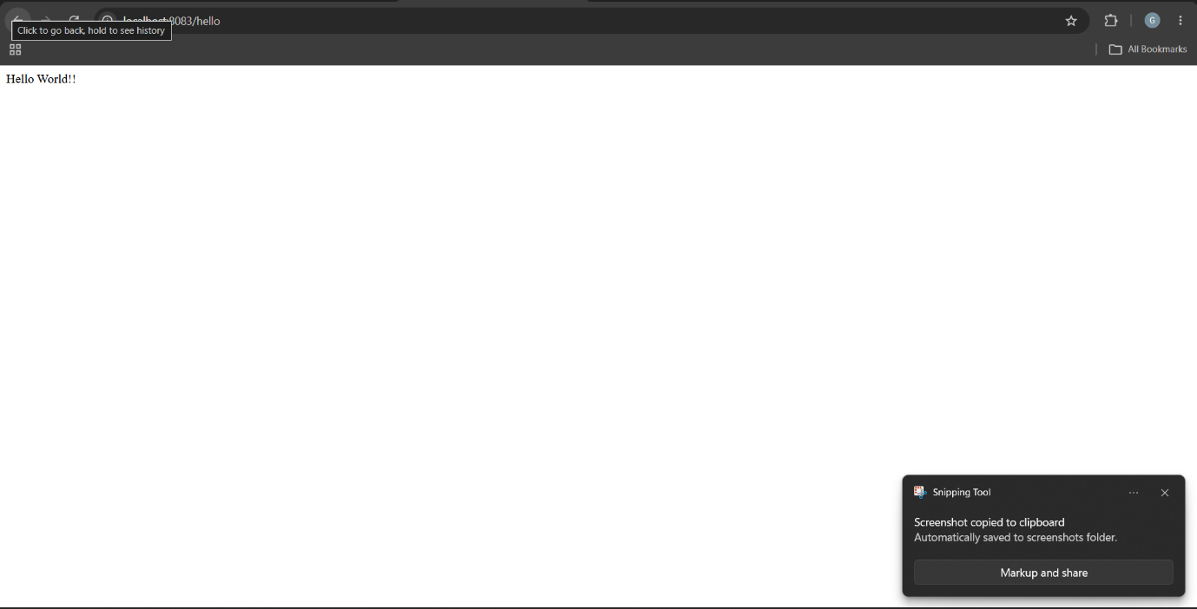
- Verified the response "Hello World!!", HTTP status 200 OK, and inspected the HTTP header details using Chrome Developer Tools and Since this is only a GET response verified it in Network tab in the inspect page section.

