Output:
Firstly, the dependencies are added to the pom.xml file to run the LoggingExample program
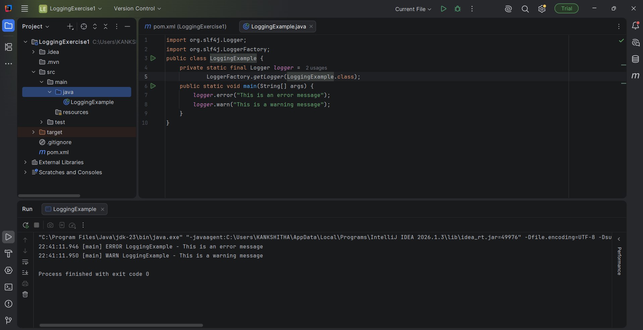
The output obtained is,

