- Opened Git Bash and moved to the existing Git repository using the cd command.
- Checked the repository status by using the git status command.
- Created a new branch named GitNewBranch using the git branch command.
- Listed all the available branches using the git branch -a command and confirmed the current branch.
- Switched to the new branch using the git checkout GitNewBranch command.
- Created a new file named branch.txt and added some sample text to it.
- Checked the repository status and verified that the new file was shown as an untracked file.
- Added the new file to the staging area using the git add command.
- Saved the changes by creating a commit using the git commit command with a commit message.
- Switched back to the master branch using the git checkout master command.
- Compared the changes between the master branch and the new branch using the git diff command.
- Merged the GitNewBranch into the master branch using the git merge command.
- Viewed the commit history using the git log --oneline --graph --decorate command.
- Deleted the merged branch using the git branch -d GitNewBranch command and finally checked the repository status using the git status command. This completed the branching and merging hands-on exercise successfully.

Commands used are:
cd <repository-folder>
git status
git branch GitNewBranch
git branch -a
git checkout GitNewBranch
git status
git add branch.txt
git commit -m "Added branch file"
git status
git checkout master
git diff master GitNewBranch
git difftool master GitNewBranch
git merge GitNewBranch
git log --oneline --graph --decorate
git branch -d GitNewBranch
git status
git push origin master

ssssOutput screens:
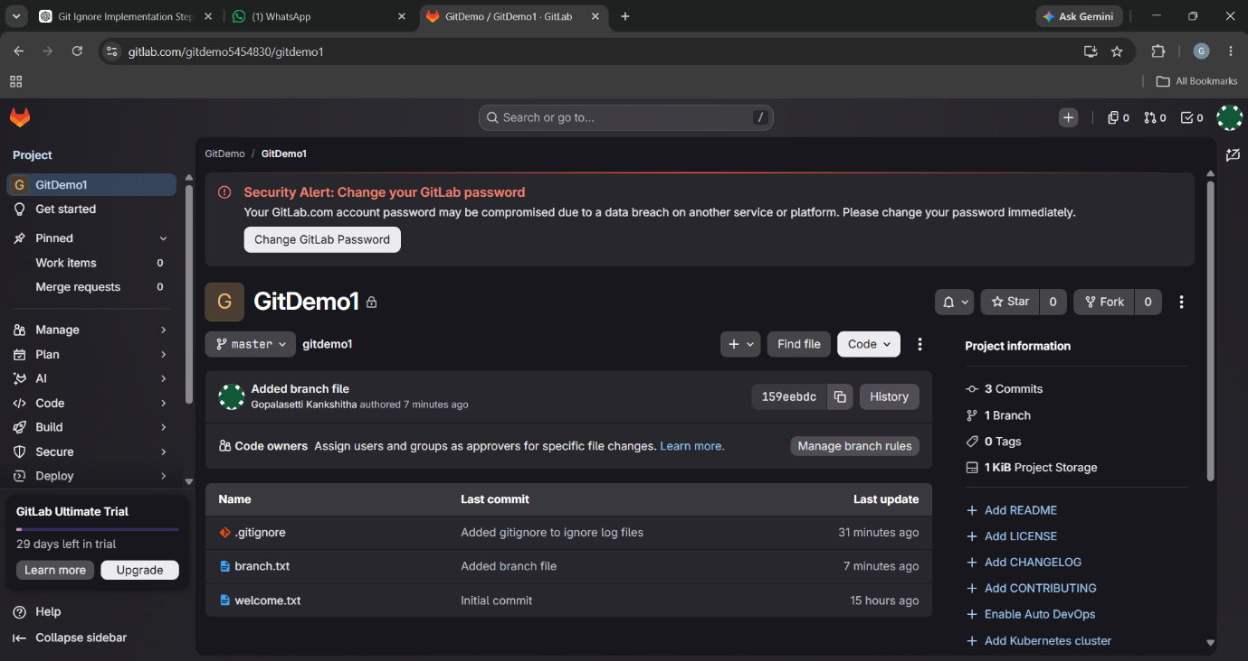

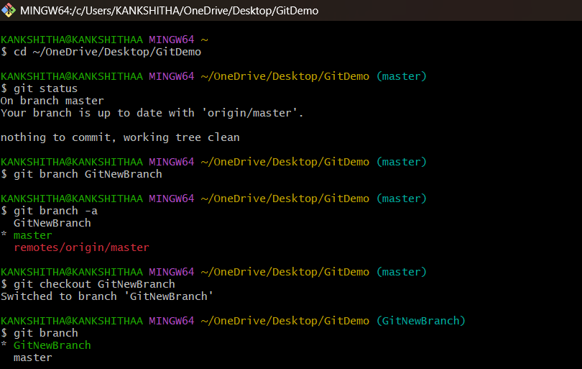
Branch Creation:

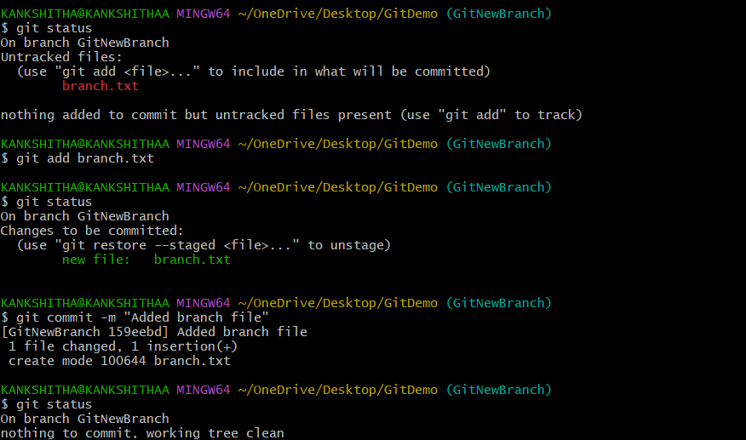
Commiting :

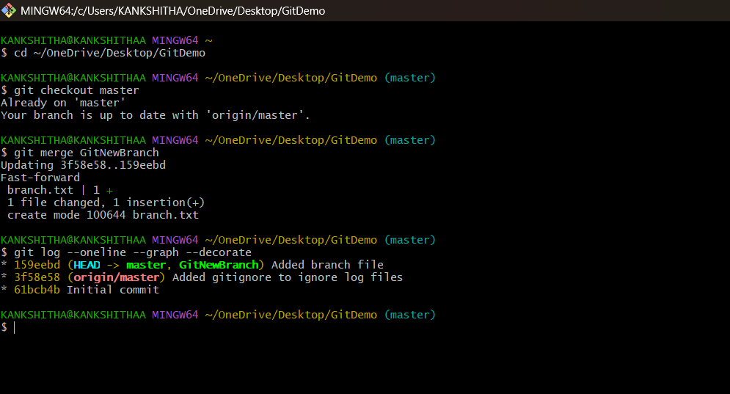
Merging branches:

Deleting the branch:
