OUTPUTS:
After Accounts table creation
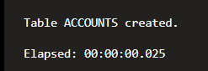
After Employees table creation
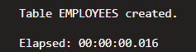
After inserting rows to Accounts
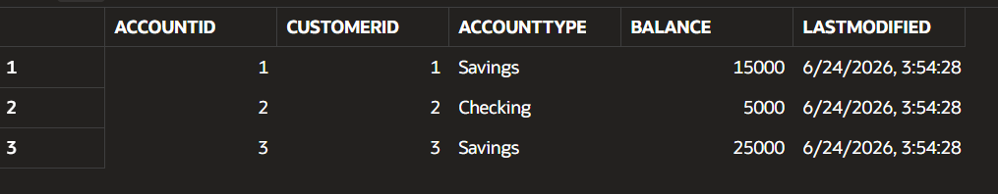
After inserting rows to Employees
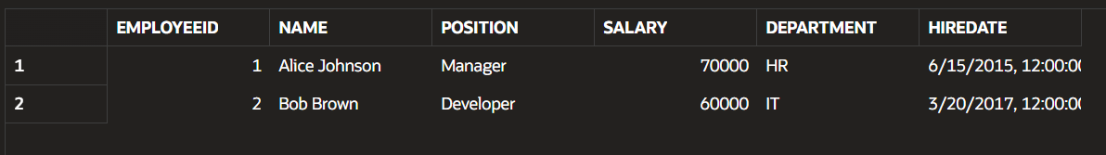
- SCENARIO 1
Procedure creation
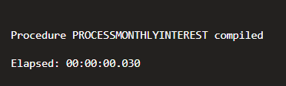
Process execution
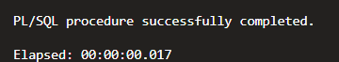
Output after Scenario 1
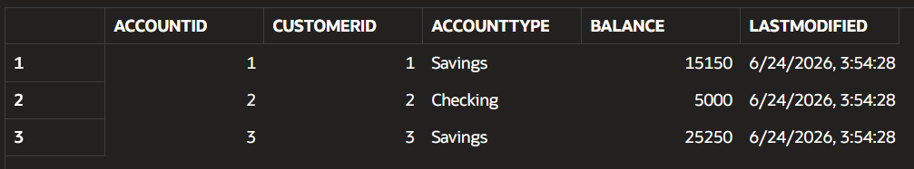
- SCENARIO 2
Procedure creation
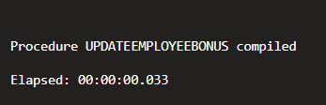
Process execution
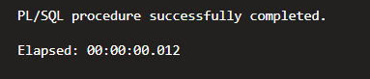
Output after Scenario 2
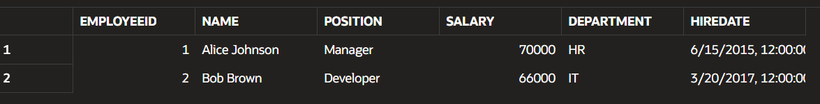
- SCENARIO 3
Procedure creation

Process execution
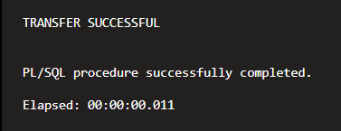

Output after Scenario 3
