Creating a Spring Web Project using Maven:
- Initialize in spring Initializer.
- Unzip and open in IntelliJ.
- Edit the SpringApplication.java code.
- Add port number in application.properties
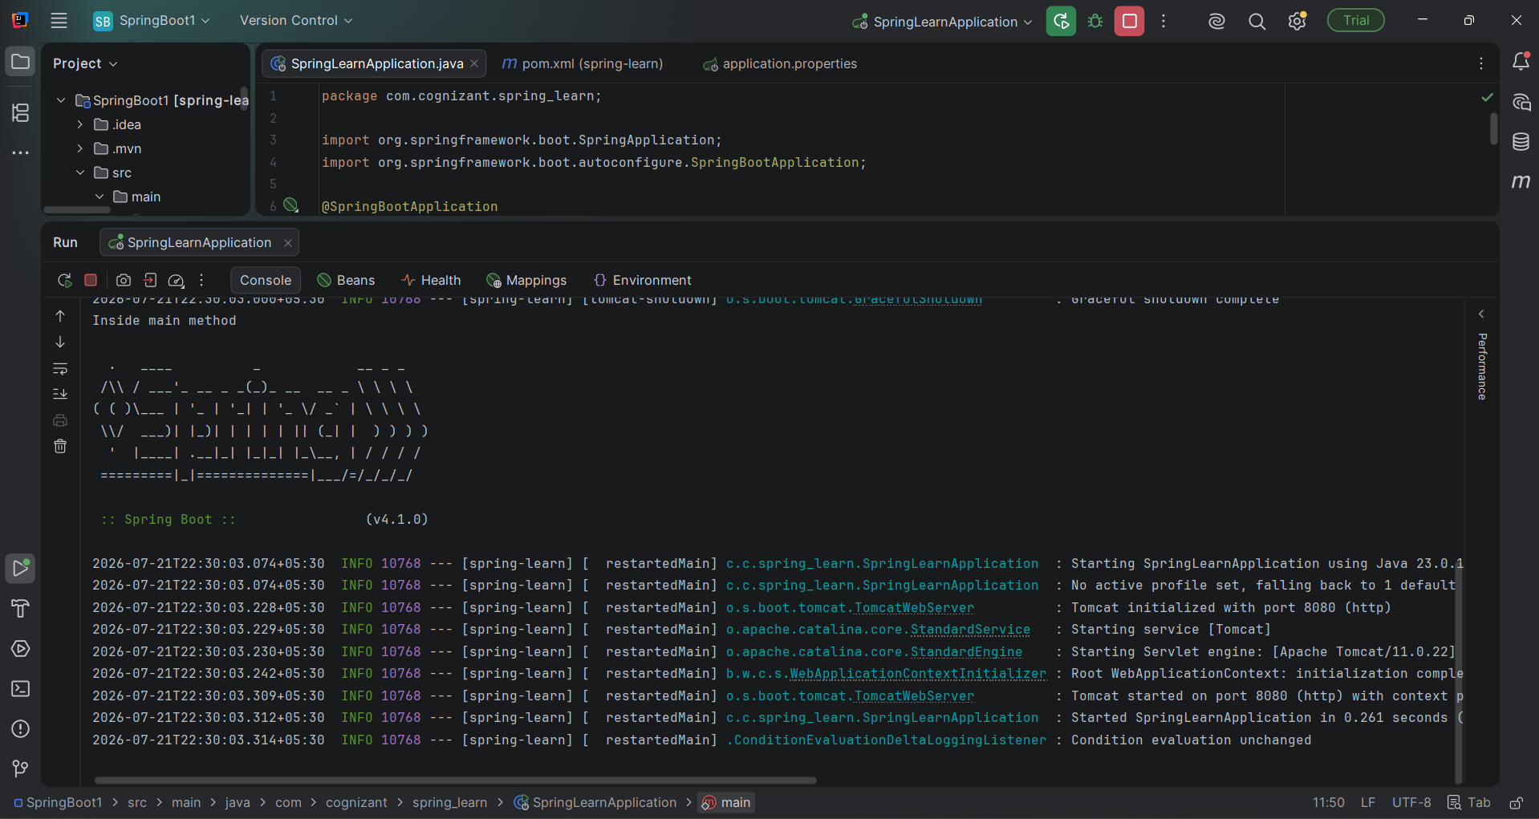
- Run SpringApplication.java.

