- Opened Git Bash and moved to the Git project folder using the cd command.
- Checked whether the repository was clean by using the git status command.
- Created a new branch named GitWork and switched to the new branch.
- Created a file named hello.xml and added some sample content to it.
- Checked the repository status and added the file to the staging area.
- Committed the changes made in the GitWork branch with a commit message.
- Switched back to the master branch.
- Created another hello.xml file in the master branch with different content and committed the changes.
- Viewed the commit history and compared the differences between the master branch and the GitWork branch.
- Merged the GitWork branch into the master branch. Git displayed a merge conflict because both branches contained different changes in the same file.
- Opened the hello.xml file, removed the conflict markers, and saved the correct content.
- Added the resolved file and committed the conflict resolution.
- Updated the .gitignore file to ignore backup files and committed the changes.
- Deleted the merged branch, checked the repository status, viewed the final log, and finally pushed the completed work to GitLab.

Commands used are:
cd <repository-folder>
git status
git branch GitWork
git checkout GitWork
touch hello.xml
git status
git add hello.xml
git commit -m "Added hello.xml in GitWork"
git checkout master
touch hello.xml
git add hello.xml
git commit -m "Added hello.xml in master"
git log --oneline --graph --decorate --all
git diff master GitWork
git merge GitWork
git add hello.xml
git commit -m "Resolved merge conflict"
git add .gitignore
git commit -m "Updated gitignore"
git branch -a
git branch -d GitWork
git log --oneline --graph --decorate
git status
git push origin master

Output screens:
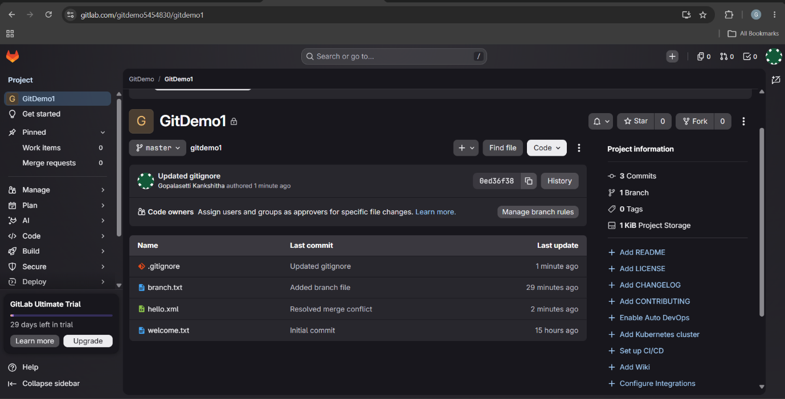

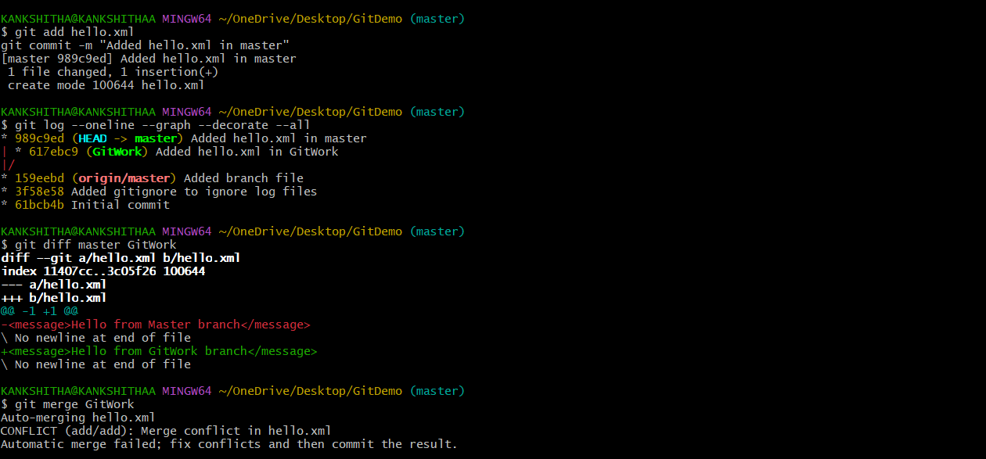
Merge Conflictsss:

Merge conflict arised:
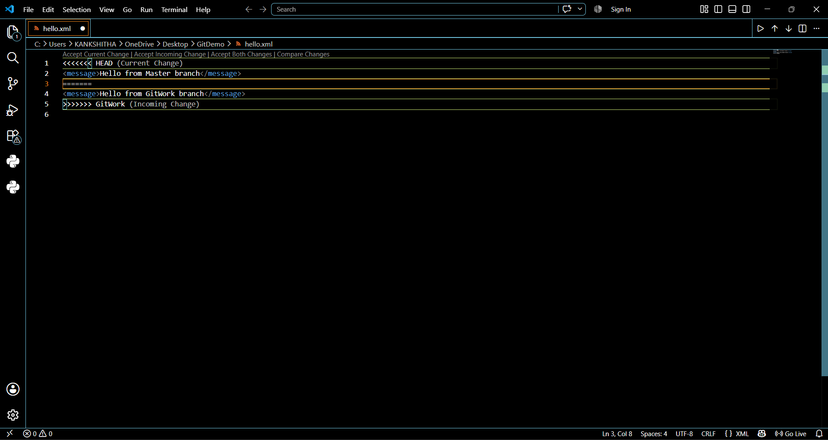

Resolved Conflict:
