Outputs:
After Customers table creation
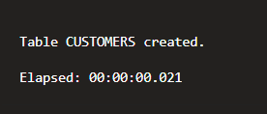
After Loans table creation
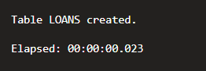
- Scenario 1 Output
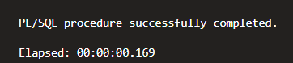
Table after Scenario 1
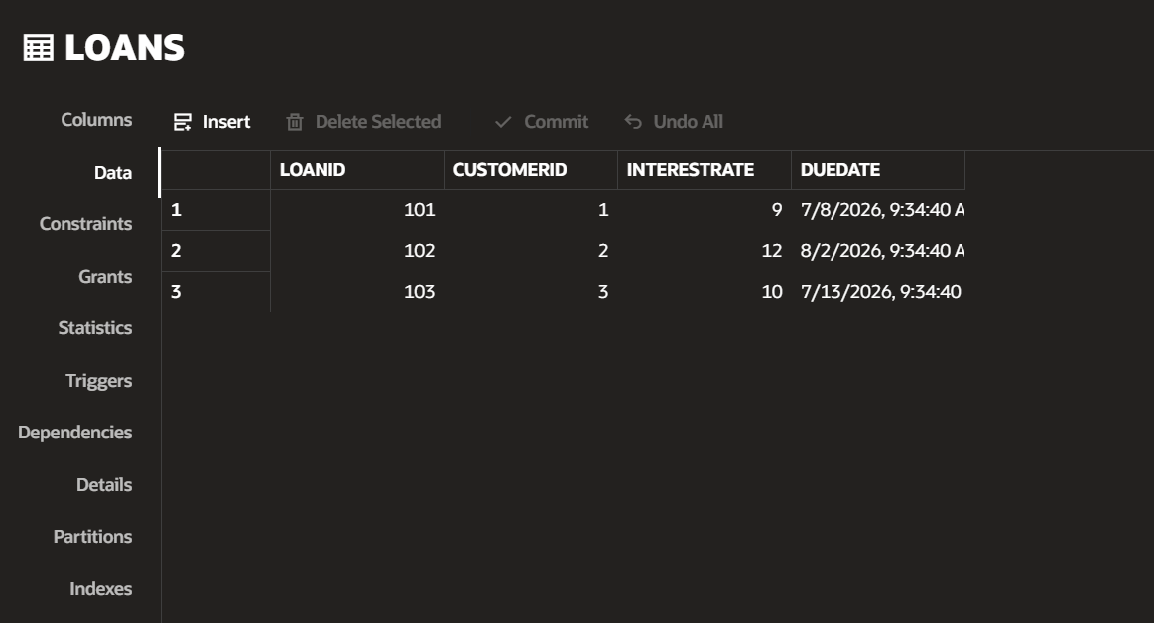
- Scenario 2 Output
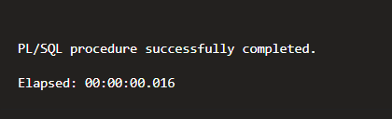

Table after Scenario 2
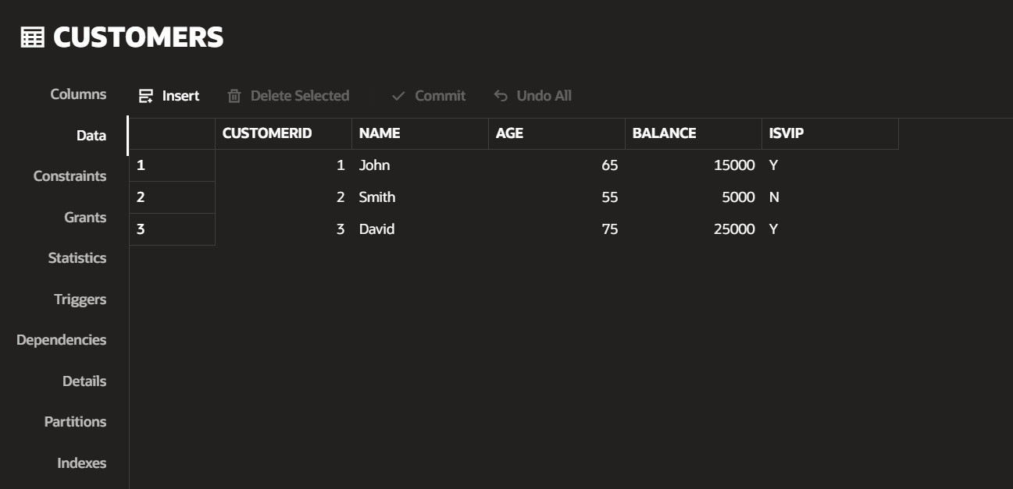

- Scanario 3 Output
