Implementation Steps
- Installed Git on the system and verified the installation using the git --version command.
- Configured the Git user name and email using the git config --global command.
- Verified the Git configuration using git config --global --list.
- Installed Notepad++ and configured it as the default editor for Git.
- Created a new folder named GitDemo and opened it using Git Bash.
- Initialized the folder as a local Git repository using the git init command.
- Created a text file named welcome.txt and added sample content to it.
- Verified the file creation and its contents using the ls and cat commands.
- Checked the repository status using the git status command.
- Added the file to the Git staging area using git add welcome.txt.
- Committed the staged file to the local repository using the git commit command.
- Created a new GitDemo1 project in GitLab without initializing it with a README file.
- Connected the local repository to the remote GitLab repository using the git remote add origin command.
- Pushed the local repository to the remote GitLab repository using the git push -u origin master command.
- Verified that the repository and the welcome.txt file were successfully uploaded to GitLab.
List of Commands Used
git --version
git config --global user.name "Your_Name"
git config --global user.email "your_email@example.com"
git config --global --list
git config --global core.editor "notepad++"
git config --global -e
cd "/c/Users/KANKSHITHA/OneDrive/Desktop/GitDemo"
git init
ls -la
notepad++ welcome.txt
ls
cat welcome.txt
git status
git add welcome.txt
git commit
git remote add origin https://gitlab.com/gitdemo5454830/gitdemo1.git
git remote -v
git push -u origin master

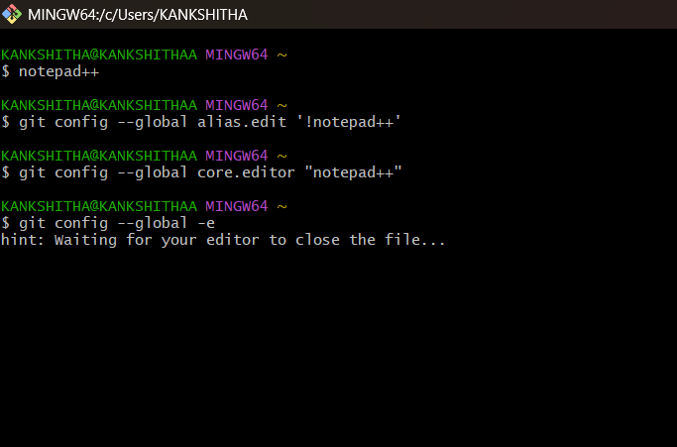
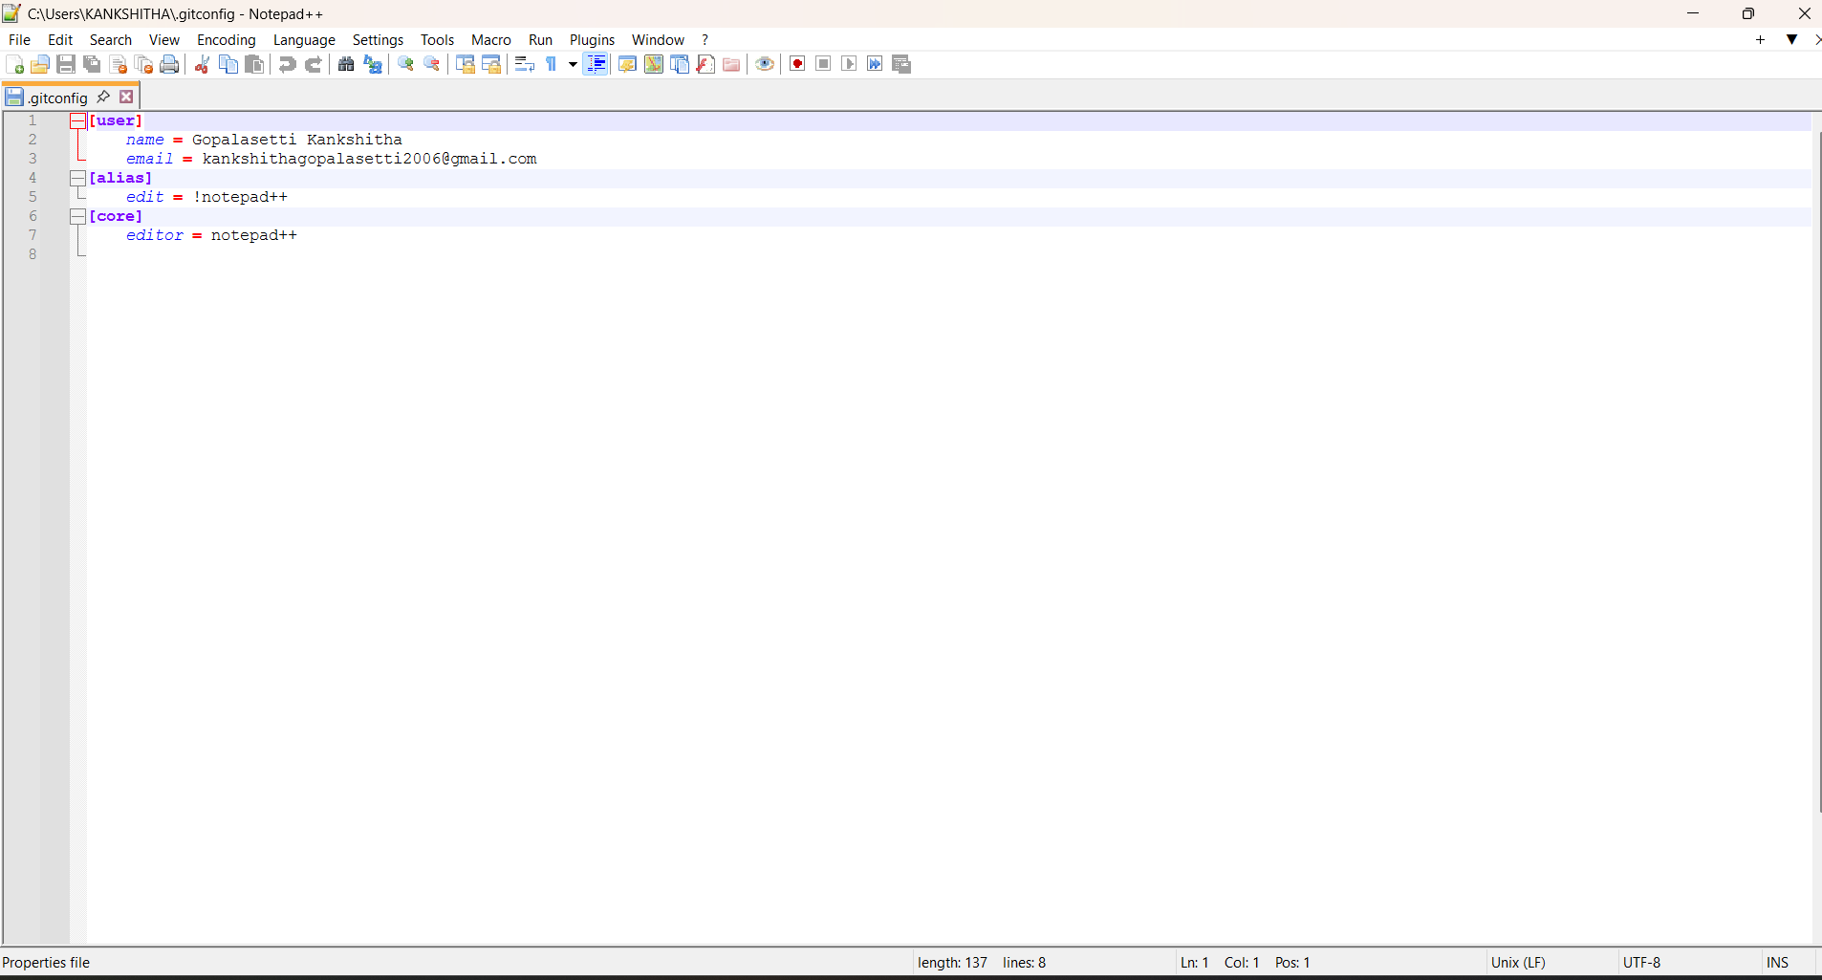

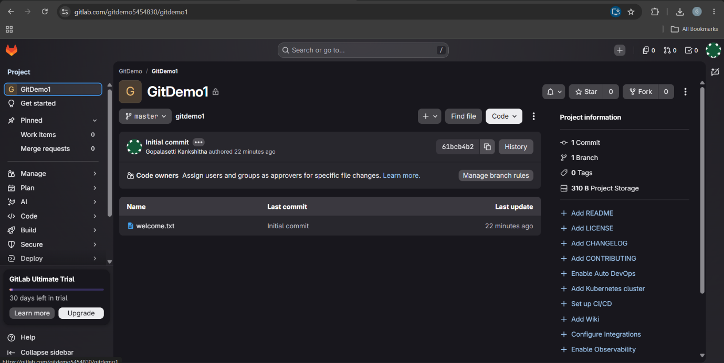
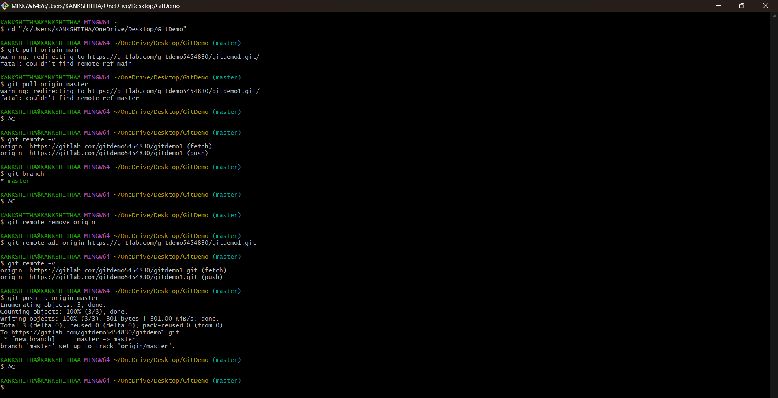
Final output screens after Commit is done

