Add a new country:
=>Adding a new country and checking in the MySQL workbench is what we do in this exercise.
- Firstly, we have to add a method into CountryService.java for adding a country
- And then we have to open the Tests file and write a test to add a code and its country to verify the method is working fine or not.
- Run the test to check the output and the test case will be passed if there are no errors.
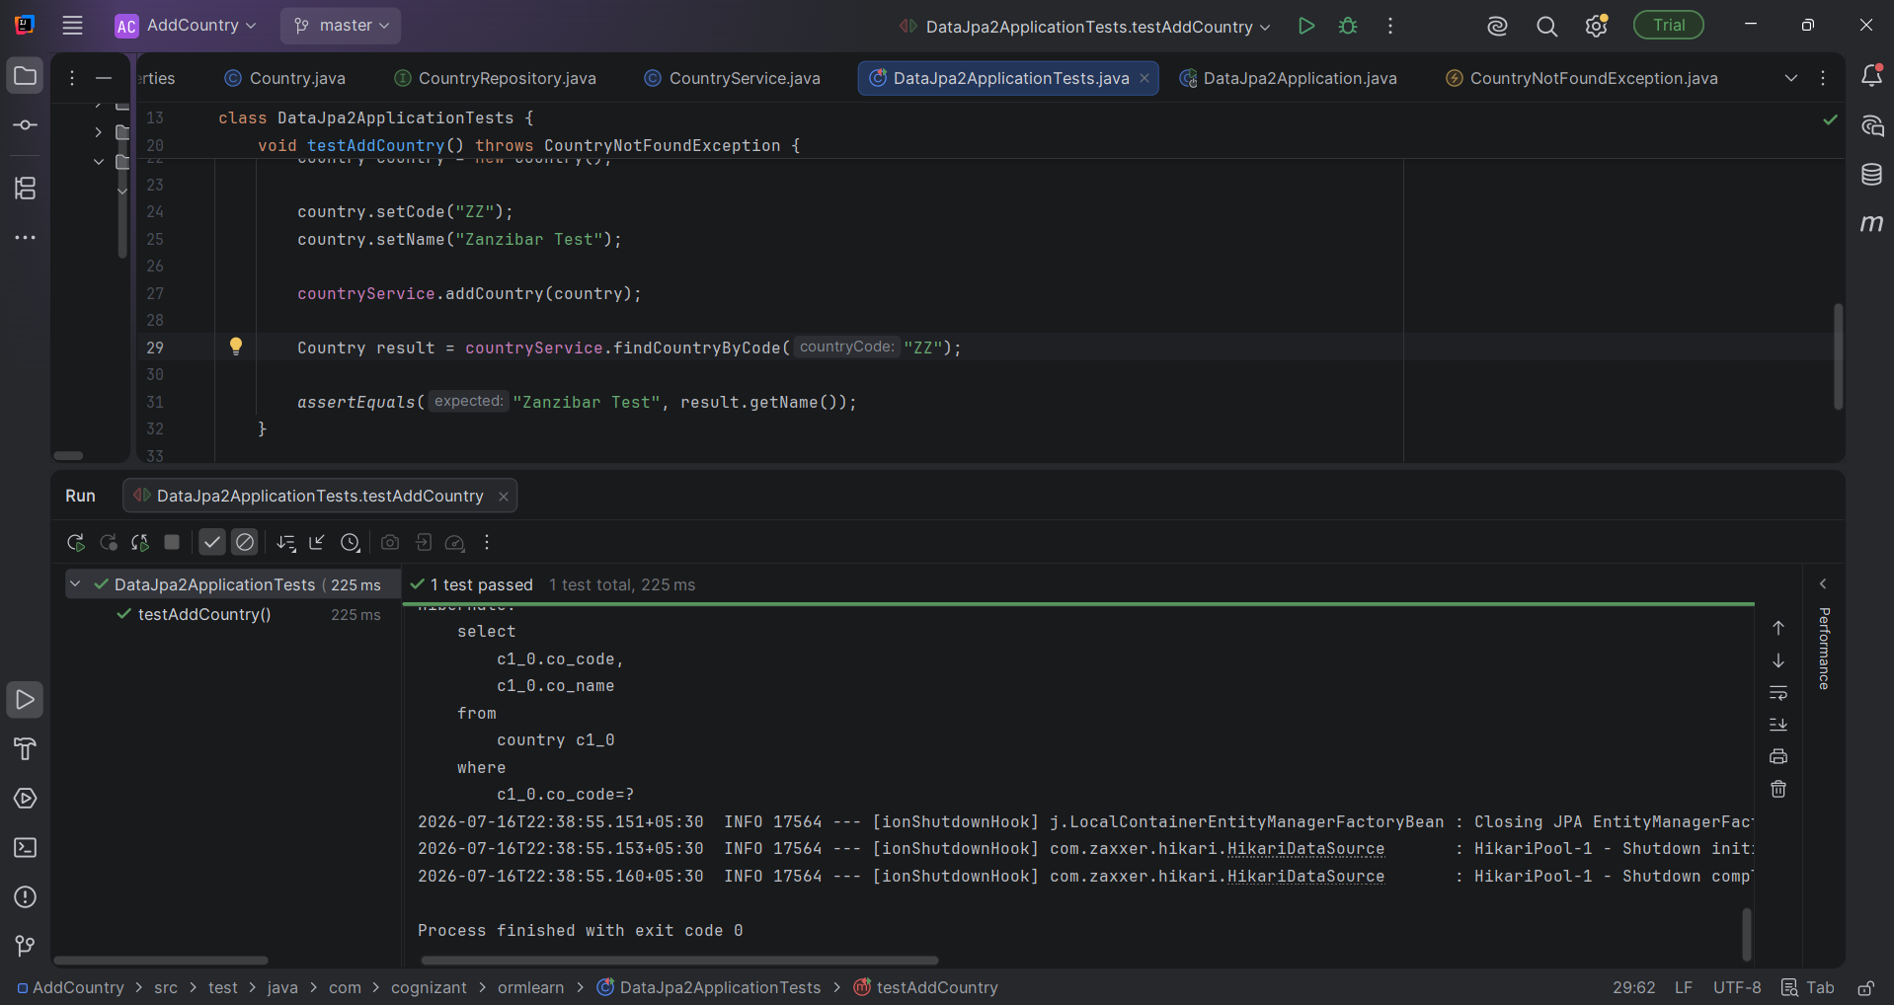
- Here we gave a code “ZZ” and “Zanzibar Test” and it is perfectly executed.

=>Verification in MySQL WorkBench
- To verify whether the code and its country is added or not we can just check it using the query,
SELECT * FROM country WHERE co_code='ZZ';
- See in the below picture, the code and the country are displayed from the table.
So this proves that the country is successfully added to the Database.
