Creating a .gitignore file
- Opened Git Bash and moved to the Git project folder using the cd command.
- Checked the repository by using the git status command to make sure everything was working properly.
- Created a file named error.log in the project folder.
- Created a new folder named log and added a log file inside it.
- Created a file named .gitignore in the project folder.
- Opened the .gitignore file and added the following lines:
- *.log
- log/
- Saved the .gitignore file.
- . Ran the git status command again to check whether the .log file and log folder were ignored.
- .Verified that Git was not showing the .log file and log folder in the status because they were successfully ignored.
- .Added the .gitignore file to the staging area using the git add .gitignore command.
- .Committed the changes to the local repository using the git commit command with a suitable commit message.
- .Finally, checked the repository again using git status and confirmed that the working tree was clean and the .gitignore file was working correctly. This completed the implementation of the Git Ignore hands-on exercise successfully.

Commands used are:

cd <repository-folder>
git status
touch error.log
mkdir log
cd log
touch server.log
cd ..
touch .gitignore
git status
git add .gitignore
git commit -m "Added gitignore to ignore log files"
git status

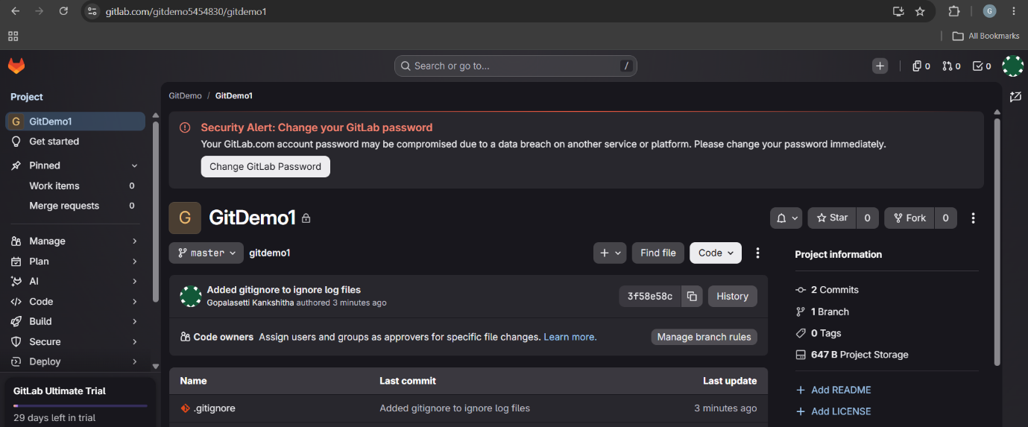
Output screens:

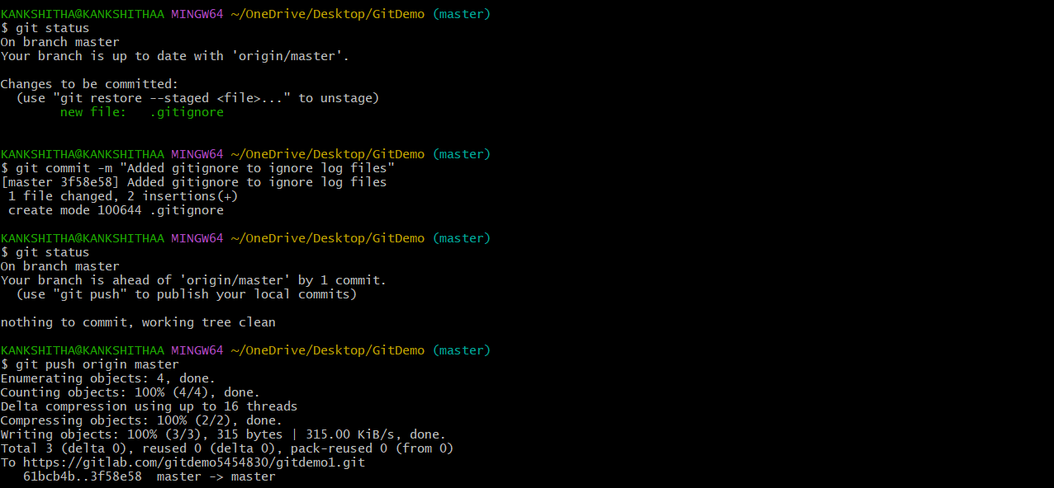
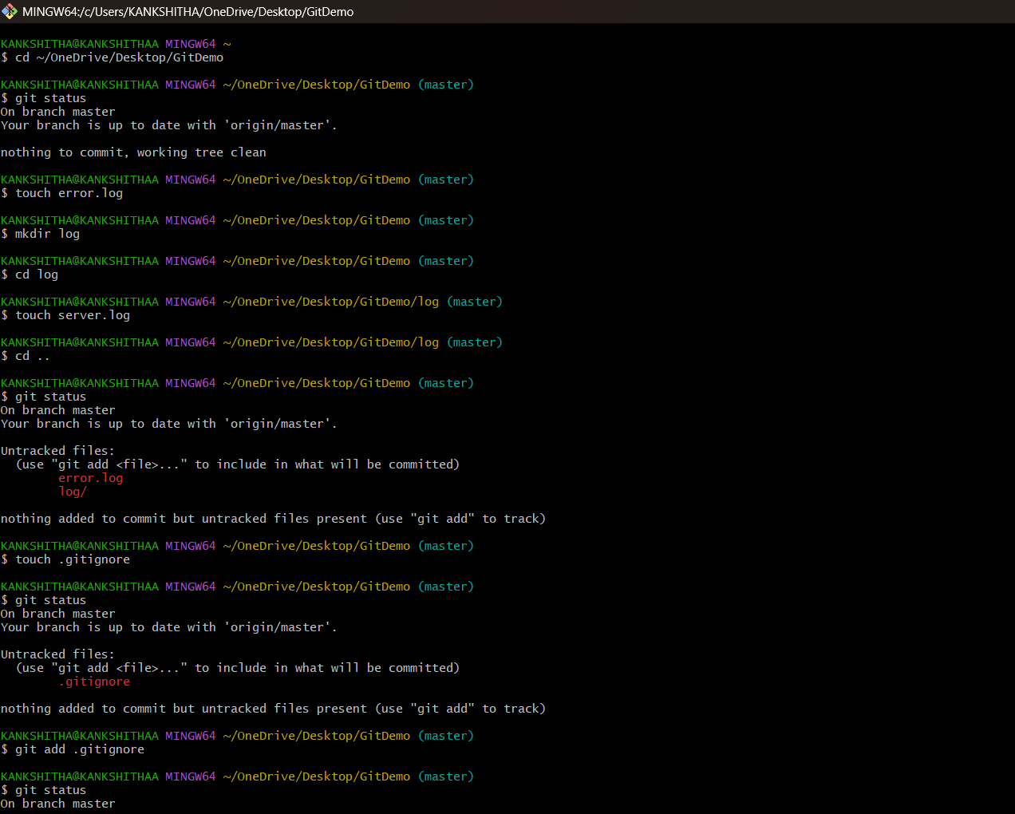
s

