Implement services for managing Country:

This exercise includes the setup of the MySQL WorkBench and the Spring application in IntelliJ.

=>Setup in MySQL WorkBench
- Login with your username and password.
- Create a table country.
- Insert the records into the table as given in the exercise handbook.
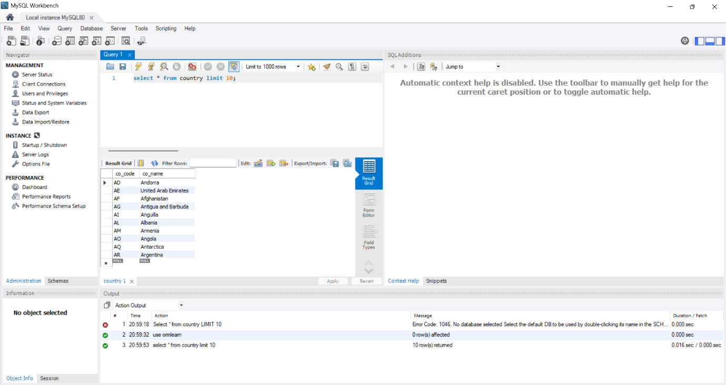
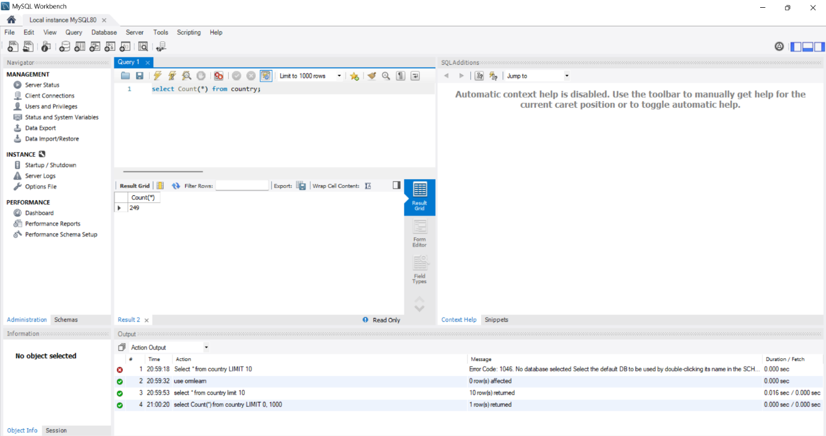
- Check whether all the tables are includes by checking the count of the table using the query
Select COUNT(*) from country;
- Now also check whether the values or inserted or not by using query
Select * from country limit 10;

This is the complete setup of SQL for this exercise.

=>Spring setup
- Open Spring Intializr and setup the spring project by adding package name, dependencies, java version etc. and download the zip file.
- Once the zip file is downloaded extract all the files and open in IntelliJ.
- Now add the required text application.properties such as adding the username and password to it.
- Also create model and repository packages and insert the required codes into it.
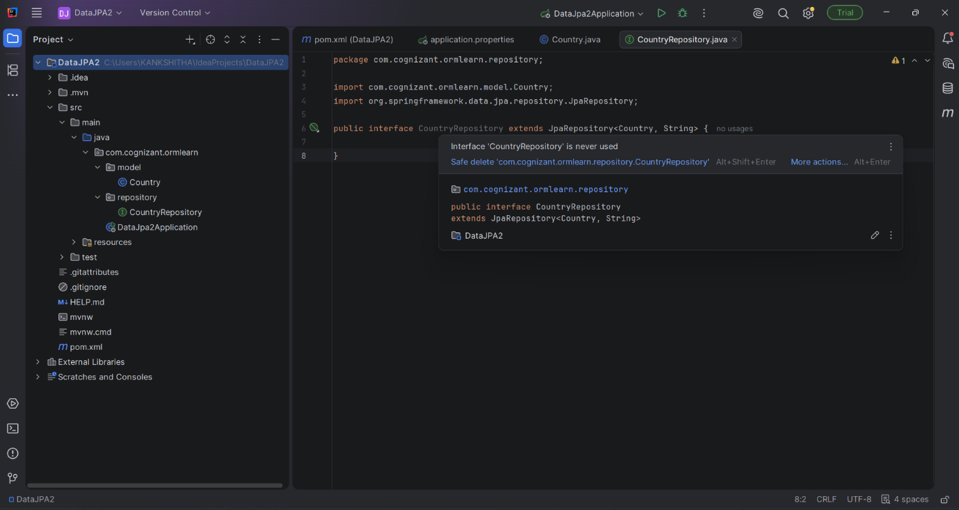

With successful completion of all this process we are ready to move on to the next exercises that will be executed on this setup.

