Assignment1

- Create a database named inventory

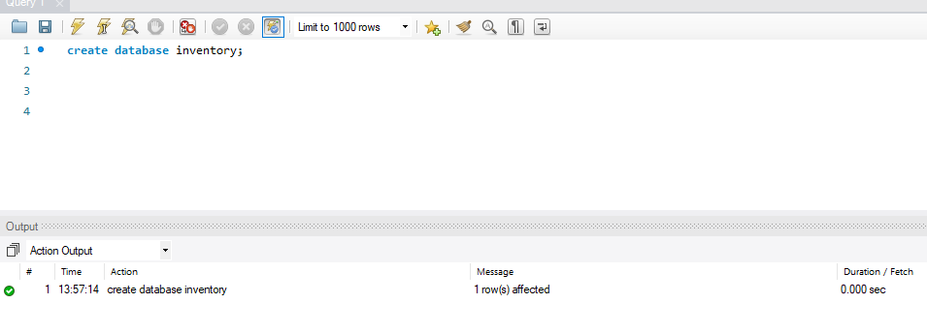
  - Create a table named supplier with three fields
supplier id of integer type,
supplier name of character type with size 5 and
supplier amount balance of numeric type to the table supplier
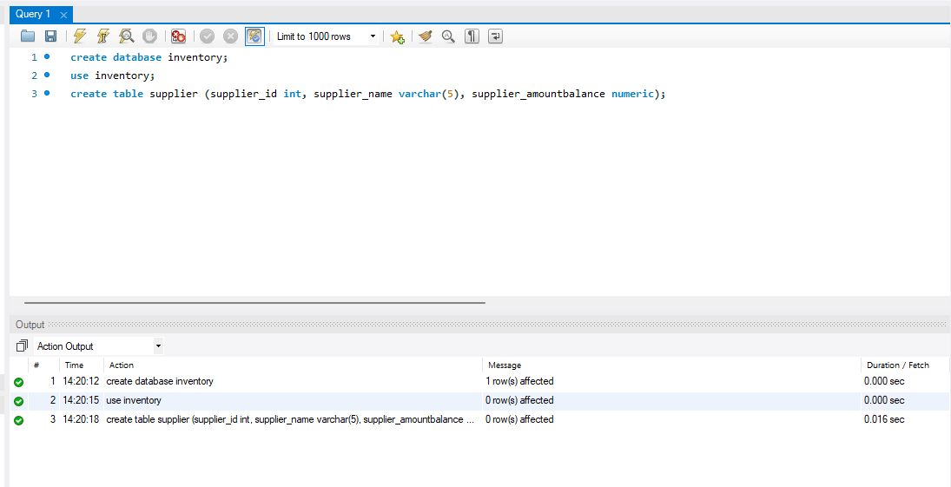

  - Alter the size of the field supplier name with size of 20

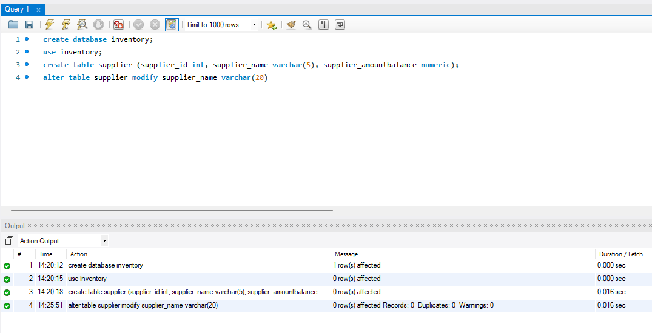

    - Add 10 supplier details to the table
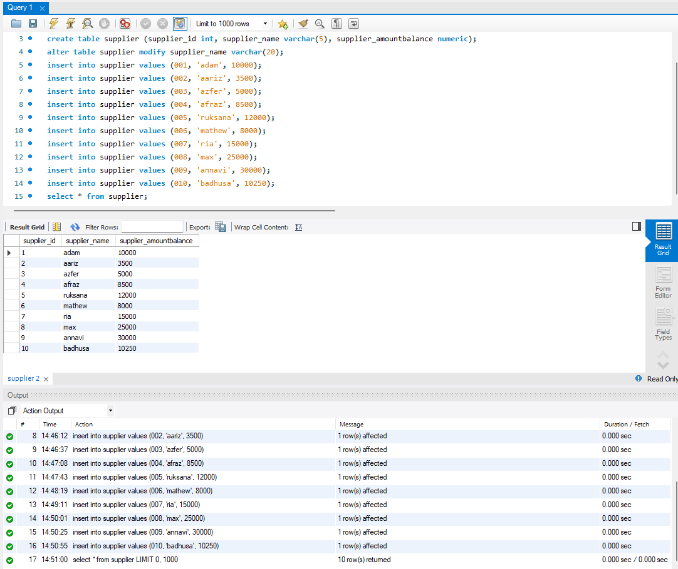

    - Alter the supplier id with primary key
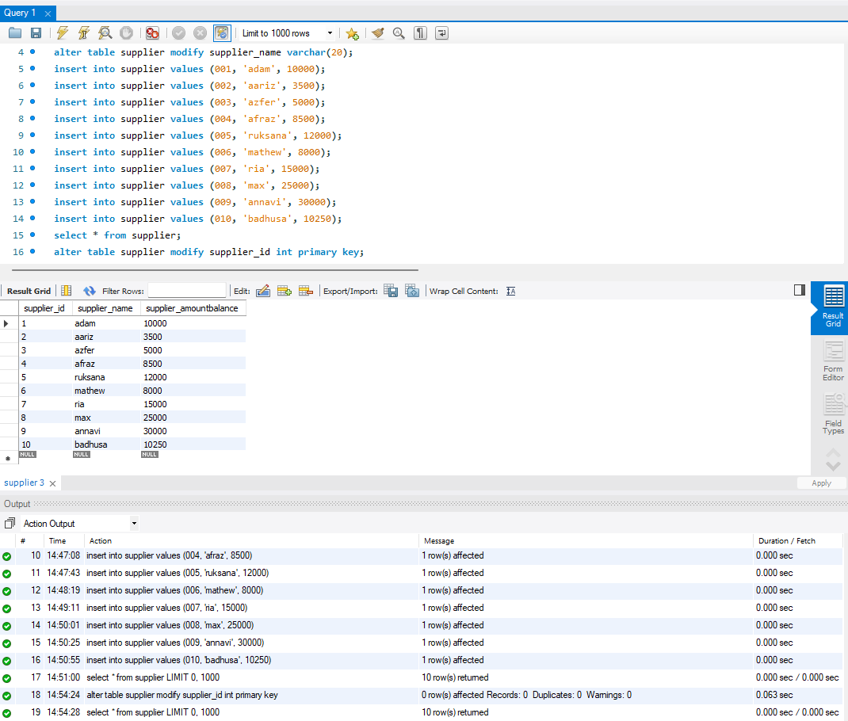

- Get count of suppliers

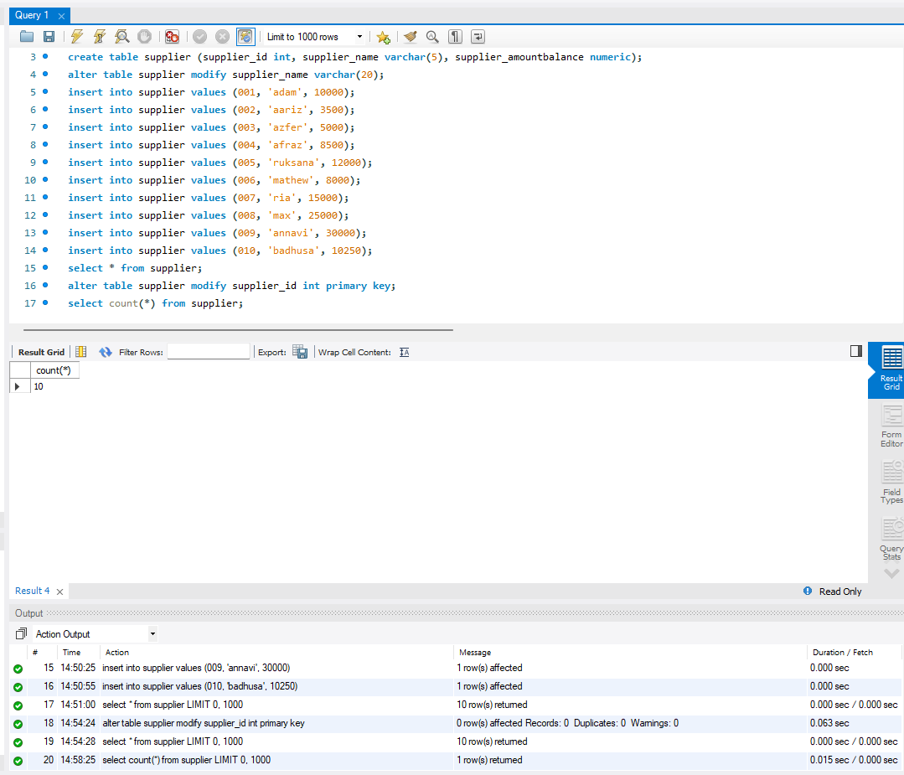

- List supplier with balance over 10000

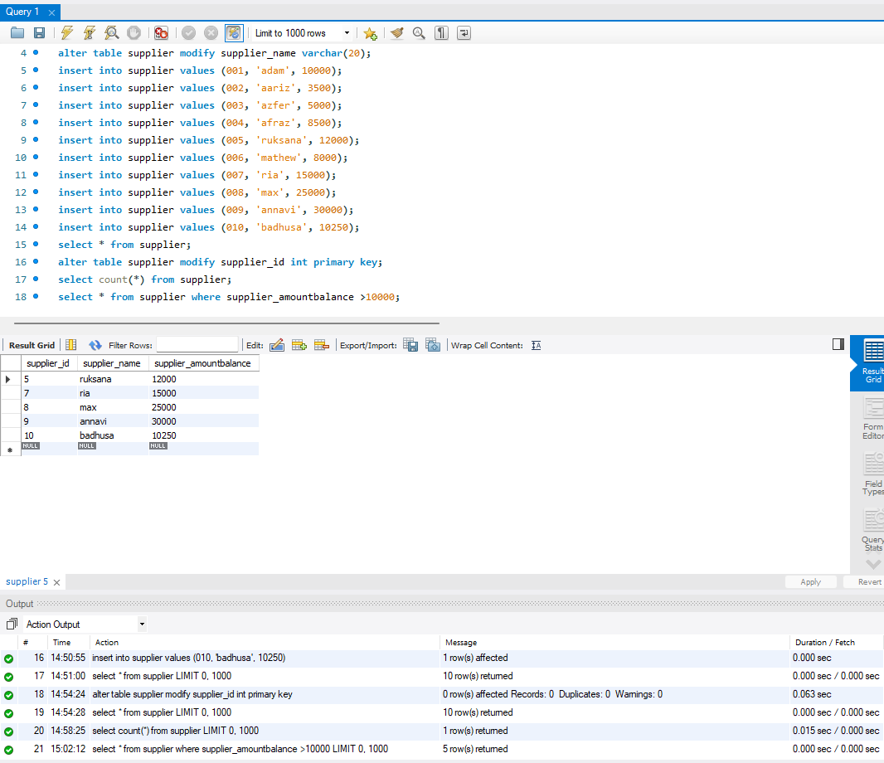

- Get supplier with name having "holdings"

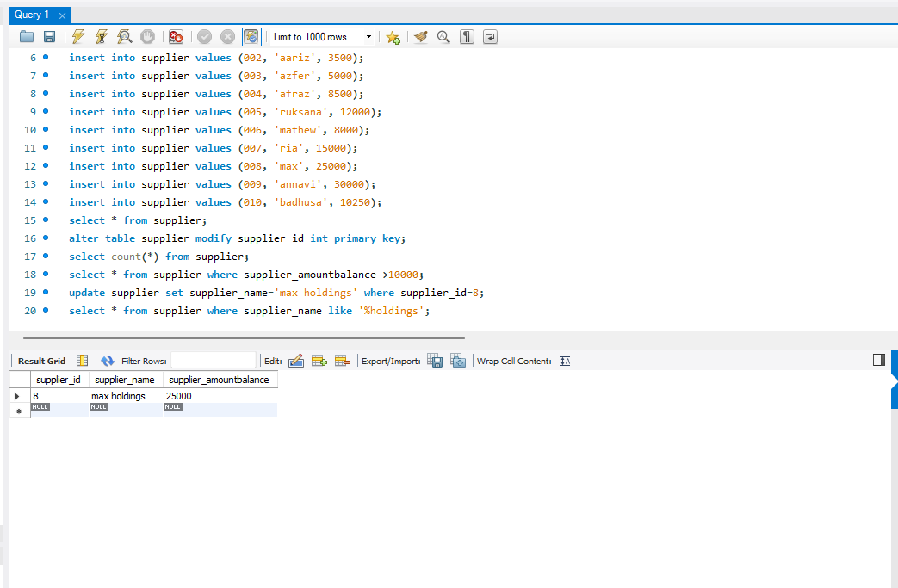
- Get total of supplier balance

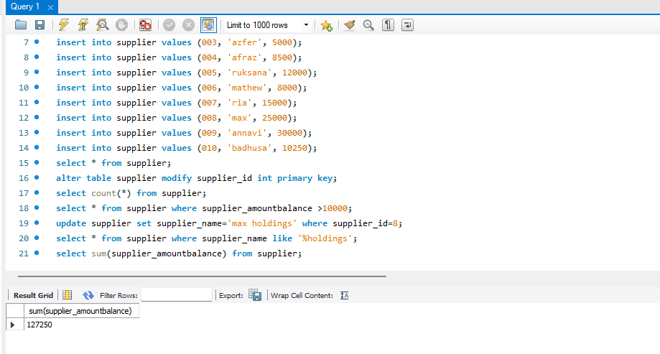

10 . Get supplier balance in descending order

