Assignment 10

- Write a procedure to fetch employee earning less than average salary

delimiter &&
create procedure avg_salary()
begin
select * from Employee where salary < (select avg(salary) from Employee);
end &&
delimiter ;

call avg_salary();
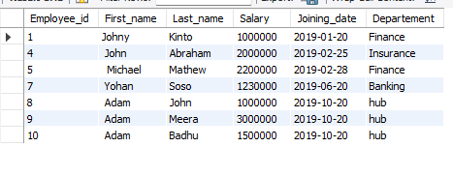

- Write a procedure to fetch salary of the employee id passed as input

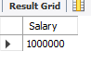
delimiter &&
create procedure find_salary(in emp int, out sal int)
begin
select Salary from Employee where Employee_id = emp;
end &&
delimiter ;
call find_salary(1,@sal);
call find_salary(7,@sal);
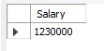

- Write a function to fetch 50% of salary

create function get_salary50(pct50 int)
returns int no sql
return pct50*.5;

select salary, get_salary50(salary) from Employee;

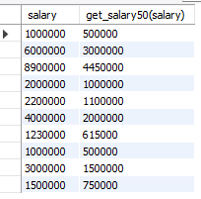
4.Write a function to add a string to the passed name

create function ename(n varchar(100))
returns varchar(100) no sql
return concat("Hello ",n) ;
Select Last_name, ename(Last_name) from Employee;
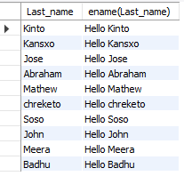

- Write a function to fetch the next maximum salary to the input number passed

create function max_sal(m int)
returns int reads sql data
return (select salary from Employee where salary > m order by salary asc limit 1 );

select max_sal(4000000);
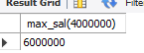
select max_sal(1000000);
