Assignment - 8

- Get first 3 employees who were the earliest to join

select * from Employee order by Joining_date limit 3;
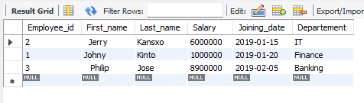
- Get first 3 employees who were the latest to join

select * from Employee order by Joining_date desc limit 3;

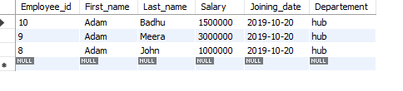
- Get details of the employees who were neither the first joinee nor last joinee

select * from Employee order by Joining_date limit 1,8;
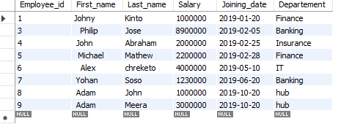

4. Create a table dpt_toppers containing employees from each department earning highest salary

create table dpt_toppers as select * from Employee where salary in ( select max(salary) from Employee group by Departement);

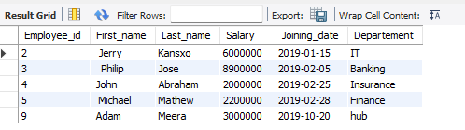

- Get top salary using max

select max(salary) from Employee;

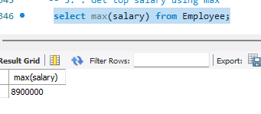
- Get top salary using limit
select salary from Employee order by salary desc Limit 1;

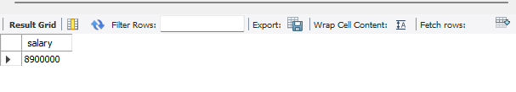
- Get top salary using sub query
select * from Employee where salary in (select Max(salary)from Employee);

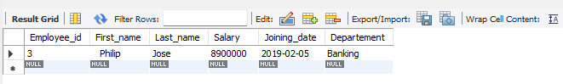
- Include comments column in dpt_toppers stating to 'give 10% bonus' for thoseemployees who have not received any reward

update dpt_toppers set comments = 'give 10% bonus' where Employee_id in (
select Employee_id from Employee where Employee_id not in (select Employee_ref_id from reward));

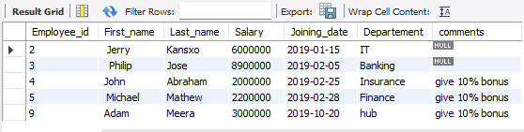

- Create a view vw_facilitated who have recieved rewards being a top salary earner of their department

create view vw_facilitated as select Employee_id from Employee where Employee_id in (select Employee_ref_id from reward);

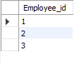
create view vw_facilitated_a as select * from Employee where Employee_id in (select Employee_ref_id from reward);

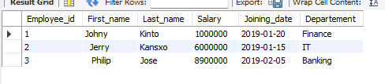
- Delete those employees from dpt_toppers who have received rewards already

delete from dpt_toppers where Employee_id in (
select Employee_id from Employee where Employee_id in (select Employee_ref_id from reward));

