Assignment - 7

- Get count of employees having last name same as first name of other employees

select count(a. Last_name) from Employee a inner join Employee b on trim(a.Last_name) = trim(b.First_name);
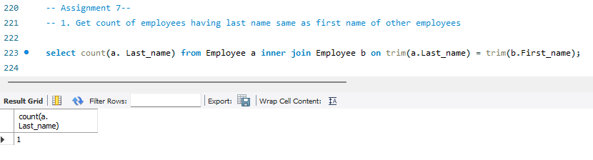

- List employees having last name same as first name of other employees

select * from Employee a inner join Employee b on trim(a.Last_name) = trim(b.First_name);

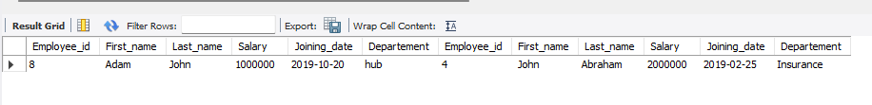
- List FName,LName,rewardamount of employees having last name same as first name of other employees or vice-versa, with each of their reward amount

select a.First_name, a.Last_name, r.amount from Employee a inner join Employee b on trim(a.Last_name) = trim(b.First_name)
left outer join reward r on a.Employee_id = r.Employee_ref_id
union
select b.First_name, b.Last_name, r.amount from Employee a inner join Employee b on trim(a.Last_name) = trim(b.First_name)
left outer join reward r on b.Employee_id = r.Employee_ref_id;

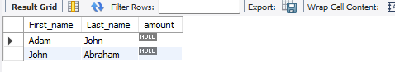

- Display the tours with source and destination as follows (use: places, tours tables)
Tour_id start_city end_city
1 hyderabad chennai

select t.id as Tour_id, place_name as start_city, place_name as end_city from tours t inner join places p on t.stloc = p.id
inner join places on t.endloc = p.id order by t.id;

select st.Tour_id, st.start_city, ed.end_city from
(select tours.id as Tour_id, places.place_name as start_city from tours inner join places on tours.stloc = places.id) st,
(select tours.id as Tour_id, places.place_name as end_city from tours inner join places on tours.endloc = places.id) ed
where st.Tour_id = ed.Tour_id;

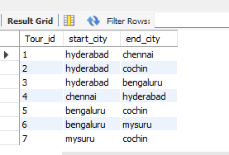

- Find duplicate outlet type with each its predecessor and successor
101 MART 106 MART
102 supermarket 103 supermarket
102 supermarket 104 supermarket
103 supermarket 104 supermarket

