Assignment 12
1. Get department's total salary belonging to each employee's department

select * from Employee e,
(select Departement, sum(Salary) as Salary_sum from Employee group by Departement) f
where e.Departement = f.Departement;

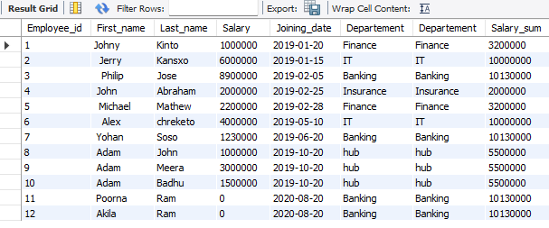
- Get department's total salary belonging to each employee's department (including nulls)

INSERT INTO Employee (Employee_id, First_name, Last_name, Joining_date, Departement) VALUES (13, ' Aariz ', 'Badhu', "2019-10-20", "hub");
INSERT INTO Employee (Employee_id, First_name, Last_name, salary, Joining_date) VALUES (14, ' Azfer ', 'Badhu', 1002400 , "2019-10-20" );
select e.Employee_id, e.Departement, ifnull(e.Departement,'unk') as 'new_type', f.Salary_sum from Employee e,
(select Departement, sum(Salary) as Salary_sum from Employee group by Departement) f
where ifnull(e.Departement,'unk') = ifnull(f.Departement,'unk');

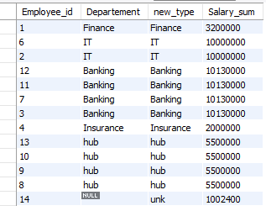

- Get each department's maximum salary(department names as columns and maximum salary in single row)

select
max(case when Departement = 'Finance' then Salary else null end) as "Finance",
max(case when Departement = 'IT' then Salary else null end) as "IT",
max(case when Departement = 'Banking' then Salary else null end) as "Banking",
max(case when Departement = 'Insurance' then Salary else null end) as "Insurance",
max(case when Departement = 'hub' then Salary else null end) as "hub",
max(case when Departement is null then Salary else null end) as "unknown"
from Employee;


- Get running total of the salary in employee table

select Employee_id, Departement, Salary, sum(Salary) over (order by Employee_id) as running_total from Employee;
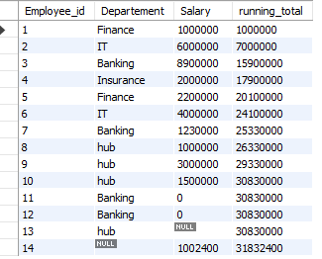
- Get department's total salary belonging to each employee's department using window functions)

select Employee_id, Departement, Salary, sum(Salary) over (partition by Departement) as total_sum from Employee order by Employee_id;
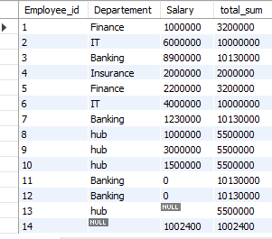

- Get nth salary (*-using all the possible ways)

select * from Employee order by salary desc limit 3,1;
select * from Employee e1 where 4 = (select count(distinct e2.salary) from Employee e2
where e1.salary <= e2.salary);

select * from
(select Employee_id, Departement, Salary, rank() over (order by Salary desc) as "rnk" from Employee) e where e.rnk = 4;
select * from
(select Employee_id, Departement, Salary, dense_rank() over (order by Salary desc) as "rnk" from Employee) e where e.rnk = 4;

select Employee_id, Departement, Salary, rank() over (order by Salary desc) as "rnk",
dense_rank() over (order by Salary desc) as "dense_rnk" from Employee;



