Assignment -6

- Get the employee’s first name and last name in separate rows.

select First_name from Employee union all
select Last_name from Employee;

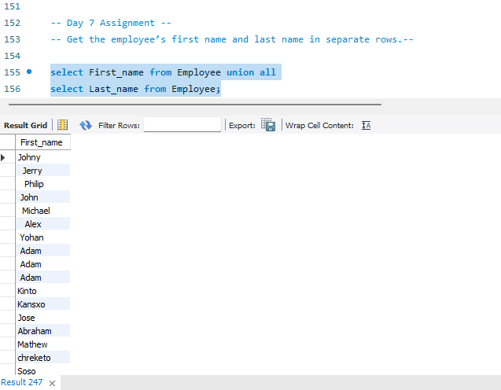
- Get the employee’s first name and last name in separate rows without duplicates.

select First_name from Employee union
select Last_name from Employee;
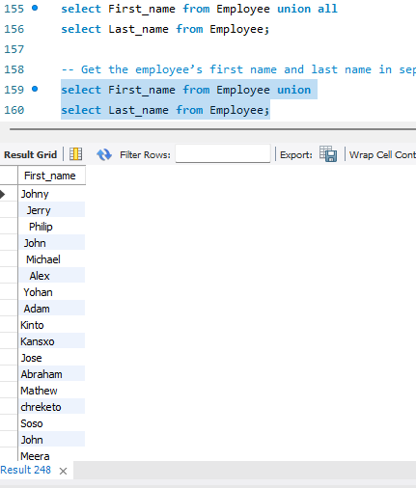
- Get the employee’s first name, each reward amount for employees who have rewards.

select First_name, amount from Employee inner join reward on Employee.Employee_id = reward.Employee_ref_id;
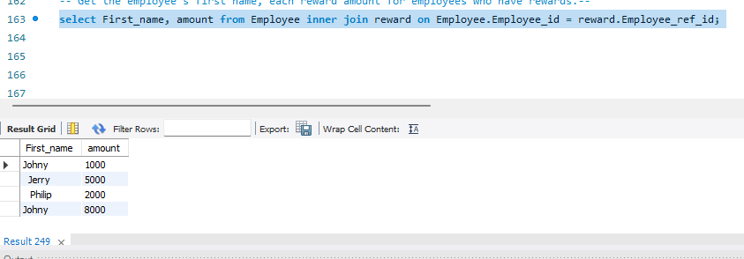
- Get the first name, each reward amount for employees who have rewards not using “Inner Join”.

select first_name, amount from Employee cross join reward on Employee.Employee_id = reward.Employee_ref_id;

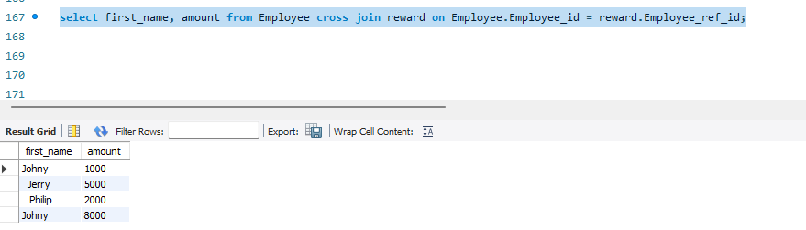

- Get the first name, each reward amount for employees along with who not have rewards by not
using “Inner Join”.

select First_name, amount from Employee left outer join reward on Employee.Employee_id = reward.Employee_ref_id;

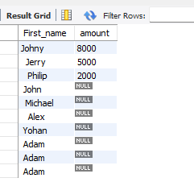

6. Get the first name, each reward amount for employees along with who not have rewards using
“union”.

select Employee_id, First_name from Employee union all
select Employee_ref_id, amount from reward ;
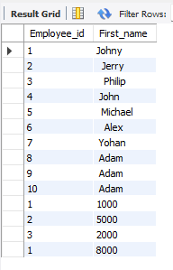
- Get count of employees having last name same as first name of other employees

select count(*) from Employee a inner join Employee b on trim(a.Last_name) = trim(b.First_name);

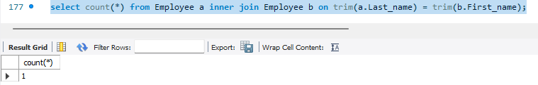
- List employees having last name same as first name of other employees

select * from Employee a inner join Employee b on trim(a.Last_name) = trim(b.First_name);

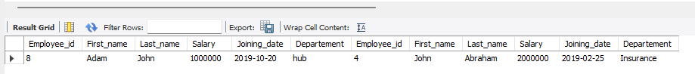
- Get count of employees not having last name same as first name of other employees

10. List FName, LName, rewardamount of employees having last name same as first name of other
employees or vice-versa, with each of their reward amount

