Assignment2 Part-3
- Get list of employees who joined in february
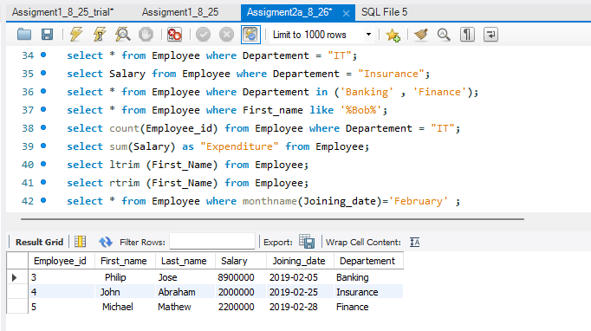
- List the salaries of employees who joined in 2nd quarter
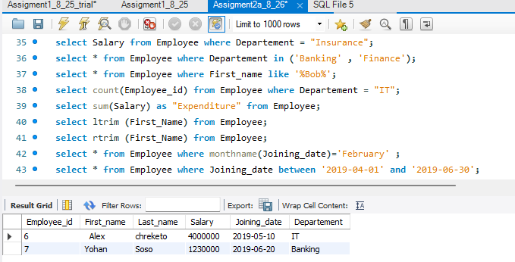
3. List the date in the format "Bob joined on day:20 month:01 year:2019
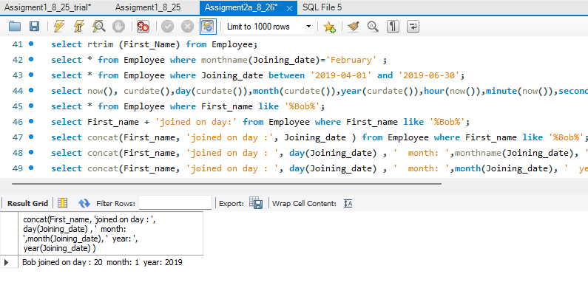

- Get employee who has "jo" in either of the names
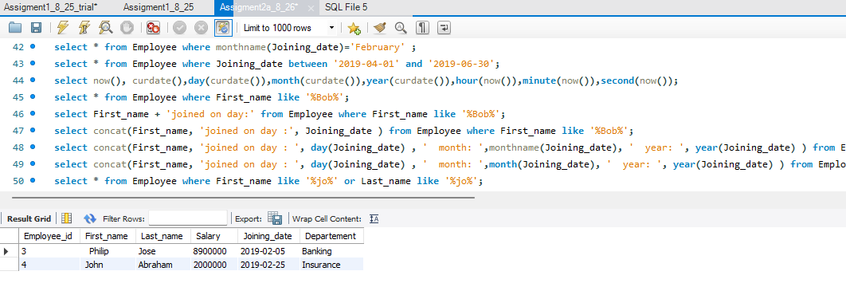
- List how much "Yohan" earns after deducting one lakh from his salary
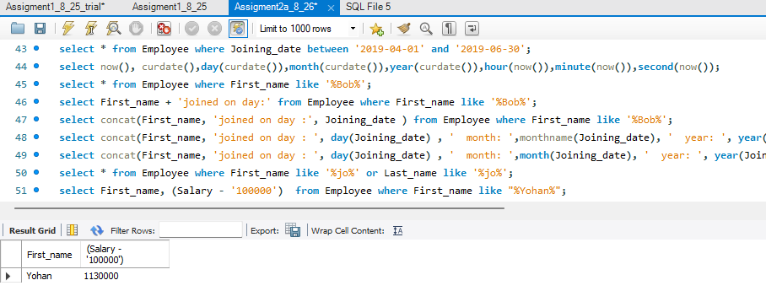
- Trim the spaces in the names and concat them as "last name, first name"
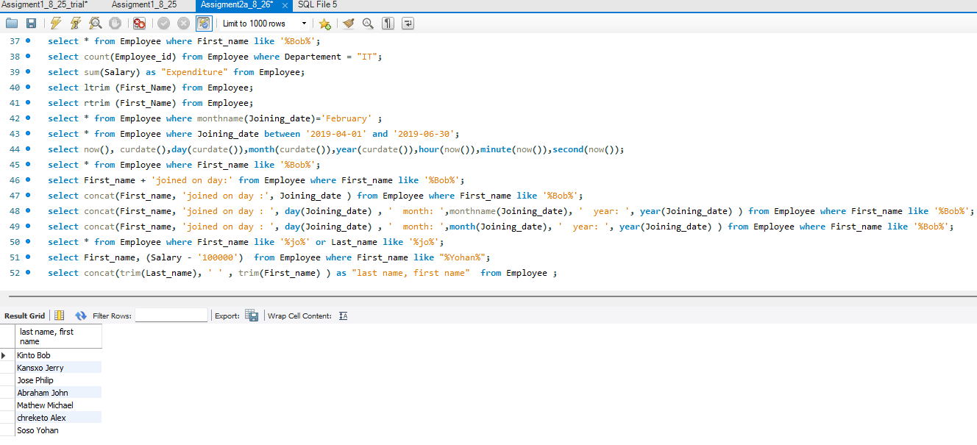

- Replace "John" with "Jane" and the rest as it is
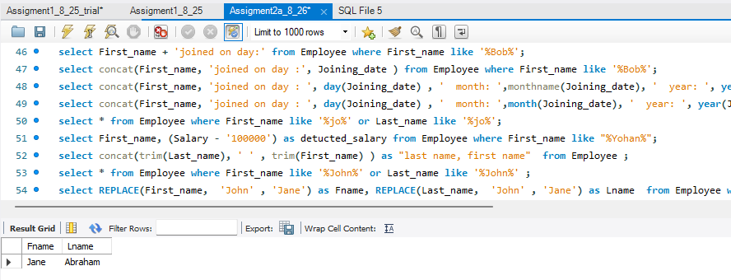
8. List the employees who earns more than one million
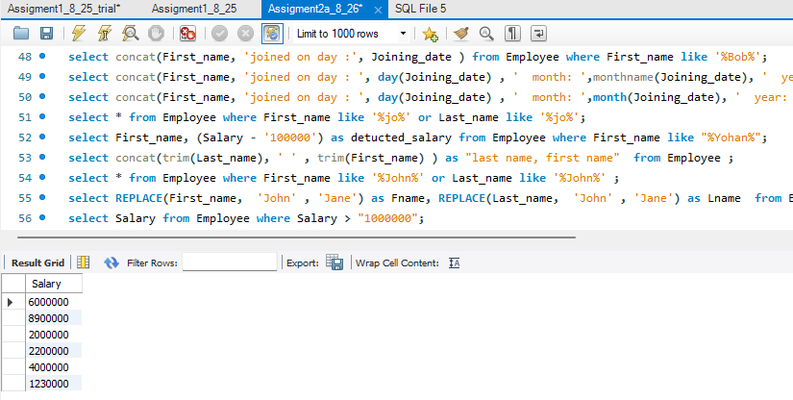
- Find the position of 'i' from the department
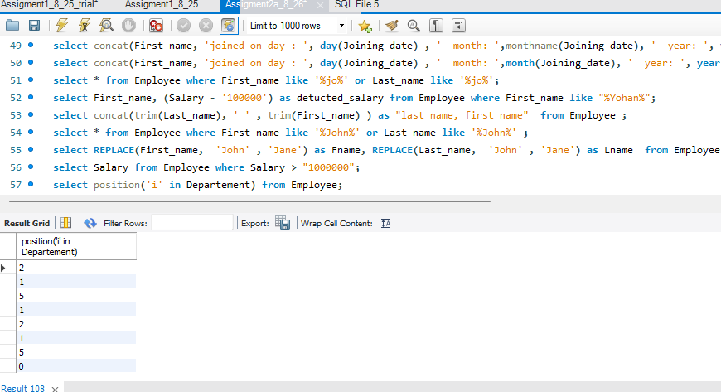

10. List salary details: Salary, HRA, DA, PF, Income(Salary+HRA+DA), Deductions(PF), Net Salary(Income-Deductions)
HRA-10% of salary, DA-5% of salary, PF-1% of salary
