Assignment4

- Fetch the departments that have less than two people in it.
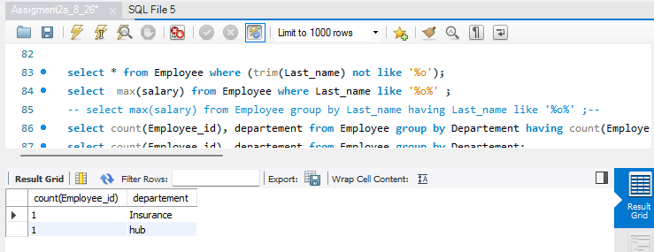
- Show all departments along with the number of people in there.
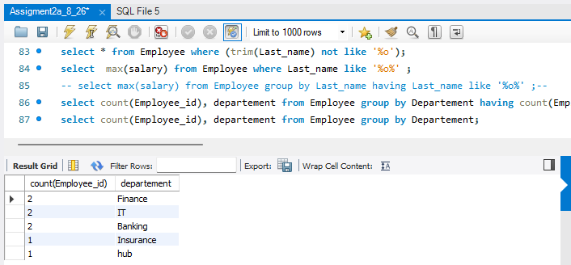
- Get total salary for each department in the month of february
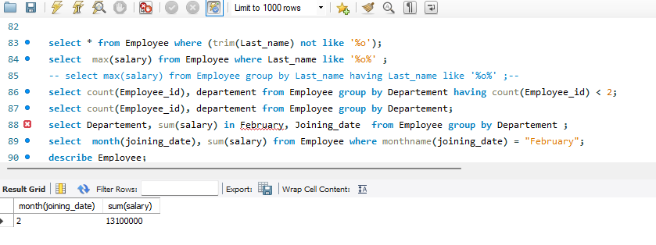

- Use any five aggegrate functions on salary for each departement
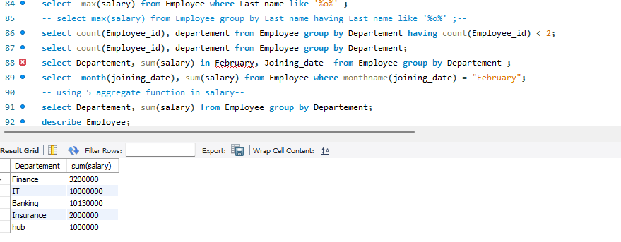
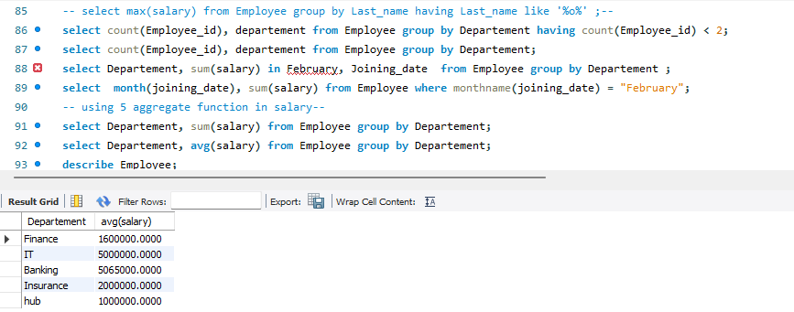
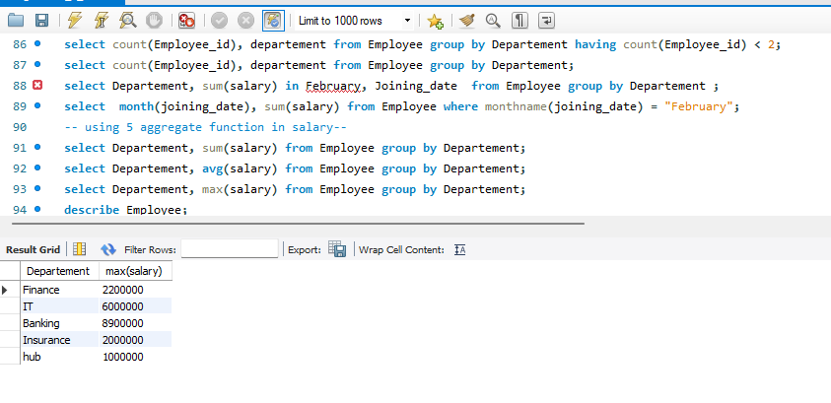
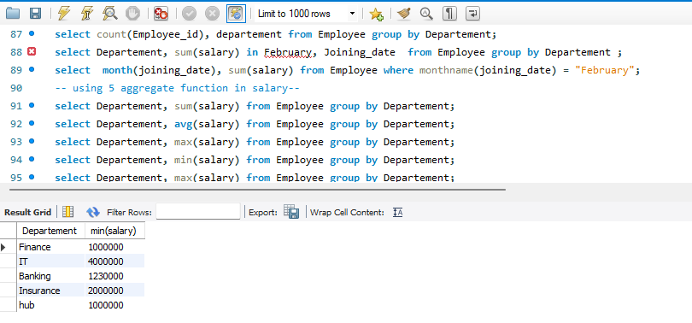

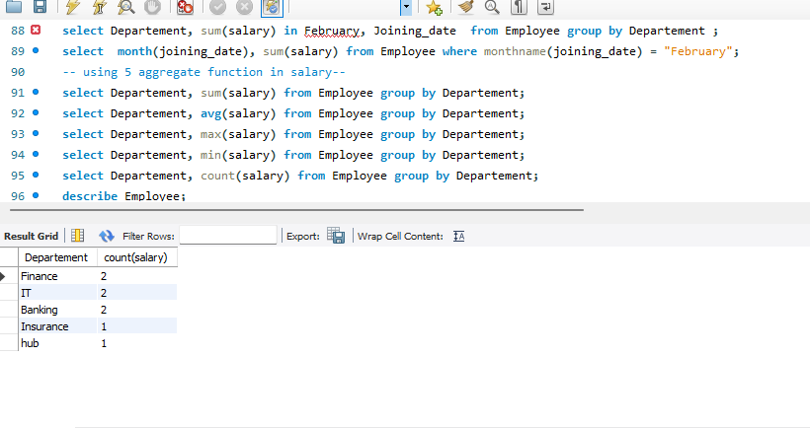
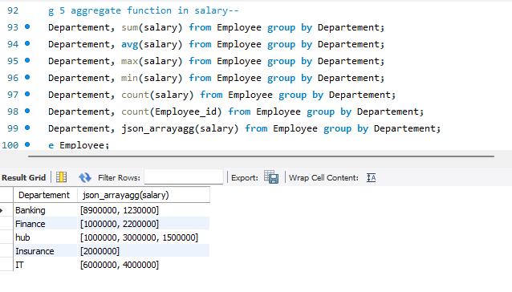
5.Get the employee’s department and minimum salary, grouped by department.
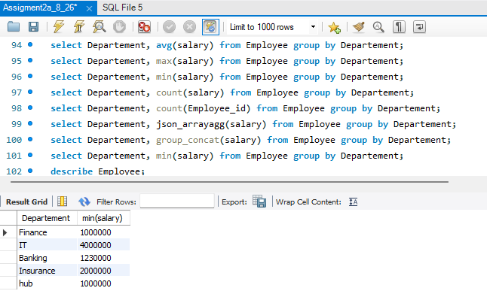

6. Get the department, the number of employees in that department, and the total salary grouped by
department, and sorted by total salary in descending order.

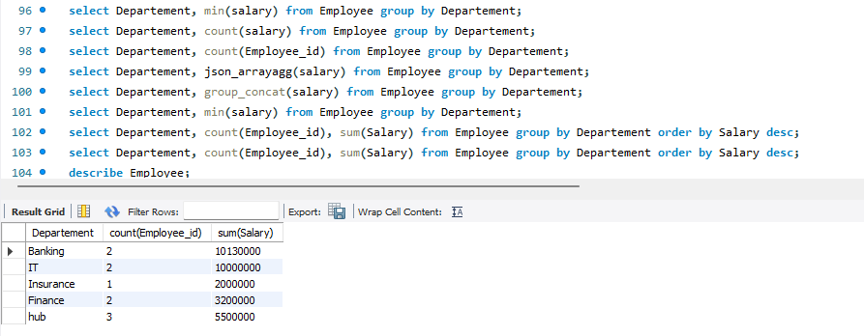
- Get the minimum salary by department in ascending order of salary.
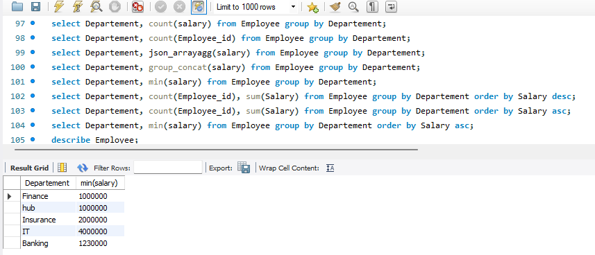
- Get the number of employees grouped by quarter and month of joining. (doubt)
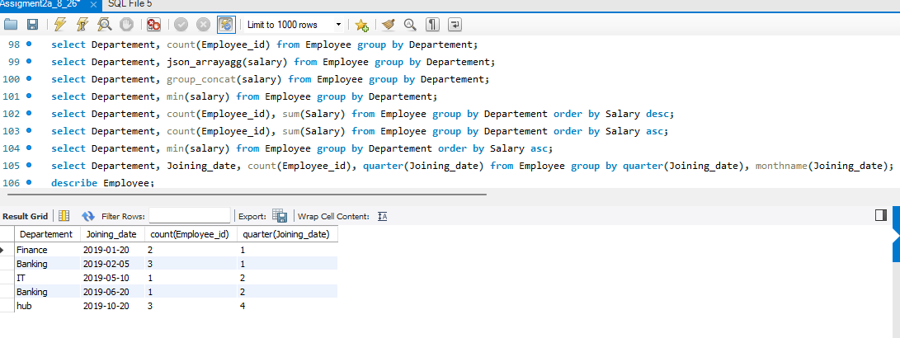
9. Get the department and maximum salary grouped by the department, where the maximum salary
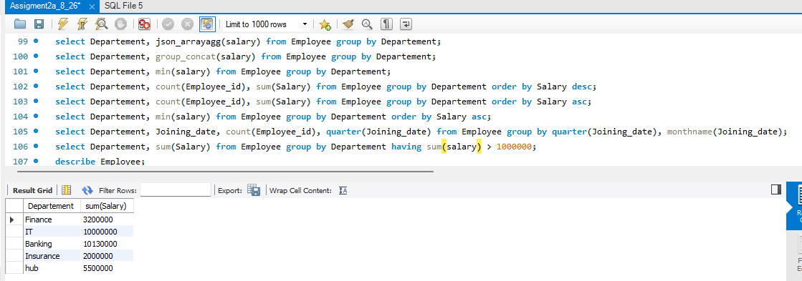
is greater than 1,000,000

- Get employees whose first name is neither “Jerry” nor “John” and ends with 'n'
