Assignment2 Part-2

1. Concat and display the names

2. List name of the employees earning salary more than 4 million

- List employees belonging to IT department
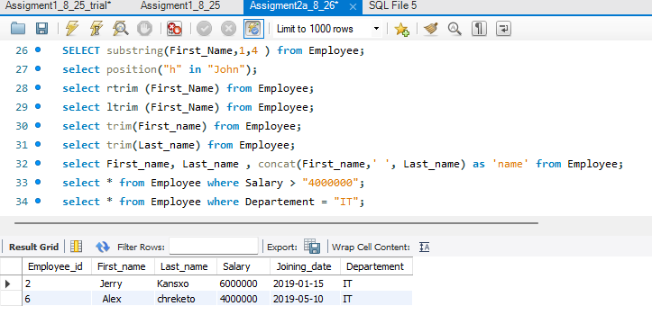
4. List salaries of Insurance department

5. List employees belonging to Banking and Finance department
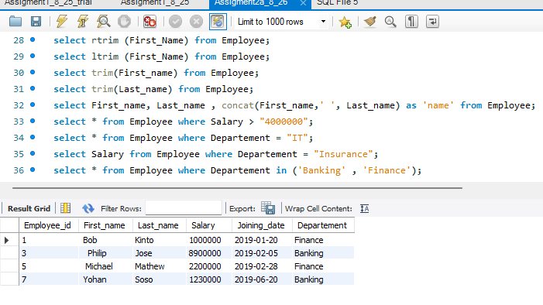
6. Get the salary employee having the name "Bob"

- List count of employees for the department IT department
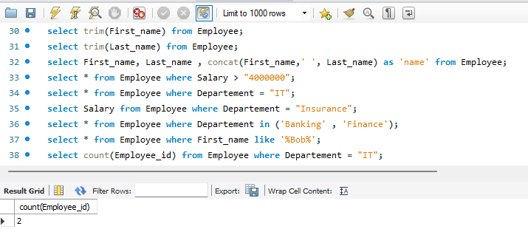
- Get total salary as "Expenditure"
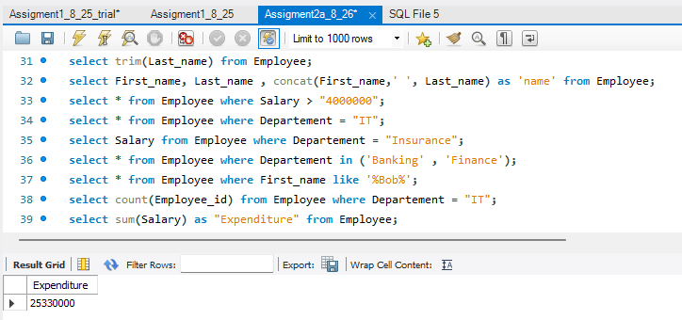

- Get first name after trimming space in suffix
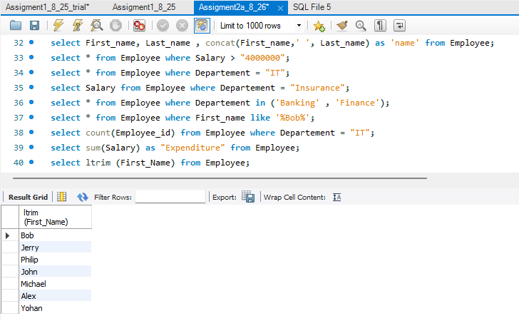
- Get last name after trimming space in prefix
