Assignment5

- update the first name to 'Johny' for the employee having the first name as 'Bob' in it
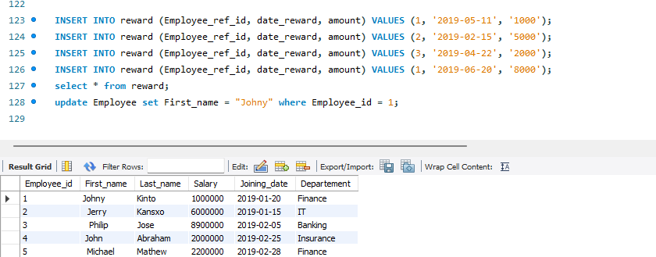

- Get the name, the amount of the reward for the employees who have rewards.

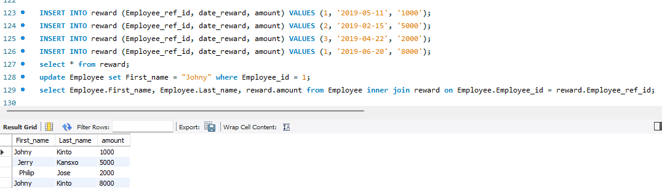
3. Get the last name, the reward amount for employees who have rewards with an amount greater
than 2500.

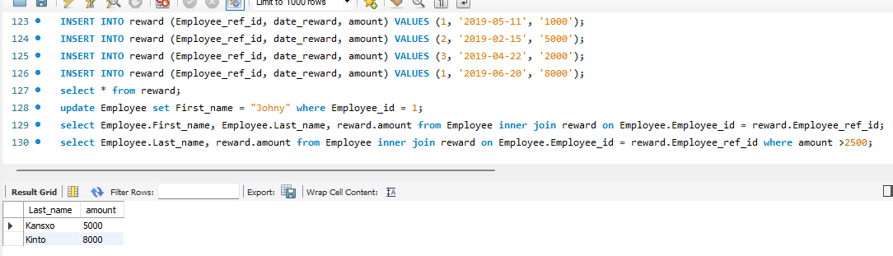

4. Get the employee name, the amount of the reward for the employees earning salary greater than 1
million, even if they have not received any rewards.

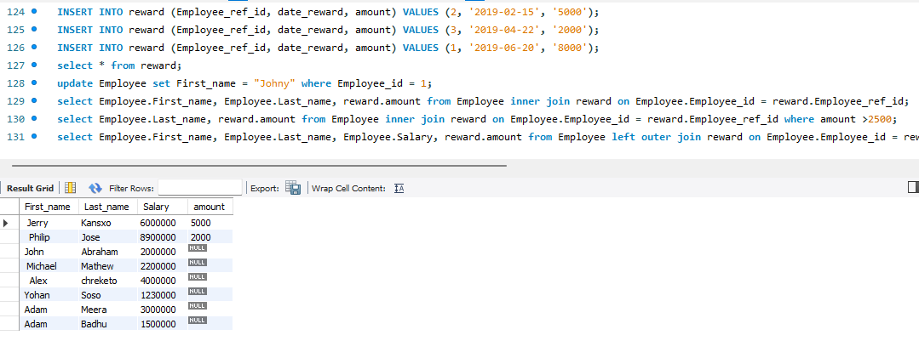

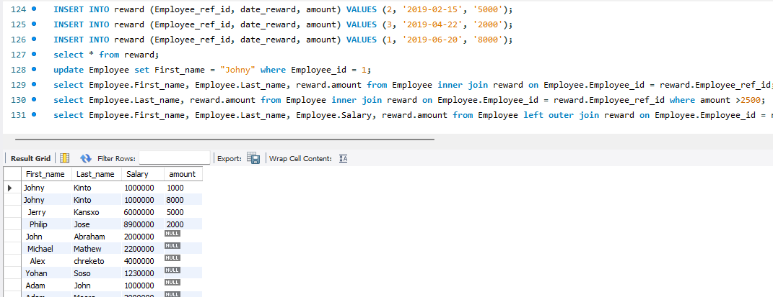

- Get total rewards for FINANCE department
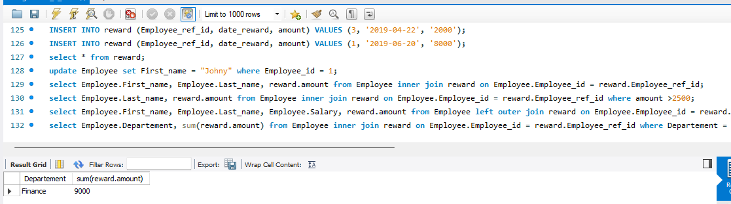

6. Get total rewards for each department

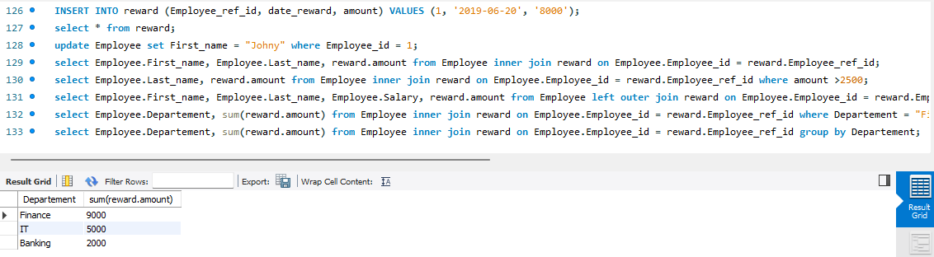
- Get net amount taken by each employee who received rewards less than 7500

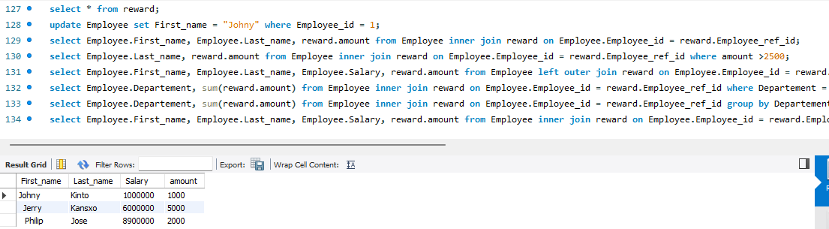

8. Get the employee name, total amount of the reward for the employees , even if they have not
received any rewards.

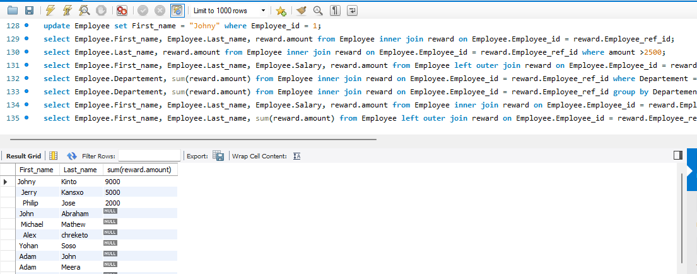

9. Get the employee name, total amount of the reward for the employees containing 'john' in their
firstname, even if they have not received any rewards.(use: having)

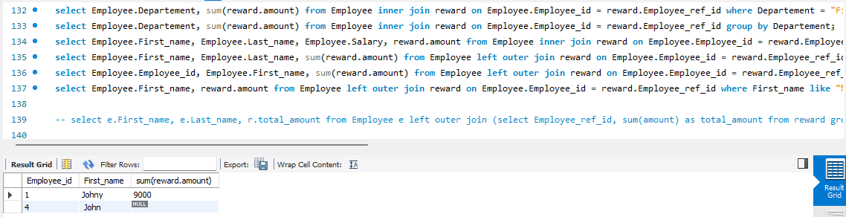

10. Get the employee name, total amount of the reward for the employees containing 'j' in their
firstname, even if they have not received any rewards.(use: where)

