Assignment11

- Create a table as same as employee table with true condition (but no columns used)

create table Employee_copy as select * from Employee where 5=5;

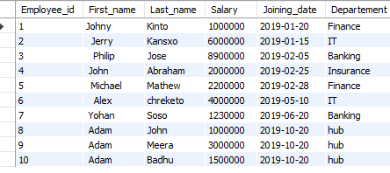
2. Create a table as same as employee table with true condition
(but columns used)

create table Employee_copy_a as select * from Employee where Employee_id = '10';


3. Create a table as same as employee table with false condition
(but columns used)

create table Employee_copy_b as select * from Employee where Employee_id = '15';


4. Create a table as same as employee table with false condition
(but no columns used)

create table Employee_copy_c as select * from Employee where 24=27;

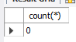

5. Write a trigger to convert negative salary to 0 before any insertion into employee
Table

insert into Employee values (12, ' Akila ', 'Ram', -3000, "2020-08-20", "Banking");
delimiter &&
create trigger chg_salato0
before insert on Employee for each row
begin
if new.Salary <0 then
set new.salary = 0;
end if;
end &&
delimiter ;
insert into Employee values (11, ' Poorna ', 'Ram', -3000, "2020-08-20", "Banking");
select * from Employee;

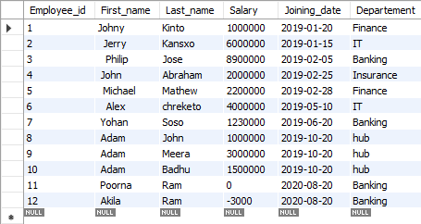

6. Write a trigger to insert an entry into new table after any insertion into employee
Table

CREATE TABLE Employee_mirror (
Employee_id int ,
First_name VARCHAR(50),
Last_name VARCHAR(50),
Salary int,
Joining_date Date,
Departement VARCHAR(50)
);
select * from Employee_mirror;
delimiter &&
create trigger Emp_mir_crt
after insert on Employee for each row
begin
insert into Employee_mirror values (new.Employee_id, new.First_name, new.Last_name, new.Salary, new.Joining_date, new.Departement);
end &&
delimiter ;
INSERT INTO Employee (Employee_id, First_name, Last_name, Salary, Joining_date, Departement) VALUES (13, ' Adam ', 'Rose', 5500000, "2020-10-30", "hub");
select * from Employee;
select * from Employee_mirror;
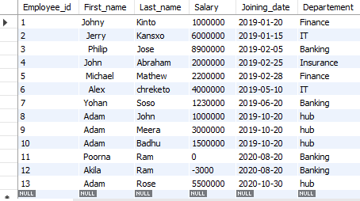
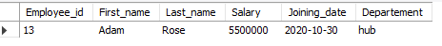

7. Write a trigger to delete entry from new table after any deletion into employee
table

delimiter &&
create trigger delafemp
after delete on Employee for each row
begin
delete from Employee_mirror where Employee_id = old.Employee_id;
end &&
delimiter ;
delete from Employee where Employee_id = 13;
select * from Employee;
select * from Employee_mirror;

