**Assignment- Regression Algorithm**

1. Problem statement identification:

Stage1: ML

Stage2: Supervised Leaning method

Stage3: Regression

2. Dataset

1338 rows × 6 columns

3. Yes, We need preprocessing method since we have nominal datas (Sex, Smoker ) to convert String data into numeric.

4. R2_score values:

1. Multiple Linear Regression:

R2_value : 0.7894790349867009

2. Support Vector ML Regression

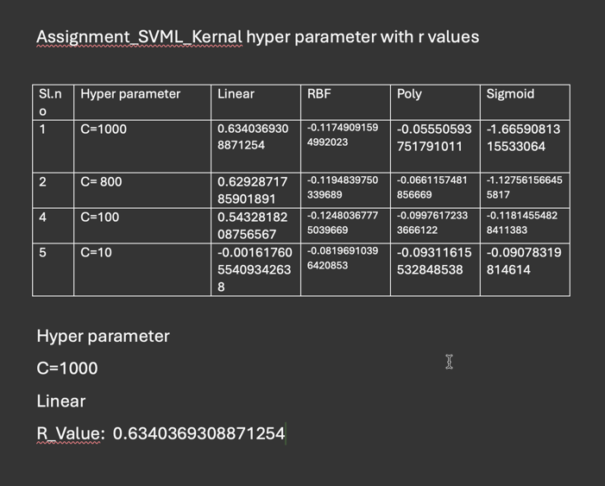

kernel='linear'

C=1000

R2_Score value : 0.6340369308871254

3. Decision Tree

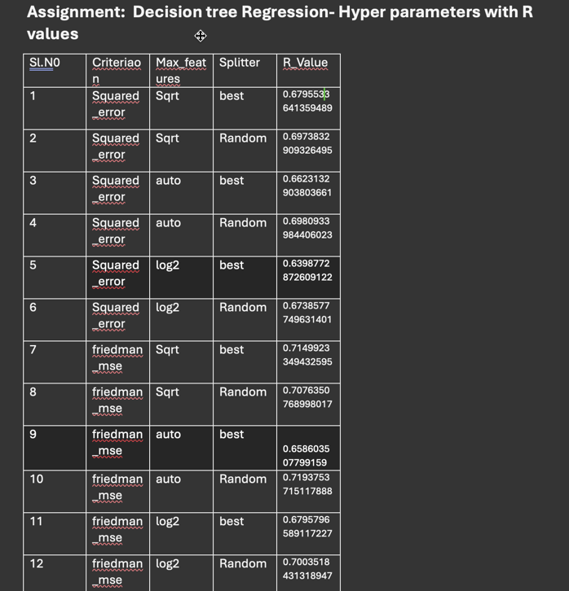

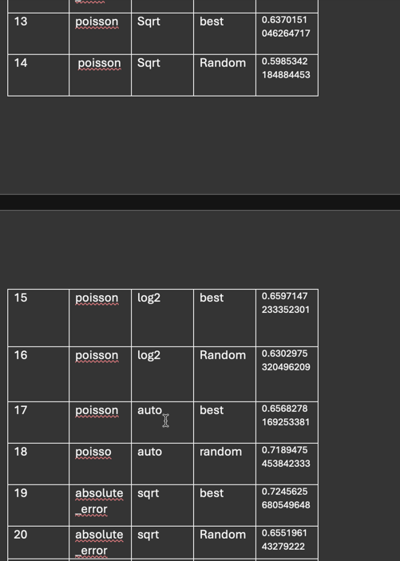

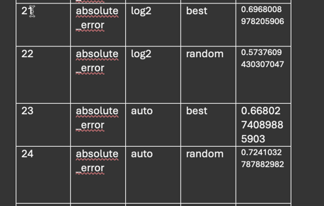

criterion='absolute_error'

max_features='sqrt'

splitter='best'

R2_Value: 0.7245625680549648

4. Random forest:

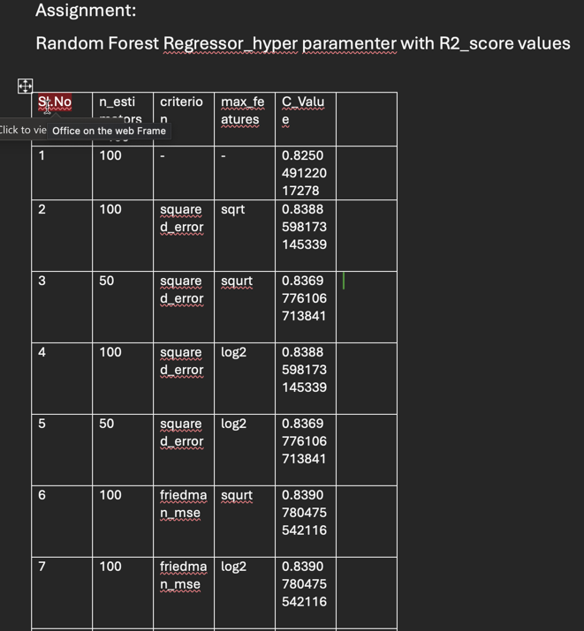

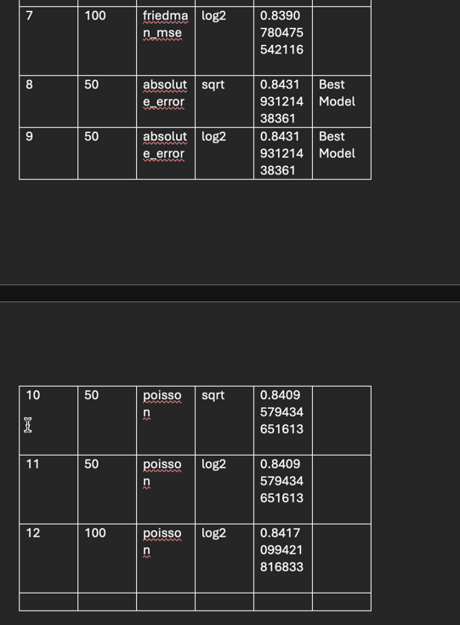

n_estimators=50

random_state=0

criterion='absolute_error'

max_features='sqrt'

R2 value: 0.843193121438361

Conclusion:

In Random Forest supervised learning method, we are getting the best model out of all other methods. We can deploy in Production.