1. Introduction
Heart Disease Prediction Using Machine Learning is a machine learning project that predicts whether a person is likely to have heart disease based on selected health-related attributes. The project uses a heart disease dataset and applies data preprocessing, visualization, and machine learning techniques. Logistic Regression and Random Forest algorithms are trained and evaluated. The Random Forest model achieved an accuracy of 88.33% on the test dataset.

2. Problem Statement
Heart disease is a major health concern, and early identification can help in timely medical evaluation. Traditional assessment may require analyzing multiple health-related factors. This project aims to develop a machine learning-based system that analyzes patient data and predicts the presence or absence of heart disease.

3. Objectives
- To collect and prepare a heart disease dataset.
- To clean and preprocess the data.
- To visualize the dataset and understand the data distribution.
- To train machine learning models for prediction.
- To compare Logistic Regression and Random Forest.
- To evaluate model performance using accuracy and classification metrics.
- To develop a simple heart disease prediction system.

4. Existing System
In the existing system, heart disease risk is mainly assessed by doctors using medical history, physical examination, laboratory tests, and other clinical information. The process may require analyzing multiple health-related factors. Manual assessment can take time and depends on proper interpretation of the available medical information.

5. Proposed System
The proposed system uses Machine Learning techniques to predict the presence or absence of heart disease based on patient health-related attributes. The dataset is cleaned and preprocessed before applying machine learning algorithms. Logistic Regression and Random Forest models are trained and evaluated. The model provides a prediction based on the input data.

6. System Requirements

6.1 Hardware Requirements
- Computer/Laptop
- Minimum 4 GB RAM
- Minimum 10 GB free storage
- Internet connection

6.2 Software Requirements
- Operating System: Windows / Linux / macOS
- Python 3.x
- Google Colab
- Pandas
- NumPy
- Matplotlib
- Scikit-learn

7. Methodology
The project follows the following steps:
- Data Collection – The heart disease dataset is collected from the UCI Heart Disease dataset.
- Data Preprocessing – Missing values are identified and removed from the dataset.
- Data Visualization – Graphs are used to understand the distribution of heart disease cases.
- Feature and Target Selection – Patient attributes are used as features and the target indicates the presence or absence of disease.
- Train-Test Split – The dataset is divided into training and testing data.
- Model Training – Logistic Regression and Random Forest algorithms are trained.
- Prediction – The trained models predict the target class for test data.
- Model Evaluation – Accuracy and classification metrics are used to evaluate the models.
- Model Comparison – The performance of both models is compared.

7.1 Project Workflow
Dataset → Data Cleaning → Visualization → Feature Selection → Train/Test Split → Model Training → Prediction → Evaluation → Model Comparison

8. Dataset Description
The dataset used in this project is the UCI Heart Disease dataset. It contains patient health-related information that can be used to predict the presence or absence of heart disease.
The original Cleveland dataset contains 303 patient records and 14 attributes. After removing records with missing values, 297 records were used for model training and testing.

8.1 Dataset Attributes
Attribute | Description
age | Age of the patient
sex | Sex of the patient
cp | Chest pain type
trestbps | Resting blood pressure
chol | Serum cholesterol
fbs | Fasting blood sugar
restecg | Resting ECG results
thalach | Maximum heart rate achieved
exang | Exercise-induced angina
oldpeak | ST depression
slope | Slope of peak exercise ST segment
ca | Number of major vessels
thal | Thalassemia-related measurement
target | Presence or absence of heart disease
Target:
- 0 → No Disease
- 1 → Disease

9. Data Preprocessing
Data preprocessing is an important step in the machine learning process. It helps to prepare the dataset before training the machine learning models.
The following preprocessing steps were performed:
- Handling Missing Values – Missing values represented by ? were identified and removed.
- Data Cleaning – The dataset was checked to ensure that the required values were in the correct format.
- Target Conversion – The original target values were converted into two classes:
  - 0 → No Disease
  - 1 → Disease
- Feature and Target Separation – The patient attributes were separated as input features (X) and the target column was separated as output (y).
- Train-Test Split – The cleaned dataset was divided into training and testing sets.

9.1 Dataset Before and After Cleaning
- Original dataset: 303 records
- Missing values found in: ca and thal
- Records after cleaning: 297
- Training data: 237 records
- Testing data: 60 records

10. Data Visualization
- Data visualization is used to understand the distribution of heart disease cases in the dataset. A bar chart was created to compare the number of patients with and without heart disease.
Figure 1: Heart Disease Distribution
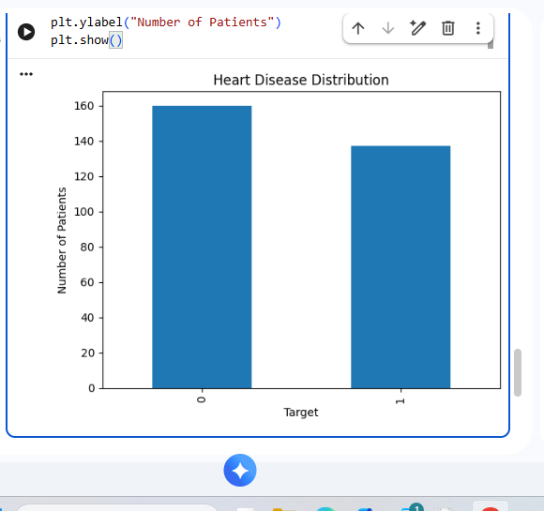
Graph interpretation:
- Target 0 represents No Disease.
- Target 1 represents Disease.
- After data cleaning, the dataset contains 160 No Disease records and 137 Disease records.

11. Machine Learning Models
Logistic Regression is a supervised machine learning algorithm used for classification problems. In this project, it is used to classify patients into two categories: No Disease and Disease.

11.2 Random Forest
Random Forest is a supervised machine learning algorithm that combines multiple decision trees to make predictions. It can handle multiple input features and is useful for classification tasks.

11.3 Model Training
The dataset was divided into training and testing data. The training data was used to train both Logistic Regression and Random Forest models. The testing data was then used to evaluate their performance.

12. Model Evaluation and Results
The trained machine learning models were evaluated using the test dataset. Accuracy and classification report were used to measure the performance of the models.

12.1 Accuracy Comparison
Machine Learning Model | Accuracy
Logistic Regression | 88.33%
Random Forest | 88.33%
Both models achieved an accuracy of 88.33% on the test dataset.

12.2 Random Forest Classification Report
Class | Precision | Recall | F1-Score
No Disease | 0.91 | 0.89 | 0.90
Disease | 0.84 | 0.88 | 0.86
Accuracy |  |  | 0.88
Interpretation:
The Random Forest model achieved good performance on the test dataset. It correctly classified most of the test samples into the No Disease and Disease categories.

12.3 Confusion Matrix
Figure 2: Confusion Matrix of Random Forest Model

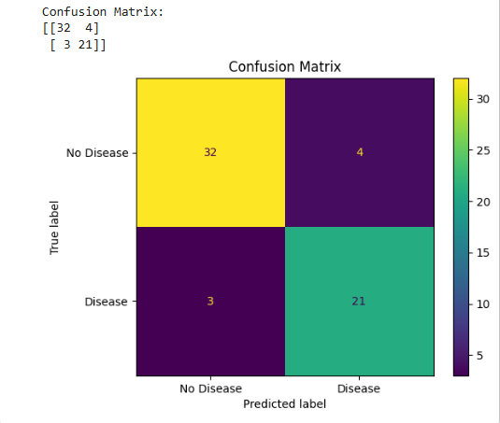

13. Feature Importance

13. Feature Importance
Feature importance is used to understand which input features contribute more to the predictions made by the Random Forest model.
The Random Forest model calculates an importance value for each feature. A bar chart is used to visualize the importance of the different features.
Figure 3: Feature Importance of Random Forest Model
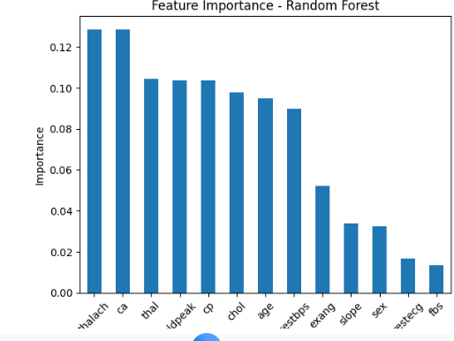

14. Model Accuracy Comparison
The accuracy of Logistic Regression and Random Forest models was compared using a bar chart. Both models achieved an accuracy of 88.33% on the test dataset.
Figure 4: Model Accuracy Comparison
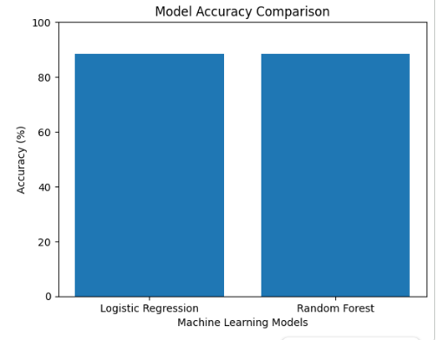

15. Prediction Result
The trained Random Forest model was used to predict the presence or absence of heart disease for the test data. The model classifies the input into two categories: No Disease and Disease.
The prediction results were compared with the actual target values to evaluate the performance of the model.
Prediction Classes:
- 0 → No Disease
- 1 → Disease
The model achieved an accuracy of 88.33% on the test dataset.

15.1 Sample Prediction
A sample patient input was provided to the trained model to demonstrate how the prediction system works. The model produces the predicted class based on the given health-related attributes.
Note: This prediction is for demonstrating the machine learning project only and should not be considered a medical diagnosis.

16. Conclusion
The Heart Disease Prediction Using Machine Learning project was successfully developed using Python and machine learning techniques. The dataset was cleaned and preprocessed before training the models.
Two machine learning algorithms, Logistic Regression and Random Forest, were implemented and evaluated. Both models achieved an accuracy of 88.33% on the test dataset.
The project demonstrates how machine learning can be applied to analyze health-related data and make predictions. This project is developed for educational purposes and is not intended to replace professional medical diagnosis.

17. Future Enhancement
The following improvements can be added to the project in the future:
- Develop a web-based interface for easy user interaction.
- Add more patient health-related features to improve the prediction system.
- Test additional machine learning algorithms and compare their performance.
- Improve model performance using suitable preprocessing and hyperparameter tuning.
- Deploy the trained model as an online application.
- Add a database to store and manage prediction-related data securely.
- Provide a simple and user-friendly interface for entering patient information.

18. References

18.1 Dataset Reference
UCI Machine Learning Repository – Heart Disease Dataset.

18.2 Software and Libraries
- Python
- Google Colab
- Pandas
- NumPy
- Matplotlib
- Scikit-learn

19. Project Advantages
- Easy to implement using Python.
- Helps analyze multiple health-related attributes.
- Uses machine learning for prediction.
- Provides measurable model performance.
- Can be extended into a web-based application.
- Useful for learning practical machine learning concepts.

20. Limitations
- The model is trained using a limited dataset.
- Prediction performance depends on the quality of the dataset.
- The system does not replace professional medical evaluation.
- More testing and validation are required before any real-world medical application.

21. Technologies Used
Technology | Purpose
Python | Programming
Pandas | Data processing
NumPy | Numerical operations
Matplotlib | Data visualization
Scikit-learn | Machine learning
Google Colab | Development environment

22. Project Workflow Summary

Dataset Collection
↓
Data Cleaning
↓
Data Visualization
↓
Feature & Target Selection
↓
Train-Test Split
↓
Logistic Regression
↓
Random Forest
↓
Prediction
↓
Model Evaluation
↓
Model Comparison

23. Final Result

The Heart Disease Prediction Using Machine Learning project was successfully implemented using Python. After preprocessing the dataset, Logistic Regression and Random Forest models were trained and evaluated.
Both models achieved an accuracy of 88.33% on the test dataset. The project successfully demonstrates the use of machine learning techniques for classification of heart disease-related data.

24. Appendix – Important Code

Appendix A: Data Loading and Preprocessing

import pandas as pd

columns = [
"age", "sex", "cp", "trestbps", "chol",
"fbs", "restecg", "thalach", "exang",
"oldpeak", "slope", "ca", "thal", "target"
]

df = pd.read_csv(
"processed.cleveland.data",
header=None,
names=columns,
na_values="?"
)

df["target"] = (df["target"] > 0).astype(int)

df = df.dropna()

Appendix B: Model Training

from sklearn.model_selection import train_test_split
from sklearn.linear_model import LogisticRegression
from sklearn.ensemble import RandomForestClassifier

X = df.drop("target", axis=1)
y = df["target"]

X_train, X_test, y_train, y_test = train_test_split(
X, y, test_size=0.2, random_state=42
)

model = LogisticRegression(max_iter=1000)
model.fit(X_train, y_train)

rf_model = RandomForestClassifier(
n_estimators=100,
random_state=42
)

rf_model.fit(X_train, y_train)

Appendix C: Prediction and Evaluation

from sklearn.metrics import accuracy_score

rf_pred = rf_model.predict(X_test)

rf_accuracy = accuracy_score(y_test, rf_pred)

print("Random Forest Accuracy:", rf_accuracy * 100, "%")

