Question 1

using Basic_Program;

using System.Net.Http.Headers;

class Demo1

{

public static void Main(string[] args)

{

FileOperations fileOperations = new FileOperations();

if (fileOperations.createfile()==false)

{

Console.WriteLine("The file exists/created and operable");

}

else

{

Console.WriteLine("The file is not operable");

}

fileOperations.writingToFile();

fileOperations.readFromFile();

}

}

using System;

using System.Collections.Generic;

using System.Linq;

using System.Text;

using System.Threading.Tasks;

namespace Basic_Program

{

internal class FileOperations

{

public bool createfile()

{

/*FileInfo f1 = new FileInfo("D:\\C# training\\Sample2.txt");

if (f1.Exists)

{

Console.WriteLine("File Exists");

Console.WriteLine(f1.IsReadOnly);

}*/

bool Locked = false;

try

{

FileStream fs = File.Open("D:\\C# training\\Sample2.txt", FileMode.OpenOrCreate,FileAccess.ReadWrite, FileShare.None);

fs.Close();

}

catch (IOException ex)

{

Locked = true;

}

finally

{

Console.WriteLine("Constraints has been checked");

}

return Locked;

}

public void writingToFile()

{

FileStream fs = new FileStream("D:\\C# training\\Sample2.txt", FileMode.Open, FileAccess.Write);

StreamWriter sw = new StreamWriter(fs);

Console.WriteLine("Input the string to ignore the line");

string word = Console.ReadLine();

Console.WriteLine("Input number of lines to write in the file");

int num = Convert.ToInt32(Console.ReadLine());

Console.WriteLine($"Input {num} strings below :");

for (int i=0;i<num;i++)

{

Console.WriteLine($"Input line {i+1} :");

string sentence = Console.ReadLine();

if (!sentence.Contains(word))

{

sw.WriteLine(sentence);

}

}

sw.Flush();

sw.Close();

fs.Close();

}

public void readFromFile()

{

Console.WriteLine("Enter the line number to read a specific line from the file");

int l = Convert.ToInt32(Console.ReadLine());

string[] lines = File.ReadAllLines("D:\\C# training\\Sample2.txt");

Console.WriteLine(" {0}", lines[l - 1]);

}

}

}

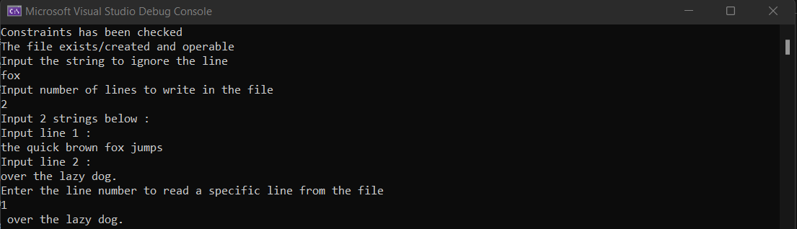

Question 2

using Basic_Program;

using System.Net.Http.Headers;

class Demo1

{

public static void Main(string[] args)

{

stringDuplication stringDuplication = new stringDuplication();

stringDuplication.findDuplicate();

}

}

using System;

using System.Collections.Generic;

using System.Linq;

using System.Text;

using System.Threading.Tasks;

namespace Basic_Program

{

internal class stringDuplication

{

public void findDuplicate()

{

Console.Write("Enter a String : ");

string inputString = Console.ReadLine();

string resultString = string.Empty;

for (int i = 0; i < inputString.Length; i++)

{

if (!resultString.Contains(inputString[i]))

{

resultString += inputString[i];

}

}

Console.WriteLine(resultString);

}

}

}



Question 3

using Basic_Program;

using System.Net.Http.Headers;

class Demo1

{

public static void Main(string[] args)

{

Consecutives consecutives= new Consecutives();

Console.WriteLine("Enter the string : ");

string input = Console.ReadLine();

consecutives.display_consecutives(input);

}

}

using System;

using System.Collections.Generic;

using System.Linq;

using System.Text;

using System.Threading.Tasks;

namespace Basic_Program

{

internal class Consecutives

{

public void display_consecutives(string input)

{

string output = "";

int count = 1;

for (int i = 1; i < input.Length; i++)

{

if (input[i] == input[i - 1])

{

count++;

}

else

{

output += input[i - 1] + count.ToString();

count = 1;

}

}

output += input[input.Length - 1] + count.ToString();

Console.WriteLine("Output : ");

Console.WriteLine(output.ToLower());

}

}

}

OUTPUT:

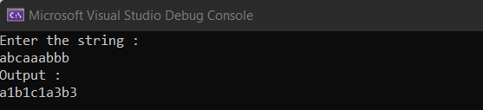

Question 4

using Basic_Program;

using System.Net.Http.Headers;

class Demo1

{

public static void Main(string[] args)

{

string s1 = Console.ReadLine();

string s2 = Console.ReadLine();

DataTransfer dt = new DataTransfer();

dt.process(s1, s2);

}

}

using System;

using System.Collections.Generic;

using System.Linq;

using System.Text;

using System.Threading.Tasks;

namespace Basic_Program

{

internal class DataTransfer

{

int length;

int index;

public void process(string s1, string s2)

{

int prefixLen = 0;

for (int i = 0; i < Math.Min(s1.Length, s2.Length); i++)

{

if (s1[i] == s2[i])

{

prefixLen++;

}

else

{

break;

}

}

string compressedS1 = s1.Substring(prefixLen);

string compressedS2 = s2.Substring(prefixLen);

Console.WriteLine($"{prefixLen} {s1.Substring(0, prefixLen)}");

Console.WriteLine($"{compressedS1.Length} {compressedS1}");

Console.WriteLine($"{compressedS2.Length} {compressedS2}");

}

}

}

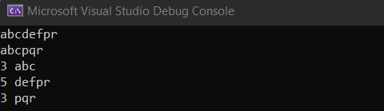

Question 5

using System;

class Program

{

static bool IsFullOfColors(string sequence)

{

int redCount = 0;

int greenCount = 0;

int yellowCount = 0;

int blueCount = 0;

for (int i = 0; i < sequence.Length; i++)

{

switch (sequence[i])

{

case 'R':

redCount++;

break;

case 'G':

greenCount++;

break;

case 'Y':

yellowCount++;

break;

case 'B':

blueCount++;

break;

}

if (Math.Abs(redCount - greenCount) > 1 || Math.Abs(yellowCount - blueCount) > 1)

{

return false;

}

}

return redCount == greenCount && yellowCount == blueCount;

}

static void Main(string[] args)

{

int n = int.Parse(Console.ReadLine());

for (int i = 0; i < n; i++)

{

string sequence = Console.ReadLine();

Console.WriteLine(IsFullOfColors(sequence) ? "True" : "False");

}

}

}



Question 6

using System;

class Program

{

static int SuperDigit(long n)

{

if (n < 10)

{

return (int)n;

}

else

{

long digitSum = 0;

while (n > 0)

{

digitSum += n % 10;

n /= 10;

}

return SuperDigit(digitSum);

}

}

static void Main(string[] args)

{

string[] inputs = Console.ReadLine().Split(' ');

long n = long.Parse(inputs[0]);

int k = int.Parse(inputs[1]);

long digitSum = 0;

while (n > 0)

{

digitSum += n % 10;

n /= 10;

}

digitSum *= k;

Console.WriteLine(SuperDigit(digitSum));

}

}



Question 7

using System;

using System.Collections.Generic;

class Program

{

static int[] parent;

static int[] size;

static int Find(int x)

{

if (parent[x] == x)

{

return x;

}

return parent[x] = Find(parent[x]);

}

static void Union(int x, int y)

{

int rootX = Find(x);

int rootY = Find(y);

if (rootX != rootY)

{

if (size[rootX] < size[rootY])

{

int temp = rootX;

rootX = rootY;

rootY = temp;

}

parent[rootY] = rootX;

size[rootX] += size[rootY];

}

}

static void Main(string[] args)

{

int n = int.Parse(Console.ReadLine());

int m = int.Parse(Console.ReadLine());

parent = new int[n + 1];

size = new int[n + 1];

for (int i = 1; i <= n; i++)

{

parent[i] = i;

size[i] = 1;

}

for (int i = 0; i < m; i++)

{

string[] line = Console.ReadLine().Split();

int x = int.Parse(line[0]);

int y = int.Parse(line[1]);

Union(x, y);

}

int[] groupSize = new int[n + 1];

for (int i = 1; i <= n; i++)

{

groupSize[Find(i)]++;

}

int cost = 0;

int remaining = n;

for (int i = 1; i <= n; i++)

{

if (groupSize[i] > 0)

{

int k = (int)Math.Ceiling(Math.Sqrt(groupSize[i]));

cost += k;

remaining -= k * k;

}

}

if (remaining > 0)

{

cost += (int)Math.Ceiling((double)remaining / Math.Sqrt(remaining));

}

Console.WriteLine(cost);

}

}



Question 8

using System;

using System.Collections.Generic;

class Solution

{

static void Main(string[] args)

{

string[] line1 = Console.ReadLine().Split();

int n = int.Parse(line1[0]); // number of armies

int q = int.Parse(line1[1]); // number of events

// initialize the armies with empty soldier lists

List<int>[] armies = new List<int>[n];

for (int i = 0; i < n; i++)

{

armies[i] = new List<int>();

}

// keep track of the soldiers' combat abilities in each army

int[] maxCombat = new int[n];

for (int i = 0; i < n; i++)

{

maxCombat[i] = int.MinValue;

}

// handle each event

for (int i = 0; i < q; i++)

{

string[] line = Console.ReadLine().Split();

int type = int.Parse(line[0]);

if (type == 1)

{ // print maximum combat ability in army

int army = int.Parse(line[1]) - 1; // 0-based indexing

Console.WriteLine(maxCombat[army]);

}

else if (type == 2)

{ // remove soldier with max combat ability

int army = int.Parse(line[1]) - 1; // 0-based indexing

int maxCombatIndex = armies[army].Count - 1;

for (int j = armies[army].Count - 2; j >= 0; j--)

{

if (armies[army][j] > armies[army][maxCombatIndex])

{

maxCombatIndex = j;

}

}

armies[army].RemoveAt(maxCombatIndex);

if (armies[army].Count > 0)

{

maxCombat[army] = armies[army][armies[army].Count - 1];

}

else

{

maxCombat[army] = int.MinValue;

}

}

else if (type == 3)

{ // add soldier with combat ability

int army = int.Parse(line[1]) - 1; // 0-based indexing

int combat = int.Parse(line[2]);

armies[army].Add(combat);

if (combat > maxCombat[army])

{

maxCombat[army] = combat;

}

}

else

{ // merge armies

int army1 = int.Parse(line[1]) - 1; // 0-based indexing

int army2 = int.Parse(line[2]) - 1; // 0-based indexing

armies[army1].AddRange(armies[army2]);

armies[army2] = null; // mark army2 as removed

maxCombat[army1] = Math.Max(maxCombat[army1], maxCombat[army2]);

maxCombat[army2] = int.MinValue;

}

}

}

}

