A method for power amplifier distortions compensation for the 5G NR communication systems

**Version 0.6**

**Abstract:**

For the past years, the Internet of Things (IoT) supported by 5G technology has been expanding rapidly across wide range of services, enabling inter-object connectivity for automotive industry, consumer electronics, transportation, logistics sectors and manufacturing. With the increasing ubiquitous usage of various small-sized sensors, manufacturing cost of each element taken remains a critical aspect. Relatively low price of individual elements is the key for enabling tightly connected environment, but may severely affect the RF chains quality as well as overall performance. With 5G expansion to the sub-THz bands, power amplifier nonlinearity may significantly limit system performance even in high-grade devices, due to power amplifier design limitations. Multiple studies were done to mitigate nonlinearity impact, both at the transmitter and receiver sides. Many solutions propose some variation for evaluation of the PA effects, via decision directed feedback, training or even statistical processing of the received signal. However, with knowledge of the PA nonlinearity function at the receiving side, the processing may be simplified to the applying of the reverse function to the equivalent signal in the time domain.

In this work we propose a method for PA nonlinear distortion compensation on the RX side, which can be adjusted for several signal waveforms, such as CP-OFDM and DFT-S-OFDM.

Provided simulation results demonstrate performance improvement both for the sub-THz PA models and models for 30-70 GHz band with much better characteristics.

# Introduction

Latest releases of the 5G New Radio (NR) standards Rel15 and Rel16 support carrier frequencies up to 52.6 GHz. Considering operations above 52.6 GHz, third generation partnership project (3GPP) radio access network (RAN) specification group already has investigated requirements for 52.6 GHz - 114.25 GHz [1]frequency band, with the main interest to first extend the current NR frequency range 2 (FR2) support to the frequency range 52.6 GHz - 71 GHz with minimal changes to the system[2][3]. Also, the possibilities of further expansion into the sub-THz band around 71-114 GHz has been considered. In this frequency band, despite recent technology advances in the PA design, they still demonstrate highly non-linear behavior for the typical allowed TX power[4]. Thus, PA distortions may become a significant performance limiting factor, especially for the highly efficient modulations like 64- and 256-QAM.

## Problem and previous solutions

In lower 5G NR bands, FR1 and, partially, FR2 the effects of the PA can be neglected in most cases since the PA operation point may be safely placed in the linear region with minimal transmitted signal distortions. The problem may be important only for cheap transceivers with the low-quality PA chains. It should be noted that the number of such devices can be very large, since cheap devices usually are a part of Internet-of-Things (IoT) infrastructure. So the problem was addressed in a number of works [5]-[11]even for the lower bands.

Rapp model of the power amplifier nonlinearity is widely used for description of the amplitude and phase distortions of the solid state power amplifiers (SSPA). Modified Rapp PA model, shown in(1) is also included as the baseline model in the 3GPP specification [1].

|  |  |  |
| --- | --- | --- |
|  |  | (1) |

where $F_{AM-AM}\left(x\right), F_{AM-PM}\left(x\right)$ is the amplitude and phase distortion, respectively. $G$ is the small signal gain, $p$ is the smoothness factor and $V_{sat}$ is the saturation voltage. $A,B,q$ are phase distortion curve parameters.

Baseline characteristics of the typical power amplifiers in the 30-70 GHz band were used to derive PA model [15], viable in the corresponding band. However, as it can be seen from the recent works [4][16][17], the sub-THz PA characteristics, even in 100-200 GHz bands, are different. To evaluate system performance at these carrier frequencies, we derive an averaged PA model on the base of recent papers. The comparison is presented on Figure 1.Based on averaged parameters ${G,p,V}_{sat}$ a 100-200 GHz PA model has been obtained.

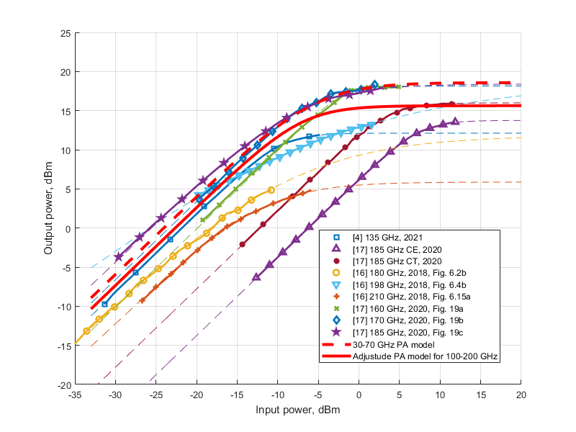

Figure 1.Comparison of SSPA characteristics based on paper research. Dashed lines of the same color as the markers are curve fits of Rapp AM-AM distortion

Figure 2shows the effect of the PA nonlinearity on the different waveforms. It can be seen that for single carrier (SC) system the effect is a straightforward amplitude distortion, which can easily be compensated. On the contrary, for OFDM, PA nonlinearity causes inter-carrier interference (ICI), which is random and cannot be compensated easily.

DFT spread OFDM (DFT-s-OFDM) represents some intermediate case, where both deterministic and random components exist, and thus, compensation is possible.

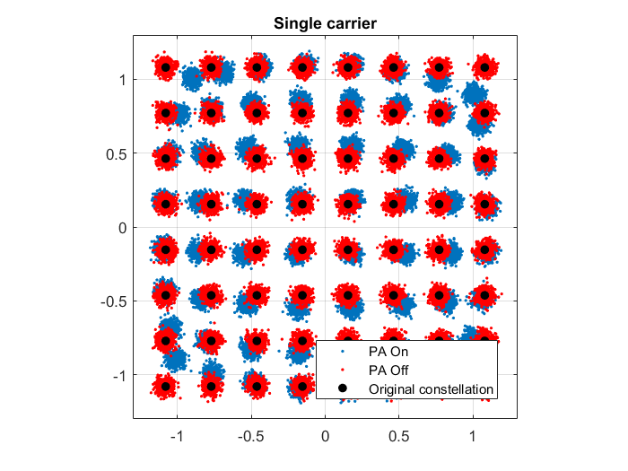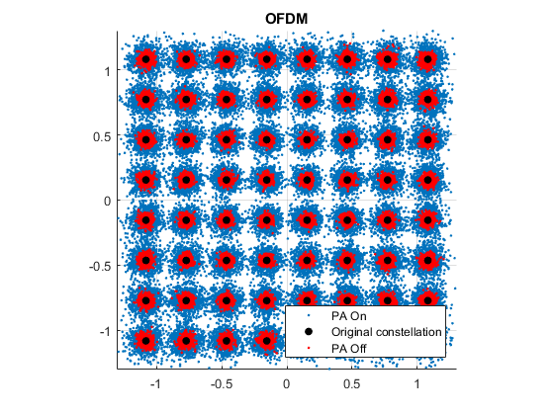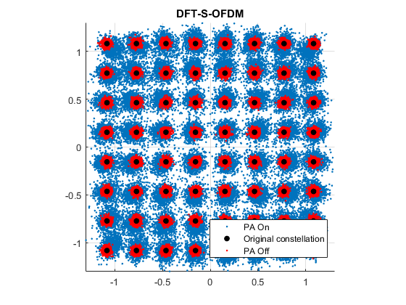

Figure 2.Examples of constellation distortion on the receiver due to PA nonlinearity.

Two different directions for the PA nonlinearity mitigation have been proposed so far. The first is PA pre-distortion at the transmitter size, with preparing of the TX signal of special properties that minimize PA negative effects. There are a number of such approaches, however they have a limited performance impact, and pre-distortion tends to have a poor performance at low IBO value[5][6][7]. Pre-distortion is also undesirable on compact simple devices like sensors, as it increases processing on the TX side, thus increasing power consumption.

Another way is the compensation of the PA nonlinearity at the receiver. In [8], statistical processing of the received signals for the evaluation of the average PA distortion for further compensation is proposed. Works [5][6][9][10][11][12][13] considers a theoretical approach for the compensation at the receiver in the very generalized case. Several methods of receiver-side nonlinearity compensation were considered for OFDM waveform [11][12][13] where PA nonlinear distortion is represented as constant complex gain and Gaussian noise component, with the main goal to obtain PA parameters (known or estimated with pilot signals) to compensate for the nonlinear distortion. A number of methods has been presented for simple single carrier waveform [5][6][9][10], including hard-decision, usage of sequential Monte-Carlo methods and inverse PA function. In several cases PA parameters are assumed known [9][11][10] at the receiver to perform nonlinearity compensation. In cases when PA parameters are estimated, the performance is the same or worse.

# New idea

As it was shown that for the SC and, most importantly, DFT-s-OFDM case, the PA distortion have some deterministic component in addition to the ICI. With the knowledge of the PA nonlinearity function, it is possible to compensate the deterministic component and improve demodulation performance. This can be done by applying the RX processing, which is equivalent to the inverse function of the PA nonlinearity.

Generally, this function is not known at the receiver, not only because the PA characteristics are not known, but also due to different TX power. Actual value of the TX power determines the working point of the PA and thus, nonlinear distortions of the signal.

In several works, like [10][11][12], the decision-directed feedback is used for estimation of the power amplifier characteristics, similarly, in [8] statistical processing is applied to adjust demodulation algorithm to the received distorted signal.

However, it is more effective to know the nonlinearity function and the working point for applying exact processing.

## Proposed RX-side compensation method

Presented below is a receiver-side PA nonlinearity compensation method for the CP-OFDM waveform, based on usage of inverse PA distortion curve (Figure 3).

The PA compensation scheme flow consist of the basic TX processing (1) that may include MIMO precoding and transform precoding (in the case of DFT-s-OFDM waveform), as well as standard OFDM IFFT block. Created OFDM baseband signal is fed to one or more TX chains that may include CP insertion and frequency up conversion and finally come to the output power amplifier PA (2) operating at the carrier frequency. It should be noted, that for proper work of the proposed scheme, that signals on the different antennas should have the same amplitudes (but may have different phases). This limits the scheme applicability to rank 1 transmission, even if several TX antennas are used. After propagating through the channel, signal comes to the RX chains of one or more receive antennas for further baseline RX processing (4) that may consist of the FFT and further maximum ration combining (MRC) and frequency domain equalization. Such processing effectively removes the impact of the frequency selective channel and we may use this signal at the PA distortion compensation block (5). This block may consist of the IFFT operation (6) for returning the signal into the time domain, the Inverse PA nonlinear function block (7) that actually performs the compensation, and a FFT block to return the compensated signal back to the FD.



Figure 3.Schematic representation of proposed receiver-side compensation scheme for DFT-S-OFDM

The inverse PA distortion function, which the signal is passed through inside of block (7), is obtained as an inverse of the Rapp AM-AM distortion in Eq. (1) with function value restrained, and is given as follows:

|  |  |
| --- | --- |
| , | (2) |

where ${F^{-1}}_{AM-AM}$ is the inverse amplitude distortion function, $α$ is a border-setting coefficient, which is required to ceil and restrain the function from reaching infinity at $x=V_{sat}$. The value used in the simulations is $α=0.9$. It is important to restrain the function with a ceiling, since allowing it to reach infinity may cause even more distortion to occur at the output of the compensation scheme.

## Simulation results and assumptions

To prove the feasibility of the proposed approach, link-layer simulations (LLS) were performed, comparing the proposed scheme with the cases of ideal PA and an uncompensated case for a given PA model. The model based on the parameters of the typical real power amplifiers in the 30-70 GHz band[15] was used along with newly developed model for the 100-200 GHz. Simulations were performed for different system parameters , such as subcarrier spacing (SCS), used waveform type, coding and modulation and etc. The full list of LLS simulation parameters is summarized in Table 1.

Table 1 Simulation assumptions and parameters

|  |  |
| --- | --- |
| Parameters | Assumption |
| Carrier frequency | 60GHz |
| Bandwidth | 400 MHz  Hexagonal 21 cells |
| Waveform | CP-OFDM, CP-DFT-s-OFDM |
| PA Model & Parameters | 30-70GHz model[15], 100-200GHz model (section 1.1) |
| TX power | 10 dBM |
| SCS | 120 kHz/ 480 kHz / 960 kHz |
| Resource blocks allocated | 256/ 64 / 32 RBs |
| Channel model/Pathloss | TDL-A, 5 ns DS, 3 km/h |
| Transmission scheme | 1x2 MRC |
| Modulation and coding | 64-QAM (MCS Table 1;22, 27)  256 QAM(MCS Table 2; 22) |
| Impairments | Phase noise (BS and UE example 2 model, [18]), compensated with LS filter  Channel estimation: LS fitting per precoding region (24 subc) |

### Simulation results for 30-70 GHz PA Model

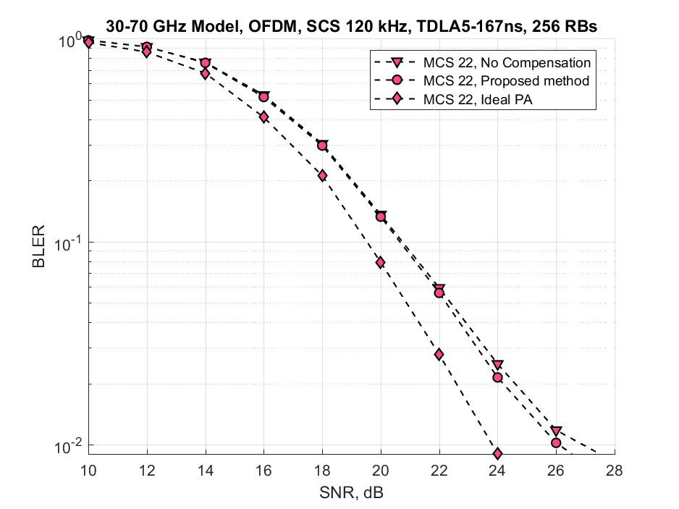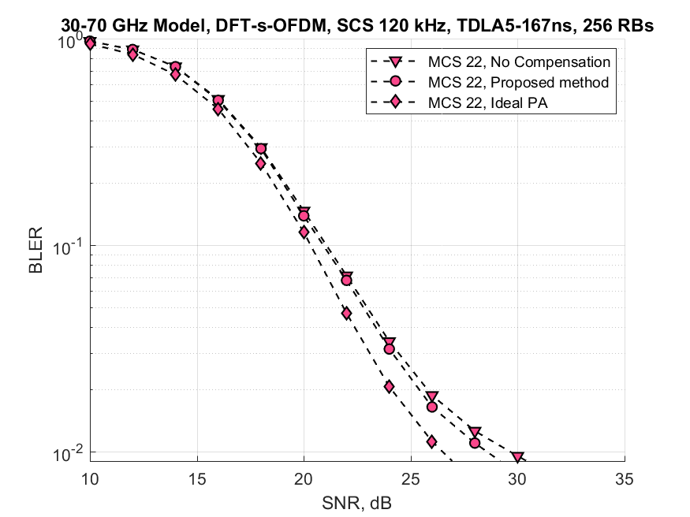

Figure 4 BLER for SCS 120 kHz, 64-QAM/256 QAM for OFDM (left) and DFT-s-OFDM(right)

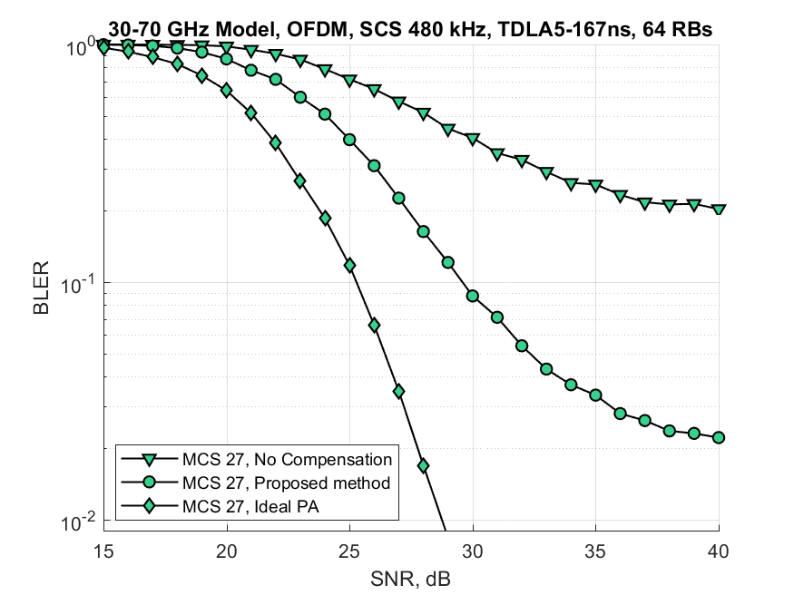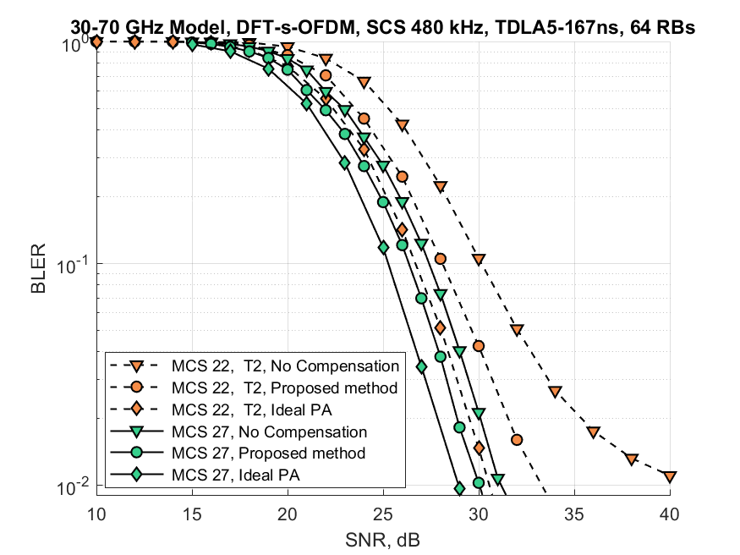

Figure 5 BLER for SCS 480 kHz, 64-QAM/256 QAM for OFDM (left) and DFT-s-OFDM(right)

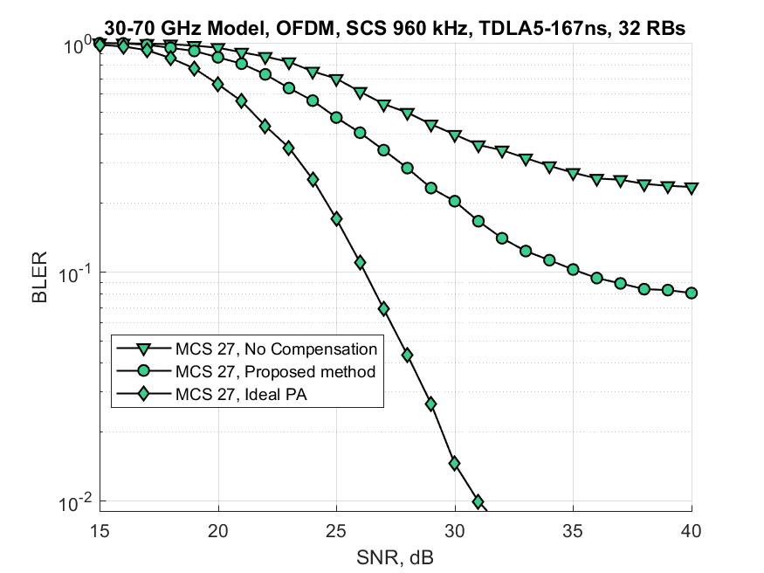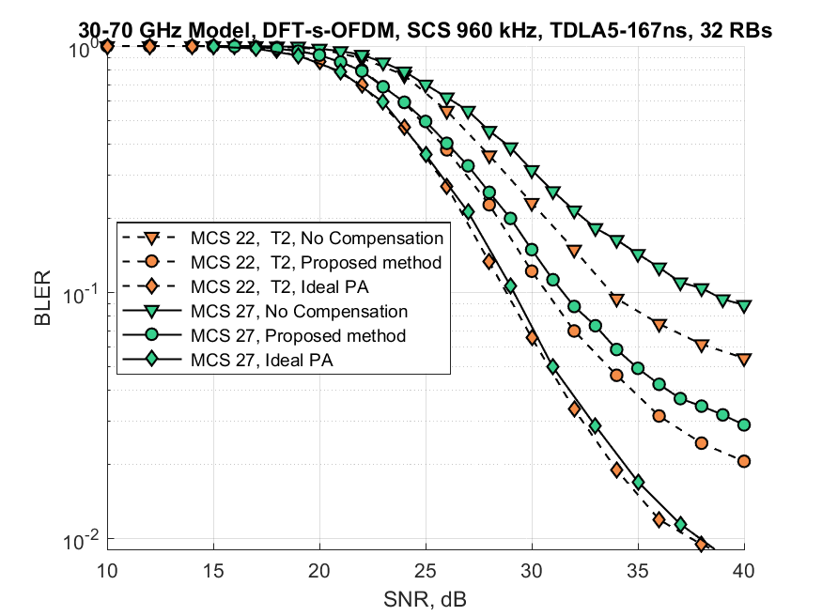

Figure 6 BLER for SCS 960 kHz, 64-QAM/256 QAM for OFDM (left) and DFT-s-OFDM(right)

### Simulation results for 100-200 GHz PA model

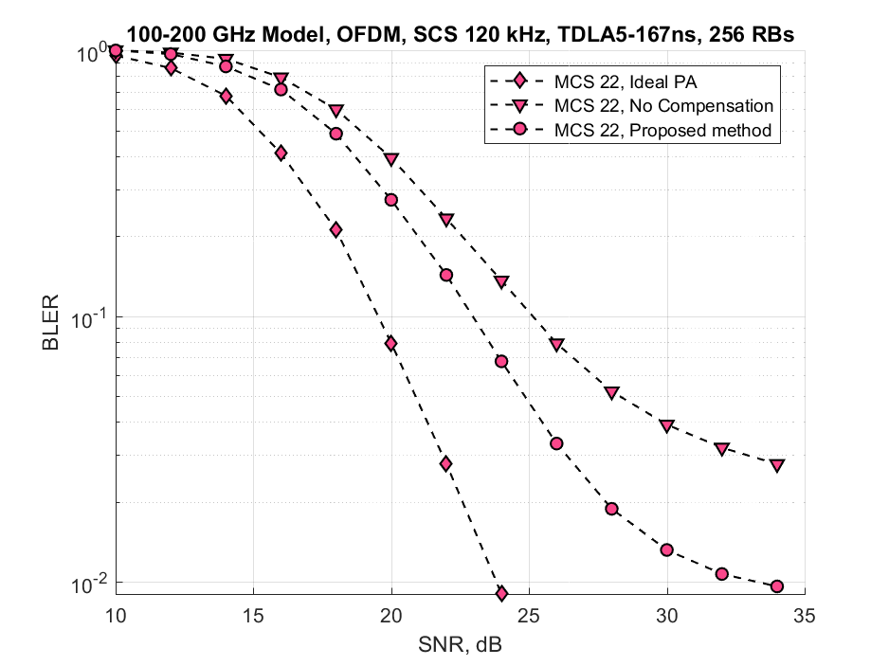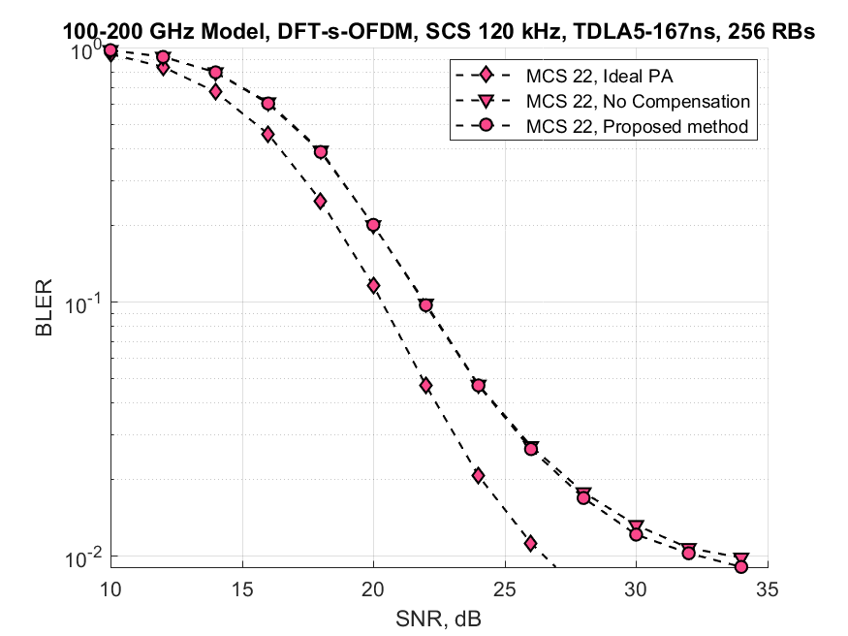

Figure 7 BLER for SCS 120 kHz, 64-QAM/256 QAM for OFDM (left) and DFT-s-OFDM(right)

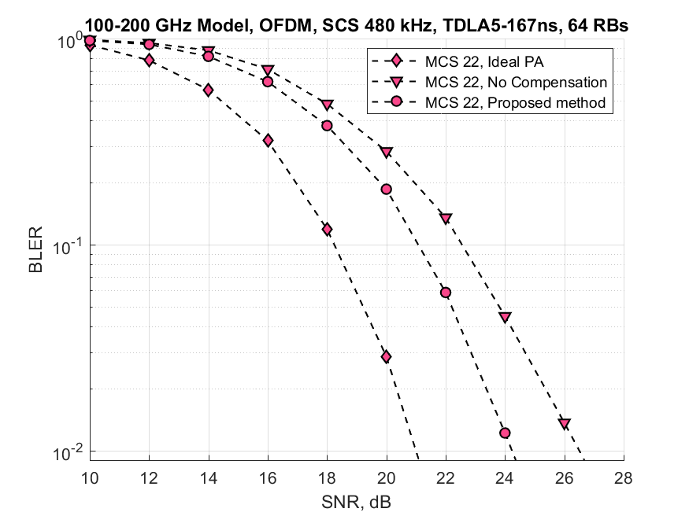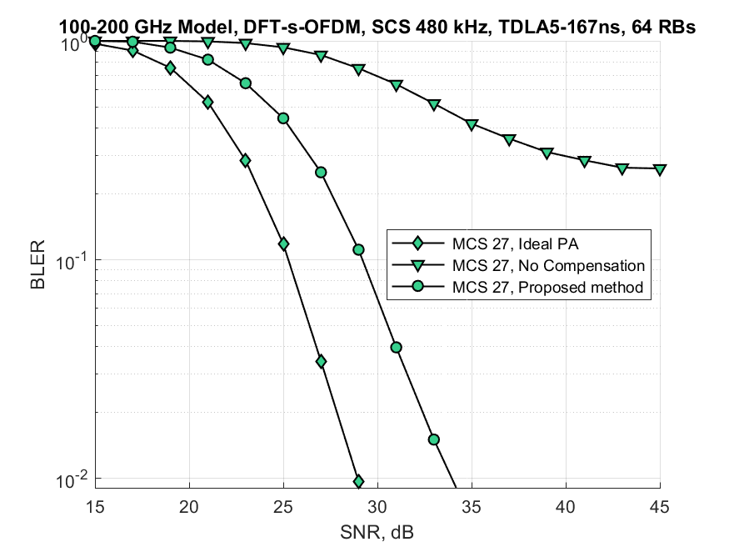

Figure 8 BLER for SCS 480 kHz, 64-QAM/256 QAM for OFDM (left) and DFT-s-OFDM(right)

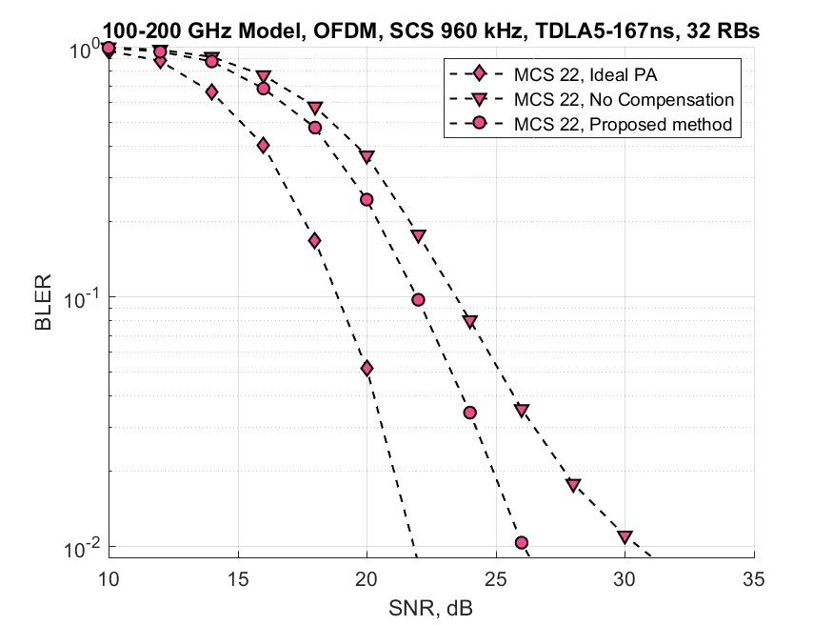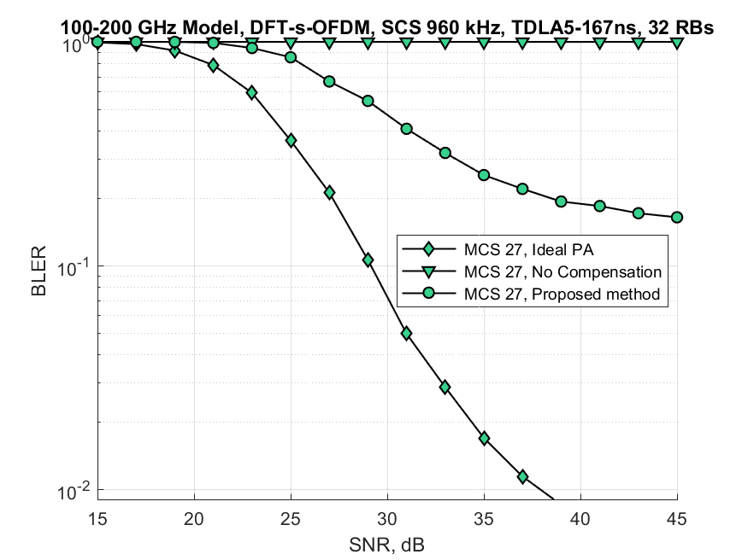

Figure 9 BLER for SCS 960 kHz, 64-QAM/256 QAM for OFDM (left) and DFT-s-OFDM(right)

### Compensation order considerations

The proposed method is intended to be applied before phase noise (PN) compensation, but other configurations have also been considered and simulated. PA nonlinearity compensation performed after PN compensation has shown minor decrease in performance, and thus PN compensation has been performed after PA compensation for most of the results. Example evaluation results comparing PA compensation before and after PN compensation are given in Figure 10.

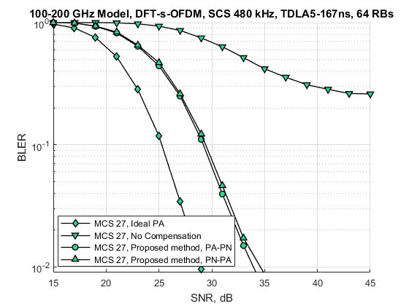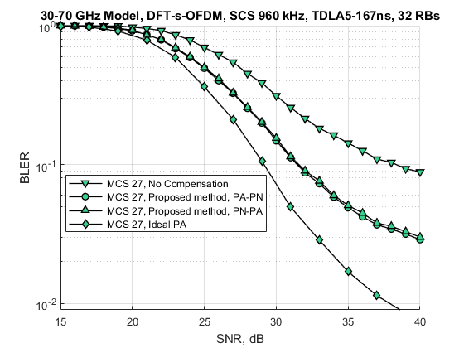

Figure 10.BLER comparison for performing PA compensation before PN (PA-PN), and after (PN-PA).

### Observations

* For the 30-70 GHz PA model (suitable for the FR2 and higher) band analysis, we can see the improvement only for the highest modulations and coding rates.
  + For the SCS 120 kHz, the negative effect of the phase noise (PN) is dominant, and with such impairments, the PA compensation effects are negligible.
  + For SCS 480 and 960, which allows better PN compensation, at some point the effect of PA becomes the main performance limiting factor and thus, PN compensation may provide several dB gain or even mitigate PA floor effect.
* For the 100-200 GHz model, the impact of the PA nonlinearity increases and in most cases, bigger than PN influence
  + The proposed PA compensation scheme shows the performance improvement for the MCS 22 and higher
* Although different implementations possible in different realizations, the logical order first in – last out in terms of impairments seems to be optimal, thus for better results, the impairments should be compensated in order channel, then power amplifier and then phase noise.

# Conclusion

A method for compensation of PA nonlinear distortion on the receiver side has been presented. The method at its core is using an inverse PA’s distortion curve for compensation, can be applied to several waveform types and can be adjusted for the task at hand. The method has been implemented and tested in a fully-fledged 5G NR link-level simulator for performance evaluation. Performance has been measured for existing 30-70 GHz PA model, as well as a new developed 100-200 GHz model, based on recent research results. In both cases, the proposed method has shown ability to significantly improve system performance in various scenarios (waveform, QAM constellation, PA model). As the method relies on receiver-side compensation, this approach can be useful for systems with a high number of low-cost energy efficient simple transmit devices (e.g. IoT). This would allow the transmitter to lower it’s power consumption since it doesn’t have to apply any kind of pre-processing for compensating PA’s nonlinearity.

# References

1. “3GPP TR 38.807 V1.0.0, "Study on NR beyond 52.6 GHz," Tech. Spec. Group Radio Access Network, Rel. 16,” Oct. 2019.
2. “Intel Corporation, "New SID: Study on supporting NR from 52.6GHz to 71 GHz", RP-193259, 3GPP TSG RAN Meeting #86,” December 2019.
3. “Qualcomm, "New WID on extending current NR operation to 71 GHz",RP-193229, 3GPP TSG RAN Meeting #86,” December 2019
4. “A 120-150 GHz Power Amplifier in 28-nm CMOS Achieving 21.9-dB Gain and 11.8-dBm Psat for Sub-THz Imaging System”, J. Zhang et. al., IEEE Access 2021
5. “Analysis and Compensation of Power Amplifier Distortions in Wireless Communication Systems”, S. Manjunath, Electronic Thesis and Dissertation Repository, 2015.
6. M. Shabany and P. G. Gulak, "Efficient Compensation of the Nonlinearity of Solid-State Power Amplifiers Using Adaptive Sequential Monte Carlo Methods," in IEEE Transactions on Circuits and Systems I: Regular Papers, vol. 55, no. 10, pp. 3270-3283, Nov. 2008, doi: 10.1109/TCSI.2008.925376.
7. Eda, Toshiyuki & Ito, Takanori&Ohmori, Hiromitsu& Sano, Akira. (2001). Adaptive Compensation of Nonlinearity in High Power Amplifier by Support Vector Machine. IFAC Proceedings Volumes. 34. 243-248. 10.1016/S1474-6670(17)41629-6.
8. G. A. Ermolaev, O. V. Bolkhovskaya and A. A. Maltsev, "Advanced Approach for TX Impairments Compensation Based on Signal Statistical Analysis at the RX Side," 2021 Wave Electronics and its Application in Information and Telecommunication Systems (WECONF), 2021, pp. 1-5, doi: 10.1109/WECONF51603.2021.9470687.
9. S. Bhat and A. Chockalingam, "Compensation of power amplifier nonlinear distortion in spatial modulation systems," 2016 IEEE 17th International Workshop on Signal Processing Advances in Wireless Communications (SPAWC), 2016, pp. 1-6, doi: 10.1109/SPAWC.2016.7536802.
10. J. Qi and S. Aissa, "Analysis and Compensation of Power Amplifier Nonlinearity in MIMO Transmit Diversity Systems," in IEEE Transactions on Vehicular Technology, vol. 59, no. 6, pp. 2921-2931, July 2010, doi: 10.1109/TVT.2010.2049594.
11. F. Gregorio, S. Werner, T. I. Laakso and J. Cousseau, "Receiver Cancellation Technique for Nonlinear Power Amplifier Distortion in SDMA–OFDM Systems," in IEEE Transactions on Vehicular Technology, vol. 56, no. 5, pp. 2499-2516, Sept. 2007, doi: 10.1109/TVT.2007.899965.
12. H. Bouhadda, R. Zayani, H. Shaiek, D. Roviras and R. Bouallegue, "Receiver Technique for Detection and Correction of Nonlinear High Power Amplifier Distortion Errors in OFDM Systems," 2015 IEEE 81st Vehicular Technology Conference (VTC Spring), 2015, pp. 1-5, doi: 10.1109/VTCSpring.2015.7146044.
13. P. Drotar, J. Gazda, M. Deumal, P. Galajda and D. Kocur, "Receiver based compensation of nonlinear distortion in MIMO-OFDM," 2010 IEEE International Microwave Workshop Series on RF Front-ends for Software Defined and Cognitive Radio Solutions (IMWS), 2010, pp. 1-4, doi: 10.1109/IMWS.2010.5440998.
14. 3GPPTR 38.803 V14.2.0, “Study on new radio access technology: Radio Frequency (RF) and co-existence aspects”, Sept 2017
15. R4-163314,”Realistic power amplifier model for the New Radio evaluation”, Nokia, May 2016
16. Amado Rey, Ana Belén. (2018). Analysis, design, and experimental evaluation of sub-THz power amplifiers based on GaAs metamorphic HEMT technology.
17. A. Ali, J. Yun, F. Giannini, H. J. Ng, D. Kissinger and P. Colantonio, "168-195 GHz Power Amplifier With Output Power Larger Than 18 dBm in BiCMOS Technology," in IEEE Access, vol. 8, pp. 79299-79309, 2020, doi: 10.1109/ACCESS.2020.2990681.
18. 3GPP TR 38.803 V14.2.0 (2017-09) “Study on new radio access technology: Radio Frequency (RF) and co-existence aspects”