Modified Wave Spectrum

In oceanography, the frequency spectrum 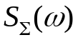 and the frequency-angular spectrum 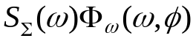 are usually measured, where 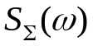 describes the wave energy distribution over frequencies and 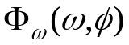 is responsible for the angular distribution function.
A “radiophysical” model of the spectrum exactly corresponding to the known experimental data was developed to describe wind waves.
In the frequency range from 0 to 1.2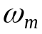 the new spectrum coincides with the JONWAP spectrum:
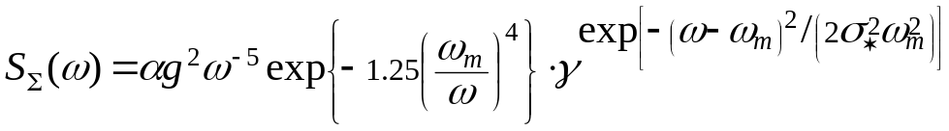 ,
where 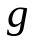 is the acceleration of gravity, 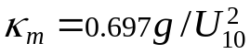, and
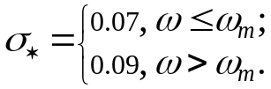
The wavenumber 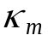and the frequency are related by the dispersion relationship for water waves.
At the frequency higher than 1.2 the wave spectrum is assigned by the formulas:
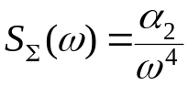 , 1.2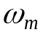 < 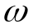 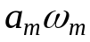;
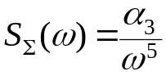 , < 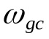 64 rad/s (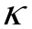= 270 rad/m);
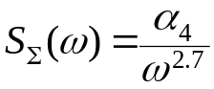 , < 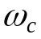 298 rad/s ( = 1020 rad/m);
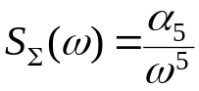 , < .
The coefficients 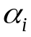 are calculated as follows:
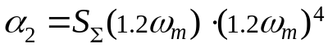 , 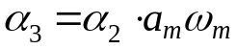 ,
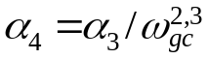 , 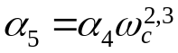.
The value of the coefficient 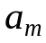 depends on the wind speed and is yielded by the expression:
.
To describe the angular distribution the following formula is used:
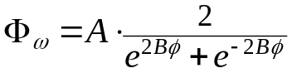 , 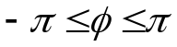
where 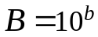 and
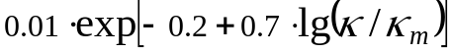.
The angle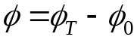, where 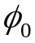 is the direction of wave propagation and 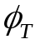 is the azimuth angle counted off from the X axis. The normalization coefficient 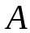 amounts to:
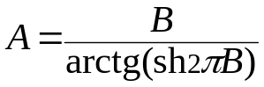 .
The developing waves are described by the concepts of the dimensionless wind fetch 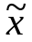 and the dimensionless frequency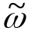:
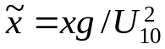 and 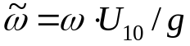
where 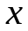 is fetch in meters. When waves are developing from the shore under the action of wind, the fetch length coincides with the distance to the shore.
As waves develop, the following parameters of the spectrum model vary: 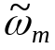, 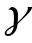, 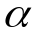. Below are the formulas for these values in the variation range of the dimensionless fetch = [1430, 20170]:
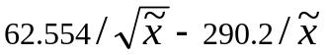,
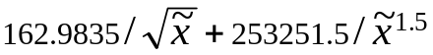,
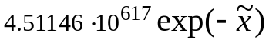.
The fetch value = 20170 corresponds to the fully developed wind waves.
The present model of the roughness spectrum has been developed by analyzing experimental data for “radiophysical” application and is successfully used for solution of different problems.
Model is working for wind speed from 2.5 m/s to 22 m/s. I believe, that sea waves can not generated at wind speed 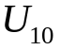 less 2.5 m/s. In this case we may see only swell. Unfortunately, I have not enough data for calibration of model for high wind speed (> 20 m/s).

Some figures.
Program name is SEAWVS_1.PAS (SEAWVS_1.EXE).

Program calculates the wavenumber spectrum 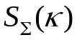 and writes results in SEAWVS_1.DAT file. The file consists from 4 columns: 1) wavenumber 2) JONSWAP spectrum 3) Our spectrum 4) Elfouhaily spectrum (JGR, 1997, v.102, N C7).
For convenient I have passed in program from 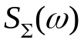 to using the following dispersion relation:
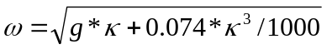
The calculations were made for case of fully developed wind waves ( >= 20170) and wind speed = 5 m/s, 10 m/s 15 m/s (files – SW5_FD.dat, SW10_FD.dat, SW15_FD.dat). It is an elevation spectrum.

The comparison of models you may see in figure 1. The wave spectrums for our model and for different wind speeds are shown in fig.2.
The changing of wave spectrum for developing wind waves is shown in fig. 3. The data files are SW10_D5.dat (=5000), SW10_D10.dat (=10000), SW10_D15.dat (=15000). The calculations were made for =10 m/s.

The same calculations were made for curvature spectrum (see fig. 4-6). The following files were obtained: SS5_FD.dat, SS10_FD.dat, SS15_FD.dat (fully developed wind waves) and SS10_D5.dat (=5000), SS10_D10.dat (=10000), SS10_D15.dat (=15000). The calculations were made for =10 m/s.

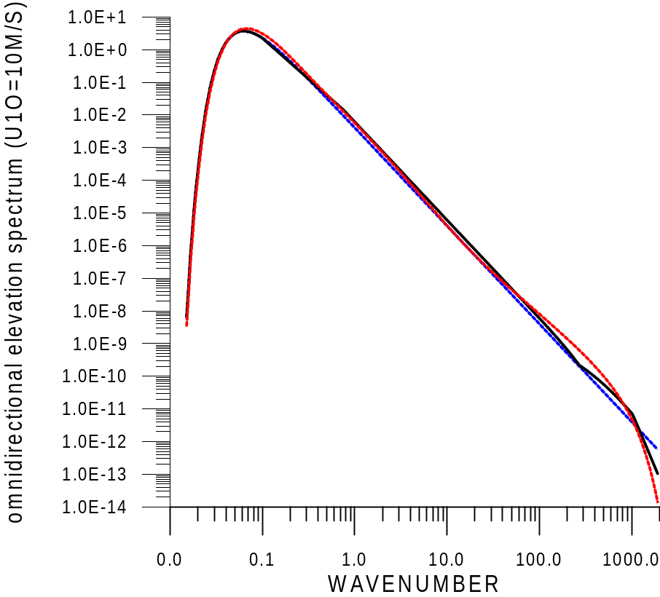

figure 1. Omnidirectional elevation spectrum for wind speed 10 m/s. Blue – Jonswap, Red – Elfouhaily, Black – our model.

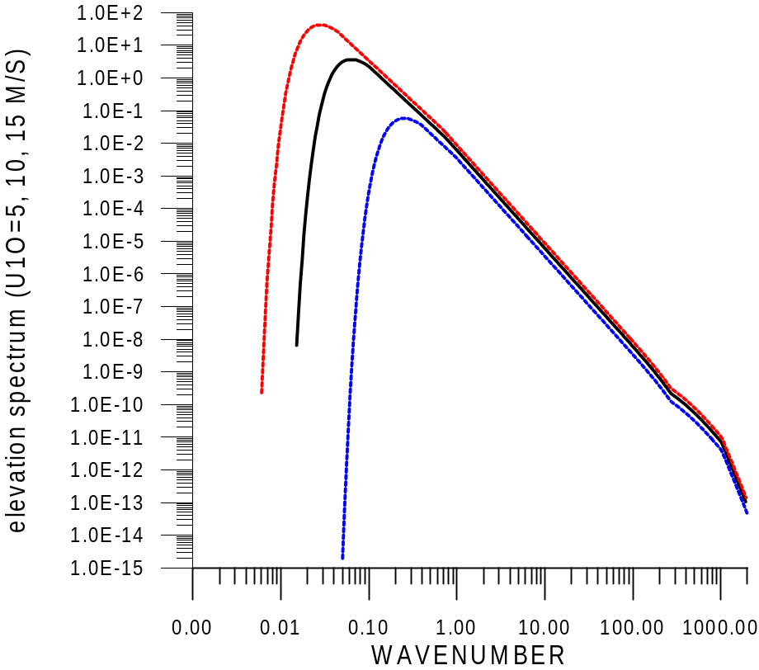

figure 2. Our model of elevation spectrum. Blue – 5 m/s, Black – 10 m/s, Red – 15 m/s.

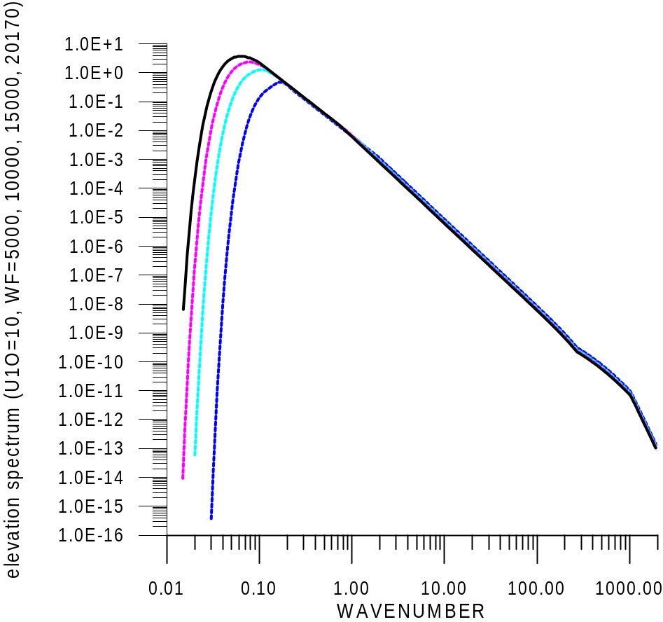

figure 3. Our model of elevation spectrum. Developing sea waves for 10 m/s (=5000, 10000, 15000, 20170). Blue line – wind fetch = 5000/s and Black – fully developed wind waves.

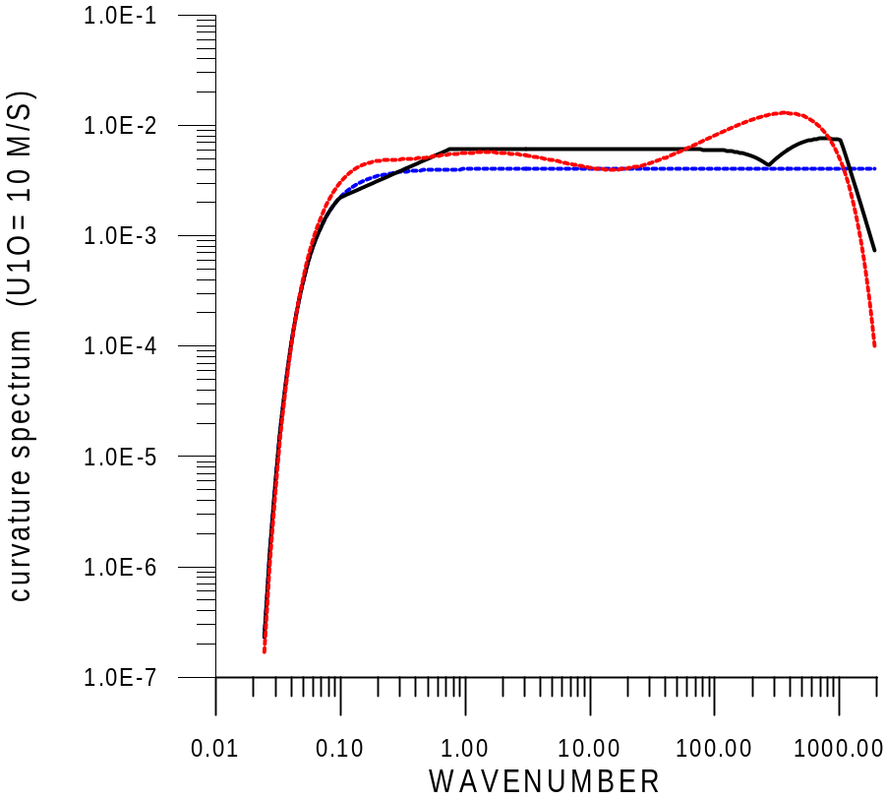

figure 4. Curvature spectrum for wind speed 10 m/s. Blue – Jonswap, Red – Elfouhaily, Black – our model.

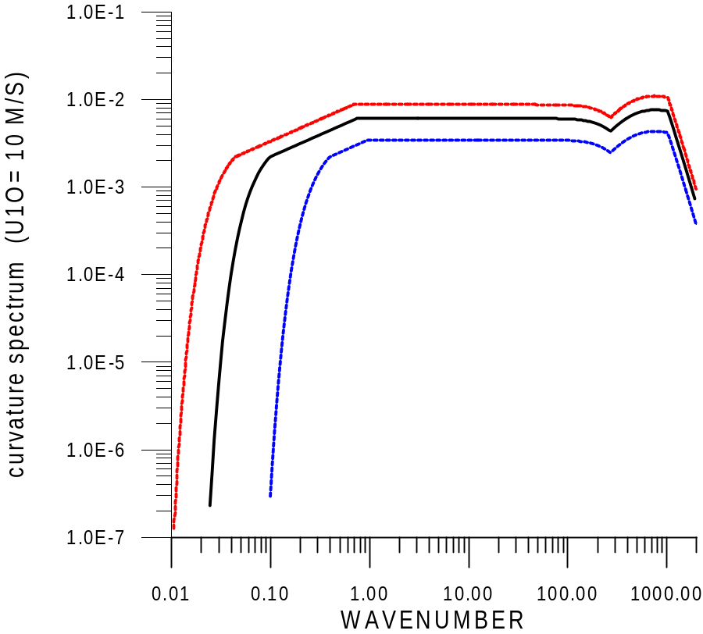

figure 5. Our model of curvature spectrum. Blue – 5 m/s, Black – 10 m/s, Red – 15 m/s.

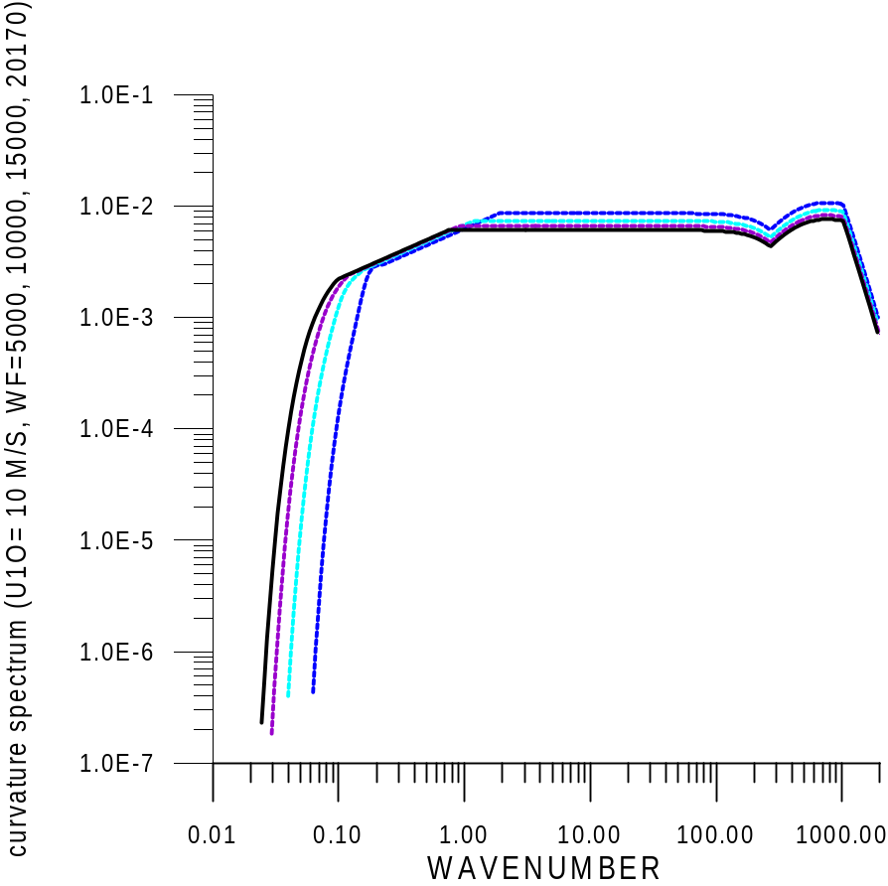

figure 6. Our model of curvature spectrum. Developing sea waves for 10 m/s (=5000, 10000, 15000, 20170). Blue line – wind fetch = 5000/s and Black – fully developed wind waves.

Instruction for program

SEAWVS_1.EXE
E X A M P L E
1) Input wind fetch (1430-20170) : 10000 , ENTER
2) Work with slick? (Y/N): N
3) long calculations? (Y/N): Y
long calculations KT = KT + HK*KT (changing step)
calculations: KT = KT + HK (permanent step)
4) Slopes (Y) or Height (N) : Y
5) Input U10, m/s : 10 , ENTER
6) Input K0 : 0.015
7) Input KK : 2000
8) Input HK : 0.05
9) File is rewritten? : Y
10) Continue ? : N

data file is SEAWVS_1.dat

