Modified Wave Spectrum

TWO-SCALE MODEL

Some remarks to previous programs.
I found that translation from Russian was not always easy understandable.

Programs SEAWVS_1.pas and SEAWVS_2.pas calculate the omnidirectional elevation spectrum and omnidirectional curvature spectrum.

-----------------------------------------------------------------------------------------------------------------

To obtain the numerical estimates of the statistical characteristics of large-scale waves, we shall divide the full sea waves spectrum into small-scale and large-scale parts in comparison with radar wavelenght and introduce a boundary wavenumber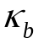. The small-scale part > 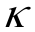 is held obeying the perturbation theory, while the large-scale part requires conformity with physical optics:
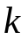R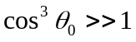,
R being the mean curvature radius, and 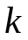 is the radar wavenumber. The latter inequality means that for electromagnetic diffraction the appropriate large-scale surface can be replaced at its arbitrary point by a tangent plane with a local normal.
The slope variance of large-scale waves is found by integration over the slope spectrum to the boundary wavenumber, i.e., the contribution is made by the waves located on the wavenumber axis to the left of the boundary wavenumber .
Let us give formulas for the dependence of the boundary wavenumber on the wind speed for the few radar wavelengths calculated for our model of the wave spectrum:
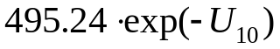.

,
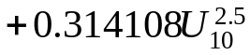
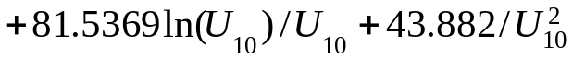 ,
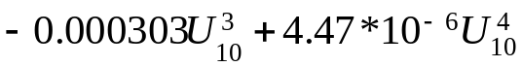 ,
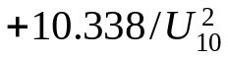 ,

The formulas work in the following interval of wind speeds 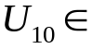 [3 m/s, 20 m/s].

SEAWVS_3.exe

The program calculates the basic statistical parameters of sea waves and saves in file. First of all we are considering the program which working with wind waves. Program calculates the double integral (wavenumber and azimuth angle).
Exist possibility to calculate the dependence of the statistical parameters on wind speed or azimuth angle (direction of wave propagation). It is possible to save in file large-scale parameters or total parameters (large-scale + small-scale).

The calculated and saved in files statistical parameters can be used in other programs (your programs).

The comparison known Cox and Munk data with our wave model are shown in figure 10.
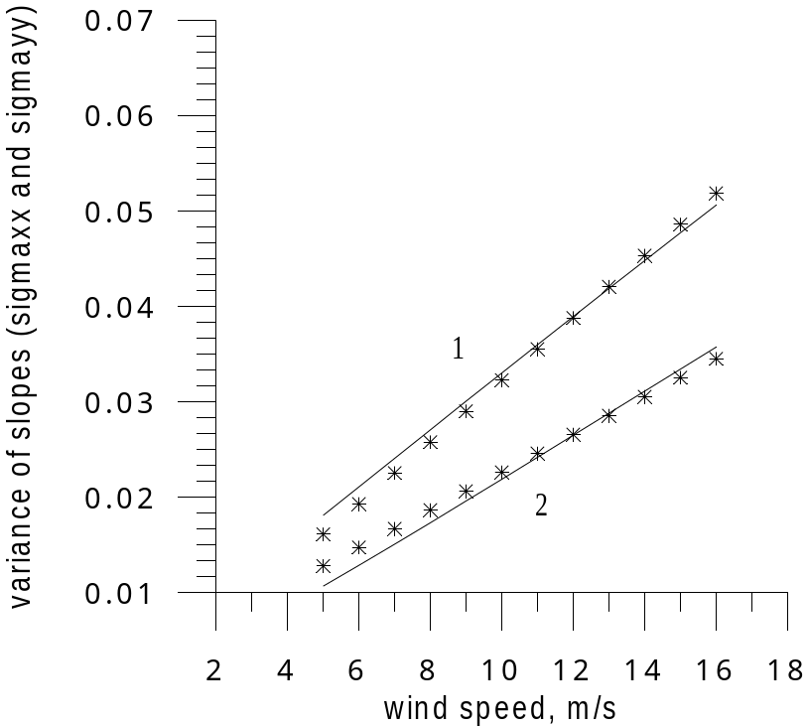

Fig. 10. Dependence of variance of slopes (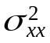 and 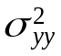) on wind speed for fully developed wind waves. Curve 1 - and curve 2 - , which were calculated by our model for fully developed wind waves. Asterisks – Cox and Munk data.

It is seen good correlation. Some difference may be explained the length of wind fetch or swell arrival. The total variance of slopes is equal to Cox and Munk data.

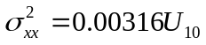
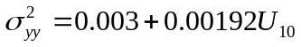
The dependence of variance of large-scale slopes () on wind speed you may see on fig. 11.

The first curve is variance of slopes along X axis (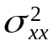) which is close to Cox and Munk data (large-scale + small-scale slopes). The other curves were plotted for radar wavelengths: 0.008 m, 0.03 m, 0.1 m, 0.23 m. It is variance of large-scale slopes.

It is seen, that variance of large-scale slopes reduces for more long radar waves.

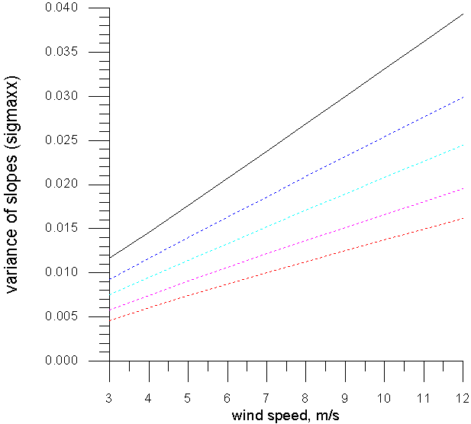

Fig. 11. Dependence of variance of slopes () on wind speed. Black line – large-scale + small-scale (Cox and Munk), blue line – radar wavelength – 0.008m, - 0.03 m – 0.1 m and red line – 0.23 m. Direction of wind is equal 0 (along X axis).

Also we may consider the changing of statistical parameters during a wind fetch. The example the dependence of variance of slopes ( and 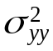) on nondimensional wind fetch is shown at fig. 12. Wind speed is equal to 7 m/s.

At the next figure you see the dependence of variance of slopes () on direction of wave propagation (azimuth angle). The total variance of slopes (large-scale + small-scale) is the black curve.

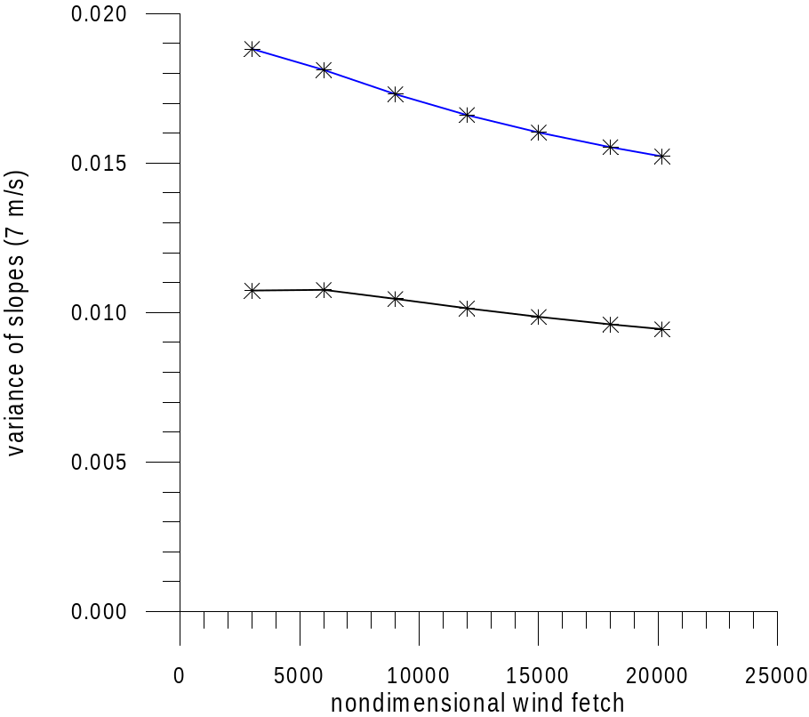

Fig. 12. Dependence of variance of slopes on nondimensional wind fetch. Blue line – (large-scale), black line – (radar wavelength – 0.03 m).
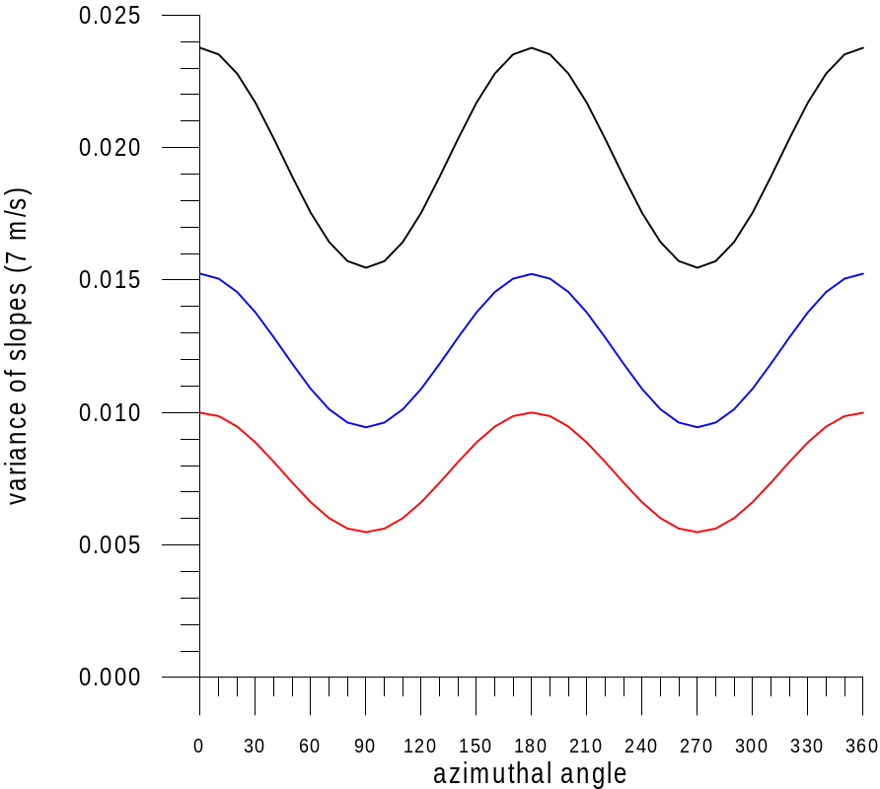

Fig. 13. Azimuthal dependence of variance of slopes (), black line – total , blue line – large-scale slopes (radar wavelength – 0.03m), red line – large-scale slopes (radar wavelength – 0.23m).

We can use our program for calculation the influence of slick on wave spectrum. In this version of program we use the parameters of sunflower oil.

SAS films on water surface efficiently damp short wind waves, i.e., slicks occur. The decrease of the spectral density depends on the film thickness and the properties of the substance.
To describe the variation of the spectral density of surface waves in the slick, we introduce a concept of contrast 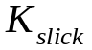 as follows:
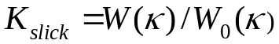, (1)
where 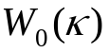 is the wave spectrum on clean water, 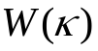 is the wave spectrum in the slick, and 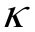 is the wavenumber.
Depending on the relation between the viscous damping decrement 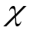 and the wind increment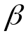, the contrast is calculated as (Ermakov, Fizika atmospery i okeana):
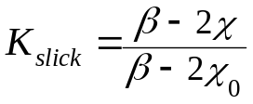, 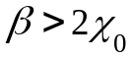 and 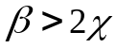 (2)
or
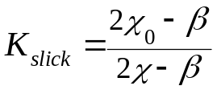, 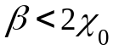 and 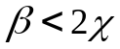. (3)
If the above-mentioned conditions are not fulfilled, strong smoothening (damping) at this wavelength is observed; in this case ≈ 0.
The expressions for the viscous damping decrement and the wind increment are given below:
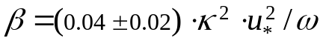, (4)
and
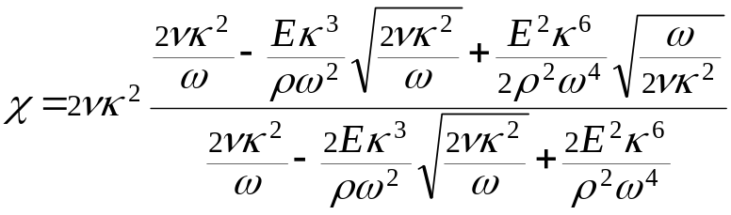 , (5)
where 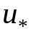 is the friction velocity (cm/s), 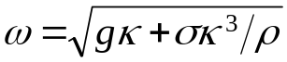 is the dispersion relation for surface waves, 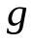 is the acceleration of gravity (cm/s2), 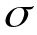 is the surface tension coefficient (g/s2), 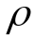 is the water density (g/cm3), 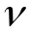 is the kinematic viscosity (cm2/s), and 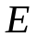 is the film elasticity modulus (mN/m) dependent on the concentration and type of the substance, 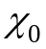 corresponds to the case of clean water.
The model described above was frequently employed to carry out numerical calculations, e.g., [Ermakov] and its adequacy was validated.
In further numerical estimates we choose vegetable oil as SAS. This choice is explained by the necessity to provide environmental safety of the future experiment, thus it is more preferable to use a substance that will not pollute the environment; and then the calculation results will be compared to the future experimental ones.
For the numerical estimates we utilize the following values: = 0.01 cm2/s, (water) = 72 g/s2, and (vegetable oil) = 40 g/s2.
The film elasticity is in the range 5 ÷ 30 mN/m; in the calculation we use two values: 10 and 20 mN/m.

More detail in our paper (Sensors 2008, 8, 3780-3801; DOI: 10.3390/s8063780, free access)

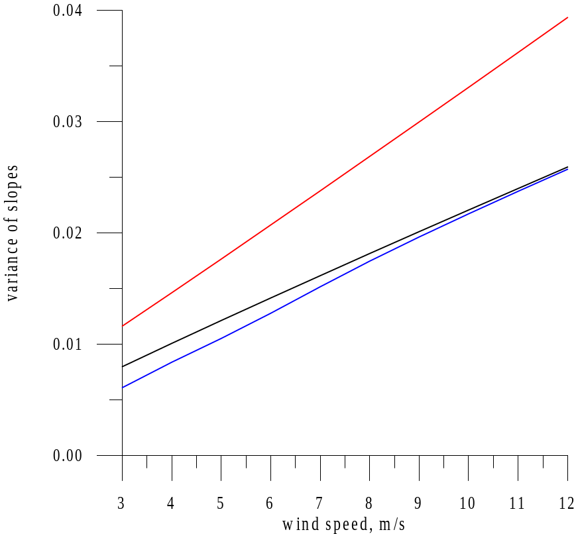

Figure 14. Dependence of total variance of slopes () on wind speed (red line). Black line is the dependence of variance of slopes of large-scale waves on wind speed (clear sea, radar wavelength 0.021 m ) and blue line – variance of slopes of large-scale waves (radar wavelength 0.021 m) in slick (E= 20).

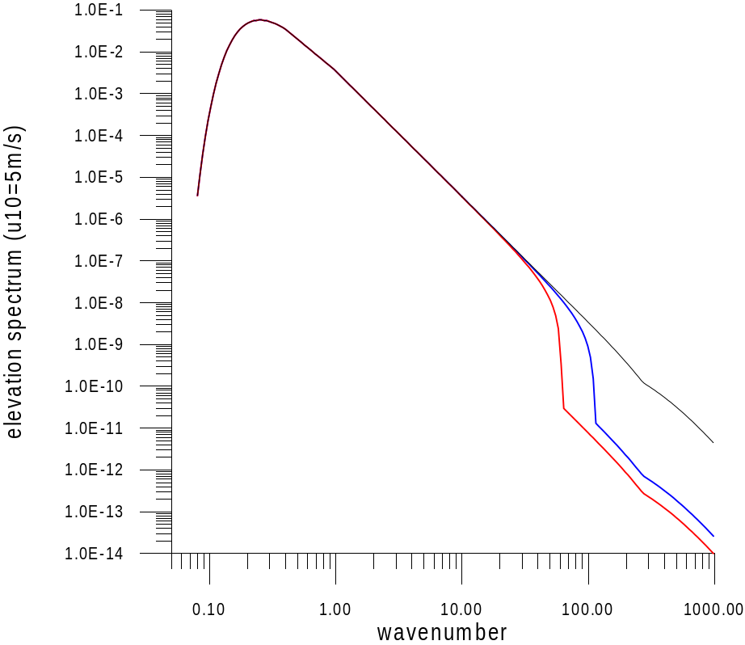

Fig.15. Omnidirectional elevation spectrum for wind speed 5 m/s. Blue line – =10, red line =20. Black – no slick.

Instruction for program

SEAWVS_3.EXE

E X A M P L E
1) Rewritten file ? Y
2) Input wind fetch (1430-20170) : 20170 , ENTER
3) Work with slick ? N
4) Input radar wavelength 0.021
5) Dependence on wind speed Y
7) Input initial wind speed, m/s : 10
8) Input final wind speed, m/s: 15
9) Input number of points: 6
10) Input direction of wind : 0
11) ONLY parameters of Large-scale waves? : Y

12) Dependence on azimuthal angle ? N

data file is SEAWVS_3.dat

Variant with slick

SEAWVS_1.EXE

E X A M P L E
1) Rewritten file ? Y
2) Input wind fetch (1430-20170) : 20170 , ENTER
3) Work with slick ? Y
Input beta (0.04): 0.04
Input sigma of water(72): 72
Input sigma of oil (40): 40
Input E of oil (5-30): 10
4) long calculations? (Y/N): Y
long calculations KT = KT + HK*KT (changing step)
calculations: KT = KT + HK (permanent step)
5) Slopes (Y) or Height (N) : Y
6) Input U10, m/s : 10 , ENTER
7) Input K0 : 0.015
8) Input KK : 2000
9) Input HK : 0.05
10) File is rewritten? : Y
11) Continue ? : N

data file is SEAWVS_1.dat

SEAWVS_3.EXE

E X A M P L E
1) Rewritten file ? Y
2) Input wind fetch (1430-20170) : 20170 , ENTER
3) Work with slick ? Y
Input beta (0.04): 0.04
Input sigma of water(72): 72
Input sigma of oil (40): 40
Input E of oil (5-30): 10
4) Input radar wavelength 0.021
5) Dependence on wind speed Y
7) Input initial wind speed, m/s : 10
8) Input final wind speed, m/s: 15
9) Input number of points: 6
10) Input direction of wind : 0
11) ONLY parameters of Large-scale waves? : Y

12) Dependence on azimuthal angle ? N

data file is SEAWVS_3.dat

